Mongols and Inner Mongolia
The Mongols of Inner Mongolia are part of a larger family of Mongolic-speaking peoples native to the eastern Eurasian steppe. Now spread between northern China, Mongolia (formerly Outer Mongolia), and Russia, these peoples share a common heritage as both nomadic herders and erstwhile conquerors of much of the Eurasian landmass under the leadership of the most famous Mongol of them all, Chinggis Khan. The majority (around 6 million) reside in the People’s Republic of China (PRC), primarily in the Inner Mongolia Autonomous Region.

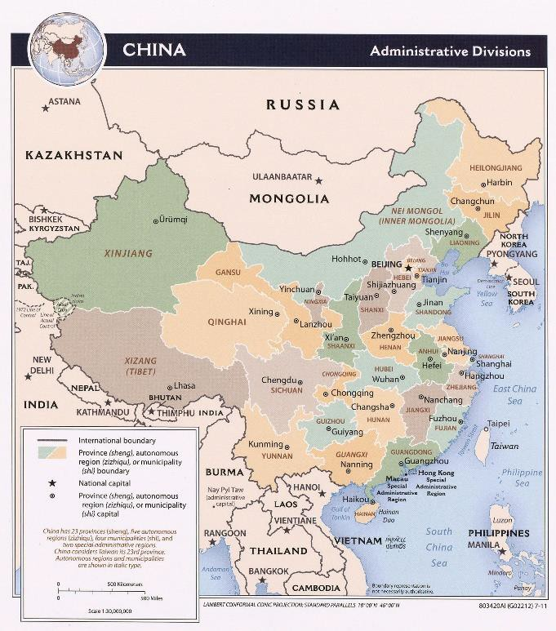
Dated 2011. Courtesy of the University of Texas Libraries, The University of Texas at Austin.

Inner Mongolia (Mongolian Öbür Monggol / Mandarin Chinese Nei Menggu) is a vast territory in northern China which runs along the border with Russia and Mongolia. The territory can be roughly divided into western desert, central grasslands, and eastern mountains. Summers are generally short and mild, followed by long, harsh winters. The Mongol inhabitants of this region traditionally specialized in the herding of livestock, engaging in a nomadic or semi-nomadic way of life to supply their animals with sufficient grazing. Many Mongol communities in the region continue this practice today. The population as a whole, however, is increasingly urbanized and concentrated in the center around the political and cultural capital of the region, Hohhot. The number of Chinese settlers arriving in Inner Mongolia increased dramatically over the 20th century, and today the majority of the population are Han Chinese, who tend to live in the more densely populated agrarian and urban areas.

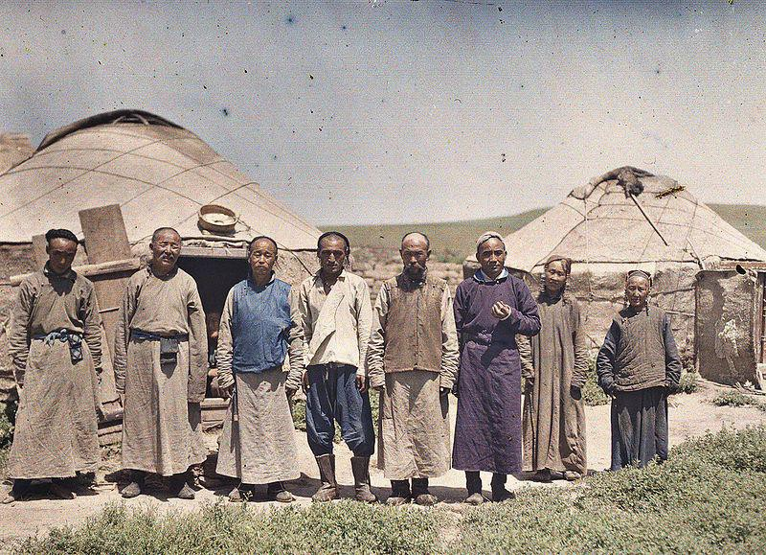
Mongol herders in Inner Mongolia in 1912, pictured in front of their ger—the Mongolian term for “yurt.” (Stéphane Passet (1875-1942), Public domain, via Wikimedia Commons)

Culture and Language
Because the majority of the population are Han, the primary language of Inner Mongolia is Mandarin Chinese, with Mongolian also having official language status in the region. Mongolian is spoken by the Mongol population and is taught in schools using the traditional vertical script that was originally introduced by Chinggis Khan. In August 2020, a move by the central PRC government to replace Mongolian-language instruction with Mandarin Chinese in three subjects at elementary and middle-school level sparked protests among the ethnic Mongol community who see this as part of a deliberate strategy by the central government to suppress and eventually erase their cultural identity.

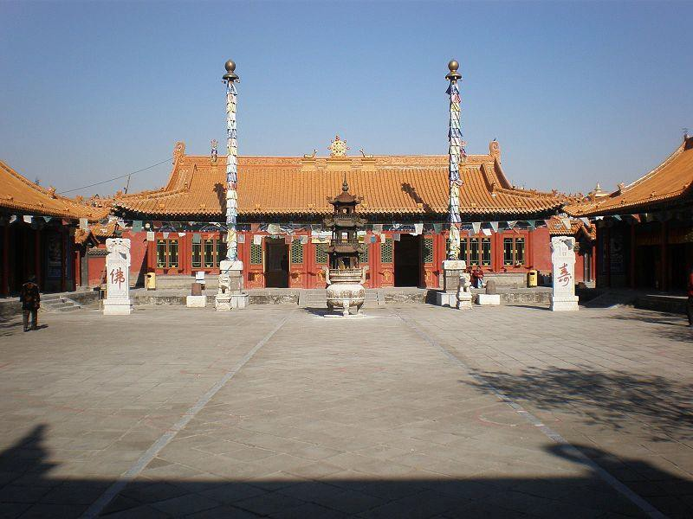
Da Zhao Temple, a Buddhist Monastery in Hohhot, Inner Mongolia. (兜兜, CC BY-SA 3.0, via Wikimedia Commons)

Tibetan Buddhism has left a tangible mark on Mongol culture, particularly in the realm of religious arts, architecture, music, and teaching. While many monasteries and temples were destroyed during China’s Cultural Revolution of 1966-76, some religious institutions survived and Tibetan Buddhism is still followed by many in Inner Mongolia. Alongside and intermixed with Buddhism, various shamanistic beliefs and practices are also an important part of Mongol life. Chinggis Khan himself is worshipped by some as an ancestor, dynastic founder, and deity to whom offerings and sacrifices are made. While also widespread in the country of Mongolia, the focal point of this tradition is the Mausoleum of Chinggis Khan in Ordos, Inner Mongolia. Though the Great Khan was never buried here, the Chinese authorities spent millions of dollars renovating the mausoleum, encouraging the veneration of Chinggis Khan as spiritual founder of the Yuan dynasty and unifier of the region.

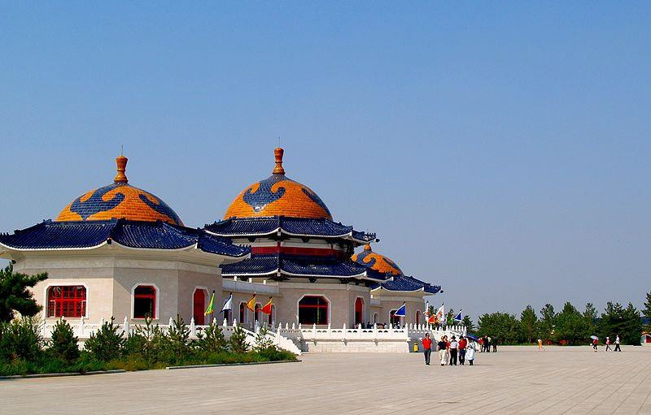
The Mausoleum of Chinggis Khan, Ordos
(Samxli at English Wikipedia, CC BY 3.0, via Wikimedia Commons)

History
Perhaps most well-known for their conquest of much of the Eurasian landmass in the 13th century under the leadership of Chinggis Khan, the Mongols were an important military and administrative influence on many European and Asian civilizations. The Mongol Empire became increasingly fragmented in the 14th century and the remaining Mongol khanates splintered or were replaced by local dynasties. This ultimately led to the incorporation of both Inner and Outer Mongolia into the Manchu Qing Empire during the 17th century.
In 1911, as the Qing Dynasty neared collapse, Outer Mongolia claimed independence. During the following turbulent decade, power in the region changed hands several times. Finally, in 1924, Outer Mongolia was declared an independent socialist state: the Mongolian People’s Republic. The country underwent a peaceful democratic revolution in 1990, and today is known simply as Mongolia. Inner Mongolia, on the other hand, remained under the control of the Republic of China that succeeded the Qing Dynasty and that later became the People’s Republic of China that exists today.

Inner Mongolia Autonomous Region
Capital: Hohhot
Population: around 25 million
Languages: Mandarin Chinese, Mongolian

As well as the Inner Mongolia Autonomous Region, created in 1947, there are also a number of Mongol Autonomous Counties outside Inner Mongolia. China’s Mongols are the 10th largest of the country’s 56 officially-recognized ethnic nationalities, or minzu. However, in Inner Mongolia they are outnumbered by Han Chinese, who constitute the majority (around 80%) of the region’s 25 million inhabitants.

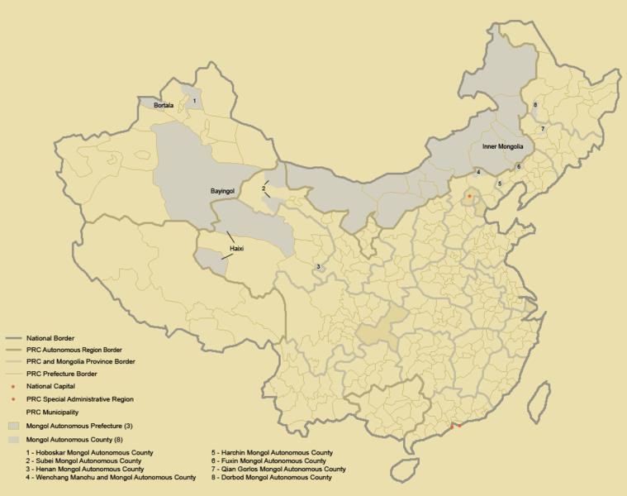
Mongol Autonomous Subjects in the PRC, CC Attribution 3.0 via Wikipedia

Inner Mongolia Today
The territory now occupied by Inner Mongolia has always represented the limit of agricultural expansion from the south, which means that it has long been an area of contact and conflict between agrarian and nomadic populations. Around one third of the Great Wall of China—built over hundreds of years to protect the settled lands to the south from the incursions of steppe nomads—runs through Inner Mongolia. The historical tension continues in some respects as Mongol communities compete for use of their traditional grazing lands with mostly Han-dominated mining and land development enterprises. The Chinese authorities have forcibly resettled thousands of herders (ostensibly to reduce overgrazing and desertification, but control of the local population may also be a factor).
Unlike in Tibet and Xinjiang, there is no coordinated campaign for Inner Mongolian independence, partly because separatist organizations have been swiftly broken up by the Chinese authorities, with leading activists imprisoned. The August 2020 protests against the reduction of Mongolian-language education in favor of Mandarin Chinese occurred against a backdrop of increasing Sinicization which brings into question the long- term vitality of Mongolian language and culture in Inner Mongolia.

Further Resources
Bilingual Education in Inner Mongolia: An Explainer (Christopher P. Atwood, Made in China Journal, August 2020) – explains the reasons behind/reactions to the reduction in Mongolian language teaching in Inner Mongolian schools in the context of China’s broader ethnic policy.
Herdsman Faces Change in Inner Mongolia (BBC, 2014) – short video interview
Ethnic Protests in China Have Lengthy Roots (Andrew Jacobs, The New York Times, June 2011) – report on the May 2011 wave of ethnic Mongolian protests and the long term causes for discontent, including the impact of mining on the environment, forced settlement, and the erosion of Mongol culture and identity.
Radio Free Asia: Inner Mongolia – Inner Mongolia news archive.

