Tibet and Tibetans
The cultural homeland of the Tibetan people is the Tibetan Plateau. This is the world’s highest and largest plateau, bounded to the south by the Himalayas, and sometimes romantically referred to as “The Roof of the World.” Today, the Tibetan Plateau is located in the People’s Republic of China and almost all Tibetans (around 98%) are Chinese citizens, making up one of China’s largest ethnic minorities.

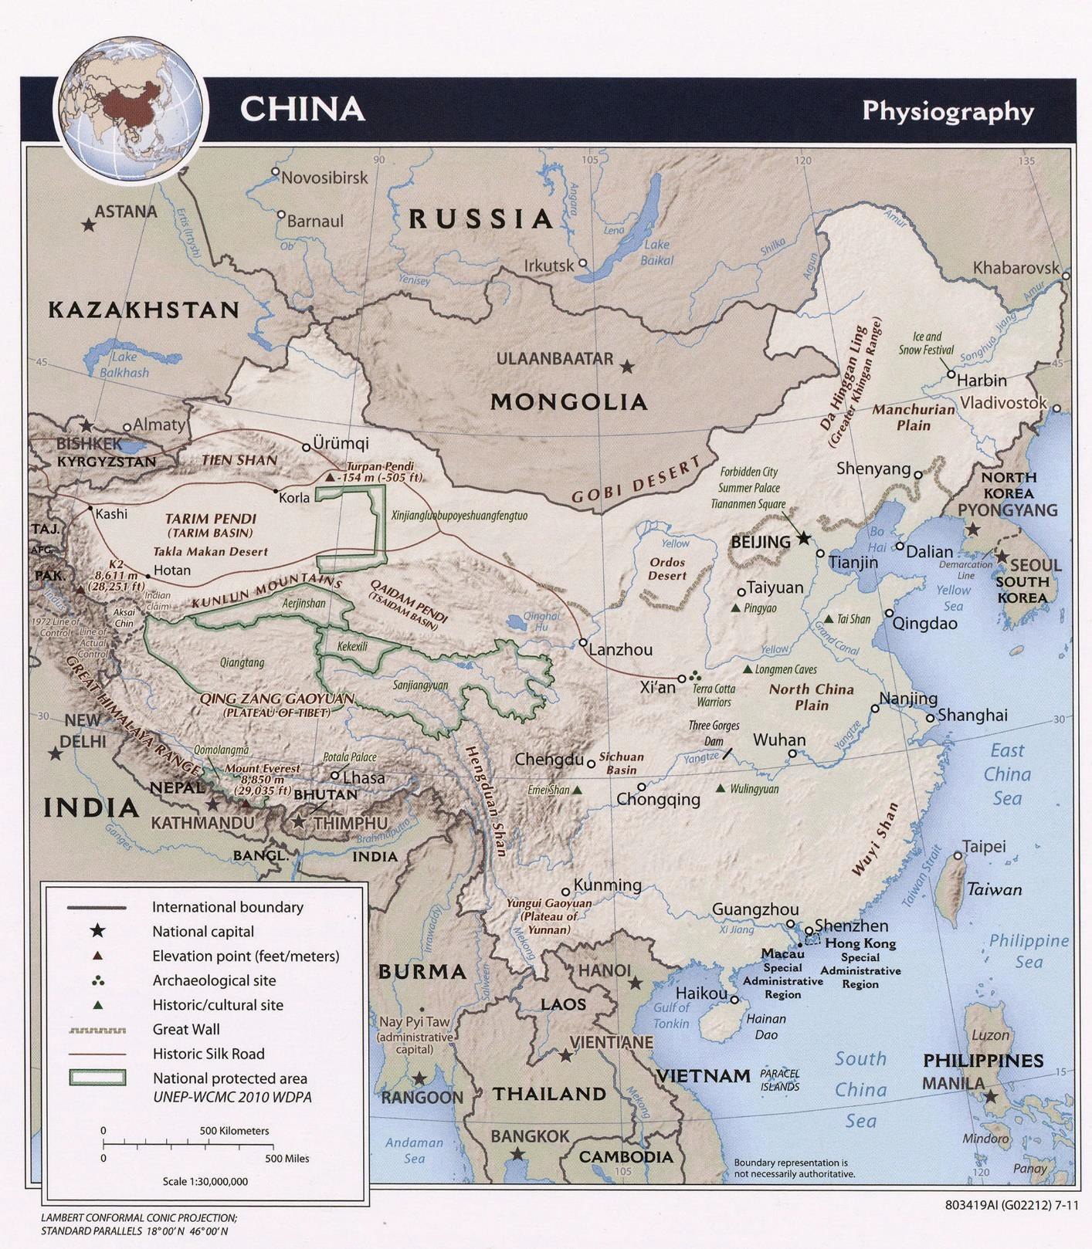
Dated 2011. Courtesy of the University of Texas Libraries, The University of Texas at Austin.

The climate on the Tibetan Plateau is generally too cold and dry for agriculture, although river systems and richer soils in the south support various crops. Barley in particular is a staple of the Tibetan diet in the form of Tsampa, or roasted flour, that can be eaten in different forms. Sometimes it is mixed with yak butter tea— another Tibetan staple. The herding of livestock including yaks, horses, sheep, and goats has always been a typical occupation on the open grassland, and many Tibetans continue to specialize in this nomadic or semi- nomadic way of life. Although the majority of the population is rural, there are several important urban centers

on the Tibetan Plateau, including Lhasa—the religious and administrative capital of Tibet since the mid-17th century.

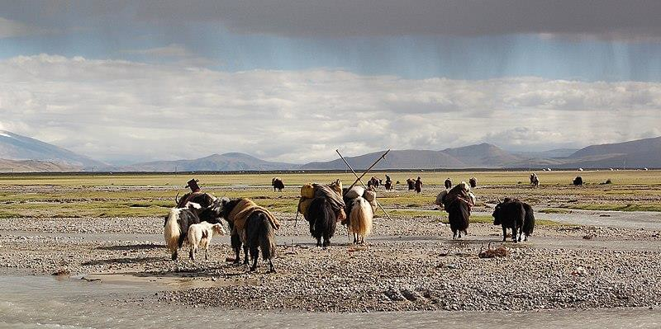
Tibetan herders and their yaks on the move near Mount Kailash
(Dieter Schuh 14:32, 3. Okt. 2009 (CEST), CC BY-SA 3.0, via Wikimedia Commons)

Tibetan Buddhism and the Dalai Lama
Buddhism became established in Tibet during the 8th century and remains at the heart of Tibetan culture. Until the Chinese government gained control of Tibet in 1959, as many as a quarter of all Tibetans were living as Buddhist monks or nuns. During China’s Cultural Revolution of 1966-1976, the communist regime sought to eradicate traditional elements in society, including religion. In Tibet, members of religious communities were imprisoned or killed and thousands of monasteries were destroyed. Today, there are less than 100 working monasteries in Tibet and just a handful of nunneries, which operate under the strict control of the authorities. Despite this, Tibet’s religious centres are focal points not just for religious pilgrimage and ritual, but also for the celebration of Tibetan culture in the form of religious art and architecture, music and dance, and annual festivals such as Losar (Tibetan New Year).

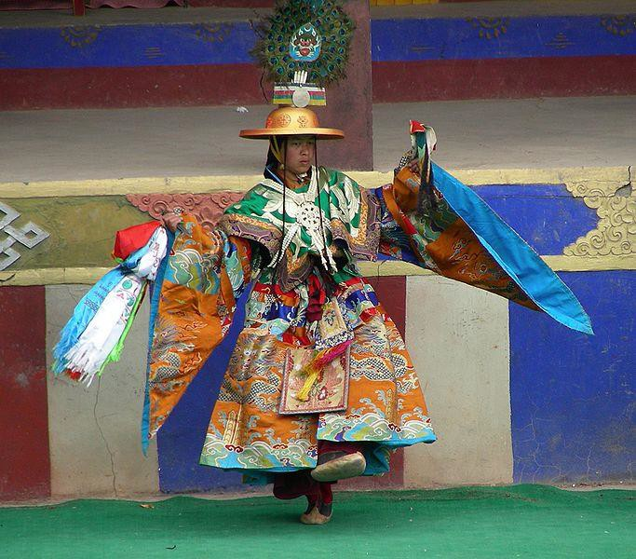
A Tibetan monk dancing at Losar. Domthok Monastery, Northern Kham (Ljbonner, CC BY-SA 4.0, via Wikimedia Commons)

The most important figure in Tibetan Buddhism is also the most famous Tibetan to the west: the Dalai Lama. The Dalai Lamas were initially spiritual leaders, and their role later expanded to include political leadership. They came to represent not only Buddhist values and traditions, but also the unity of the Tibetan state. The 14th Dalai Lama fled Tibet in the 1950s to escape persecution by the communist authorities and set up a Tibetan government-in-exile in India. He and many others continue to call for Tibetan independence, fiercely resisted by the Chinese authorities.

History
Tibetans have played an important role in the history of Central, Inner and East Asia. In the 7th-9th centuries, the Tibetan Empire ruled over a region far beyond its contemporary borders. Even today, Tibetan religion and culture exert significant influence over much of Inner Asia, where the Mongols and others continue to follow Tibetan Buddhism.
At various times in its history, Tibet has functioned as an independent entity or been ruled by powerful dynasties. In the 18th century, Tibet was conquered by the Manchu Qing Dynasty. After the fall of the Qing in 1912, Tibet struggled for independence until the 1950s, when it was incorporated into the People's Republic of China (PRC). The Tibet Autonomous Region (TAR, also called the Xizang Autonomous Region) is a province-level autonomous region of the PRC created in 1965.

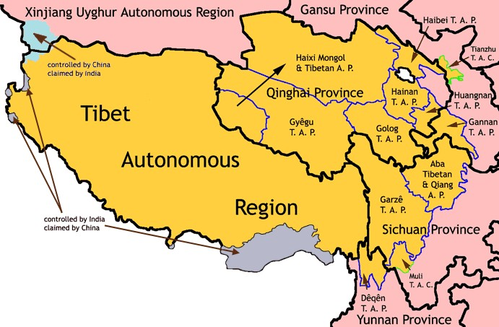
Map showing the Tibet Autonomous Region alongside the various Tibetan Autonomous Prefectures and Counties in Qinghai, Sichuan, Gansu, and Yunnan Provinces.
(TAR-TAP-TAC.png, CC BY-SA 3.0 via Wikimedia Commons)

Tibet Autonomous Region
Capital: Lhasa
Population: around 3.2 million Languages: Tibetan, Mandarin Chinese
The Tibet Autonomous Region includes about half of historical Tibet, including the traditional provinces of Ü-Tsang and the western half of Kham. The borders of the present Autonomous Region coincide roughly with the area that was under the control of the government of Tibet in 1950. The TAR is the second-largest

province-level division of China by area after Xinjiang, spanning over 470,000 square miles, but is the smallest in terms of population. Although increasing numbers of China’s Han majority have migrated to the region, around 90% of its inhabitants are Tibetan.
Depending on who is speaking, “Tibet” may refer to the TAR, or to a much larger territory incorporating the entire Tibetan Plateau, which includes culturally Tibetan areas in neighboring provinces of the PRC. Of the 6 to 7 million Tibetans in China, only around half live in the TAR. Tibetan areas in Qinghai, Sichuan, Gansu, and Yunnan provinces have been designated Tibetan Autonomous Prefectures or Counties, but are not recognized by the Chinese authorities as included under the term “Tibet.”

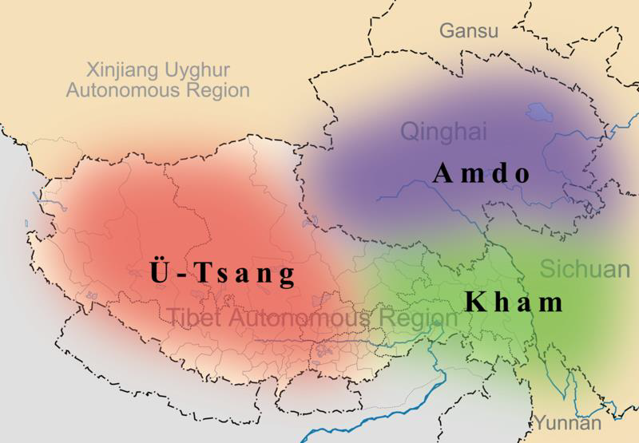
Tibetans have their own names for the areas of historical Tibet, extending across the Tibetan Plateau. This map shows those regions overlayed onto contemporary regional borders. (Kmusser, CC BY-SA 3.0, via Wikimedia Commons)

Tibet Today
Since the 1950s, the Chinese administration has invested in the development of modern industries in Tibet, including hydroelectric power production, manufacturing, and mining. New transport infrastructure now links Tibet with the rest of the country, and education and healthcare are more readily available. China promotes the region as both a domestic and international tourist destination where visitors can experience the rich Tibetan culture for themselves.
However, China’s incorporation of Tibet remains a highly contentious issue. While the Chinese perspective insists that Tibet has been a part of China for centuries, the view of many Tibetans is that Tibet is an independent country under Chinese occupation. The region is often the site of conflict over religious freedom, usually symbolized by the Dalai Lama. It is also a site of inter-ethnic conflict, particularly due to Tibetan resistance to the settlement of increasing numbers of Han Chinese in their homeland. While Chinese investment may have improved the quality of life of Tibetans in some respects, it has been accompanied by the restriction of individual freedoms and the erosion of Tibetan culture. Tibetan resistance to Chinese government oppression came to the fore in protests such as those surrounding the 2008 Beijing Olympics and the 2010 student protests against the curtailing of Tibetan language use in schools. However, the authorities react harshly to dissent and exercise such tight control of the public sphere that speaking out against the government is difficult. With limited options for making their voices heard, it is reported that since 2009 over 166 Tibetans have publically set fire to themselves to protest Chinese rule.

Further Resources
The Question of Tibet (Backgrounder by Jayshree Bajoria, Council on Foreign Relations, 2008) – overview of how the dispute over Tibetan territory evolved over the course of the 20th Century.
Tibet Oral History Project – a project to interview Tibetan elders living in exile about their life experiences (interviews, videos, short narratives, photos etc.)
The Human Rights Situation in Tibet and the International Response (CECC, September 2020) - details of a hearing held by the Congressional-Executive Commission on China to examine the current situation facing Tibetans, both inside China and globally.
Timeline of Tibetan protests in China (CNN, January 2012) – a snapshot of Tibetan protests against Chinese authority between March 2008 and January 2012.
Free Tibet – an organization founded in 1987 to advocate for Tibetan independence by sharing information, campaigning against human rights abuses faced by Tibetans in China, and lobbying for action by international leaders.
China File: Tibet – Tibet-related articles in an online magazine published by the Center on U.S.-China Relations at Asia Society
SupChina: Tibet – Tibet-related articles on a website carrying news and information on the business, technology, politics, culture, and society of China.

