Uyghurs and Xinjiang
Uyghurs are a Turkic-speaking, majority Muslim people who live primarily in the westernmost territory of the People’s Republic of China (PRC), in what is officially known as the Xinjiang Uyghur Autonomous Region (Xinjiang or XUAR). Although the term “Uyghur” became used to describe Turkic Muslims of this region only in the early 20th Century, the people now called the Uyghurs have deep roots here. Uyghur culture grew out of the fertile oases that skirt the Taklamakan Desert, located in the Tarim Basin to the south of the Tien Shan mountain range (known as Tengri Tagh in Uyghur). For centuries, these oases supported the towns and cities that served as the stopping points for Silk Road traders; the most famous is perhaps Kashgar, where a number of trade routes converged on the city’s great bazaar.

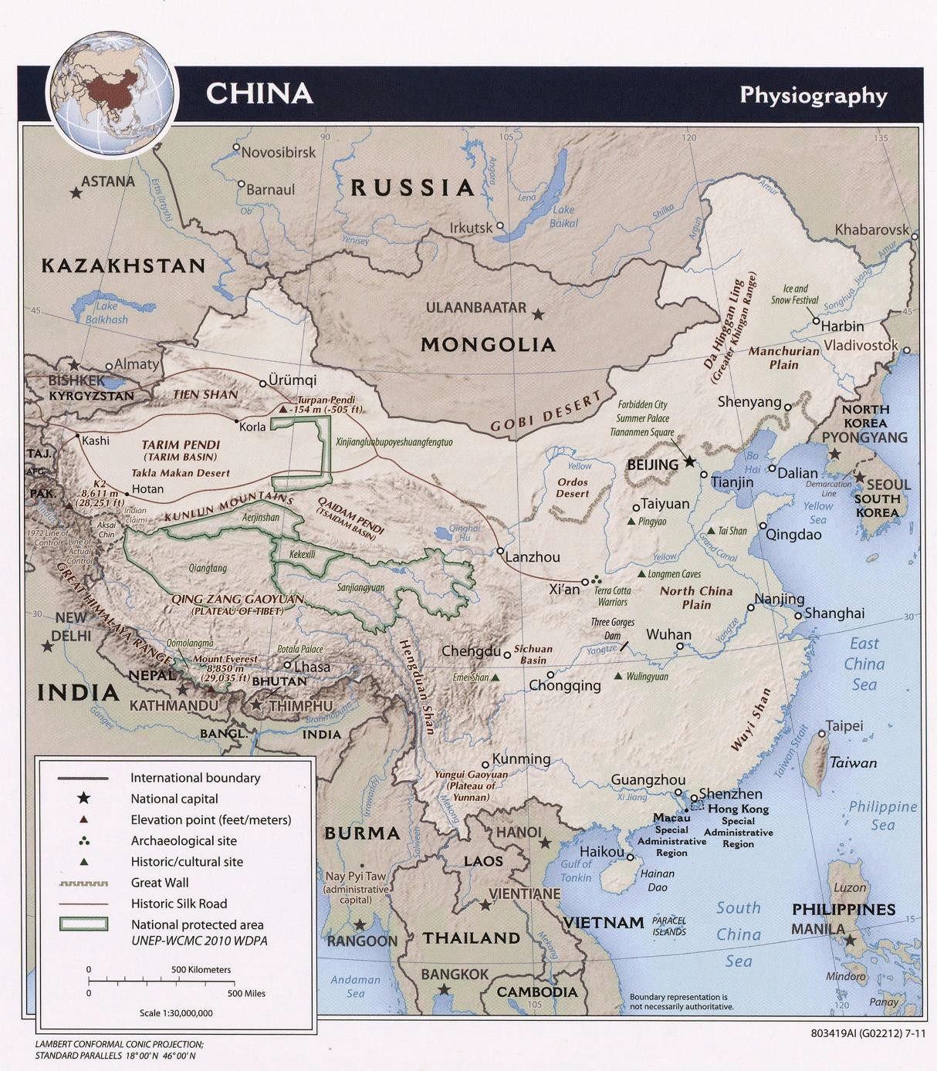
Dated 2011. Courtesy of the University of Texas Libraries, The University of Texas at Austin.

The Uyghur Region is geographically and culturally removed from the Han Chinese heartlands of east and southeast China. The region borders with Mongolia to the northeast, Russia to the north, Kazakhstan, Kyrygzstan, and Tajikistan to the northwest, Afghanistan to the west, and Pakistan and India to the southwest. While the official Chinese stance is that Xinjiang is properly a part of China, many Uyghurs reject both this assertion and the name Xinjiang, preferring to refer to the region as East Turkistan. In recent years, the government of the PRC has taken an increasingly brutal approach in its efforts to eradicate separatist sentiment in the region, imprisoning over a million Uyghurs and other Muslims in internment camps and embarking on

a campaign of “re-education” and population control. Some Uyghur and international critics of the PRC’s policies (including, as of January 2021, the US government) have gone as far as to describe this repression as genocide.

History
When the Manchu Qing Dynasty came to power in the mid-17th Century, the Tien Shan mountain range divided the oasis-dwelling Muslims of the Tarim Basin from the territory of the nomadic Dzungars to the north. These were a Mongolic, Buddhist people who conquered the Tarim Basin in 1680 and began resettling Uyghurs to farm fertile areas in the north. The Dzungars were themselves conquered and effectively exterminated by the Qing just a few decades later. Under the Qing, the Dzungarian Basin and Tarim Basin were combined into one region and given the name Xinjiang, meaning “new frontier.” Having cleared the northern part of this territory of its previous inhabitants, the Qing authorities encouraged settlers from elsewhere. This helps explain the demographic makeup of Xinjiang today, with the Uyghur population concentrated in the south and other ethnic communities mainly residing in the north.
During the tumultuous warlord era and years of civil war that followed the fall of the Qing Dynasty in 1912, there were two attempts to establish an independent republic in the region. The first (1933-34) centered on Kashgar in the southwest; the second (1944-49), on the northern territory adjacent to the Soviet Union. Both attempts ultimately failed, and in 1949, Xinjiang was incorporated into the People's Republic of China.

Culture and Language
Islam became established among the oasis communities of the Tarim Basin in the 10th-11th centuries, largely superseding a pre-Islamic heritage of Buddhism and other religious beliefs. As part of its attempts to force Uyghur assimilation into a unified Chinese culture, the PRC government has discouraged religious practice in Xinjiang. It has been reported that since 2017, Chinese authorities have destroyed thousands of mosques in the region.

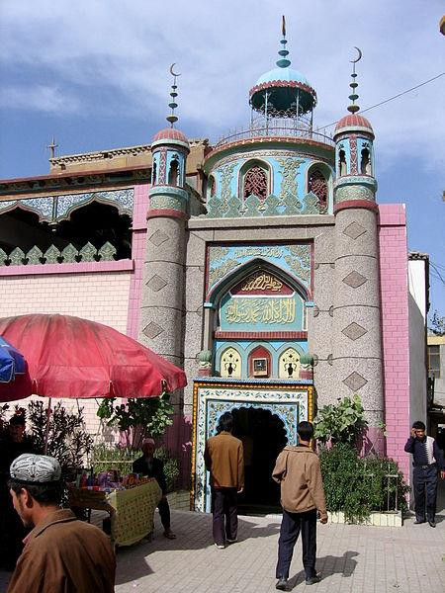
Khotan Mosque, Khotan, built in 1870 (Colegota, CC BY-SA 2.5 ES, via Wikimedia Commons)

Uyghur is a Turkic language, similar to those spoken by neighboring Uzbeks, Kyrgyz, and Kazakhs. As in other Turkic societies, the Arabic script was adopted for the language along with Islam. Twentieth-century script reforms saw both Cyrillic and Latin versions of the alphabet introduced, but today Uyghurs in China use a reformed Uyghur Arabic alphabet. Uyghurs living in the former Soviet republics of Central Asia (there are over 200,000 Uyghurs living in Kazakhstan, for example) still use the Uyghur Cyrillic script.
Uyghurs have a strong literary and musical tradition, with the national style of sung oral epic—the Uyghur Muqam—designated an Intangible Cultural Heritage of Humanity by UNESCO. Prominent Uyghur cultural figures—writers, artists, and scholars among them—have been particularly targeted by the PRC authorities and many of them imprisoned.

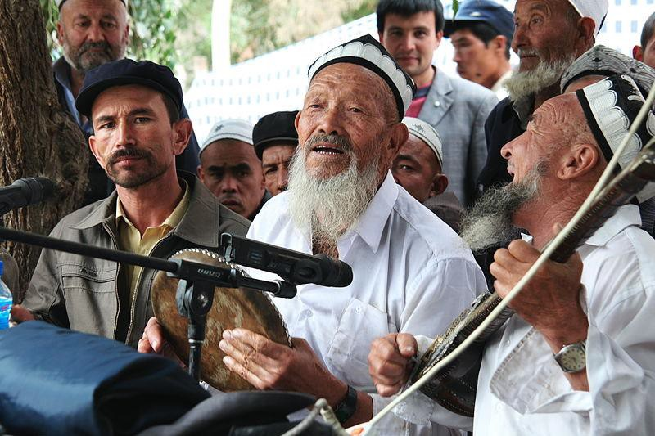
Uyghur musicians at a meshrep, or traditional male gathering. (https://www.flickr.com/photos/travelingmipo/, CC BY-SA 2.0, via Wikimedia Commons)

Xinjiang Uyghur Autonomous Region Capital: Ürümqi
Population: approx. 25 million
Languages: Uyghur, Mandarin Chinese
Xinjiang is the PRC’s largest administrative division, comprising approximately one-sixth of its total land area. Uyghurs comprise around half the population of this ethnically diverse territory. Han Chinese are the second largest ethnic group by a large margin, with Kazakhs, Hui (ethnic Chinese Muslims), Mongols, Krygyz, Tajiks, and others also inhabiting the region. The name of the region is misleading: in fact, Xinjiang has been parceled up into a series of smaller autonomous prefectures and counties, arguably in order to reduce Uyghur influence and keep local populations divided. More than half the territory of XUAR is dedicated to autonomous prefectures and counties where Uyghurs are not the titular ethnicity (for example, Bayingolin Mongol Autonomous Prefecture, or Ili Kazakh Autonomous Prefecture).

Xinjiang Today
While Han Chinese have profited both as the implementers and beneficiaries of investment and development focused in the north of the region, Uyghurs have become increasingly marginalized and outnumbered in what they regard as their ancestral homeland. Since the 1980s, resentment has occasionally boiled over into violence, characterized by the authorities as Islamic terrorism in the cause of separatism, though often stemming from other grievances. This has led to a hardening of Chinese policy in the region, culminating in

today’s regime of mass incarceration and extreme surveillance. Uyghurs in particular are at risk of imprisonment for practicing their religion, following their cultural traditions, and even speaking their language. There are reports of the cultural heritage that connects Uyghurs to the land—for example, shrines, mosques, and cemeteries—being deliberately erased. Though Uyghurs overseas are campaigning for international recognition and a response to this assault on their people and culture, the PRC government currently shows no sign of altering its approach.
Click here for a map of China’s “reeducation centers” in Xinjiang.

Further Resources
Uyghurs in China (Congressional Research Service) – 2-page overview with an emphasis on human rights issues and the US response.
Uighurs and China’s Xinjiang Region (Council on Foreign Relations, Backgrounder by Preeti Bhattacharji, 2012) – addresses the problems of ethnic tension and domestic terrorism in Xinjiang.
The Spatial Cleansing of Xinjiang: Mazar Desecration in Context (Rian Thum, Made in China Journal, August 2020) – offers concrete examples of the destruction of Uyghur sacred sites and explains what these sites and their destruction mean for Uyghurs.
China's hidden camps: What's happened to the vanished Uighurs of Xinjiang? (John Sudworth, BBC) - interactive story map.
The Xinjiang Data Project – includes story maps, links to articles, and access to primary data.
International Consortium of Investigative Journalists: The China Cables - primary source documents relating to the internment camps, translated into English.
The Uighurs and China’s Long History of Trouble with Islam (Ian Johnson, The New York Review of Books China Archive, November 2018) – overview of the history underlying the persecution of Muslims in China.
China File: Xinjiang – Xinjiang-related articles in an online magazine published by the Center on U.S.- China Relations at Asia Society
SupChina: Xinjiang – Xinjiang-related articles on a website carrying news and information on the business, technology, politics, culture, and society of China.
Congressional-Executive Commission on China > Xinjiang – The CECC was created by Congress in October 2000 to monitor human rights and the development of the rule of law in China, and to submit an annual report to the President and the Congress.

