Finnish Himmeli Decorations Craft Activity Pack

Create a traditional Finnish Christmas decoration for your home or classroom.

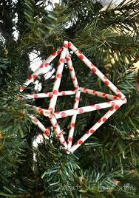
You will need:
- This activity pack!
- 12 equal lengths of drinking straw (you can make different sizes of himmeli with different lengths of straw. We cut each straw into three.)
- String
- Optional: metallic spray paint (you might want white paper straws for this)

Activity pack contents:
  - Printout 1: Discover Finland!
  - Printout 2: About Himmeli
  - Printout 3: Craft Instructions

DISCOVER FINLAND!
Finland Fact File
Location: Northern Europe Capital City: Helsinki
Official Languages: Finnish, Swedish Population: 5.5 million people (less than Indiana)
Size: 130, 672 square miles (more than three times bigger than Indiana)
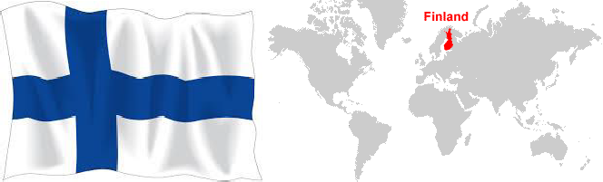
CHALLENGE 1: If you have a world atlas or globe at home or in your classroom, can you find Finland there? Can you find the capital city, Helsinki? Can you name the four countries closest to Finland? (Tip: if you don’t have an atlas or globe, try using the Internet)

CHALLENGE 2: Take a look at the https://www.visitfinland.com/destinations/ webpage and scroll down to explore some of the different places you could visit in Finland. Where would you go first?

Some things that Finland is famous for are:

Formula One Racing Drivers
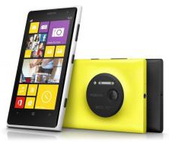
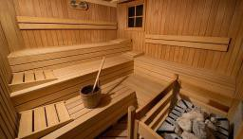

Nokia

The Moomins

Saunas

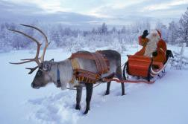
Have you met the Moomins?

Angry Birds

Lapland
- Listen to a Moomin story or watch an episode on the Moomin Official channel: https://www.youtube.com/channel/UC82jKc
_wW8iHVXU9GrYRunw
- Explore the world of the Moomins at https://www.moomin.com/en/explore/

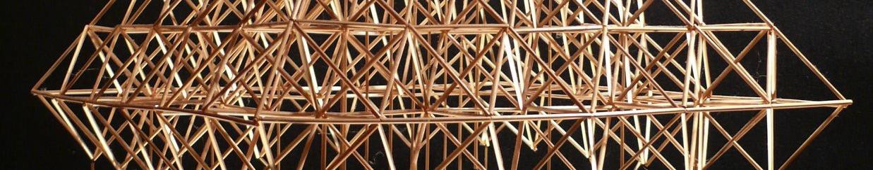

About Himmeli

Himmeli is the Finnish name for a traditional decoration that people hang in their homes around Christmas and New Year, or at wedding celebrations. Decorations like these are found in many countries apart from Finland: Estonia, Belarus, Sweden, Lithuania, Poland, Norway, Denmark, and Russia, among others. In fact, the name “himmeli” comes from himmel, the Swedish word for sky or heaven. Himmeli would usually be made out of straw or reeds, but nowadays people also use metal and other materials. Himmeli often hang above the dinner table during the holiday season. Sometimes, the whole ceiling is covered with these geometric mobiles. People believe that the larger your himmeli is, the better your harvest will be in the summer.
In 2016, a Lithuanian artist set a world record for the biggest himmeli ever made. Take a look at how he did it:
https://www.youtube.com/watch?v=wlLd4Am2xtM And now, have a go at making your own himmeli!
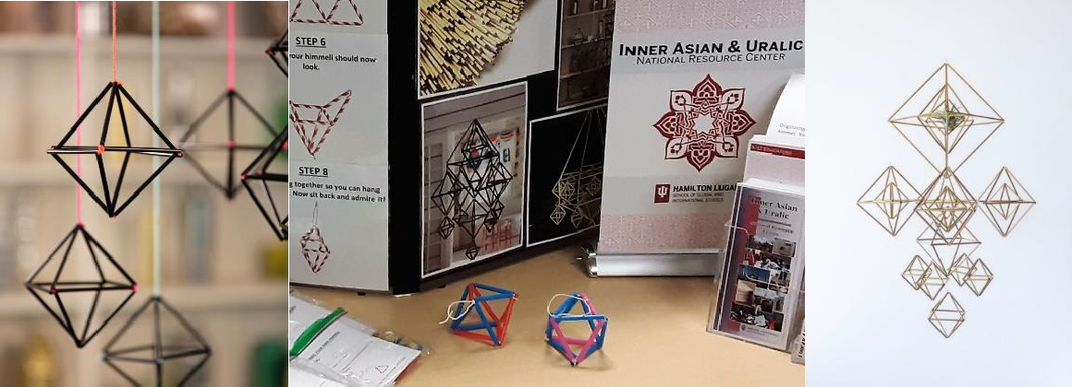

MAKE YOUR OWN HIMMELI
https://www.theguardian.com/lifeandstyle/do- something-blog/2014/jun/06/how-to-make-a-himmeli- sculpture

STEP 1

Take three pieces of straw and thread them on to your string.

STEP 2
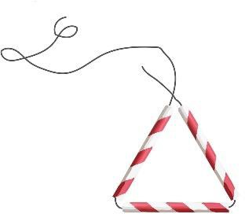
Shape them into a triangle and tie a knot.

STEP 3

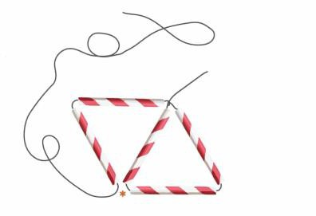
Add two more pieces of straw to create a second triangle and tie.

STEP 4
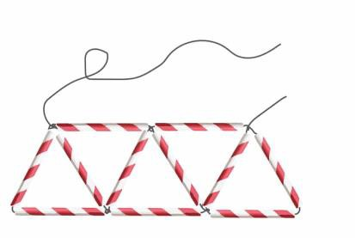
Repeat Step 3 until you have five triangles in a row.

STEP 5
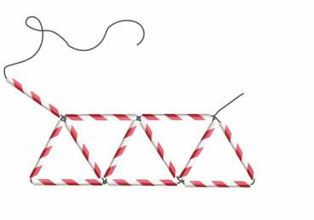
Add on one final piece of straw and tie it to the short end of string.

STEP 6
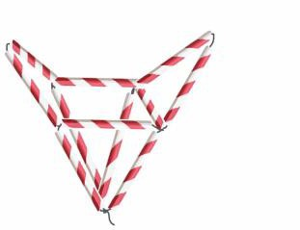
This is how your himmeli should now look.

STEP 7
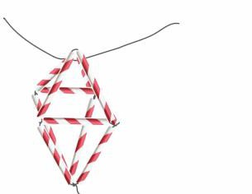
Take a piece of string and tie it through the top of your himmeli.

STEP 8
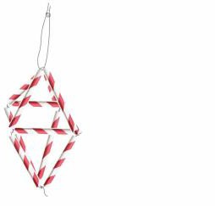
Tie the string together so you can hang your himmeli. Now sit back and admire it!

IDEAS:
- Get that extra bit of bling by spraying your himmeli silver or gold.
- Tie larger and smaller himmeli together to make a bigger decoration.

