Learning Math with Yurts Lesson – 4th-5th Grade

Objective: To teach students state-tested math skills through the use of yurts.

Standards:
4.5.3 Know and use formulas for finding the perimeters of rectangles and squares. (Core Standard)
4.5.4 Know and use formulas for finding the areas of rectangles and squares. (Core Standard)
5.5.2 Solve problems involving perimeters and areas of rectangles, triangles, parallelograms, and trapezoids, using appropriate units. (Core Standard)

Approximate length: 30 minutes

Materials needed:
Rulers
Copies of worksheets
Transparencies
Overhead projector
Glue or tape (for optional activity)
Scissors (for optional activity)
Copies of yurt outline (for optional activity)

About the Lesson:
A yurt is a portable, round, felt and wooden home used by nomads in Central Asia. Families who keep sheep or goats need to be able to move around with their flocks to find new grassy pastures. They can carry a yurt with them, much like a tent. Since the summertime can be very hot and the winter can be very cold, the yurt is made of felt, which keeps the inside cool in the summer and warm in the winter. A picture of a yurt can be seen in the supplementary materials. Teachers may wish to make a transparency of the picture to put on the overhead so that students can see what a yurt looks like.

The yurt can be used to teach math skills, like measuring the circumference and diameter of a circle, measuring perimeter and area of a rectangle, measuring distances to objects, as well as other math skills.

Procedures:
- Show students the pictures of yurts on an overhead projector. (Teachers may also wish to show students the short video showing the inside of a yurt and/or the video on how felt is made to cover the outside of a yurt.) Explain what a yurt is.
- Have students do the worksheet for their grade level. (Note: Worksheets may be printed in black and white.) There are suggested grade levels with each lesson, but teachers can decide which one is most appropriate for their students.
- After finishing the worksheet, students could do the optional activity and build their own paper yurt. The instructions are listed in the following “optional activity” section.

Optional Activity:
- Once students have completed their worksheet, they may wish to make their own miniature yurt. The last page of this file is an outline of a yurt that can be cut out and assembled.
- If students want to decorate the walls and roof of their yurt, they should do that before cutting it out.
- First, have students cut around the outside of the yurt along the black lines. (Do NOT cut off the big circle from the rectangular part and do NOT cut the door yet.)
- Second, students should cut down the line in the big circle part, down to the little circle.
- Students should cut out the little circle in the center entirely and throw it away. (The big round part will be the roof.)
- Next, students should cut the two lines on the side of the door, but not the one on top. Students should fold on the top line of the door.
- Students should bring the two sides of the rectangle together so that the tabs are lined up and it forms a circle. Glue or tape the sides together.
- Students should wrap the two sides of the big circle together, bringing them to the top of the circle below. The sides of the big circle may overlap each other a little. It should form a dome shape on top of the circle below.

Optional Video Link:
Inside a Kyrgyz yurt
http://www.youtube.com/watch?v=8YLXS1X9UT4

Making felt
http://www.youtube.com/watch?v=gJ0uojUHYdA

Name: _________________________________________________________________

Finding the Perimeter and Area of Yurt Felt (Rectangle) – Grades 4-5

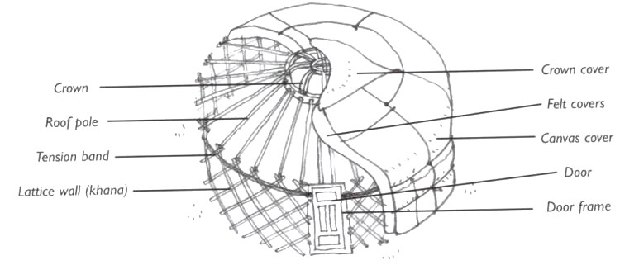

A yurt is a round, portable home that can be moved around, almost like a tent. Some people in Central Asia live in yurts so they can follow their sheep and goat flocks to fresh pastures. The walls are made of cross-hatched wood and are covered with felt, a material made of wool. In this lesson, pretend the felt surrounding your yurt has worn out and you need new felt. Measure the perimeter and area of the felt strip to make sure the felt is big enough to cover your yurt. Using your ruler, make all measurements to the nearest half-inch, but then list the measurement in feet. (Ex: 3 in. = 3 ft., 5 in. = 5ft., etc.)

- What is the perimeter of the rectangle? (Remember the perimeter is just the addition of all sides, or P = 2W + 2L.) ___________________________________________________
- What is the area of the rectangle? (Remember the area is just length times width, or A = L x W.) __________________________________________________________________
- The walls of your yurt are 6 ft. tall. The circumference (length all the way around) your yurt is 48ft. Is the piece of felt you measured big enough to fit your yurt? ________________________________________________________________________
- How much longer would the felt need to be in order to fit your yurt? ________________________________________________________________________

Felt (Rectangle) to Measure for Worksheet

Transparencies

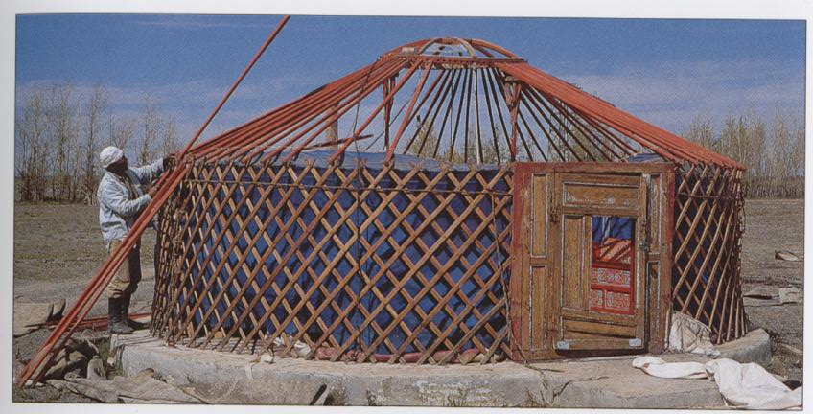

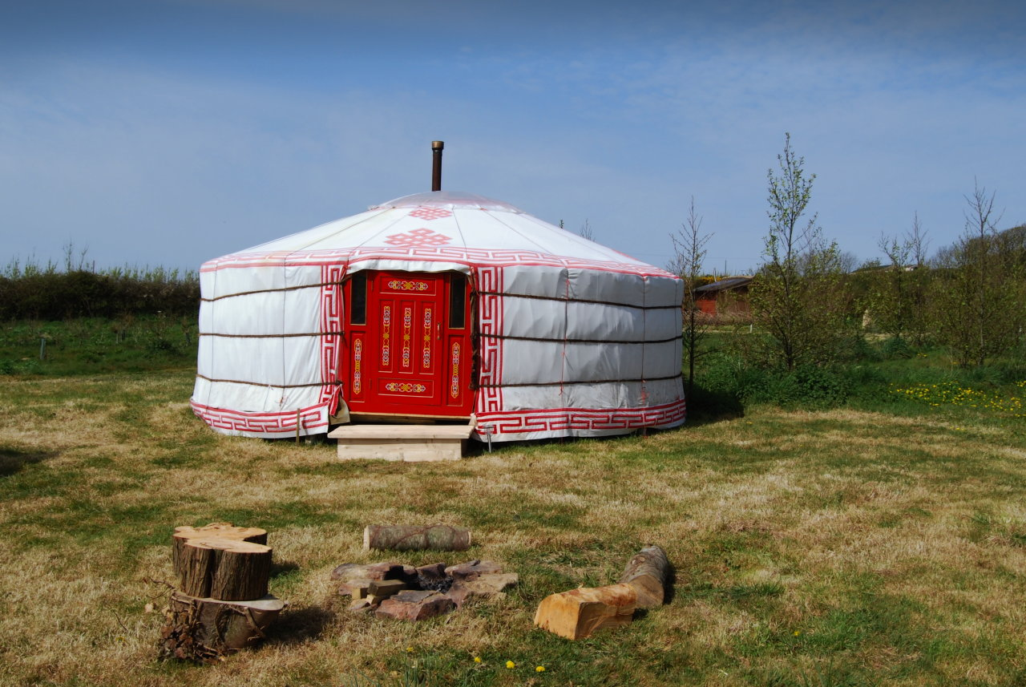

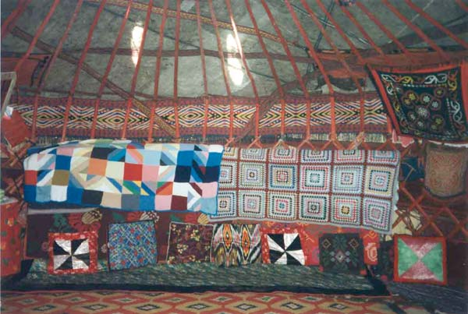
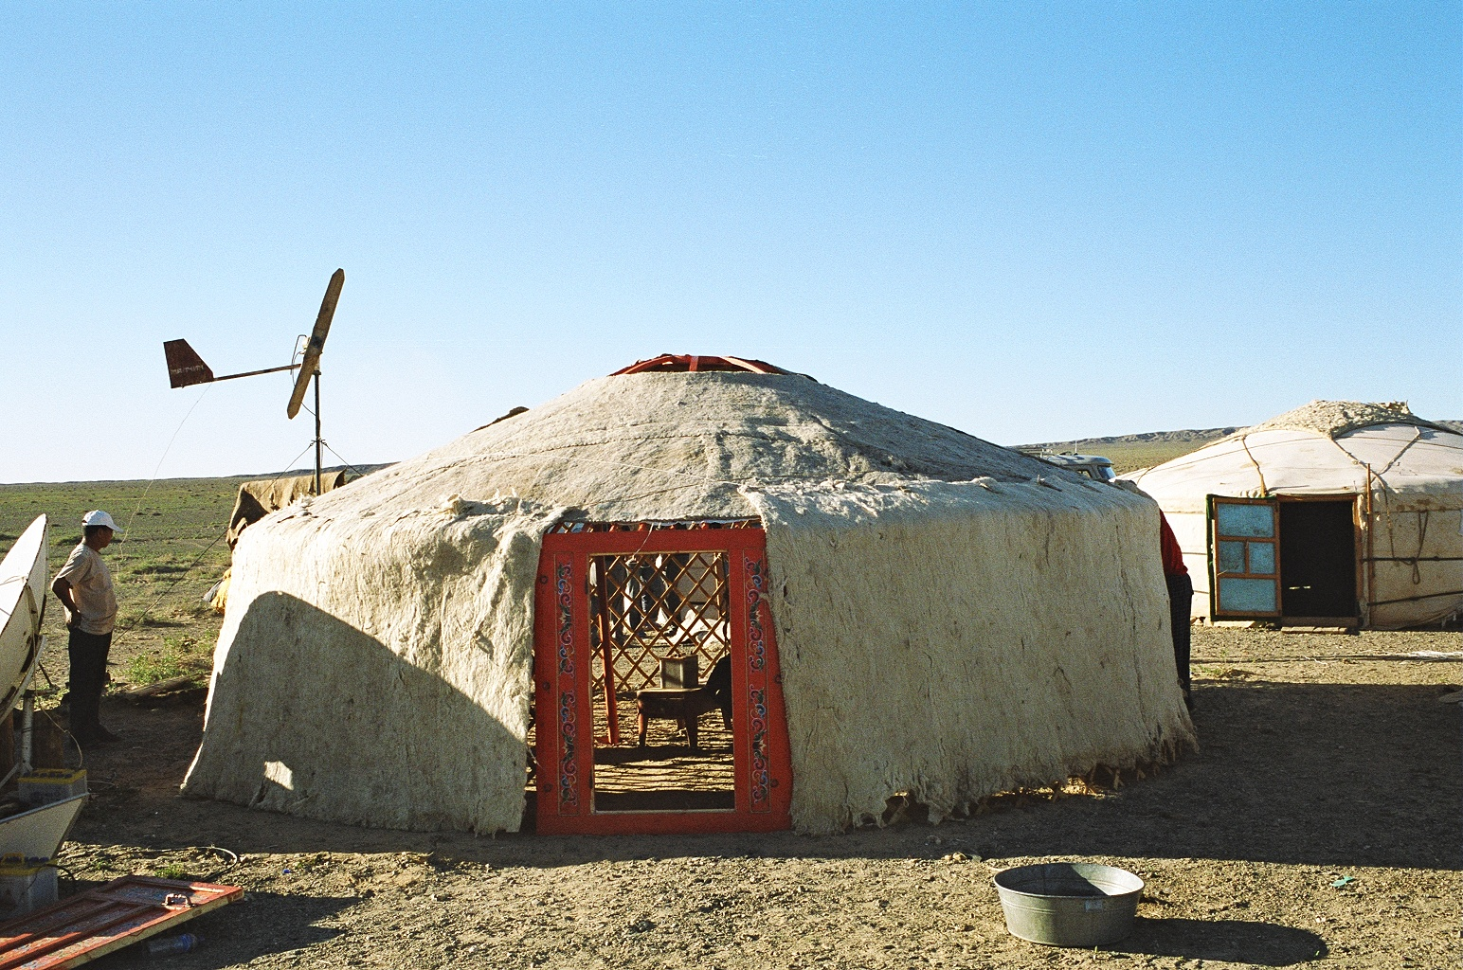
Yurt_Cut-out

