Learning Math with Yurts Lesson – 6th Grade

Objective: To teach students state-tested math skills through the use of yurts.

Standards:
6.5.4 Students understand the concept of the constant $π$ as the ratio of the circumference to the diameter of a circle. Develop and use the formulas for the circumference and area of a circle. (Core Standard)

Approximate length: 30 minutes

Materials needed:
Rulers
Copies of worksheets
Transparencies
Overhead projector
Glue or tape (for optional activity)
Scissors (for optional activity)
Copies of yurt outline (for optional activity)

About the Lesson:
A yurt is a portable, round, felt and wooden home used by nomads in Central Asia. Families who keep sheep or goats need to be able to move around with their flocks to find new grassy pastures. They can carry a yurt with them, much like a tent. Since the summertime can be very hot and the winter can be very cold, the yurt is made of felt, which keeps the inside cool in the summer and warm in the winter. A picture of a yurt can be seen in the supplementary materials. Teachers may wish to make a transparency of the picture to put on the overhead so that students can see what a yurt looks like.

The yurt can be used to teach math skills, like measuring the circumference and diameter of a circle, measuring perimeter and area of a rectangle, measuring distances to objects, as well as other math skills.

Procedures:
- Show students the pictures of yurts on an overhead projector. (Teachers may also wish to show students the short video showing the inside of a yurt.) Explain what a yurt is.
- Have students do the worksheet for their grade level. Teachers can decide which one is most appropriate. “Finding Radius, Diameter, Circumference, and Area of a Yurt” is most geared towards 4-5th grade, and possibly 3rd. “Learning to measure distances with a ruler” is mostly for 1st – 2nd grade, and possibly 3rd. “How many sheep are in front of each yurt?” is for kindergarteners.
- After finishing the worksheet, students could do the optional activity of building their own paper yurt. The instructions are listed below in the “optional activity” section.

Optional Activity:
- Once students have measured the yurt on paper, they may wish to make their own miniature yurt. The last page of this file is an outline of a yurt that can be cut out and assembled.
- If students want to decorate the walls and roof of their yurt, they should do that before cutting it out.
- First, have students cut out the yurt. (Do NOT cut off the big circle from the rectangular part.)
- Second, students should cut down the line in the big circle part, down to the little circle.
- Students should cut out the little circle entirely. The big round part will be the roof.
- Next, students should cut the two lines on the side of the door, but not the one on top. Students should fold on the top line of the door.
- Students should bring the two sides of the rectangle together so that the tabs are lined up and it forms a circle. Glue or tape the sides together.
- Students should wrap the two sides of the big circle together, bringing them to the top of the circle below. The sides of the big circle may overlap each other a little. It should form a dome shape on top of the circle below.

Optional Video Link:
Inside a Kyrgyz yurt
http://www.youtube.com/watch?v=8YLXS1X9UT4

Making felt
http://www.youtube.com/watch?v=gJ0uojUHYdA

Name: _______________________________________________________________

Finding the Radius, Diameter, Circumference, and Area of a Yurt – Grade 6

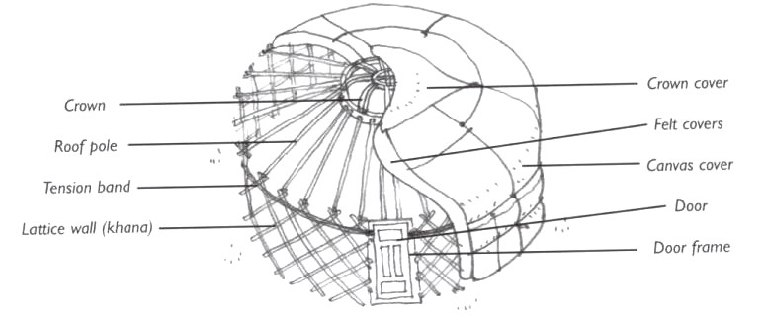

A yurt is a round, portable home that can be moved around, almost like a tent. Some people in Central Asia live in yurts so they can follow their sheep and goat flocks to fresh pastures. In this lesson, we will measure the bottom of a yurt as we learn how to measure the radius, diameter, and circumference of a circle.

- With your ruler, measure in inches the radius (r) of the yurt. (Hint: The radius is the short line.) What is the radius of the yurt? ________________________________________________________________________
- Now, with your ruler, measure the diameter (d) of the circle. (Hint: The diameter is the long line.) How long is the diameter of the yurt? ________________________________________________________________________
- The diameter of a circle is also two times the radius. Multiply the radius by 2 and see what answer you get. Is it the same as the answer to number 2? ________________________________________________________________________
- The circumference of a circle is the total perimeter around the circle. To figure out the circumference, you multiply the diameter by $π$ (pi). $π$ is equal to 3.14….. What is the circumference of the yurt? ________________________________________________________________________
- The area of a circle is the total amount of space inside the circle. To figure out the area, you multiply $π$ by the radius squared. The formula looks like this $A=πr^{2}$. To square a number, you multiply it by itself. For example, $3^{2}$ = 3 x 3 = 9. So, take the number you got in answer number one, multiply it by itself, and then multiply it by $π$ (3.14). What is the area of the yurt? ______________________________________________________________________________

Teacher Answers to Worksheet
Note: The circle may not exactly match up on the ruler, depending where on the line students place their rulers. However, it should be pretty close. Have students give the nearest estimate to a full or half-inch.
- Radius = 2.5 in.
- Diameter = 5 in.
- Yes, the answer is the same.
- Circumference = 15.7 in.
- Area = 19.625 in.

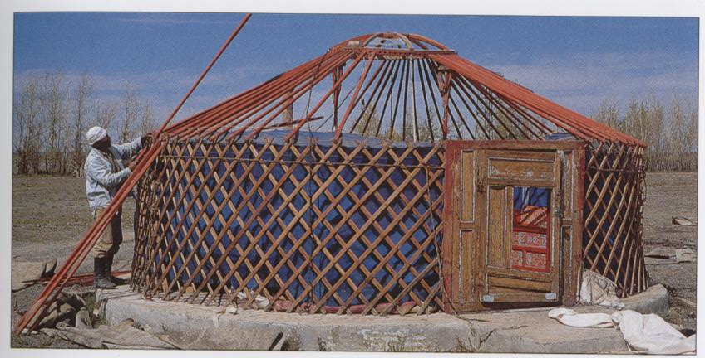
Transparencies

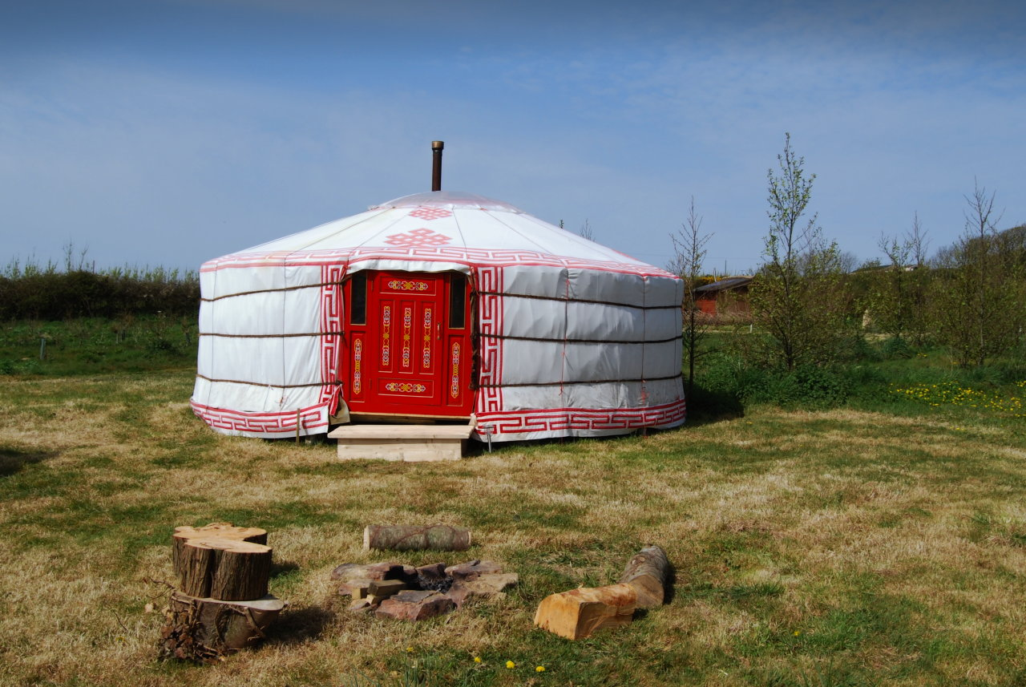

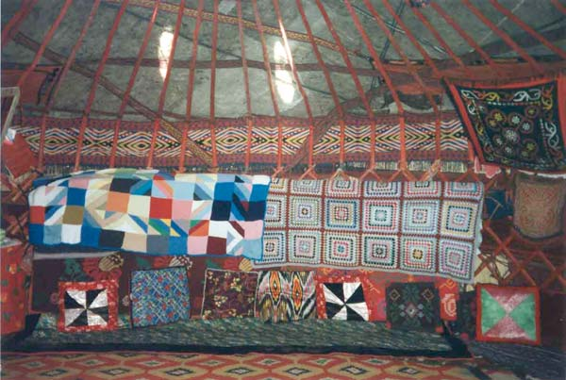

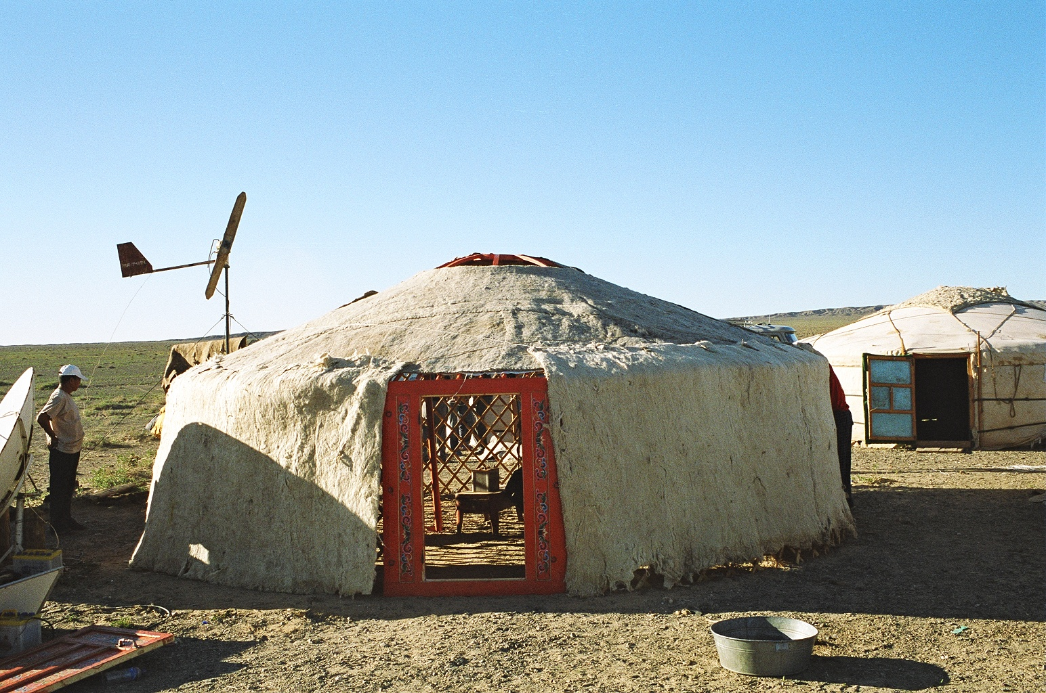
Yurt Cut-out

