**Learning Math with Yurts Lesson - Kindergarten**

**Objective:** To teach students state-tested math skills through the use of yurts.

**Standards:**

**K.1.6** Count, recognize, represent, name, and order a number of objects up to 10. (Core Standard)

**Approximate length:** 30 minutes

**Materials needed:**

Rulers

Copies of worksheets

Transparencies

Overhead projector

Glue or tape (for optional activity)

Scissors (for optional activity)

Copies of yurt outline (for optional activity)

**About the Lesson:**

A **yurt** is a portable, round, felt and wooden home used by nomads in Central Asia. Families who keep sheep or goats need to be able to move around with their flocks to find new grassy pastures. They can carry a yurt with them, much like a tent. Since the summertime can be very hot and the winter can be very cold, the yurt is made of felt, which keeps the inside cool in the summer and warm in the winter. A picture of a yurt can be seen in the supplementary materials. Teachers may wish to make a transparency of the picture to put on the overhead so that students can see what a yurt looks like.

The yurt can be used to teach math skills, like measuring distances and adding objects, as well as other math skills.

**Procedures:**

1. Show students the pictures of yurts on an overhead projector. (Teachers may also wish to show students the short video showing the inside of a yurt.) Explain what a yurt is.
2. Have students do the worksheet for their grade level. Teachers can decide which one is most appropriate. “Finding Radius, Diameter, Circumference, and Area of a Yurt” is most geared towards 4-5th grade, and possibly 3rd. “Learning to measure distances with a ruler” is mostly for 1st – 2nd grade, and possibly 3rd. “How many sheep are in front of each yurt?” is for kindergarteners.
3. After finishing the worksheet, students could do the optional activity of building their own paper yurt. The instructions are listed below in the “optional activity” section.

**Optional Activity:**

1. Once students have measured the yurt on paper, they may wish to make their own miniature yurt. The last page of this file is an outline of a yurt that can be cut out and assembled.
2. If students want to decorate the walls and roof of their yurt, they should do that before cutting it out.
3. First, have students cut out the yurt. (Do NOT cut off the big circle from the rectangular part.)
4. Second, students should cut down the line in the big circle part, down to the little circle.
5. Students should cut out the little circle entirely. The big round part will be the roof.
6. Next, students should cut the two lines on the side of the door, but not the one on top. Students should fold on the top line of the door.
7. Students should bring the two sides of the rectangle together so that the tabs are lined up and it forms a circle. Glue or tape the sides together.
8. Students should wrap the two sides of the big circle together, bringing them to the top of the circle below. The sides of the big circle may overlap each other a little. It should form a dome shape on top of the circle below.

**Optional Video Link:**

Inside a Kyrgyz yurt

<http://www.youtube.com/watch?v=8YLXS1X9UT4>

Making felt

<http://www.youtube.com/watch?v=gJ0uojUHYdA>

Name: _____________________________________________

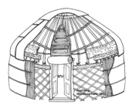

**How many sheep are in front of each yurt?**

**A B C**

**________ _______ _______**



C:\Users\davisali\AppData\Local\Microsoft\Windows\Temporary Internet Files\Content.IE5\A8UJGN5E\MC900413632[1].wmfC:\Users\davisali\AppData\Local\Microsoft\Windows\Temporary Internet Files\Content.IE5\A8UJGN5E\MC900413632[1].wmfC:\Users\davisali\AppData\Local\Microsoft\Windows\Temporary Internet Files\Content.IE5\FFS4SQ60\MC900413632[1].wmfC:\Users\davisali\AppData\Local\Microsoft\Windows\Temporary Internet Files\Content.IE5\FFS4SQ60\MC900413632[1].wmf

C:\Users\davisali\AppData\Local\Microsoft\Windows\Temporary Internet Files\Content.IE5\A8UJGN5E\MC900413632[1].wmfC:\Users\davisali\AppData\Local\Microsoft\Windows\Temporary Internet Files\Content.IE5\A8UJGN5E\MC900413632[1].wmfC:\Users\davisali\AppData\Local\Microsoft\Windows\Temporary Internet Files\Content.IE5\A8UJGN5E\MC900413632[1].wmfC:\Users\davisali\AppData\Local\Microsoft\Windows\Temporary Internet Files\Content.IE5\FFS4SQ60\MC900413632[1].wmf

C:\Users\davisali\AppData\Local\Microsoft\Windows\Temporary Internet Files\Content.IE5\A8UJGN5E\MC900413632[1].wmf

**D E F**

C:\Users\davisali\AppData\Local\Microsoft\Windows\Temporary Internet Files\Content.IE5\A8UJGN5E\MC900413632[1].wmfC:\Users\davisali\AppData\Local\Microsoft\Windows\Temporary Internet Files\Content.IE5\A8UJGN5E\MC900413632[1].wmfC:\Users\davisali\AppData\Local\Microsoft\Windows\Temporary Internet Files\Content.IE5\A8UJGN5E\MC900413632[1].wmfC:\Users\davisali\AppData\Local\Microsoft\Windows\Temporary Internet Files\Content.IE5\A8UJGN5E\MC900413632[1].wmfC:\Users\davisali\AppData\Local\Microsoft\Windows\Temporary Internet Files\Content.IE5\A8UJGN5E\MC900413632[1].wmfC:\Users\davisali\AppData\Local\Microsoft\Windows\Temporary Internet Files\Content.IE5\A8UJGN5E\MC900413632[1].wmfC:\Users\davisali\AppData\Local\Microsoft\Windows\Temporary Internet Files\Content.IE5\A8UJGN5E\MC900413632[1].wmfC:\Users\davisali\AppData\Local\Microsoft\Windows\Temporary Internet Files\Content.IE5\A8UJGN5E\MC900413632[1].wmfC:\Users\davisali\AppData\Local\Microsoft\Windows\Temporary Internet Files\Content.IE5\A8UJGN5E\MC900413632[1].wmfC:\Users\davisali\AppData\Local\Microsoft\Windows\Temporary Internet Files\Content.IE5\A8UJGN5E\MC900413632[1].wmfC:\Users\davisali\AppData\Local\Microsoft\Windows\Temporary Internet Files\Content.IE5\A8UJGN5E\MC900413632[1].wmfC:\Users\davisali\AppData\Local\Microsoft\Windows\Temporary Internet Files\Content.IE5\A8UJGN5E\MC900413632[1].wmfC:\Users\davisali\AppData\Local\Microsoft\Windows\Temporary Internet Files\Content.IE5\A8UJGN5E\MC900413632[1].wmfC:\Users\davisali\AppData\Local\Microsoft\Windows\Temporary Internet Files\Content.IE5\A8UJGN5E\MC900413632[1].wmfC:\Users\davisali\AppData\Local\Microsoft\Windows\Temporary Internet Files\Content.IE5\A8UJGN5E\MC900413632[1].wmfC:\Users\davisali\AppData\Local\Microsoft\Windows\Temporary Internet Files\Content.IE5\A8UJGN5E\MC900413632[1].wmfC:\Users\davisali\AppData\Local\Microsoft\Windows\Temporary Internet Files\Content.IE5\A8UJGN5E\MC900413632[1].wmfC:\Users\davisali\AppData\Local\Microsoft\Windows\Temporary Internet Files\Content.IE5\A8UJGN5E\MC900413632[1].wmfC:\Users\davisali\AppData\Local\Microsoft\Windows\Temporary Internet Files\Content.IE5\A8UJGN5E\MC900413632[1].wmfC:\Users\davisali\AppData\Local\Microsoft\Windows\Temporary Internet Files\Content.IE5\A8UJGN5E\MC900413632[1].wmf**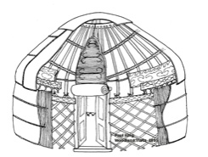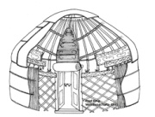 _______ ________ ________**

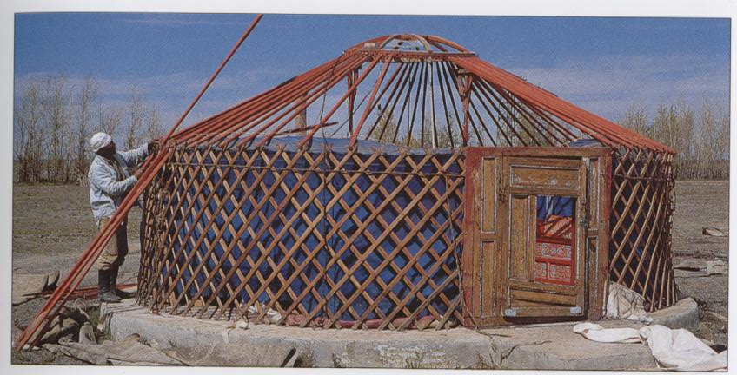**Transparencies**

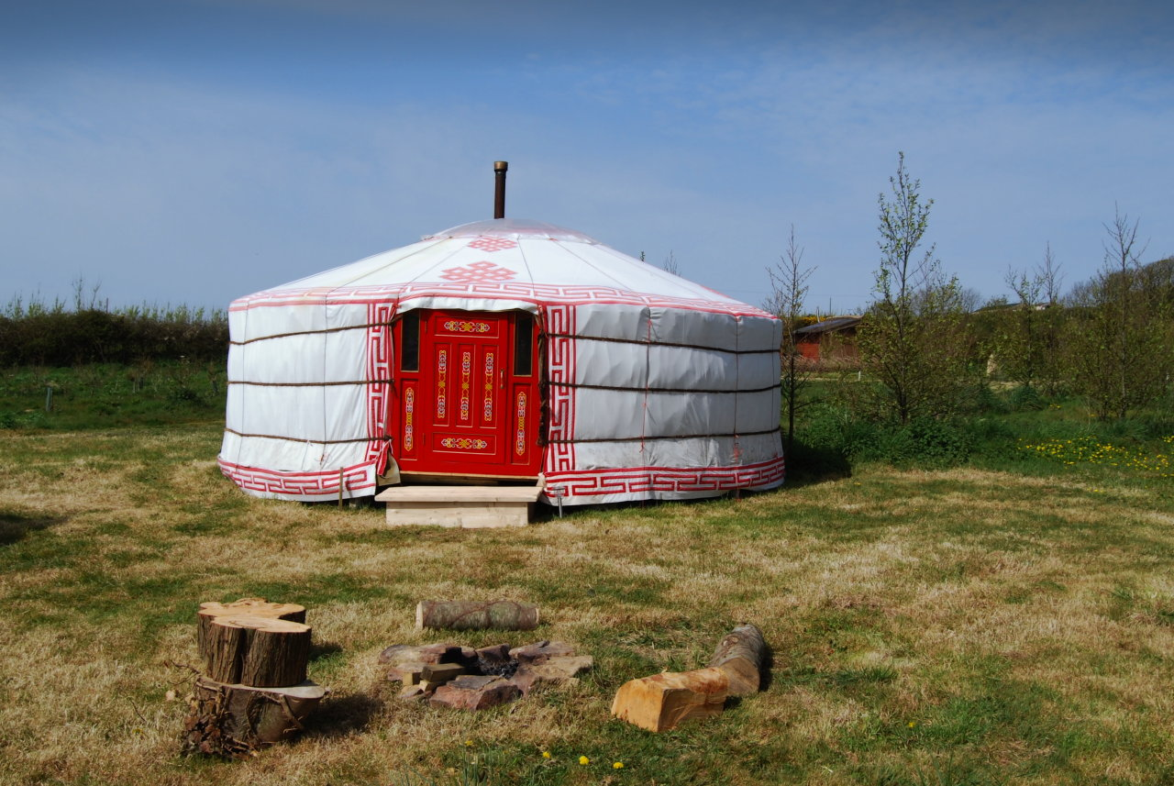

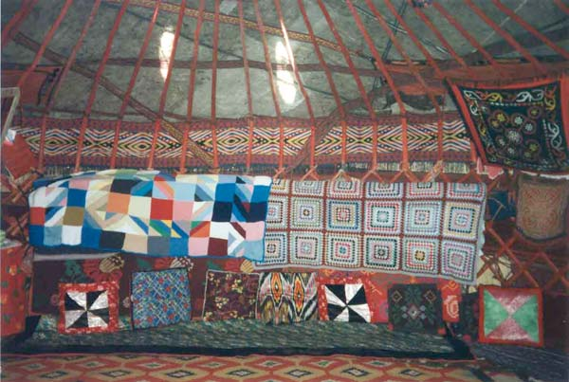

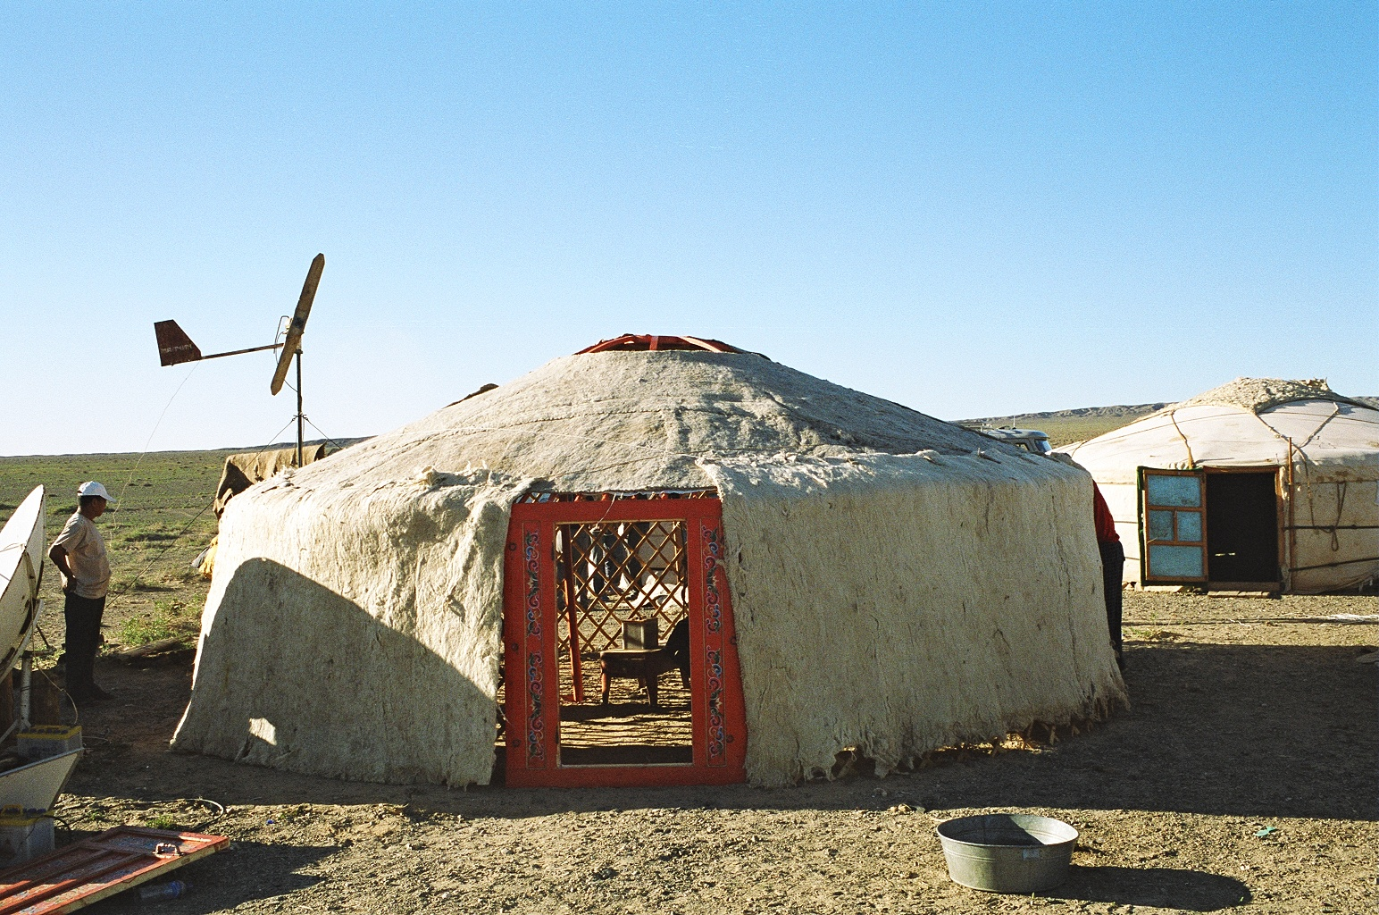

**Yurt Cut-out**