MAKE YOUR OWN GER/YURT*
Print the ger template and make sure you have crayons, scissors, and glue, plus any other decorations you want to use. Then…
*Known as Ger in Mongolia and Yurts elswhere
- Color the door of your ger. Add any other designs you want to the roof and wall of the ger, or leave it white. | 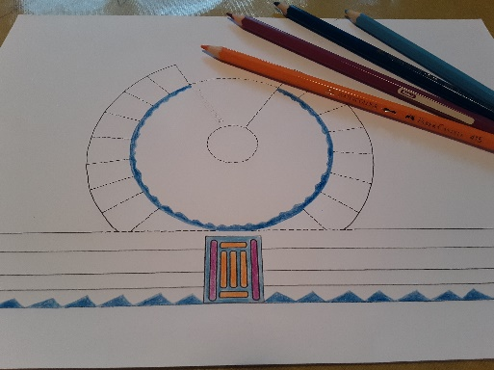  These bits are going to have glue on them, so don’t color here!
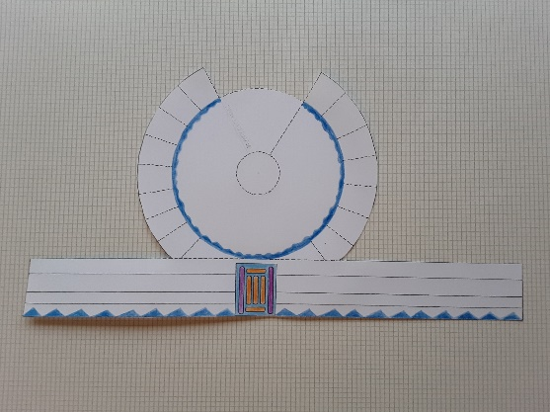 | - Cut around the outside of the whole template.
- Cut along all the dotted lines. DO NOT CUT WHERE THERE IS NO DOTTED LINE! The roof and wall sections of the template should stay joined. | 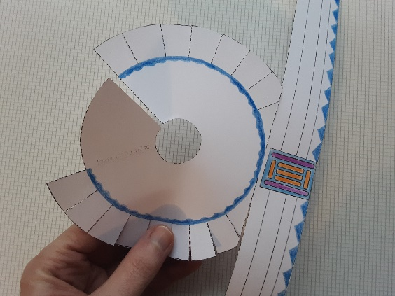  Do not cut here…  …or here!
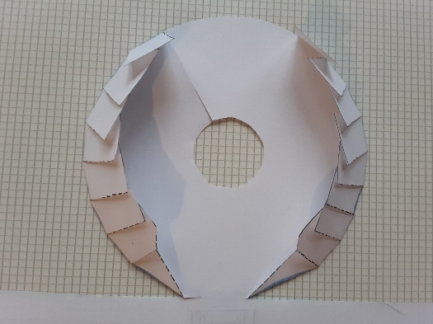 | - Turn the template face down and fold the flaps inwards around the roof circle. They will overlap.
- Turn the template face up again. Flatten the flaps out around the roof circle so that they don’t get in the way of the glue. | 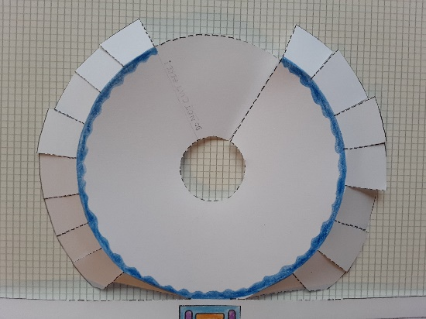
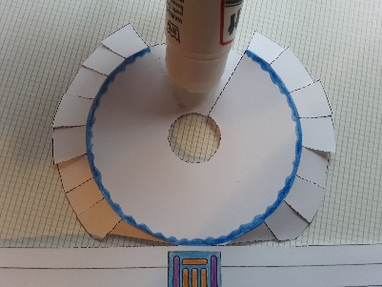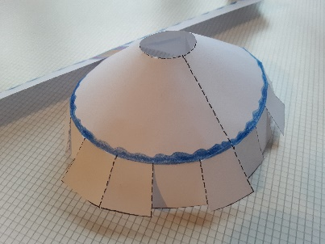 | - Cover the section of the roof circle between the cut edge and the “DO NOT CUT HERE!” line with glue. Pull the cut edge around so that it exactly meets the opposite line, and stick.
- Cover the back of the wall strip with glue, avoiding the section in the middle where the door is. | 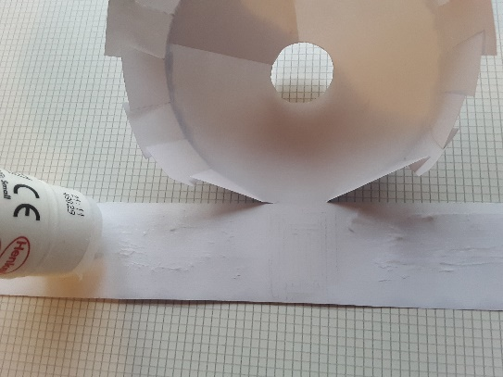
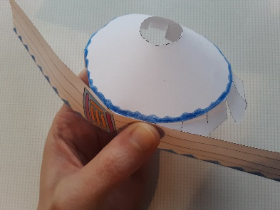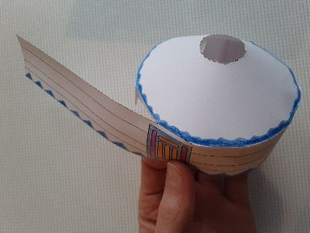 | - Starting on one side of the door, use your fingers to press the flaps to the glue, wrapping the wall around the flaps. Repeat on the other side.
- Admire your ger—and maybe make another one! | 