Saving the Takhi Horse from Extinction – K – 3rd Grade

Objective: The students will be able to. . .
- Define the terms "extinction" and "endangered"
- Understand why conservation efforts are important for saving critically endangered species throughout the world
- Identify methods that zoos are using to conserve endangered species populations

INDIANA STATE STANDARDS:

K.LS.3 Use observations to describe patterns of what plants and animals (including humans) need to survive
- LS.4 Use a model to represent the relationship between the needs of different plants and animals (including humans) and the places they live.
- LS.1 Determine patterns and behavior (adaptations) of parents and offspring which help offspring to survive.
- LS.4 Construct an argument that some animals form groups that help members survive.

Approximate length: 45 minutes

Materials needed:

Computer and projector
Further information about Takhi Horses:
  - https://rangerrick.org/ranger_rick/takhi-horses/
  - http://wwf.panda.org/knowledge_hub/teacher_resources/best_place_species/bac k_from_the_brink/takhi.cfm

About the Lesson:

The Takhi horse is a native animal of the Central Eurasian Steppe that almost went extinct 60 years ago. Thanks to conservation efforts by zoos, the population has increased and many horses have been released into the wild. This lesson briefly introduces the concept of endangered animals and provides general information about the Takhi horse. In addition, it provides a group lesson suggestion so that students can investigate other conservation efforts around the world.

Procedures:

Note: All resources found in this lesson plan were created by the author. Any outside resources used have been cited. All images were taken from websites that offer free stock images and stock footage.

- Begin by introducing students to the Takhi horse and endangered animals. A PowerPoint presentation has been provided for use in the classroom. If the teacher would like to turn this into a reading activity, the following websites have decent printables:
  - https://rangerrick.org/ranger_rick/takhi-horses/
  - http://wwf.panda.org/knowledge_hub/teacher_resources/best_place_speci es/back_from_the_brink/takhi.cfm
- After the short presentation, split students into small groups and assign each group an endangered animal. The Endangered Animals PDF provides a number of animals. This assignment can also be completed individually.
- Have students research conservation efforts for their animals and present their findings to the class.

Note: All resources found in this lesson plan were created by the author. Any outside resources used have been cited. All images were taken from websites that offer free stock images and stock footage.

Arabian Oryx California Condor Corroboree Frog Bongo
Regent Honeyeater Panamanian Golden Frog Bellinger River Turtle Golden Lion Tamarin Amur Leopard
Brown Pelican
Virginia Northern Flying Squirrel Steller Sea Lion
Island Night Lizard Lake Erie Water Snake Gray Wolf
Giant Manta Ray Saiga Antelope Bald Eagle
Gray Whale White Rhinoceros Peregrine Falcon
Galapagos Giant Tortoise

The Takhi Horse of Mongolia

What is an endangered animal?

According to the World Wildlife Federation (WWF), threatened species can fall into three categories:

Critically Endangered (CR): A species facing an extremely high risk of extinction in the wild. Endangered (EN): A species considered to be facing a very high risk of extinction in the wild. Vulnerable (VU): A species considered to be facing a high risk of extinction in the wild.
Source: http://wwf.panda.org/our_work/wildlife/about_species/

Think-Pair-Share!

- With a partner, list as many endangered species as you can! After 3 minutes, the partners with the longest list win!

Now, each group will share 1 animal from their list.

Try to share the name of an animal that nobody else has mentioned!

How many of the following animals did your class list? Can you
name all of these animals?

Blue Whale
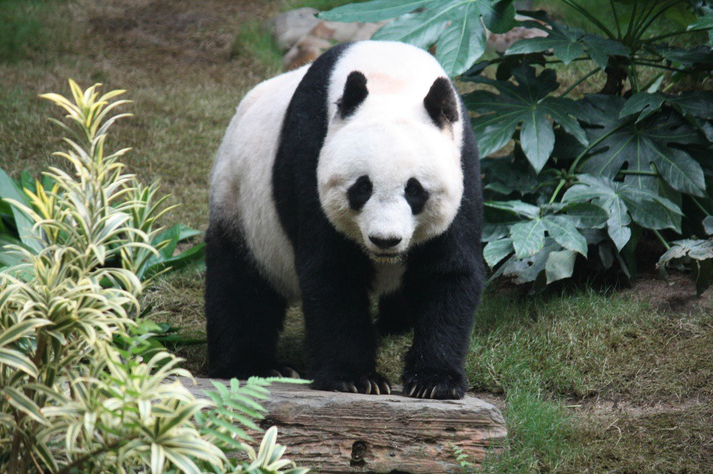
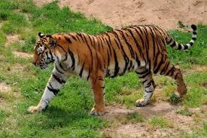
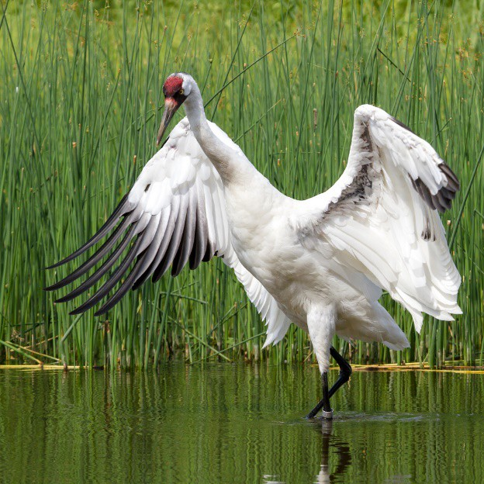
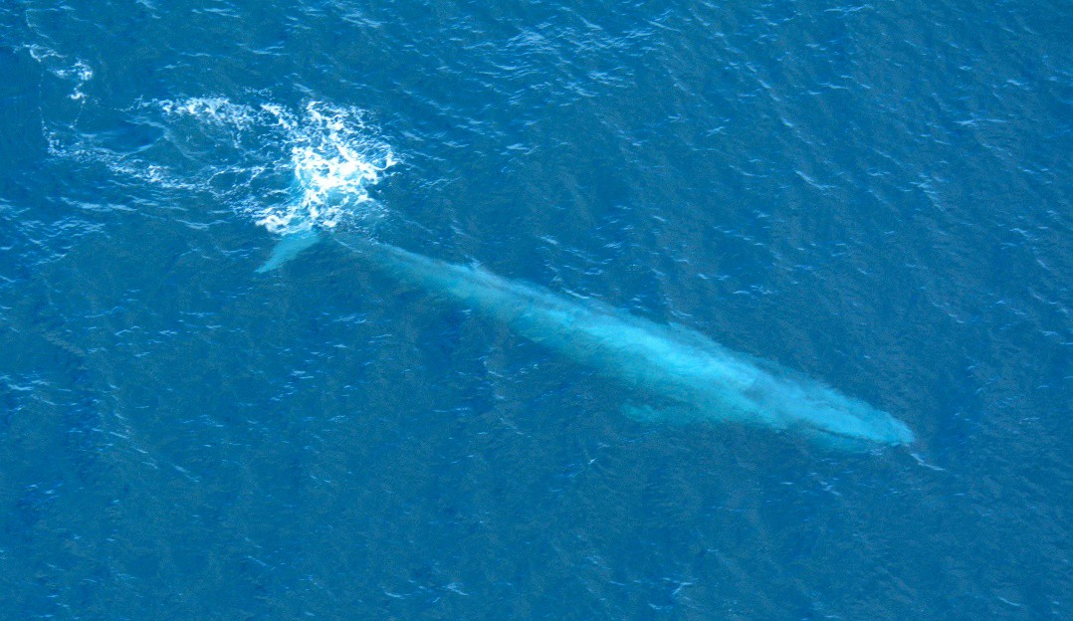
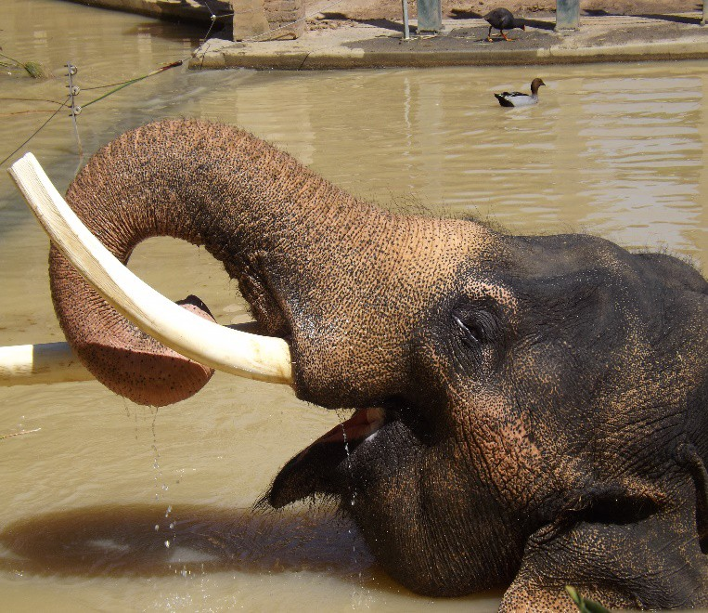
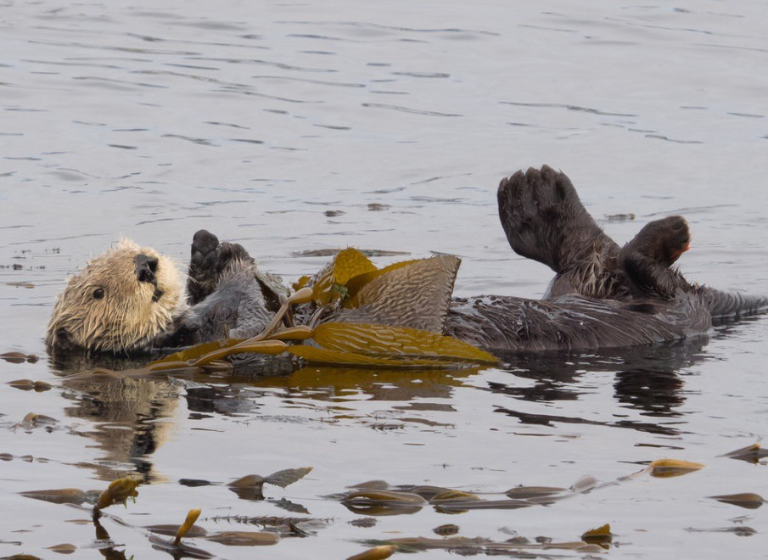
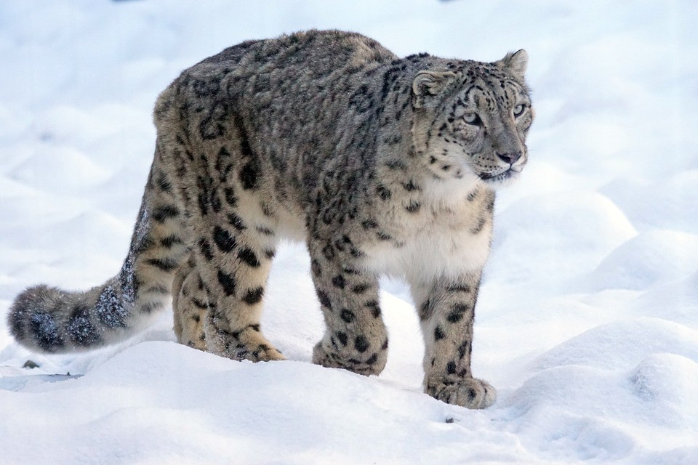
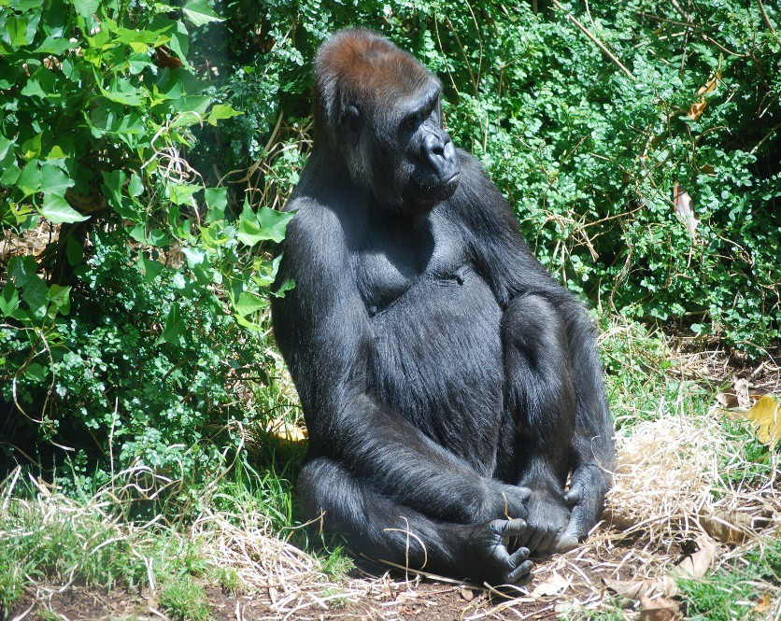
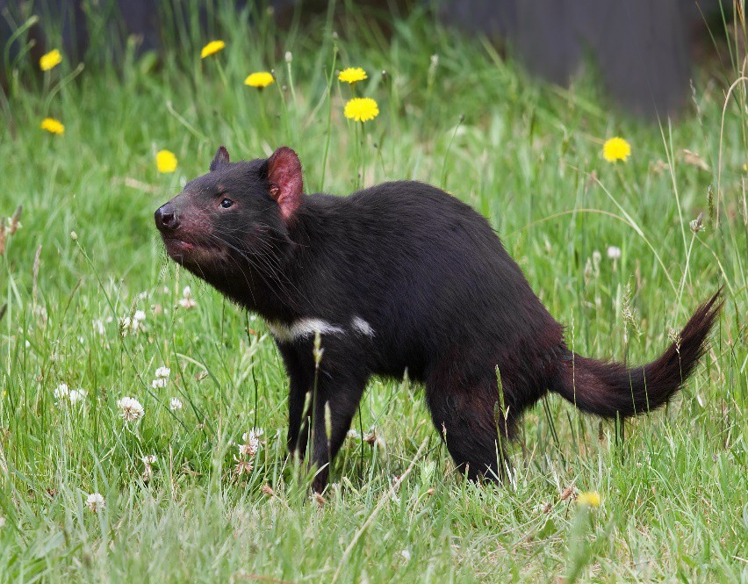
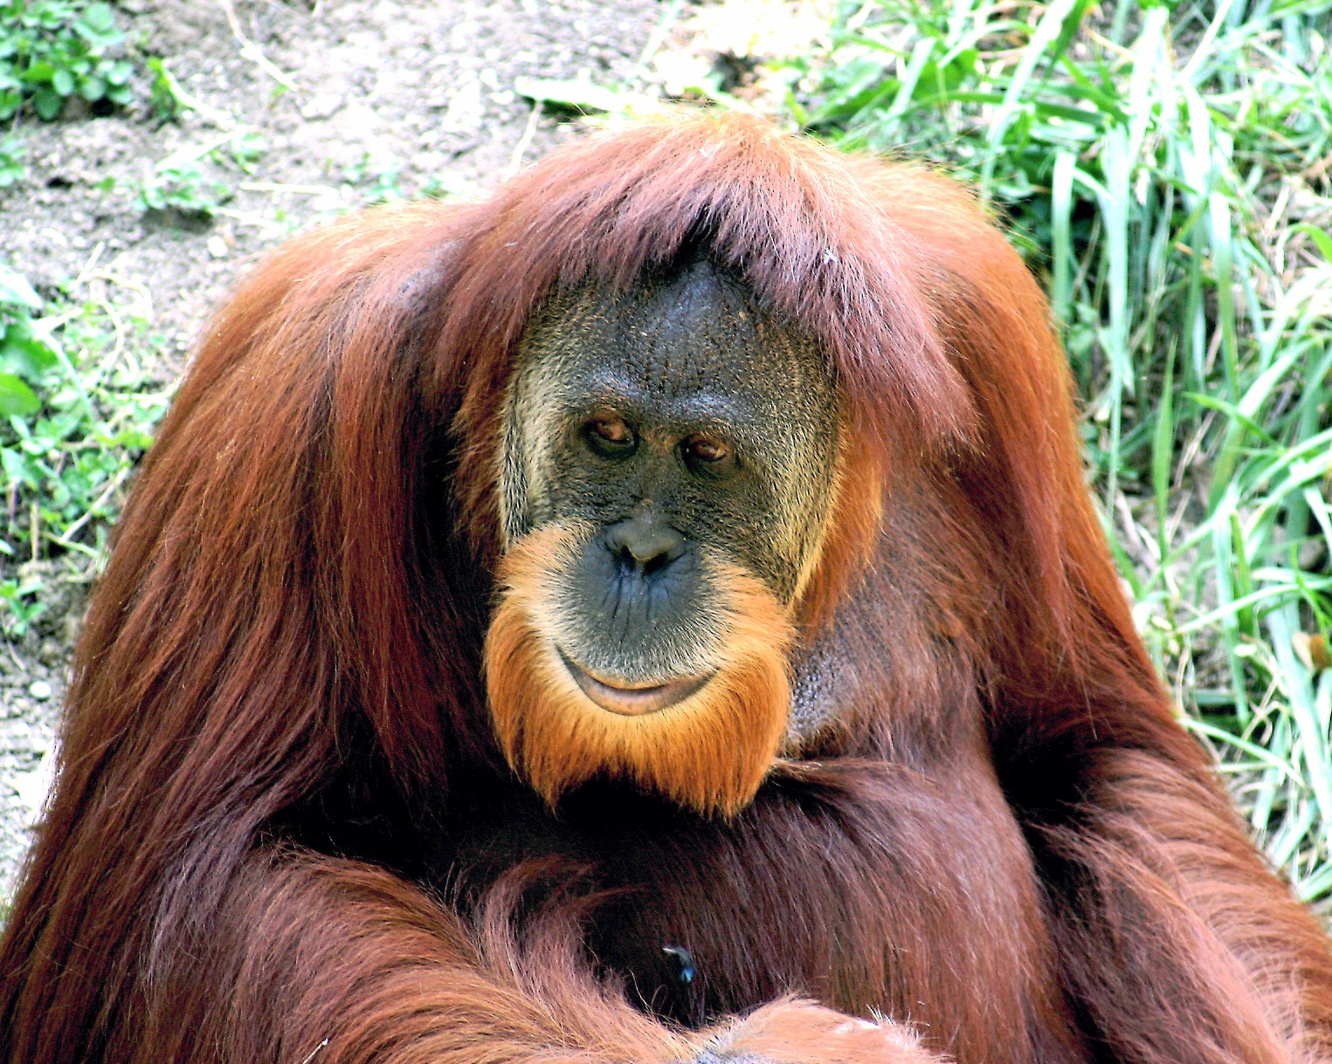
e
Panda
oping Crane
Tiger Who Blue Whal

Sea Ot Snow Leopard

Tasmanian Devil
ter
Gorilla
Asian Elephant
Orangutan

Most of those animals are well-known. However, have you ever
heard of the...?
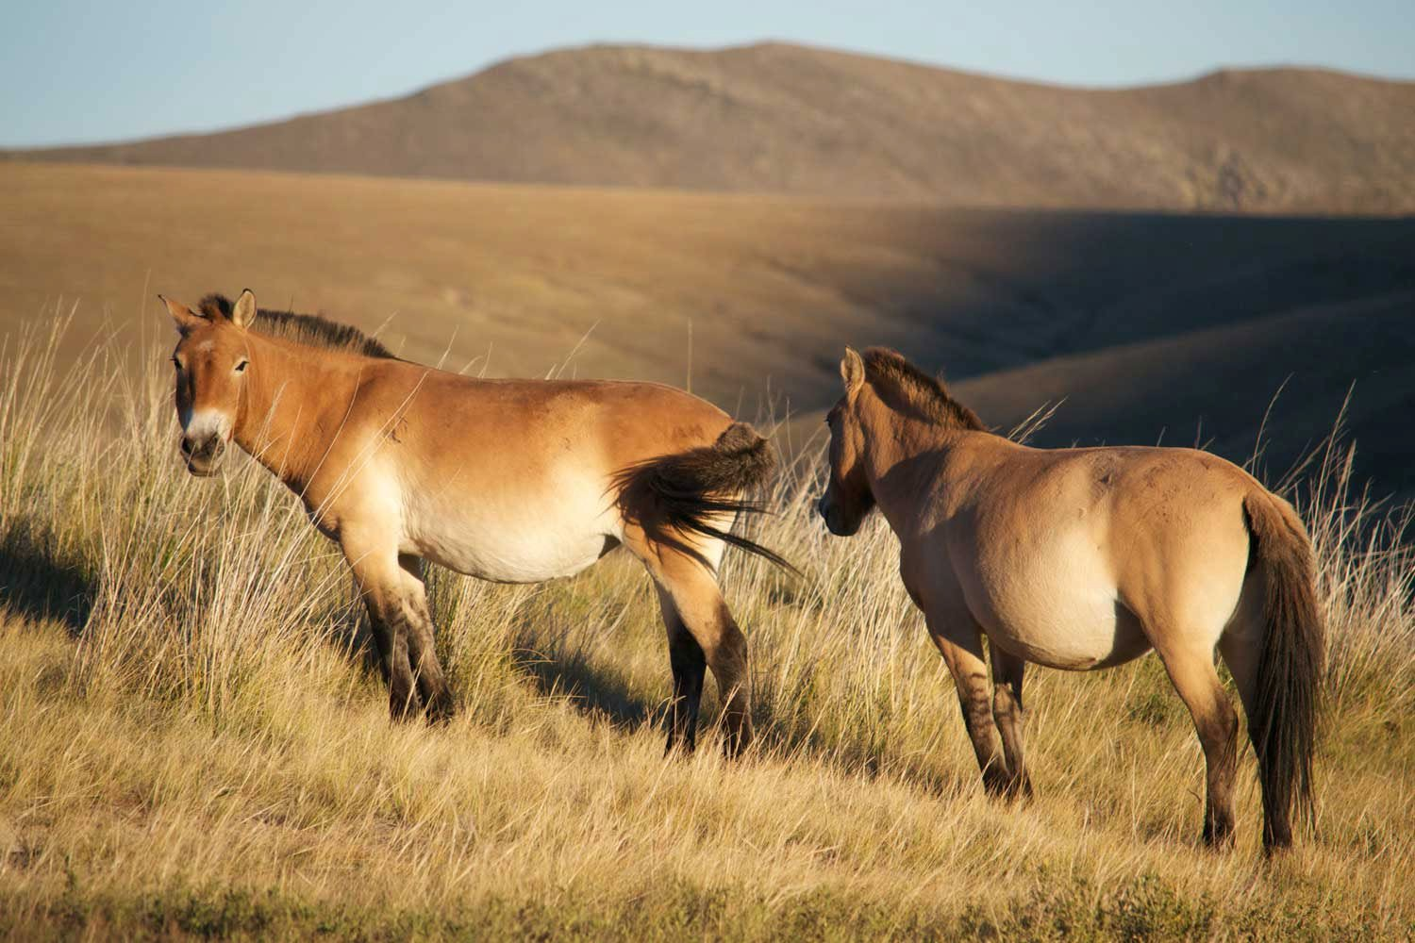
Takhi Horse

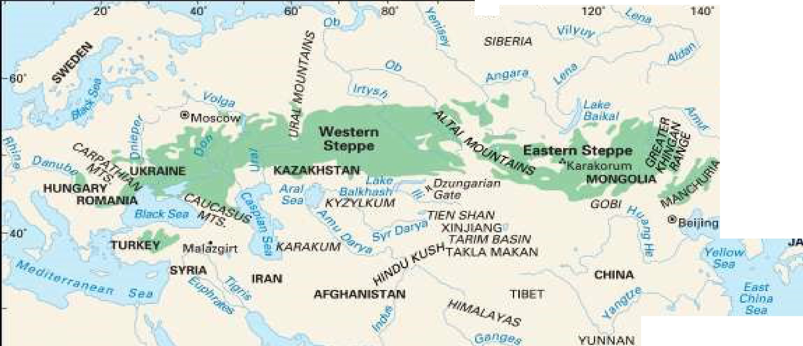
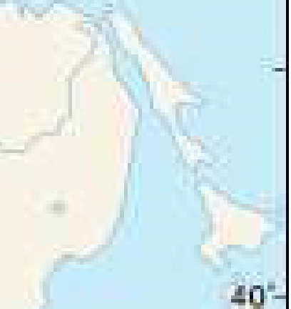
.
100"

AN

:20"
- - 11A - f.l
:to·

0 D 1::10 i _r•· , .-.Ii:., J
I

About Takhi horses...
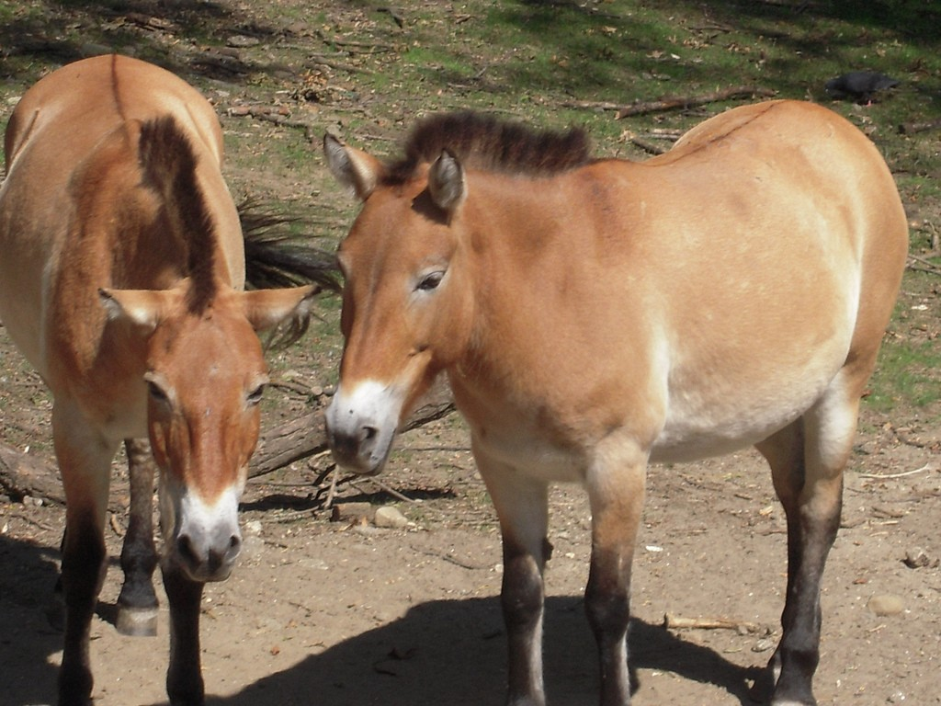
- They are more stocky and shorter than domesticated horses
- They are the only wild horses in the world that are not descendants from previously domesticated horses (Most “wild horses” come from domesticated horses that were set free or escaped).
- They live in herds that consist of one male horse and a number of female horses.
- They may live up to 36 years of age.

On the brink of extinction
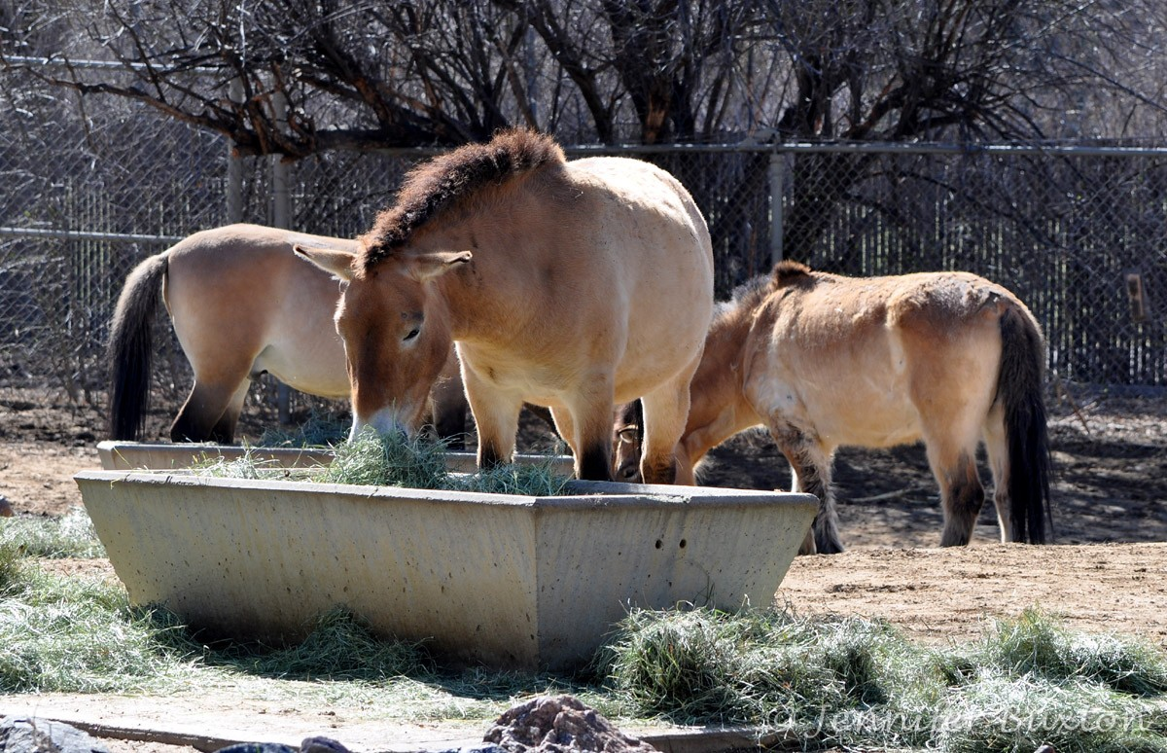

An amazing comeback story...
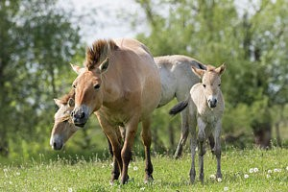
  - Captive breeding programs that began in zoos have revived the Takhi horse population
  - The largest breeding program is found at the Askania Nova preserve in Ukraine
  - Zoos all over the world now participate in the breeding program
  - By the 1990s, there were over 1500 Takhi horses in the world
  - Approximately 300 horses have been reintroduced to their native homeland of Mongolia

