**Silk Road Reading Unit – 2nd-3rd Grade**

**Objective:** Students will gain a basic understanding of what the Silk Road is by reading a short passage and answering questions.

**CORE STANDARDS:**

- **2.2.4** Ask and respond to questions (*when, who, where, why, what if, how*) to aid comprehension about important elements of informational texts.

- **3.2.3** Show understanding by identifying answers in the text.

- **3.2.5** Distinguish the main idea and supporting details in expository (informational) text.

**Approximate length:** 20-30 minutes

**Materials needed:**

Copies of reading passages and questions

Transparencies of maps and pictures

Overhead projector (or Powerpoint presentation with maps and pictures)

**About the Lesson:**

This reading activity has been designed to help students learn more about the Silk Road while improving their reading and comprehension skills. The following passage is intended for Grades 2-3.

However, teachers may wish to use higher level texts for the students with higher reading proficiency or lower level texts for ESL students or students struggling with reading. Other lesson plans of varying difficulty are available on our website.

Maps and pictures have been provided as supplementary materials. Teachers may wish to make overhead transparencies of the materials or use them in a Powerpoint presentation so that students can see where the Silk Road is and what silk worms look like. A globe or world map may also be a helpful tool for teachers to use when showing where Asia is in relation to the USA.

**Procedures:**

1. Teachers may wish to show the maps to students (via an overhead projector or Powerpoint presentation) and, depending on previous knowledge, explain where Asia is in relation to the US. The map will help students see where the Silk Road was. The corresponding US map shows approximately how long the Silk Road would be if it were located in the US.
2. Teachers should place pictures of the silk worms and their cocoons on the overhead projector. Leave them up while the students are working. Don’t explain yet to the students what the pictures are. Tell them they will find out as they read the passage.
3. Teachers should hand out the reading passage and accompanying question and answer worksheet. Have students read the passage and answer the questions.
4. Ask students if any of them know what the pictures are now. You may wish to discuss the passage further with students or ask them what experience they have had with silk.

C:\Users\davisali\AppData\Local\Microsoft\Windows\Temporary Internet Files\Content.IE5\HYV5QG03\MC900415366[1].wmfName:___________________________________

**Introduction to the Silk Road – 2nd /3rd Grade**

The **Silk Road** is the name of a group of roads and paths in Asia that ***traders*** used. A ***trader*** is a person who buys and sells things. The Silk Road was on both land and sea.

The Silk Road was used a long time ago. People did not have cars. They had to walk or ride horses or camels. The Silk Road was more than 4,600 miles long. (That is like driving from Disneyworld in Florida to the dog sled races in Alaska! It would take more than three and a half days to drive. Think about how long it would take to walk!)

People in the west learned that silk came from China, in the east. ***Silk*** is a soft and pretty cloth. People in the west wanted more and more silk. Traders took silk along the roads so that people in the west could buy silk. This is why the roads were named the Silk Road.

**Fun Fact**

People in the west did not know how silk was made. They thought silk came from trees. They were wrong. Silk does not come from trees. Silk is made from silk worms.

**Questions**

1. Where was the Silk Road? ________________________________

______________________________________________________

1. What does a trader do? __________________________________

______________________________________________________

1. How long was the Silk Road? ______________________________

______________________________________________________

1. Who really liked silk? ____________________________________

______________________________________________________

1. What is silk made out of? _________________________________

______________________________________________________

***Bonus Question!!!***

Have you ever felt silk? How does it feel?_________________________

__________________________________________________________

C:\Users\davisali\AppData\Local\Microsoft\Windows\Temporary Internet Files\Content.IE5\FFS4SQ60\MC900013236[1].wmf

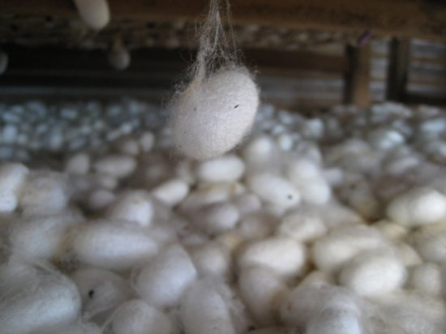**Transparencies**



