Circulating Items Inventory - Afghanistan

Book/Bound
Producer/Publisher Year Made Length Image
English? Artist/Author
Category of Item Item # Item Name

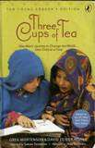
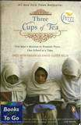
3100 Three Cups of Tea: Young Reader's Edition
Yes Greg Mortenson and David Oliver Relin, Adapted
Puffin Books 2009 209 pp.

3101 Three Cups of Tea Yes Greg Mortenson and David Oliver Relin
Penguin Books 2006 349 pp.

4930 Dari Writing (Workbook) Yes Rahmon
Inomkhojayev

4931 Dari Writing (Workbook) Yes Rahmon
Inomkhojayev
Center for Languages of the Central Asian Region

Center for Languages of the Central Asian Region
2008 60 pp.

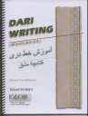
2008 60 pp.

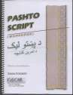
4932 | Pashto Script (Workbook) | Yes | Rahmon | Center for | 2008 | 84 pp.
 |  |  | Inomkhojayev | Languages of the
 |  |  |  | Central Asian
 |  |  |  | Region

4933 Pashto Script (Workbook) Yes Rahmon
Inomkhojayev

4934 Pashto Script (Workbook) Yes Rahmon
Inomkhojayev
Center for Languages of the Central Asian Region

Center for Languages of the Central Asian Region
2008 84 pp.

2008 84 pp.

4935 Pashto: An Elementary Textbook
Yes Rahmon
Inomkhojayev
Center for Languages of the Central Asian Region
2007 316 pp.

4936 Pashto: An Elementary Textbook
Yes Rahmon
Inomkhojayev
Center for Languages of the Central Asian Region
2007 316 pp.

CD
4972 Cultivating Afghanistan Yes Wissing, Douglas WFIU 2009 44 min.
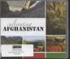

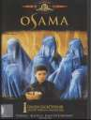
DVD

4907 Osama Yes Barmak, Siddiq Barmak.NHK/Lebr ocquy Fraser
2003 83 min.

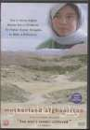
4912 Motherland Afghanistan Yes Mojadidi, Sedika Independent Lens 2006 74 min.

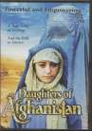
4915 Daughters of Afghanistan Yes Armstrong, Sally Video Service Corp 2004 58 min.

4919 The Kite Runner Yes Forster, Marc Dreamworks Pictures
4925 | Kandahar: Journey into | Yes | Makhmalbaf, Mohsen | Makhmalbaf Film | 2000 | 85 min.
 | the Heart of Afghanistan |  |  | House

4960 The Taliban Yes The History Channel A&E Television Networks
2007 127 min.

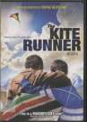
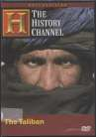
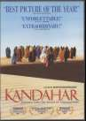
2005 50 min.

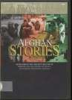
4963 Afghan Stories Yes Davies, Taran Vanguard Cinema 2002 60 min.

4970 Taliban II: The Revival Yes Avgeropoulos, Yorgos Pathfinder Home
Entertainment
2007 51 min.

