Circulating Items Inventory - Artifacts Inner Asian & Uralic National Resource Center
January 2008

Azerbaijan Azerbaijan

Art

Item: 2506

Title: Tin Engraving of Nizami (Azeri poet) Category Language: Description: Artifact

Artist:

Picture

Cassette
English Version:
Cyrillic Title Чиканка поета Низами
Chikanka poeta Nizami
Prducr: Date:
Length:
Cooperative ARZ

Item: 2037

Title: Agadadash Agayev - Karvan

Category Language: Description:

Artifact

Artist:
Picture

Item: 2028
Title: Passion Plays
Category Language: Description:

Cloth

Item: 2043

Title: Embroidered cloths (3)

Category Language: Description:
Artifact

Artist:

Picture

English Version:
Cyrillic Title
Prducr: Date:
Length:
Artifact
Azerbaijani Passion Plays in Moharram
Artist: Prducr: Date:
Length:
Moazzenzaadeh
Picture
English Version:
Cyrillic Title
English Version:
Cyrillic Title
Prducr:
Date: Length:

Clothing

Item: 4362
Title: Boys Costume
Category Language: Description:

Item: 2507
Title: Slippers, red with cream stripes
Category Language: Description:

Item: 4587
Title: Socks

Category Language: Description:
Artifact

Artist:

Picture

Artifact
cream-colored jacket with black pants Azeri (small), black & gold blouse
Artist: Prducr: Date:
Length:
Picture
English Version:
Cyrillic Title
Artifact
red knitted woollen slippers with cream stripes
Artist: Prducr: Date:
Length:
Picture
English Version:
Cyrillic Title
English Version:
Cyrillic Title
Prducr:
Date: Length:

Item: 2045
Title: Women's costume
Category Language: Description:

Item: 4366
Title: Women's Pants

Category Language: Description:

Artifact
Maroon with gold embroidery

Artist:
Picture

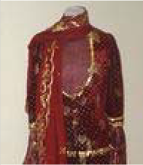
Flag
Artifact
Azeri wedding costume: red velvet skirt and jacket with gold trim, semi-sheer red and gold blouse, red and gold headscarf (4 parts total)
Artist: Prducr: Date:
Length:
Picture
English Version:
Cyrillic Title
English Version:
Cyrillic Title
Prducr: Date:
Length:

Item: 2491

Title: Azeri Flag

Category Language: Description:

Artifact
small flag w/ metal stand

Artist:
Picture

Item: 2070
Title: flag on metal base

Category Language: Description:
Artifact

Artist:

Picture

Item: 2071
Title: small flag w/ metal stand

Category Language: Description:
Artifact

Artist:

Picture

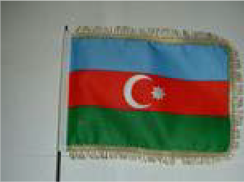
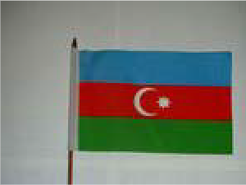
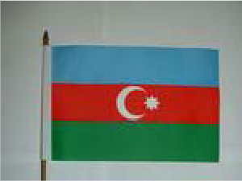
Item: 2266
English Version:
Cyrillic Title
Prducr: Date:
Length:
English Version:
Cyrillic Title
Prducr: Date:
Length:
English Version:
Cyrillic Title
Prducr: Date:
Length:
Title: small flag w/ wooden stand

Category Language: Description:

Artifact

Artist:
Picture

Hat

Item: 2112

Title: Turban

Category Language: Description:

Artifact
blue and gold turban

Artist:
Picture

Miniature

Item: 2130

Title: Azeri female

Category Language: Description:

Artifact
composition in traditional dress.

Artist:
Picture

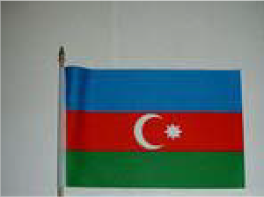
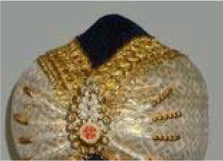
English Version:
Cyrillic Title
Prducr: Date:
Length:
English Version:
Cyrillic Title
Prducr:
Date: Length:
English Version:
Cyrillic Title
Prducr:
Date: Length:

Pamphlet

Item: 2160

Title: Azerbaijan Republic (country survey)

Category Language: Description:

Artifact
Pamphlet:

Artist:
Picture

Item: 2163
Title: Azerbaijan State Theater of Opera and Ballet

Category Language: Description:

Artifact
Brochure (Azeri/Russian/English)

Artist:
Picture

Artifact
composition Azeri female in traditional dress.
Artist: Prducr: Date:
Length:
Picture
English Version:
Cyrillic Title
English Version:
Cyrillic Title
Prducr:
Date: Length:
English Version:
Cyrillic Title
Prducr:
Date: Length:

Item: 2161
Title: Seki (in Latinic Azeri)

Category Language: Description:

Artifact
Pamphlet:

Artist:
Picture

Item: 2162
Title: Travel Brochure “Gobustan”

Category Language: Description:

Artifact Azeri
(Azeri/Russian/English)

Artist:
Picture

Photo
English Version:
Cyrillic Title
Prducr:
Date: Length:
English Version:
Cyrillic Title
Prducr: Date:
Length:

Item: 2177

Title: 5 Azeri Novruz cards

Category Language: Description:

Artifact
5 Azeri Novruz cards

Artist:
Picture

Item: 2175
Title: Azerbaijan Landscapes postcard set
Category Language: Description:

Item: 2176
Title: large postcard set “Azerbaijan Miniatures” (with Azeri, Russian, English
Category Language: Description:

Item: 2178
English Version:
Cyrillic Title
Prducr: Date:
Length:
Artifact
“Azerbaijan Landscapes” postcard set
Artist: Prducr: Date:
Length:
Picture
English Version:
Cyrillic Title
Artifact
large postcard set “Azerbaijan Miniatures” (with Azeri, Russian, English commentary)
Artist: Prducr: Date:
Length:
Picture
English Version:
Cyrillic Title
Title: postcard set “Azerbaijanian Jewellery Art” [sic]
Category Language: Description:

Item: 2179
Title: set of art cards

Category Language: Description:

Artifact
set of art cards

Artist:
Picture

Item: 2180
Title: set of large cards showing Azerbaijani carpets
Category Language: Description:

Item: 2209
Artifact
postcard set “Azerbaijanian Jewellery Art” [sic]
Artist: Prducr: Date:
Length:
Picture
English Version:
Cyrillic Title
English Version:
Cyrillic Title
Prducr: Date:
Length:
Artifact
set of large cards showing Azerbaijani carpets
Artist: Prducr: Date:
Length:
Picture
English Version:
Cyrillic Title
Title: Shaki. The Palace of Shaki Khans postcard set
Category Language: Description:

Item: 4604
Title: water_14.jpg
Category Language: Description:

Item: 4605
Title: water_15.jpg
Category Language: Description:

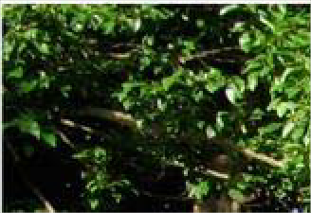
Artifact
“Shaki. The Palace of Shaki Khans” postcard set
Artist: Prducr: Date:
Length:
Picture
English Version:
Cyrillic Title
Artifact
İsti Su, Azerbaijan A river in southern Azerbaijan known simply as İsti Su (Hot Water). Located about twenty miles from the Iranian border, locals bathe in its hot, spring-fed waters to cure whatever ails them.
Artist: Prducr: Date:
Length:
Greg Burris
Picture
English Version:
Cyrillic Title

Poster
Artifact

Cyrillic Title

English Version:
Caspian Ship Graveyard, Azerbaijan During Soviet times, the area around Azerbaijan’s capital city of Baku was said to be among the most polluted places on earth. Although things have become considerably cleaner in the intervening sixteen years, relics of the Soviet past—like this ship graveyard just south of Baku—can still be found.

Artist: Prducr: Date: Length:
Greg Burris
Picture

Item: 2214
Title: Azeri philanthropist Zeynalabdin Taghiyev Category Language: Description: Artifact

Artist:

Picture

Rug

Item: 2224

Title: Orange miniature carpet

Category Language: Description:
Artifact

Artist:

Picture

Stamps
English Version:
Cyrillic Title
Prducr:
Date: Length:
English Version:
Cyrillic Title
Prducr: Date:
Length:

Item: 2240

Title: Azeri stamps

Category Language: Description:

Artifact

Artist:
Picture

Item: 2228
Title: Kitabi-Dada Qorqud – 1300

Category Language: Description:

Artifact
set of Azerbaijan stamps

Artist:
Picture

Artifact
Azerbaijan stamp set

Artist:
Picture

Central Asia
English Version:
Cyrillic Title
Prducr: Date:
Length:
English Version:
Cyrillic Title
Prducr: Date:
Length:
English Version:
Cyrillic Title
Prducr:
Date: Length:

Accessories

Item: 4672

Title: Bag

Category Language: Description:

Artifact
Small blue bag with gold patter

Artist:
Picture

Item: 4673
Title: Hanging decoration
Category Language: Description:

Cassette
English Version:
Cyrillic Title
Prducr: Date:
Length:
Artifact
Small red bag with gold flower design
Artist: Prducr: Date:
Length:
Picture
English Version:
Cyrillic Title
Artifact
Black felt decoration with sliver design and tassels
Artist: Prducr: Date:
Length:
Picture
English Version:
Cyrillic Title

Item: 2029

Title: Education in Central Asia

Category Language: Description:

Artifact
set of small tapes

Artist:
Picture

Map

Item: 2121

Title: Asia political and physical map

Category Language: Description:
Artifact

Artist:

Picture

Item: 2117
Title: China

Category Language: Description:
Artifact

Artist:

Picture

English Version:
Cyrillic Title
Prducr: Date:
Length:
English Version:
Cyrillic Title
Prducr:
Date: Length:
English Version:
Cyrillic Title
Prducr:
Date: Length:

Item: 2116
Title: Energy Map of Central Asia
Category Language: Description:

Item: 2120
Title: map of Caspian sea basin

Category Language: Description:
Artifact

Artist:

Picture

Item: 2119
Title: Map of Russia at the beginning of the 20th Century

Category Language: Description:
Artifact

Artist:

Picture

Artifact
Petroleum Economist Energy Map Series no. 18, 4th edition.
Artist: Prducr: Date:
Length:
Picture
English Version:
Cyrillic Title
English Version:
Cyrillic Title
Prducr: Date:
Length:
English Version:
Cyrillic Title
Prducr:
Date: Length:

Item: 2118
Title: Russian revolution

Category Language: Description:
Artifact

Artist:

Picture

Miniature

Item: 4496

Title: Central Asian Design Rug Bag

Category Language: Description:
Artifact

Artist:

Picture

Item: 4521
English Version:
Cyrillic Title
Prducr:
Date: Length:
English Version:
Cyrillic Title
Prducr: Date:
Length:
Title: Doll in Ethnic Dress
Category Language: Description:

Item: 4484
Title: Figurine of Woman Making Plov

Category Language: Description:

Artifact
Wood, painted

Artist:
Picture

Item: 4522
Title: Lighted Minature Yurt

Category Language: Description:

Artifact
Cloth

Artist:
Picture

Item: 4481
Artifact
Doll dressed in indistinct Central Asian dress
Artist: Prducr: Date:
Length:
Picture
English Version:
Cyrillic Title
English Version:
Cyrillic Title
Prducr: Date:
Length:
English Version:
Cyrillic Title
Prducr: Date:
Length:
Title: Miniature felt camel

Category Language: Description:

Artifact

Artist:
Picture

Item: 4515
Title: Miniature Yurt

Category Language: Description:

Artifact
Felt

Artist:
Picture

Item: 4494
Title: Minitature Yurt

Category Language: Description:

Artifact
Felt, paper bottom

Artist:
Picture

Item: 4476
English Version:
Cyrillic Title
Prducr: Date:
Length:
English Version:
Cyrillic Title
Prducr: Date:
Length:
English Version:
Cyrillic Title
Prducr: Date:
Length:
Title: Small yurt

Category Language: Description:

Artifact
Small yurt without lights

Artist:
Picture

Item: 4477
Title: Watermelon Vendor Figurine

Category Language: Description:
Artifact

Artist:

Picture

Item: 2138
Title: wooden Kyrgyz/Kazakh queen and king
Category Language: Description:

English Version:
Cyrillic Title
Prducr: Date:
Length:
English Version:
Cyrillic Title
Prducr: Date:
Length:
Artifact
set in brown and blue dress (King has shield)
Artist: Prducr: Date:
Length:
Picture
English Version:
Cyrillic Title

Miscellaneous

Item: 4498
Title: Bread Poker

Category Language: Description:
Artifact

Artist:

Picture

Item: 4520
Title: Clay Camel Pendant

Category Language: Description:

Artifact
Clay

Artist:
Picture

Item: 4480
Title: Decorative plate

Category Language: Description:

Artifact
English Version:
Cyrillic Title
Prducr:
Date: Length:
English Version:
Cyrillic Title
Prducr: Date:
Length:

Cyrillic Title

English Version:
Decorative plate with mosque and flower design

Artist: Prducr: Date: Length:
Picture

Item: 4519
Title: Felt Camel Pendant

Category Language: Description:

Artifact
Felt, white

Artist:
Picture

Item: 4502
Title: Knife with Sheath

Category Language: Description:

Artifact
Metal; incised writing on knife

Artist:
Picture

Item: 4482
Title: Metal bowl

Category Language: Description:

Artifact
English Version:
Cyrillic Title
Prducr:
Date: Length:
English Version:
Cyrillic Title
Prducr: Date:
Length:

Cyrillic Title

English Version:
Metal bowl with design.

Artist: Prducr: Date: Length:
Picture

Item: 4479
Title: Mouth organ in wooden box

Category Language: Description:
Artifact

Artist:

Picture

Item: 4478
Title: Small wooden container with carved design Category Language: Description: Artifact

Artist:

Picture

Photo
English Version:
Cyrillic Title
Prducr:
Date: Length:
English Version:
Cyrillic Title
Prducr: Date:
Length:

Item: 2181

Title: 1992 Photographic Calendar: “Silk Road”
Category Language: Description:

Poster

Item: 2215

Title: Caspian Sea Region: Promise and Peril.

Category Language: Description:

Artifact
National Geographic. May 1999

Artist:
Picture

Finland
Artifact
1992 Photographic Calendar: “Silk Road”
Artist: Prducr: Date:
Length:
Picture
English Version:
Cyrillic Title
English Version:
Cyrillic Title
Prducr:
Date: Length:

Miniature

Item: 4500

Title: Finnish Reindeer

Category Language: Description:

Artifact

Artist:
Picture

Hungary

Photo

Item: 2183

Title: Magyarorszag photo slides set
Category Language: Description:

Item: 2182
Title: set of “Budapest” photo slides

Category Language: Description:

Artifact
set of “Budapest” photo slides

Artist:
Picture

English Version:
Cyrillic Title
Prducr: Date:
Length:
Artifact
1 set of “Magyarorszag photo slides
Artist: Prducr: Date:
Length:
Picture
English Version:
Cyrillic Title
English Version:
Cyrillic Title
Prducr:
Date: Length:

Kazakhstan

Accessories

Item: 2000

Title: Amulet

Category Language: Description:

Artifact
leather Kazakh amulet

Artist:
Picture

Art

Item: 2005

Title: Posters

Category Language: Description:

Artifact
set of # fairytale posters

Artist:
Picture

Item: 4607
English Version:
Cyrillic Title
Prducr: Date:
Length:
English Version:
Cyrillic Title
Prducr:
Date: Length:
Title: zhailau

Category Language: Description:

Artifact
Framed leatherwork

Artist:
C. Kozhokmatov
Picture

Clothing

Item: 2504

Title: Hat (national costume)
Category Language: Description:

Item: 4627
Title: Kazakh men's hat - kalpak

Category Language: Description:

Artifact
Made of wool

Artist:
Picture

English Version:
Cyrillic Title
Prducr: Date:
Length:
2007
Artifact
Green velveteen round hat w/ gold trim
Artist: Prducr: Date:
Length:
Picture
English Version:
Cyrillic Title
English Version:
Cyrillic Title
Prducr:
Date: Length:

Item: 2051
Title: Man's robe

Category Language: Description:

Artifact
black men's robe

Artist:
Picture

Item: 2503
Title: Pants (national costume)
Category Language: Description:

Item: 2505
Title: shawl for covering women's head
Category Language: Description:

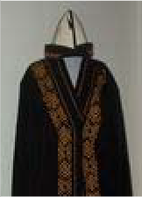
English Version:
Cyrillic Title
Prducr:
Date: Length:
Artifact
Green velveteen boy's pants w/ gold trim
Artist: Prducr: Date:
Length:
Picture
English Version:
Cyrillic Title
Artifact
white shawl with sewn in head hole, blue, pink silver embroidery
Artist: Prducr: Date:
Length:
Picture
English Version:
Cyrillic Title
kimishek

Item: 2502
Title: Shirt (national costume)
Category Language: Description:

Item: 2047
Title: Woman's vest

Category Language: Description:

Artifact
women's vest - red-silver

Artist:
Picture

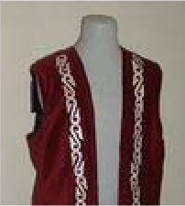
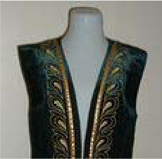
Artifact
Green velveteen boy's short- sleeved jacket w/ gold trim
Artist: Prducr: Date:
Length:
Picture
English Version:
Cyrillic Title
English Version:
Cyrillic Title
Prducr: Date:
Length:
Artifact
women's vest - green-gold with hat
Artist: Prducr: Date:
Length:
Picture
English Version:
Cyrillic Title

Flag

Item: 2072

Title: Large flag

Category Language: Description:

Artifact
Turkmenistan

Artist:
Picture

Item: 2076
Title: medium-sized flag

Category Language: Description:
Artifact

Artist:

Picture

Artifact
red woman’s vest, with gold trim and clasp
Artist: Prducr: Date:
Length:
Picture
English Version:
Cyrillic Title
English Version:
Cyrillic Title
Prducr:
Date: Length:
English Version:
Cyrillic Title
Prducr:
Date: Length:

Item: 2075
Title: mini flag

Category Language: Description:
Artifact

Artist:

Picture

Item: 2073
Title: small w/ stand

Category Language: Description:
Artifact

Artist:

Picture

Hat
English Version:
Cyrillic Title
Prducr:
Date: Length:
English Version:
Cyrillic Title
Prducr: Date:
Length:

Item: 2102

Title: Kalpak
Category Language: Description:

Item: 4475
Title: Kazakh green hat

Category Language: Description:
Artifact

Artist:

Picture

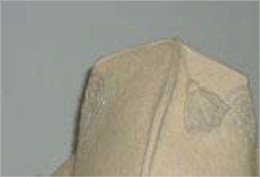
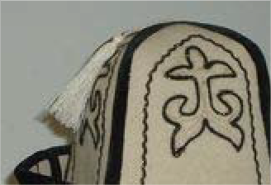
Item: 4670
Artifact
white plain felt kalpak with white tassel
Artist: Prducr: Date:
Length:
Picture
English Version:
Cyrillic Title
Artifact
White felt, black velvet borders, gold and black embroidery w/ white tassle
Artist: Prducr: Date:
Length:
Picture
English Version:
Cyrillic Title
English Version:
Cyrillic Title
Prducr:
Date: Length:
Title: Kazakh women's hat

Category Language: Description:

Artifact
Red with gold pattern

Artist:
Picture

Item: 2086
Title: Man's hat

Category Language: Description:

Artifact
man's hat - black on white

Artist:
Picture

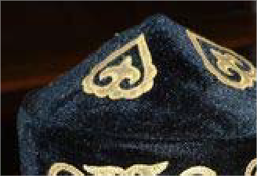
Artifact
English Version:
Cyrillic Title
Prducr: Date:
Length:
English Version:
Cyrillic Title
Prducr: Date:
Length:

Cyrillic Title

English Version:
man's hat - gold on black

Artist: Prducr: Date: Length:
Picture

Artifact
man's hat - gold on black

Artist:
Picture

Item: 2497
Title: Taqiya
Category Language: Description:

Instrument

Item: 2115

Title: Dombra

Category Language: Description:

Artifact
string instrument

Artist:
Picture

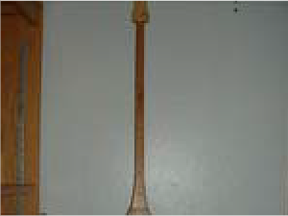
English Version:
Cyrillic Title
Prducr: Date:
Length:
Artifact
Blue Kazakh hat, yurt-shaped with gold trim
Artist: Prducr: Date:
Length:
Picture
English Version:
Cyrillic Title
English Version:
Cyrillic Title
Prducr:
Date: Length:

Map

Item: 2122
Title: Map of Kazakhstan (Cyrillic 1:2,500,000) Category Language: Description: Artifact

Artist:

Picture

Miniature

Item: 4530

Title: Bulbous Kazakh Female

Category Language: Description:

Artifact
Wood

Artist:
Picture

Item: 2267
English Version:
Cyrillic Title
Prducr:
Date: Length:
English Version:
Cyrillic Title
Prducr: Date:
Length:
Title: camel

Category Language: Description:

Artifact
Gray felt camel w/ ornate saddle

Artist:
Picture

Item: 2494
Title: Dombra (Kazakh national instrument, lute)

Category Language: Description:

Artifact
toy/miniature dombra

Artist:
Picture

Item: 2135
Title: eagle-and-dombra figure

Category Language: Description:

Artifact
small, wooden (Kazakhstan)

Artist:
Picture

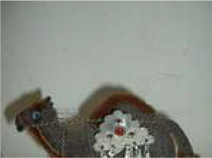
Item: 4523
English Version:
Cyrillic Title
Prducr: Date:
Length:
English Version:
Cyrillic Title
Prducr: Date:
Length:
English Version:
Cyrillic Title
Prducr: Date:
Length:
Title: Orange Wooden Female Figurine

Category Language: Description:

Artifact
Wood

Artist:
Picture

Item: 4524
Title: Orange Wooden Male Figurine Category Language: Description: Artifact

Artist:

Picture

Item: 4525
Title: Small Bulbous Kazakh Female Figurine with Plume

Category Language: Description:

Artifact
Wood, feather

Artist:
Picture

Item: 4512
English Version:
Cyrillic Title
Prducr: Date:
Length:
English Version:
Cyrillic Title
Prducr: Date:
Length:
English Version:
Cyrillic Title
Prducr: Date:
Length:
Title: Small Kazakh Male Figurine

Category Language: Description:

Artifact
Wood

Artist:
Picture

Item: 2131
Title: small wooden dolls

Category Language: Description:

Artifact
family (father, mother, son)

Artist:
Picture

Artifact
couple

Artist:
Picture

Item: 4528
English Version:
Cyrillic Title
Prducr: Date:
Length:
English Version:
Cyrillic Title
Prducr: Date:
Length:
English Version:
Cyrillic Title
Prducr:
Date: Length:
Title: Small Wooden Kazakh Female Figurine with Plume

Category Language: Description:

Artifact
Wood, feather

Artist:
Picture

Item: 4501
Title: Wooden Kazakh Warrior Figurine

Category Language: Description:

Artifact
Wood, paint

Artist:
Picture

Item: 4503
Title: Wooden Kazakh Woman Figurine

Category Language: Description:

Artifact
Wood, paint

Artist:
Picture

Item: 2133
English Version:
Cyrillic Title
Prducr: Date:
Length:
English Version:
Cyrillic Title
Prducr: Date:
Length:
English Version:
Cyrillic Title
Prducr: Date:
Length:
Title: Yurt

Category Language: Description:

Artifact

Artist:
Picture

Item: 2134
Title: yurta

Category Language: Description:

Artifact
toy Kazakh

Artist:
Picture

Miscellaneous

Item: 2495

Title: Doll, Kazakh female

Category Language: Description:
Artifact

Artist:

Picture

English Version:
Cyrillic Title
Prducr: Date:
Length:
English Version:
Cyrillic Title
Prducr: Date:
Length:
English Version:
Cyrillic Title
Prducr:
Date: Length:

Item: 2496
Title: Dolls, Pair of male and female carved wooden Kazakh
Category Language: Description:

Item: 4510
Title: Kazakhstan Button

Category Language: Description:

Artifact Kazakh
"Kazakhstan 10 Years"

Artist:
Picture

Money
Artifact
carved wooden male and female Kazakh dolls
Artist: Prducr: Date:
Length:
Picture
English Version:
Cyrillic Title
English Version:
Cyrillic Title
Prducr: Date:
Length:

Item: 2159

Title: 3 packets of photocopied tenge

Category Language: Description:

Artifact
(1-, 3-, 5-tenge denominations)

Artist:
Picture

Item: 2154
Title: 9 bills

Category Language: Description:
Artifact

Artist:

Picture

Pamphlet

Item: 2164

Title: Erbolat Toulebai.
Category Language: Description:

English Version:
Cyrillic Title
Prducr: Date:
Length:
English Version:
Cyrillic Title
Prducr: Date:
Length:
Artifact
Art Brochure: (Album of paintings by the artist. In Kazakh and Russian. Almaty: 1994)
Artist: Prducr: Date:
Length:
Picture
English Version:
Cyrillic Title

Item: 2169
Title: Repetek Sandy Desert Biosphere Reserve

Category Language: Description:

Artifact
Pamphlet: (Ashkhabad: 1982)

Artist:
Picture

Photo

Item: 2208

Title: Badkhyzskii Zapovednik postcard set
Category Language: Description:

Stamps
English Version:
Cyrillic Title
Prducr:
Date: Length:
Artifact
“Badkhyzskii Zapovednik” postcard set
Artist: Prducr: Date:
Length:
Picture
English Version:
Cyrillic Title

Item: 2230

Title: envelope fragments

Category Language: Description:

Artifact
(7)

Artist:
Picture

Kyrgyzstan

Accessories

Item: 2265

Title: horsewhip

Category Language: Description:

Artifact
Manas horsewhip

Artist:
Picture

Item: 2260
Title: whip
Category Language: Description:

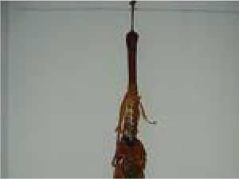
English Version:
Cyrillic Title
Prducr: Date:
Length:
English Version:
Cyrillic Title
Prducr: Date:
Length:
Artifact
Manas 1000 year commemorative whip
Artist: Prducr: Date:
Length:
Picture
English Version:
Cyrillic Title

Art

Item: 2019

Title: Lithograph

Category Language: Description:

Artifact
Lithograph “Baibige”. 1993

Artist:
Mataev
Picture

Artifact
Lithograph “Abyshkya”. 1993

Artist:
Mataev
Picture

Item: 2011
Title: Oil painting
Category Language: Description:

English Version:
Cyrillic Title
Prducr: Date:
Length:
English Version:
Cyrillic Title
Prducr:
Date: Length:
Artifact
Oil painting, primative style, symbols
Artist: Prducr: Date:
Length:
Picture
English Version:
Cyrillic Title

Item: 2006
Title: Painting
Category Language: Description:

Item: 2010
Title: Wall-hanging
Category Language: Description:

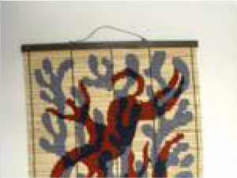
Item: 2008
Artifact
painting of old Kyrgyz man with white kalpak, goatee (side-view)
Artist: Prducr: Date:
Length:
Picture
English Version:
Cyrillic Title
Artifact
painting of old Kyrgyz man with white Kalpak, goatee, Soviet medal
Artist: Prducr: Date:
Length:
Picture
English Version:
Cyrillic Title
Artifact
Kyrgyz reed and string wall- hanging
Artist: Prducr: Date:
Length:
Picture
English Version:
Cyrillic Title
Title: Watercolor

Category Language: Description:

Artifact
watercolor of Kyrgyz woman

Artist:
Picture

Artifact
watercolor of Kyrgyz man

Artist:
Picture

Artifact
Watercolor "Village Life"

Artist:
Nargiza Buronov
Picture

Item: 2018
English Version:
Cyrillic Title
Prducr: Date:
Length:
English Version:
Cyrillic Title
Prducr: Date:
Length:
English Version:
Cyrillic Title
Prducr: Date:
Length:
Title: Wood carving
Category Language: Description:

Item: 2021
Title: Wooden screen
Category Language: Description:

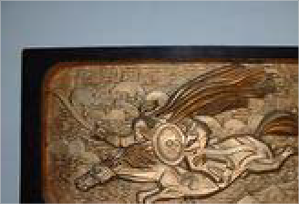
Clothing
Artifact
Manas wood-carving, painted gold.
Artist: Prducr: Date:
Length:
Picture
English Version:
Cyrillic Title
Artifact
small wooden screen from embroidered in red outline of archery theme
Artist: Prducr: Date:
Length:
Picture
English Version:
Cyrillic Title
Artifact
wooden embroidered screen w/ Manas theme
Artist: Prducr: Date:
Length:
Picture
English Version:
Cyrillic Title

Item: 4626

Title: Kyrgyz men's hat - dopu (wool)

Category Language: Description:

Artifact
Made of wool

Artist:
Picture

Item: 2053
Title: Man's robe
Category Language: Description:

Item: 2052
Title: Sholpan
Category Language: Description:

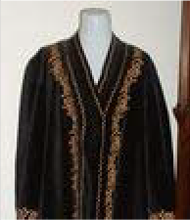
Item: 2056
English Version:
Cyrillic Title
Prducr: Date:
Length:
2007
Artifact
Black Kyrgyz male robe w/ gold trim
Artist: Prducr: Date:
Length:
Picture
English Version:
Cyrillic Title
Artifact
black sholpan with purple and orange decorative trim
Artist: Prducr: Date:
Length:
Picture
English Version:
Cyrillic Title
Title: Woman's costume
Category Language: Description:

Item: 2054
Title: Woman's jacket
Category Language: Description:

Item: 4371
Title: Woman's short-sleeved jacket

Category Language: Description:

Artifact
Black jacket with gold embroidery

Artist:
Picture

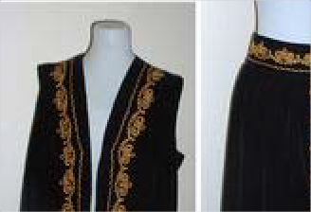
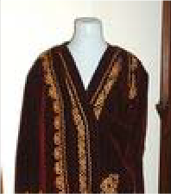
Item: 2055
Artifact
Black Kyrgyz Women's Costume: 2 parts, vest and skirt w/ gold trim
Artist: Prducr: Date:
Length:
Picture
English Version:
Cyrillic Title
Artifact
maroon Women's jacket w/ gold trim
Artist: Prducr: Date:
Length:
Picture
English Version:
Cyrillic Title
English Version:
Cyrillic Title
Prducr: Date:
Length:
Title: Woman's vest
Category Language: Description:

Item: 2633
Title: Woman's vest and skirt
Category Language: Description:

Flag

Item: 2492

Title: Flag of the Kyrgyz Republic

Category Language: Description:

Artifact
small flag

Artist:
Picture

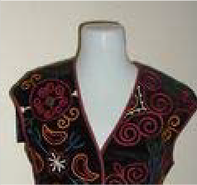
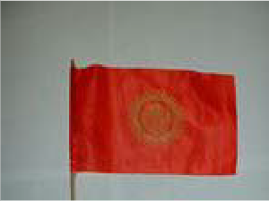
Artifact
women's vest w/ tassels: black w/ purple, blue, orange, cream and green embroidery
Artist: Prducr: Date:
Length:
Picture
English Version:
Cyrillic Title
Artifact
maroon vest and skirt with gold trim in two threads, bull's horns pattern
Artist: Prducr: Date:
Length:
Picture
English Version:
Cyrillic Title
English Version:
Cyrillic Title
Prducr:
Date: Length:

Item: 2074
Title: flag w/ wooden base (2)

Category Language: Description:

Artifact
Kyrgyz flag

Artist:
Picture

Item: 2077
Title: large flag

Category Language: Description:
Artifact

Artist:

Picture

Hat
English Version:
Cyrillic Title
Prducr:
Date: Length:
English Version:
Cyrillic Title
Prducr: Date:
Length:

Item: 2090

Title: Kalpak
Category Language: Description:

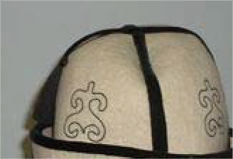
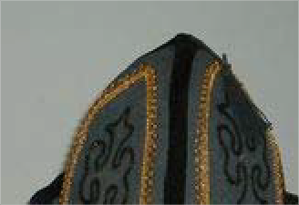
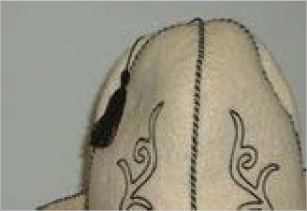
Artifact
all-white Kyrgyz kalpak with black trim and tassel
Artist: Prducr: Date:
Length:
Picture
English Version:
Cyrillic Title
Artifact
white Kyrgyz kalpak with black brim, trim, and tassel
Artist: Prducr: Date:
Length:
Picture
English Version:
Cyrillic Title
Artifact
charcoal gray kalpak with velvet cuff, black & gold borders and black tassel
Artist: Prducr: Date:
Length:
Picture
English Version:
Cyrillic Title
Artifact
white kalpak with white cuff, black borders and black tassel
Artist: Prducr: Date:
Length:
Picture
English Version:
Cyrillic Title

Item: 2089
Title: Man's hat

Category Language: Description:

Artifact
man's hat - black-white

Artist:
Picture

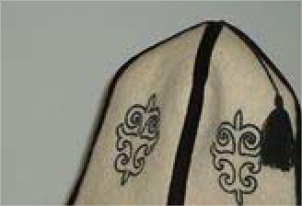
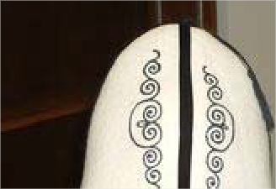
Item: 2093
Artifact
white kalpak with black velvet cuff, black velvet borders and black tassel
Artist: Prducr: Date:
Length:
Picture
English Version:
Cyrillic Title
English Version:
Cyrillic Title
Prducr: Date:
Length:
Artifact
Male felt hat: white w/ black trim and gold trim on brim
Artist: Prducr: Date:
Length:
Picture
English Version:
Cyrillic Title
Title: Woman's hat
Category Language: Description:

Instrument

Item: 4579

Title: Komuz - three stringed instrument Category Language: Description: Artifact

Artist:

Picture

Item: 2257
Title: mouth harp

Category Language: Description:

Artifact
mouth-harp in wooden case

Artist:
Picture

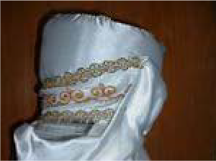
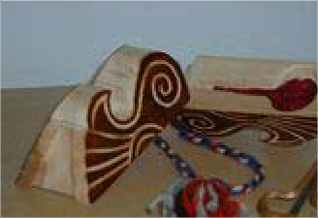
Artifact
Elechek (married female hat)
~white turban w/ gold trim w/ white scarf/veil w/ fringe
Artist: Prducr: Date:
Length:
Picture
English Version:
Cyrillic Title
English Version:
Cyrillic Title
Prducr:
Date: Length:
English Version:
Cyrillic Title
Prducr:
Date: Length:

Miniature

Item: 4493
Title: Kyrgryz Doll

Category Language: Description:

Artifact
Name: Jamilya; made of felt

Artist:
Picture

Item: 4529
Title: Kyrgyz Male Wooden Stylus

Category Language: Description:

Artifact
Wood

Artist:
Picture

Item: 4527
Title: Small Wooden Kyrgyz Female Figurine

Category Language: Description:

Artifact
Wood

Artist:
Picture

English Version:
Cyrillic Title
Prducr:
Date: Length:
English Version:
Cyrillic Title
Prducr: Date:
Length:
English Version:
Cyrillic Title
Prducr:
Date: Length:

Item: 2136
Title: wooden Kyrgyz couple
Category Language: Description:

Item: 4526
Title: Wooden Kyrgyz Male Figurine

Category Language: Description:

Artifact
Wood, fur

Artist:
Picture

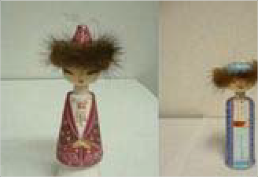
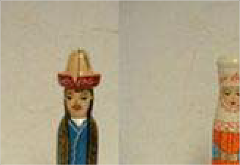
Item: 2237
Artifact
with fur-rimmed hats (Female in pink and male in blue)
Artist: Prducr: Date:
Length:
Picture
English Version:
Cyrillic Title
Artifact
(Female in blue and orange; male in blue and green)
Artist: Prducr: Date:
Length:
Picture
English Version:
Cyrillic Title
English Version:
Cyrillic Title
Prducr: Date:
Length:
Title: yurt

Category Language: Description:

Miscellaneous

Item: 4509

Title: Manas Button

Category Language: Description:

Artifact Kyrgyz
"Manas 1000 Years"

Artist:
Picture

Money

Item: 2155

Title: 5 bills

Category Language: Description:
Artifact

Artist:

Picture

Artifact
1-meter diameter, several fabric & wood parts; natural felt color w/ blue & red stitching
Artist: Prducr: Date:
Length:
Picture
English Version:
Cyrillic Title
English Version:
Cyrillic Title
Prducr:
Date: Length:
English Version:
Cyrillic Title
Prducr:
Date: Length:

Pamphlet

Item: 2166

Title: Kyrgyzstan – The Land of Sky-High Mountains

Category Language: Description:

Artifact
Travel Brochure:

Artist:
Picture

Item: 2165
Title: Kyrgyzstan: A Nomadic Culture in the Modern World.
Category Language: Description:

Photo
English Version:
Cyrillic Title
Prducr: Date:
Length:
Artifact
Pamphlet: Charles Sumner School Museum.
Artist: Prducr: Date:
Length:
Picture
English Version:
Cyrillic Title

Item: 2186

Title: 2 “Kyrgyzstan: k 60 letiyu obrazovaniya Kyrgyzskoi SSR” postcard sets
Category Language: Description:

Item: 2185
Title: Calendar with Kyrghi paintings (1996)
Category Language: Description:

Item: 2207
Title: Frunze postcard set

Category Language: Description:

Artifact
“Frunze” postcard set

Artist:
Picture

Item: 2188
Artifact
2 “Kyrgyzstan: k 60 letiyu obrazovaniya Kyrgyzskoi SSR” postcard sets
Artist: Prducr: Date:
Length:
Picture
English Version:
Cyrillic Title
Artifact
Calendar with Kyrghi paintings (1996)
Artist: Prducr: Date:
Length:
Picture
English Version:
Cyrillic Title
English Version:
Cyrillic Title
Prducr: Date:
Length:
Title: Kyrgyzstan postcard set

Category Language: Description:

Artifact
“Kyrgyzstan” postcard set

Artist:
Picture

Item: 2187
Title: Po Kyrgyzii postcard set

Category Language: Description:

Artifact
“Po Kyrgyzii” postcard set

Artist:
Picture

Item: 2184
Title: postcard

Category Language: Description:

Artifact
postcard

Artist:
Picture

Item: 4591
English Version:
Cyrillic Title
Prducr: Date:
Length:
English Version:
Cyrillic Title
Prducr: Date:
Length:
English Version:
Cyrillic Title
Prducr: Date:
Length:
Title: water_1.jpg
Category Language: Description:

Item: 4592
Title: water_2.jpg
Category Language: Description:

Poster

Item: 2218

Title: symbols of the 40 tribes of Kyrgyzstan Category Language: Description: Artifact

Artist:

Picture

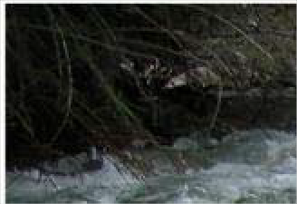
Artifact
A winter day in Saruu Village, Kyrgyzstan. Much of Central Asia’s water exists in snow and ice in the mountainous republics of Kyrgyzstan and Tajikistan.
Artist: Prducr: Date:
Length:
Jackson Kellogg
Picture
English Version:
Cyrillic Title
Artifact
A swift moving mountain stream in Kyrgyzstan. Melting snows in the mountainous areas of Central Asia form the Amu Darya and Syr Darya Rivers. These rivers are vital to economy of the entire region.
Artist: Prducr: Date:
Length:
Jackson Kellogg
Picture
English Version:
Cyrillic Title
English Version:
Cyrillic Title
Prducr:
Date: Length:

Mongolia

Item: 2235
Title: Mongol Khans and their Legacy

Category Language: Description:

Artifact
National Geographic:

Artist:
Picture

Clothing

Item: 4610

Title: Mongolian Hat (Men's)

Category Language: Description:
Artifact

Artist:

Picture

Item: 4611
English Version:
Cyrillic Title
Prducr: Date:
Length:
English Version:
Cyrillic Title
Prducr: Date:
Length:
2007
Title: Mongolian Hat (Women's)

Category Language: Description:

Artifact

Artist:
Picture

Item: 2060
Title: Woman's robe

Category Language: Description:

Artifact
women's purple quilted robe

Artist:
Picture

Flag

Item: 2079

Title: flag-banner

Category Language: Description:
Artifact

Artist:

Picture

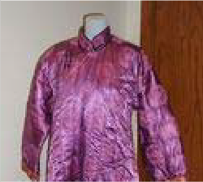
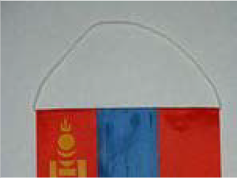
English Version:
Cyrillic Title
Prducr: Date:
Length:
2007
English Version:
Cyrillic Title
Prducr: Date:
Length:
English Version:
Cyrillic Title
Prducr:
Date: Length:

Item: 2078
Title: small flag (hanging banner)

Category Language: Description:
Artifact

Artist:

Picture

Hat

Item: 2111

Title: Cone-shaped hat
Category Language: Description:

Miniature
English Version:
Cyrillic Title
Prducr:
Date: Length:
Artifact
blue/multi-colored soft cone- shaped hat with multi-colored fringe
Artist: Prducr: Date:
Length:
Picture
English Version:
Cyrillic Title

Item: 4669

Title: Camel, stuffed. With metal ornamenting

Category Language: Description:

Artifact

Artist:
Picture

Item: 2152
Title: toy ger

Category Language: Description:

Artifact
(battery operated)

Artist:
Picture

Miscellaneous

Item: 4577

Title: Bone Game in Leather bag with four bones Category Language: Description: Artifact

Artist:

MonSoc

Picture

English Version:
Cyrillic Title
Prducr: Date:
Length:
2007
English Version:
Cyrillic Title
Prducr: Date:
Length:
English Version:
Cyrillic Title
Prducr:
Date: Length:

Item: 4671
Title: Mongolian tea cup with metal frame.

Category Language: Description:
Artifact

Artist:

Picture

Photo

Item: 2189

Title: 2000-2002 Mongolian Calendar: “The Lunar Calendar of XVII Jaran”
Category Language: Description:

Item: 2173
English Version:
Cyrillic Title
Prducr:
Date: Length:
Artifact
2000-2002 Mongolian Calendar: “The Lunar Calendar of XVII Jaran”
Artist: Prducr: Date:
Length:
Picture
English Version:
Cyrillic Title
Title: large photo of Mongolian woman and ger
Category Language: Description:

Item: 2192
Title: Mongolia postcard set

Category Language: Description:

Artifact
Mongolia postcard set

Artist:
Picture

Item: 2191
Title: set of large, ‘Welcome to Gobi Desert’ postcards
Category Language: Description:

Item: 2190
Artifact
large photo of Mongolian woman and ger
Artist: Prducr: Date:
Length:
Picture
English Version:
Cyrillic Title
English Version:
Cyrillic Title
Prducr: Date:
Length:
Artifact
set of large, ‘Welcome to Gobi Desert’ postcards
Artist: Prducr: Date:
Length:
Picture
English Version:
Cyrillic Title
Title: set of small ‘Mongolia’ postcards

Category Language: Description:

Artifact
set of small ‘Mongolia’ postcards

Artist:
Picture

Regional

Accessories

Item: 2252

Title: Birds

Category Language: Description:

Artifact
set of blue and yellow birds

Artist:
Picture

Item: 2249
Title: gourd naas-holder

Category Language: Description:
Artifact

Artist:

Picture

English Version:
Cyrillic Title
Prducr: Date:
Length:
English Version:
Cyrillic Title
Prducr: Date:
Length:
English Version:
Cyrillic Title
Prducr:
Date: Length:

Item: 2244
Title: Knife
Category Language: Description:

Item: 4585
Title: Power Transmission Cable (From JVC Stereo)
Category Language: Description:

Item: 2241
Title: rosary

Category Language: Description:

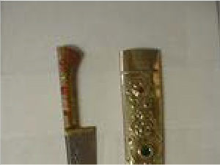
Artifact
Artifact
knife w/ gold colored sheath and Arabic writing
Artist: Prducr: Date:
Length:
Picture
English Version:
Cyrillic Title
Artifact
Friction-based coupling. Polarized, ungrounded. Appears to be designed for use with 110v AC line current.
Artist: Prducr: Date:
Length:
Picture
English Version:
Cyrillic Title

Cyrillic Title

English Version:
black and red

Artist: Prducr: Date: Length:
Picture

Item: 2234
Title: Scabbard knives

Category Language: Description:

Artifact
(2)

Artist:
Picture

Item: 2236
Title: small black knife
Category Language: Description:

Item: 2250
Title: Spoons

Category Language: Description:

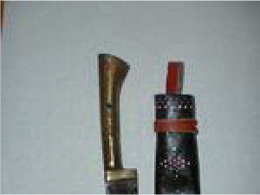
Artifact
English Version:
Cyrillic Title
Prducr:
Date: Length:
Artifact
in black leather (stitched green, red) sheath
Artist: Prducr: Date:
Length:
Picture
English Version:
Cyrillic Title

Cyrillic Title

English Version:
2 wooden spoons

Artist: Prducr: Date: Length:
Picture

Item: 2258
Title: tea cosy
Category Language: Description:

Item: 2251
Title: Wind Chime

Category Language: Description:

Artifact
silent wind chime

Artist:
Picture

Art
Artifact
Red, blue, black striped tea cosy w/ gold lamé and 3 yellow poofs
Artist: Prducr: Date:
Length:
Picture
English Version:
Cyrillic Title
English Version:
Cyrillic Title
Prducr: Date:
Length:

Item: 2243

Title: Hanging
Category Language: Description:

Item: 2247
Title: Pin

Category Language: Description:

Item: 2017
Title: Plaque

Category Language: Description:

Artifact
Metal relief plaque of Stalin

Artist:
Picture

Artifact
maroon felt hanging needle cushion w/ golden embroidery
Artist: Prducr: Date:
Length:
Picture
English Version:
Cyrillic Title
Artifact
Red w/ gold and green design pin cushion and pink ruffle
Artist: Prducr: Date:
Length:
Picture
English Version:
Cyrillic Title
English Version:
Cyrillic Title
Prducr: Date:
Length:

Cassette

Item: 2035
Title: Bebeho Meros 2

Category Language: Description:
Artifact

Artist:

Picture

Cloth

Item: 2263

Title: cotton

Category Language: Description:

Artifact
sample of cotton

Artist:
Picture

Item: 2042
English Version:
Cyrillic Title
Prducr:
Date: Length:
English Version:
Cyrillic Title
Prducr: Date:
Length:
Title: Decorative design cloth

Category Language: Description:

Artifact

Artist:
Picture

Flag

Item: 2084

Title: 2 small komosomol flags

Category Language: Description:

Artifact
with Lenin pins

Artist:
Picture

Item: 2085
Title: small decorative banner
Category Language: Description:

English Version:
Cyrillic Title
Prducr: Date:
Length:
English Version:
Cyrillic Title
Prducr:
Date: Length:
Artifact
black w/ polychrome embroidery and white fringe
Artist: Prducr: Date:
Length:
Picture
English Version:
Cyrillic Title

Map

Item: 2129
Title: Caspian Sea oil and gas reserves Category Language: Description: Artifact

Artist:

Picture

Item: 2127
Title: National Geographic World (Political) map

Category Language: Description:

Artifact
(March 1995) COPY 1

Artist:
Picture

Artifact
(March 1995) COPY 22

Artist:
Picture

English Version:
Cyrillic Title
Prducr:
Date: Length:
English Version:
Cyrillic Title
Prducr: Date:
Length:
English Version:
Cyrillic Title
Prducr: Date:
Length:

Miniature

Item: 2264
Title: camel

Category Language: Description:

Artifact
white camel

Artist:
Picture

Item: 2149
Title: ceramic turbaned female
Category Language: Description:

Item: 2153
Title: figure of an old man

Category Language: Description:

Artifact
English Version:
Cyrillic Title
Prducr:
Date: Length:
Artifact
in green and yellow dress (Hands are broken off)
Artist: Prducr: Date:
Length:
Picture
English Version:
Cyrillic Title

Cyrillic Title

English Version:
in turban holding vase

Artist: Prducr: Date: Length:
Picture

Item: 2150
Title: small wooden female
Category Language: Description:

Item: 2151
Title: wooden couple

Category Language: Description:

Artifact
in orange and brown.

Artist:
Picture

Item: 2148
Title: wooden turbaned male

Category Language: Description:

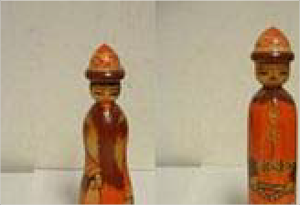
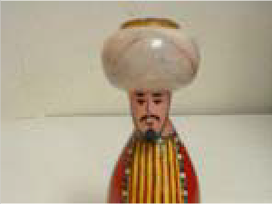
Artifact
Artifact
with orange tibiteka (skullcap) and blue khalat (robe)
Artist: Prducr: Date:
Length:
Picture
English Version:
Cyrillic Title
English Version:
Cyrillic Title
Prducr: Date:
Length:

Cyrillic Title

English Version:
with watermelons

Artist: Prducr: Date: Length:
Picture

Miscellaneous

Item: 2239

Title: metal bell

Category Language: Description:
Artifact

Artist:

Picture

Photo

Item: 2212

Title: 1001 Nights postcard set ПЕРЕЧЕНЬ ИЛЛЮСТРАЦЙ К СКАЗКАМ "

Category Language: Description:

Artifact
1001 Nights postcard set

Artist:
Picture

Item: 2213
English Version:
Cyrillic Title
Prducr: Date:
Length:
English Version:
ПЕРЕЧЕНЬ ИЛЛЮСТРАЦЙ К СКАЗКАМ "ТЬІСЯЧА И ОДНА НОЧЬ"
Cyrillic Title
Prducr: Date:
Length:
Title: 2 Navruz cards

Category Language: Description:

Artifact
- Navruz cards

Artist:
Picture

Item: 2174
Title: black and white photo of an old woman making a blanket
Category Language: Description:

Poster

Item: 2223

Title: famous Russian painting montage

Category Language: Description:

Artifact
(2)

Artist:
Picture

English Version:
Cyrillic Title
Prducr: Date:
Length:
Artifact
black and white photo of an old woman making a blanket
Artist: Prducr: Date:
Length:
Picture
English Version:
Cyrillic Title
English Version:
Cyrillic Title
Prducr:
Date: Length:

Rug

Item: 2227
Title: red miniature carpet

Category Language: Description:
Artifact

Artist:

Picture

Stamps

Item: 2233

Title: various stamp fragments
Category Language: Description:

Russia
English Version:
Cyrillic Title
Prducr:
Date: Length:
Artifact
large folder and stamped envelopes
Artist: Prducr: Date:
Length:
Picture
English Version:
Cyrillic Title

Art

Item: 2242

Title: Bronze plaque

Category Language: Description:

Artifact
w/ bust of Stalin

Artist:
Picture

Item: 2024
Title: Print

Category Language: Description:

Artifact
Print of "Sto Vekov"

Artist:
Ilya Glazonov
Picture

Cassette (audio)

Item: 2501

Title: Tatar music
Category Language: Description:

English Version:
Cyrillic Title
Prducr: Date:
Length:
English Version:
Cyrillic Title
Prducr: Date:
Length:
Artifact
Tatar
accordion & piano music, some jazzy, some folky
Artist: Prducr: Date:
Length:
Garifullin, Saidas
Picture
English Version:
Kazan
Cyrillic Title
1999
Saideshtan Saideshka

Map

Item: 2123
Title: Revolution (1905-1909)

Category Language: Description:
Artifact

Artist:

Picture

Poster

Item: 2216

Title: Economic Evolution of the Former Soviet Union: Communism to Capitalis

Category Language: Description:

Artifact
National Geographic.March 1993

Artist:
Picture

Item: 2217
English Version:
Cyrillic Title
Prducr:
Date: Length:
English Version:
Cyrillic Title
Prducr: Date:
Length:
Title: Russia and the Independent Nations of the Former Soviet Union

Category Language: Description:

Artifact
National Geographic. 1998.

Artist:
Picture

Tajikistan

Art

Item: 2012

Title: Watercolor

Category Language: Description:

Artifact
watercolor of Tajik man

Artist:
Picture

Calendar
English Version:
Cyrillic Title
Prducr: Date:
Length:
English Version:
Cyrillic Title
Prducr: Date:
Length:

Item: 4652

Title: The Heritage of Ancestors
Category Language: Description:

Cassette

Item: 2030

Title: Voice recordings
Category Language: Description:

Flag

Item: 2080

Title: small flag (silk)

Category Language: Description:
Artifact

Artist:

Picture

Artifact
Tajik
2007 Calendar
Artist: Prducr: Date:
Length:
Picture
English Version:
Open Society Inst
Cyrillic Title
Artifact
cassette of voice recordings from Tajikistan
Artist: Prducr: Date:
Length:
Picture
English Version:
Cyrillic Title
English Version:
Cyrillic Title
Prducr:
Date: Length:

Miniature

Item: 4508

Title: Tajik Fan

Category Language: Description:

Artifact
Wood, cloth

Artist:
Picture

Pamphlet

Item: 2167

Title: Chumkhurii Tochikiston
Category Language: Description:

Photo
English Version:
Cyrillic Title
Prducr: Date:
Length:
Artifact
Pamphlet: (Tajik National Anthem)
Artist: Prducr: Date:
Length:
Picture
English Version:
Cyrillic Title

Item: 2211

Title: Leninabad postcard set

Category Language: Description:

Artifact
“Leninabad” postcard set

Artist:
Picture

Item: 2210
Title: Shusha postcard set

Category Language: Description:

Artifact
“Shusha” postcard set

Artist:
Picture

Tibet

Cloth

Item: 4668

Title: Tibetan fabric

Category Language: Description:
Artifact

Artist:

Picture

English Version:
Cyrillic Title
Prducr: Date:
Length:
English Version:
Cyrillic Title
Prducr: Date:
Length:
English Version:
Cyrillic Title
Prducr:
Date: Length:

Miscellaneous

Item: 4504

Title: Om Mani Padme Hum Rock
Category Language: Description:

Item: 4667
Title: Prayer wheel

Category Language: Description:

Artifact
- pieces with case

Artist:
Picture

Item: 4499
Artifact
Red pigment on rock, Incised writing
Artist: Prducr: Date:
Length:
Picture
English Version:
Cyrillic Title
English Version:
Cyrillic Title
Prducr: Date:
Length:
2007
Title: Vajra

Category Language: Description:

Artifact
Tibet Buddhist ritual item

Artist:
Picture

Photo

Item: 2193

Title: 1991 Photographic Calendar: “My Tibet”
Category Language: Description:

Item: 2194
Title: 1998 Photographic Calendar: “Tibetan Voices”
Category Language: Description:

English Version:
Cyrillic Title
Prducr: Date:
Length:
Artifact
1991 Photographic Calendar: “My Artist:
Tibet”
Picture
English Version:
Cyrillic Title
Prducr:
Date: Length:
Artifact
1998 Photographic Calendar: “Tibetan Voices”
Artist: Prducr: Date:
Length:
Picture
English Version:
Cyrillic Title

Turkey

Cassette (audio)

Item: 2500

Title: Kirim Turk Muzigi

Category Language: Description:
Artifact Turkish

Artist:

Picture

Item: 2499
Title: Koranic Recitation (Turkish Hafiz) Category Language: Description: Artifact Arabic

Artist:

Picture

Clothing
English Version:
Cyrillic Title
Esin Engin Muzik merkezi
Prducr: Date:
Length:
English Version:
Cyrillic Title
Prducr: Date:
Length:

Item: 4589

Title: Bag/Purse

Category Language: Description:

Artifact

Artist:
Picture

Artifact

Artist:
Picture

Item: 4646
Title: Belly dancing wear

Category Language: Description:

Artifact
Blue with metal attachments

Artist:
Picture

Item: 4643
English Version:
Cyrillic Title
Prducr: Date:
Length:
English Version:
Cyrillic Title
Prducr: Date:
Length:
English Version:
Cyrillic Title
Prducr:
Date: Length:
2007
Title: Turkish fez

Category Language: Description:

Artifact
Maroon with black tassel

Artist:
Picture

Item: 4644
Title: Turkish hat
Category Language: Description:

Item: 4642
Title: Turkish slippers

Category Language: Description:

Artifact
Blue with yellow trim

Artist:
Picture

Item: 4645
English Version:
Cyrillic Title
Prducr: Date:
Length:
2007
Artifact
Black with gold and mirror trim (male?)
Artist: Prducr: Date:
Length:
Picture
English Version:
Cyrillic Title
2007
English Version:
Cyrillic Title
Prducr: Date:
Length:
2007
Title: Turkish woman's hat
Category Language: Description:

Miniature

Item: 4647

Title: Miniature Turkish Rug

Category Language: Description:

Artifact
Floral pattern

Artist:
Picture

Artifact
Tree pattern in center

Artist:
Picture

Item: 4651
Artifact
Yellow hat with integrated scarf. Coin trimming
Artist: Prducr: Date:
Length:
Picture
English Version:
Cyrillic Title
2007
English Version:
Cyrillic Title
Prducr:
Date: Length:
2007
5 x 7 inches
English Version:
Cyrillic Title
Prducr: Date:
Length:
2007
8 x 10 inches
Title: Turkish Dolls - man and woman; woman in green headscarf, man with re

Category Language: Description:

Artifact

Artist:
Picture

Item: 4650
Title: Turkish Dolls - man and woman; woman in pink headscarf, man with red

Category Language: Description:

Artifact

Artist:
Picture

Item: 4649
Title: Turkish Dolls - man, woman, and girl Category Language: Description: Artifact

Artist:

Picture

Item: 4574
English Version:
Cyrillic Title
Prducr: Date:
Length:
2007
English Version:
Cyrillic Title
Prducr: Date:
Length:
2007
English Version:
Cyrillic Title
Prducr: Date:
Length:
2007
Title: Turkish Polyglot Doll

Category Language: Description:

Artifact
12 inch tall. Quite attractive

Artist:
Picture

Photo

Item: 2195

Title: Hande's slide picture set

Category Language: Description:

Artifact
Hande's slide picture set

Artist:
Picture

Item: 4600
Title: water_10.jpg
Category Language: Description:

English Version:
Cyrillic Title
Prducr: Date:
Length:
2000
English Version:
Cyrillic Title
Prducr:
Date: Length:
Artifact
Where the Golden Horn meets the Bosporus, Istanbul. Middle right, ferries head out of the Golden Horn toward the Asian side. Left background, ferries head out of Kadıköy and the port of Haydarpaşa toward the European side. Foreground, the Karaköy neighborhood.
Artist: Prducr: Date:
Length:
Donny Smith
Picture
English Version:
Cyrillic Title

Item: 4601
Title: water_11.jpg
Category Language: Description:

Item: 4602
Title: water_12.jpg

Category Language: Description:

Artifact
Galata Bridge; Istanbul

Artist:
Greg Burris
Picture

Item: 4603
Title: water_13.jpg
Category Language: Description:

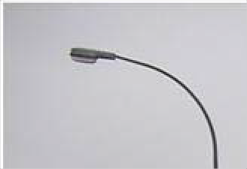
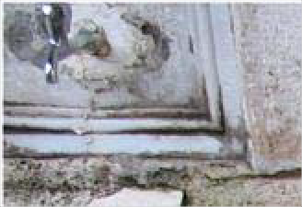
Artifact
The Bosporus, Istanbul. Ships pass the city center as they have for millenia. On the left, the dome of the 15th-century Firuz Ağa Mosque; on the right, two minarets of the 17th-century Sultan Ahmet (Blue) Mosque.
Artist: Prducr: Date:
Length:
Donny Smith
Picture
English Version:
Cyrillic Title
English Version:
Cyrillic Title
Prducr: Date:
Length:
Artifact
Ablution fountain, Kılıç Ali Paşa Mosque, Istanbul. Since Muslims must wash before prayer (namaz), mosques provide running water for worshippers. In Turkey, this is generally a faucet and a stone seat next to a covered fountain in the mosque courtyard. This mosque was built by a 16th-century admiral of the Ottoman navy.
Artist: Prducr: Date:
Length:
Donny Smith
Picture
English Version:
Cyrillic Title

Item: 4595
Title: water_5.jpg
Category Language: Description:

Item: 4596
Title: water_6.jpg

Category Language: Description:

Artifact

Cyrillic Title

English Version:
Hasankeyf, Turkey A view of the Euphrates River from the small village of Hasankeyf in Eastern Turkey. The government has drawn up plans to construct a dam that will completely submerge this entire area in the near future.
A view of the Euphrates River from the small village of Hasankeyf in Eastern Turkey. The government has drawn up plans to construct a dam that will completely submerge this entire area in the near future.

Artist: Prducr: Date: Length:
Greg Burris
Picture

Item: 4597
Artifact
Roman Aqueduct, Istanbul. This aqueduct, built during the Roman period, was used to transport water until the 19th century.
Artist: Prducr: Date:
Length:
Jackson Kellogg
Picture
English Version:
Cyrillic Title
Title: water_7.jpg
Category Language: Description:

Item: 4598
Title: water_8.jpg
Category Language: Description:

Item: 4599
Title: water_9.jpg
Category Language: Description:

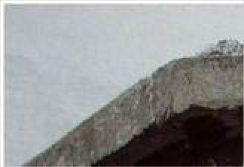
Artifact
Hasankeyf, Turkey A view of the Euphrates River from the small village of Hasankeyf in Eastern Turkey. The government has drawn up plans to construct a dam that will completely submerge this entire area in the near future.
Artist: Prducr: Date:
Length:
Greg Burris
Picture
English Version:
Cyrillic Title
Artifact
Hasankeyf, Turkey A view of the Euphrates River from the small village of Hasankeyf in Eastern Turkey. The government has drawn up plans to construct a dam that will completely submerge this entire area in the near future.
Artist: Prducr: Date:
Length:
Greg Burris
Picture
English Version:
Cyrillic Title

Turkmenistan
Artifact

Cyrillic Title

English Version:
Fountain, corner of Susam and Güneşli Streets, Cihangir neighborhood, Istanbul. Since the area has had indoor plumbing for many years, this 16th-century fountain stands abandoned. Its basins and taps are now below the level of the street and its side walls are used to store crates for the manav (fruit and vegetable stand) next door.

Artist: Prducr: Date: Length:
Donny Smith
Picture

Accessories

Item: 2261

Title: bread decorator

Category Language: Description:

Artifact
bread-decorator

Artist:
Picture

Item: 2259
Title: coin purse
Category Language: Description:

Item: 2004
English Version:
Cyrillic Title
Prducr: Date:
Length:
Artifact
black coin purse w/ multicolored stitching
Artist: Prducr: Date:
Length:
Picture
English Version:
Cyrillic Title
Title: Handbag

Category Language: Description:

Artifact
Red carpet handbag

Artist:
Picture

Item: 2255
Title: Hot pad
Category Language: Description:

Item: 2256
Title: patch
Category Language: Description:

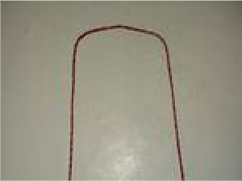
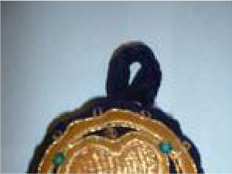
Item: 2254
English Version:
Cyrillic Title
Prducr: Date:
Length:
Artifact
Blue hot pad w/ red, orange and white stitching
Artist: Prducr: Date:
Length:
Picture
English Version:
Cyrillic Title
Artifact
Black patch w/ mulitcolored embroidery
Artist: Prducr: Date:
Length:
Picture
English Version:
Cyrillic Title
Title: Pillow Cover

Category Language: Description:

Artifact
Yellow/black pillow cover

Artist:
Picture

Item: 2001
Title: Pins

Category Language: Description:

Artifact
pins (6)

Artist:
Picture

Artifact
6 Turkmenistani pins

Artist:
Picture

Art
English Version:
Cyrillic Title
Prducr: Date:
Length:
English Version:
Cyrillic Title
Prducr: Date:
Length:
English Version:
Cyrillic Title
Prducr:
Date: Length:

Item: 2015

Title: Bread decorator

Category Language: Description:

Artifact
Turkmen bread-decorator

Artist:
Picture

Item: 2014
Title: Talisman
Category Language: Description:

Item: 2013
Title: Wall-hanging

Category Language: Description:

Artifact
small wall-hanging (cloth)

Artist:
Picture

English Version:
Cyrillic Title
Prducr: Date:
Length:
Artifact
Turkmen hanging talisman, woven wool
Artist: Prducr: Date:
Length:
Picture
English Version:
Cyrillic Title
English Version:
Cyrillic Title
Prducr: Date:
Length:

Booklet

Item: 2025
Title: Storybook
Category Language: Description:

Cassette (audio)
Artifact
Turkmen Storybook “Gorogly” (two volumes in Latinnic Turkmen)
Artist: Prducr: Date:
Length:
Picture
English Version:
Cyrillic Title
Artifact
Storybook: “Sto Zolotykh” (Turkmen fairytale in Russian)
Artist: Prducr: Date:
Length:
Picture
English Version:
Cyrillic Title
Artifact
Storybook: “Korpe Dogan” (Turkmen fairytale) (Ashgabat: 1999)
Artist: Prducr: Date:
Length:
Picture
English Version:
Cyrillic Title

Item: 2493

Title: Turkmen Language Cassettes
Category Language: Description:

Cloth

Item: 4365

Title: Scarf
Category Language: Description:

Clothing

Item: 2058

Title: Man's robe

Category Language: Description:

Artifact
Gray Man's Robe

Artist:
Picture

Artifact
Turkmen
Department of State Language Instruction Cassette
English Version:
Cyrillic Title
Artist: Prducr: Date:
Length:
Picture
Artifact
Orange and black scarf, bird pattern with purple flowers
Artist: Prducr: Date:
Length:
Picture
English Version:
Cyrillic Title
English Version:
Cyrillic Title
Prducr:
Date: Length:

Item: 2059
Title: Man's shirt

Category Language: Description:

Artifact
white men's shirt

Artist:
Picture

Item: 2057
Title: T-shirts (2)

Category Language: Description:
Artifact

Artist:

Picture

Item: 4608
Title: Turkmen Hat (White & Wooly) Category Language: Description: Artifact

Artist:

Picture

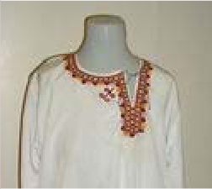
English Version:
Cyrillic Title
Prducr:
Date: Length:
English Version:
Cyrillic Title
Prducr: Date:
Length:
English Version:
Cyrillic Title
Prducr:
Date: Length:
2007

Flag

Item: 2081

Title: large flag

Category Language: Description:
Artifact

Artist:

Picture

Item: 2083
Title: Pink banner

Category Language: Description:

Artifact
communist collective labor

Artist:
Picture

Item: 2082
English Version:
Cyrillic Title
Prducr: Date:
Length:
English Version:
Cyrillic Title
Prducr: Date:
Length:
Title: small (hand-held) flag

Category Language: Description:

Artifact

Artist:
Picture

Hat

Item: 2094

Title: Man's hat

Category Language: Description:

Artifact
man's hat - sheepskin (Turkmen)

Artist:
Picture

Item: 2095
Title: Skullcap

Category Language: Description:

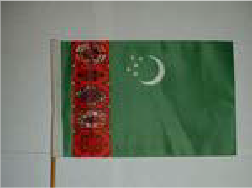
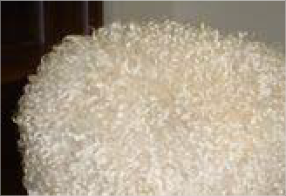
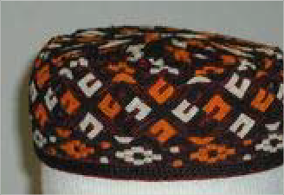
Artifact
English Version:
Cyrillic Title
Prducr: Date:
Length:
English Version:
Cyrillic Title
Prducr:
Date: Length:

Cyrillic Title

English Version:
black, orange and white Turkmen skullcap

Artist: Prducr: Date: Length:
Picture

Item: 2096
Title: Woman's hat

Category Language: Description:

Artifact
White, black and red women's hat

Artist:
Picture

Map

Item: 2124

Title: industries

Category Language: Description:
Artifact

Artist:

Picture

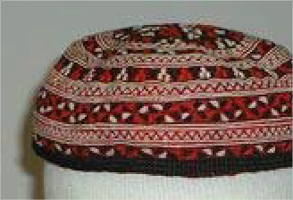
Artifact
Black skullcap w/ multicolored embroidery and braided edging
Artist: Prducr: Date:
Length:
Picture
English Version:
Cyrillic Title
English Version:
Cyrillic Title
Prducr: Date:
Length:
English Version:
Cyrillic Title
Prducr:
Date: Length:

Miniature

Item: 2508
Title: Female Turkmen Figurine
Category Language: Description:

Item: 4514
Title: Miniature Turkmen Yurt

Category Language: Description:

Artifact
Felt; Turkmen braid

Artist:
Picture

Item: 2144
Title: sitting camel

Category Language: Description:

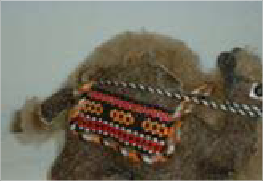
Artifact
Artifact
A painted female Turkmen figurine standing approximately 6" tall
Artist: Prducr: Date:
Length:
Picture
English Version:
Cyrillic Title
English Version:
Cyrillic Title
Prducr: Date:
Length:

Cyrillic Title

English Version:
small light brown felt statue

Artist: Prducr: Date: Length:
Picture

Item: 2509
Title: Small Male Turkmen Figurine
Category Language: Description:

Item: 4513
Title: Small Turkmen Female Figurine

Category Language: Description:

Artifact
Wood

Artist:
Picture

Item: 2142
Title: Small wooden statue

Category Language: Description:

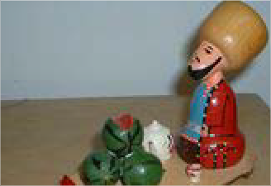
Artifact
Artifact
A painted male Turkmen figurine standing approximately 3" tall
Artist: Prducr: Date:
Length:
Picture
English Version:
Cyrillic Title
English Version:
Cyrillic Title
Prducr: Date:
Length:

Cyrillic Title

English Version:
of big-hatted man, teacup, teapot and 4 melons

Artist: Prducr: Date: Length:
Picture

Item: 4495
Title: Turkmen Design Bag

Category Language: Description:
Artifact

Artist:

Picture

Item: 4511
Title: Turkmen Watermelon Seller Figurine

Category Language: Description:

Artifact
Wood

Artist:
Picture

Item: 4506
Title: Turkmen Woman Figurine

Category Language: Description:

Artifact
English Version:
Cyrillic Title
Prducr:
Date: Length:
English Version:
Cyrillic Title
Prducr: Date:
Length:

Cyrillic Title

English Version:
Wood; red, green and blue

Artist: Prducr: Date: Length:
Picture

Item: 4507
Title: Turkmen Woman Serving Nan Figurine

Category Language: Description:

Artifact
Wood; blue

Artist:
Picture

Item: 4505
Title: Turkmen Woman Weaving Rug

Category Language: Description:

Artifact
Wood

Artist:
Picture

Item: 4516
Title: Turkmens Riding Camel Figurine

Category Language: Description:

Artifact
English Version:
Cyrillic Title
Prducr:
Date: Length:
English Version:
Cyrillic Title
Prducr: Date:
Length:

Cyrillic Title

English Version:
Wood

Artist: Prducr: Date: Length:
Picture

Item: 2146
Title: woman

Category Language: Description:

Artifact
weaving carpet

Artist:
Picture

Item: 2139
Title: wooden camel

Category Language: Description:

Artifact
with Turkmen couple on board

Artist:
Picture

Item: 2140
Title: wooden Turkmen female

Category Language: Description:

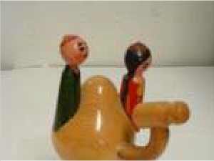
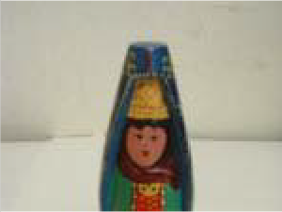
Artifact
English Version:
Cyrillic Title
Prducr:
Date: Length:
English Version:
Cyrillic Title
Prducr: Date:
Length:

Cyrillic Title

English Version:
with green khalat (robe) and red dress

Artist: Prducr: Date: Length:
Picture

Item: 2141
Title: wooden woman
Category Language: Description:

Item: 2143
Title: yurt

Category Language: Description:

Artifact
Tan miniature felt with top flap

Artist:
Picture

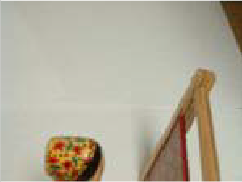
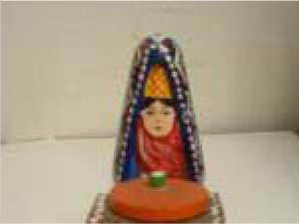
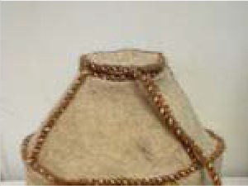
Artifact
in red dress making carpet on loom
Artist: Prducr: Date:
Length:
Picture
English Version:
Cyrillic Title
Artifact
w/ blue headdress, carrying bread and salt and wearing a blue xhalat (robe)
Artist: Prducr: Date:
Length:
Picture
English Version:
Cyrillic Title
English Version:
Cyrillic Title
Prducr: Date:
Length:

Miscellaneous

Item: 4588
Title: Shoulder Bag
Category Language: Description:

Item: 4497
Title: Turkmen Bread Poker

Category Language: Description:
Artifact

Artist:

Picture

Money
Artifact
rough cloth, blue, brown, and salmon pattern
Artist: Prducr: Date:
Length:
Picture
English Version:
Cyrillic Title
English Version:
Cyrillic Title
Prducr: Date:
Length:

Item: 2156

Title: 13 bills

Category Language: Description:

Artifact

Artist:
Picture

Item: 2157
Title: 9 coins

Category Language: Description:
Artifact

Artist:

Picture

Pamphlet

Item: 2171

Title: Chardjou
Category Language: Description:

English Version:
Cyrillic Title
Prducr: Date:
Length:
English Version:
Cyrillic Title
Prducr: Date:
Length:
Artifact
Travel Brochure: (Soviet-era, in English).
Artist: Prducr: Date:
Length:
Picture
English Version:
Cyrillic Title

Item: 2168
Title: Turkmenistan
Category Language: Description:

Photo

Item: 2196

Title: 1994 picture calendar

Category Language: Description:

Artifact
1994 picture calendar

Artist:
Picture

Item: 2197
Artifact
2 Pamphlets (Russian and English)
Artist: Prducr: Date:
Length:
Picture
English Version:
Cyrillic Title
English Version:
Cyrillic Title
Prducr: Date:
Length:
Title: Ashkhabad postcard

Category Language: Description:

Artifact
Ashkhabad postcard

Artist:
Picture

Item: 2199
Title: Postcards from Ashkabad

Category Language: Description:

Artifact
Postcards from Ashkabad

Artist:
Picture

Item: 2198
Title: Turkmen card “Garassyz Bayramynyz Mubarek Bolsun!”
Category Language: Description:

Item: 2498
English Version:
Cyrillic Title
Prducr: Date:
Length:
English Version:
Cyrillic Title
Prducr: Date:
Length:
Artifact
Turkmen card “Garassyz Bayramynyz Mubarek Bolsun!”
Artist: Prducr: Date:
Length:
Picture
English Version:
Cyrillic Title
Title: Turkmenistan: Ancient Merv

Category Language: Description:

Artifact Turkmen
poscard set from ruins at Merv

Artist:
Magadov, H.
Picture

Poster

Item: 2219

Title: Turkmen 60th Anniversary

Category Language: Description:
Artifact

Artist:

Picture

Rug

Item: 2253

Title: Red rugs w/ white tassels and 2 octagons Category Language: Description: Artifact

Artist:

Picture

English Version:
Cyrillic Title Древний Мерв
Drevny Merv
Prducr: Date:
Length:
English Version:
Cyrillic Title
Prducr:
Date: Length:
English Version:
Cyrillic Title
Prducr:
Date: Length:

Item: 2226
Title: small carpet

Category Language: Description:
Artifact

Artist:

Picture

Item: 2225
Title: small rug

Category Language: Description:
Artifact

Artist:

Picture

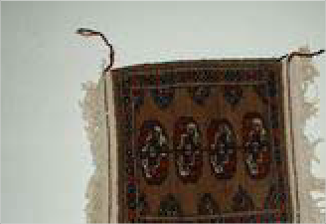
Stamps
English Version:
Cyrillic Title
Prducr:
Date: Length:
English Version:
Cyrillic Title
Prducr: Date:
Length:

Item: 2231

Title: Turkmen stamps

Category Language: Description:

Artifact

Artist:
Picture

Tuvan

Clothing

Item: 2061

Title: Woman's vest

Category Language: Description:

Artifact
women's purple quilted vest

Artist:
Picture

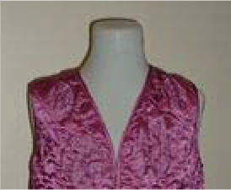
Instrument
English Version:
Cyrillic Title
Prducr: Date:
Length:
English Version:
Cyrillic Title
Prducr: Date:
Length:

Item: 2238

Title: mouth harp

Category Language: Description:

Artifact
(boot shaped wooden case)

Artist:
Picture

Uzbekistan

Accessories

Item: 2003

Title: Scarf

Category Language: Description:

Artifact
Red Scarf with pink roses

Artist:
Picture

Art
English Version:
Cyrillic Title
Prducr: Date:
Length:
English Version:
Cyrillic Title
Prducr: Date:
Length:

Item: 2245

Title: Tile

Category Language: Description:

Item: 2016
Title: Watercolor
Category Language: Description:

Cassette

Item: 2039

Title: Fayz Domiyor Otlin to'plami

Category Language: Description:
Artifact

Artist:

Picture

Artifact
Bukhara 2500 anniversary tile w/ relief of the tomb of Samanids
Artist: Prducr: Date:
Length:
Picture
English Version:
Cyrillic Title
Artifact
watercolor paintings (originals by children)
Artist: Prducr: Date:
Length:
Picture
English Version:
Cyrillic Title
English Version:
Cyrillic Title
Prducr:
Date: Length:

Item: 2036
Title: Komolidden Rahimov: Ushshoq Category Language: Description: Artifact

Artist:

Picture

Item: 2031
Title: Uzbek music

Category Language: Description:

Artifact
English Version:
Cyrillic Title
Prducr:
Date: Length:
Artifact
cassette of Uzbek music (60 min) (Sherali Jo'raev "Gulbadan")
Artist: Prducr: Date:
Length:
Picture
English Version:
Cyrillic Title

Cyrillic Title

English Version:
Ulugbek Otajonov "Vafodoringman" (Uzbek music)

Artist: Prducr: Date: Length:
Picture

Artifact
Terma: "Yangilik" (Uzbek music)

Artist:
Picture

Item: 2038
Title: Yo'nimda Qol 'Muhriddin Kholiqov' Category Language: Description: Artifact

Artist:

Picture

Item: 2040
Title: Yulduz Uzmonova "Dune"

Category Language: Description:
Artifact

Artist:

Picture

English Version:
Cyrillic Title
Prducr: Date:
Length:
English Version:
Cyrillic Title
Prducr: Date:
Length:
English Version:
Cyrillic Title
Prducr: Date:
Length:

Cloth

Item: 2041
Title: Hanging

Category Language: Description:

Artifact
Scroll hanging made of felt

Artist:
Picture

Clothing

Item: 2068

Title: Man's robe
Category Language: Description:

English Version:
Cyrillic Title
Prducr:
Date: Length:
Artifact
satin hanging w/ images of a woman, mosque and map
Artist: Prducr: Date:
Length:
Picture
English Version:
Cyrillic Title
Artifact
men's blue and black winter robe and belt sash
Artist: Prducr: Date:
Length:
Picture
English Version:
Cyrillic Title

Item: 2063
Title: Robe
Category Language: Description:

Item: 2065
Title: Slippers
Category Language: Description:

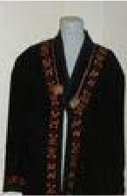
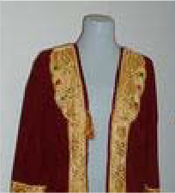
Item: 2046
Artifact
Black robe with multicolored embroidery and braided edging (Karakalpak)
Artist: Prducr: Date:
Length:
Picture
English Version:
Cyrillic Title
Artifact
Crimson Robe w/ golden embroidery MISSING AS OF 11/30/05
Artist: Prducr: Date:
Length:
Picture
English Version:
Cyrillic Title
Artifact
Crimson with gold embroidered slippers
Artist: Prducr: Date:
Length:
Picture
English Version:
Cyrillic Title
Title: Woman's dress
Category Language: Description:

Hat

Item: 2105

Title: Karakalpak
Category Language: Description:

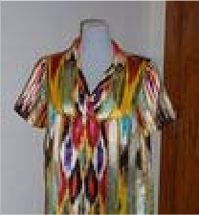
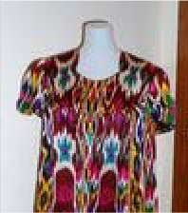
Item: 2097
Artifact
multicolored silk women's dress (Uzbek/Tajik: atlas)
Artist: Prducr: Date:
Length:
Picture
English Version:
Cyrillic Title
Artifact
Multi-colored dress w "shokh amir temur" in the fabric
Artist: Prducr: Date:
Length:
Picture
English Version:
Cyrillic Title
Artifact
Karakalpak curly sheep hair hat (brown)
Artist: Prducr: Date:
Length:
Picture
English Version:
Cyrillic Title
Title: Man's hat

Category Language: Description:

Artifact
man's hat - black

Artist:
Picture

Item: 2109
Title: Skullap
Category Language: Description:

Item: 2098
Title: Skullcap

Category Language: Description:

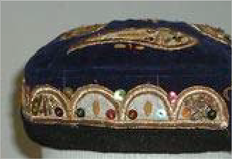
English Version:
Cyrillic Title
Prducr: Date:
Length:
Artifact
soft black velvet tibiteka (skullcap) with gold decorations
Artist: Prducr: Date:
Length:
Picture
English Version:
Cyrillic Title
Artifact
blue velvet skullcap w/ paisleys in gold embroidery for women
Artist: Prducr: Date:
Length:
Picture
English Version:
Cyrillic Title

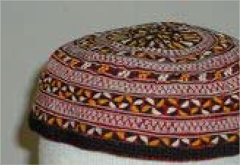
Artifact
Artifact
gold, red, and blue skullcap with gold tassel
Artist: Prducr: Date:
Length:
Picture
English Version:
Cyrillic Title
Artifact
soft red, black and white tibiteka (skullcap)
Artist: Prducr: Date:
Length:
Picture
English Version:
Cyrillic Title
Artifact
soft maroon, yellow, white and black tibiteka (skullcap)
Artist: Prducr: Date:
Length:
Picture
English Version:
Cyrillic Title

Cyrillic Title

English Version:
soft black velvet tibiteka (skullcap) with gold decorations

Artist: Prducr: Date: Length:
Picture

Artifact
Artifact
hard black tibiteka (skullcap) with white decorations
Artist: Prducr: Date:
Length:
Picture
English Version:
Cyrillic Title
Artifact
Black hat with multicolored embroidery and braided edging (Karakalpak)
Artist: Prducr: Date:
Length:
Picture
English Version:
Cyrillic Title
Artifact
Dopi: black and white (made from paper)
Artist: Prducr: Date:
Length:
Picture
English Version:
Cyrillic Title

Cyrillic Title

English Version:
Dopi: black and white embroidered with teardrop design and bordered by small circles

Artist: Prducr: Date: Length:
Picture

Item: 2100
Title: Woman's hat
Category Language: Description:

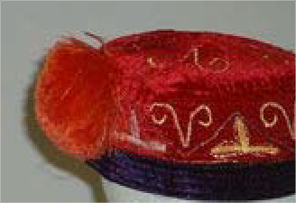
Map
Artifact
Dopi: black and white embroidered with teardrop design and bordered by cloverleaf and curled "Y"s
Artist: Prducr: Date:
Length:
Picture
English Version:
Cyrillic Title
Artifact
blue w/ paisley women's Navruz hat
Artist: Prducr: Date:
Length:
Picture
English Version:
Cyrillic Title
Artifact
Karakalpak red velvet, gold embroidered, purple bordered hat
Artist: Prducr: Date:
Length:
Picture
English Version:
Cyrillic Title

Item: 2126

Title: Khiva

Category Language: Description:

Artifact

Artist:
Picture

Item: 2125
Title: Map of Uzbekistan

Category Language: Description:
Artifact

Artist:

Picture

Miniature

Item: 4518

Title: Figurine of Liquid Seller

Category Language: Description:

Artifact
Clay

Artist:
Picture

English Version:
Cyrillic Title
Prducr: Date:
Length:
English Version:
Cyrillic Title
Prducr: Date:
Length:
English Version:
Cyrillic Title
Prducr:
Date: Length:

Item: 4517
Title: Figurine of Watermelon Seller

Category Language: Description:

Artifact
Clay

Artist:
Picture

Item: 2147
Title: small wooden dolls

Category Language: Description:

Artifact
couple

Artist:
Picture

Money
English Version:
Cyrillic Title
Prducr:
Date: Length:
English Version:
Cyrillic Title
Prducr: Date:
Length:

Item: 2158

Title: 5 bills

Category Language: Description:

Artifact

Artist:
Picture

Pamphlet

Item: 2172

Title: Bibi-Khanym Mosque
Category Language: Description:

Photo

Item: 2432

Title: 92 year old woman Tuda village, Boysun
Category Language: Description:

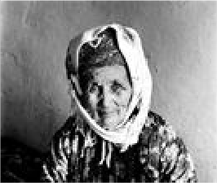
English Version:
Cyrillic Title
Prducr: Date:
Length:
Artifact
Tourist brochure (Russian/English).
Artist: Prducr: Date:
Length:
Picture
English Version:
Cyrillic Title
Artifact
92 year old woman Tuda village, Boysun
Artist: Prducr: Date:
Length:
Zilola Saidova
Picture
English Version:
Cyrillic Title

Item: 2401
Title: A Gypsy child sleeping in an alvonch (type of cradle)
Category Language: Description:

Item: 2435
Title: A Tajik woman Sarosiyo village, Boysun.
Category Language: Description:

Item: 2364
Title: Abra chinon (ceremony for shaping the bride's eyebrows)

Category Language: Description:

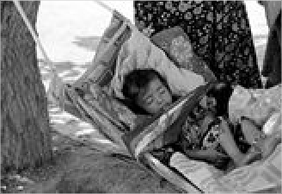
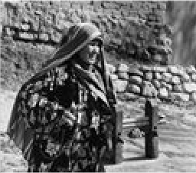
Artifact
Artifact
A Gypsy child sleeping in an alvonch (type of cradle)
Artist: Prducr: Date:
Length:
Shavkat Boltaev
Picture
English Version:
Cyrillic Title
Artifact
A Tajik woman Sarosiyo village, Boysun.
Artist: Prducr: Date:
Length:
Zilola Saidova
Picture
English Version:
Cyrillic Title

Cyrillic Title

English Version:
Abra chinon (ceremony for shaping the bride's eyebrows)

Artist: Prducr: Date: Length:
Shavkat Boltaev
Picture

Item: 2426
Title: Advice

Category Language: Description:

Artifact
Advice

Artist:
Shavkat Boltaev
Picture

Item: 2438
Title: After circumcision

Category Language: Description:

Artifact
After circumcision

Artist:
Shavkat Boltaev
Picture

Item: 2484
Title: after the battle

Category Language: Description:

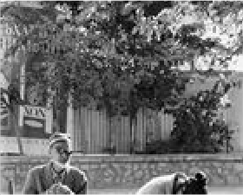
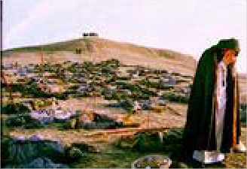
Artifact
English Version:
Cyrillic Title
Prducr:
Date: Length:
English Version:
Cyrillic Title
Prducr: Date:
Length:

Cyrillic Title

English Version:
"after the battle"

Artist: Prducr: Date: Length:
Shavkat Boltaev
Picture

Artifact
"after the battle"

Artist:
Shavkat Boltaev
Picture

Item: 2293
Title: At a brick producing plant (series)

Category Language: Description:

Artifact
At a brick producing plant (series)

Artist:
Shavkat Boltaev
Picture

Artifact
At a brick producing plant (series)

Artist:
Shavkat Boltaev
Picture

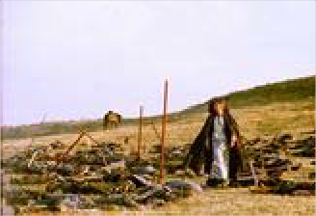
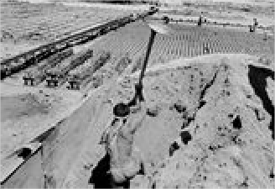
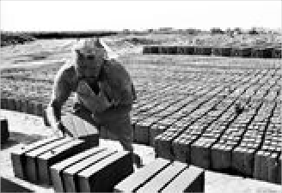
English Version:
Cyrillic Title
Prducr: Date:
Length:
English Version:
Cyrillic Title
Prducr: Date:
Length:
English Version:
Cyrillic Title
Prducr:
Date: Length:

Artifact
At a brick producing plant (series)

Artist:
Shavkat Boltaev
Picture

Artifact
At a brick producing plant (series)

Artist:
Shavkat Boltaev
Picture

Artifact
At a brick producing plant (series)

Artist:
Shavkat Boltaev
Picture

Artifact
At a brick producing plant (series)

Artist:
Shavkat Boltaev
Picture

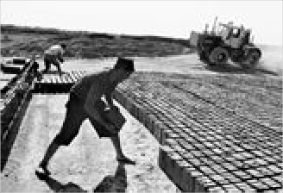
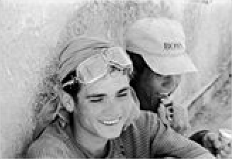
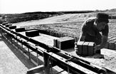
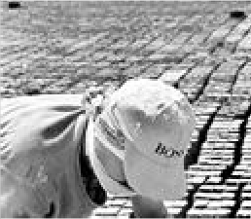
English Version:
Cyrillic Title
Prducr: Date:
Length:
English Version:
Cyrillic Title
Prducr: Date:
Length:
English Version:
Cyrillic Title
Prducr: Date:
Length:
English Version:
Cyrillic Title
Prducr:
Date: Length:

Artifact
At a brick producing plant (series)

Artist:
Shavkat Boltaev
Picture

Item: 2333
Title: At a Bukharan synagogue

Category Language: Description:

Artifact
At a Bukharan synagogue

Artist:
Shavkat Boltaev
Picture

Artifact
At a Bukharan synagogue

Artist:
Shavkat Boltaev
Picture

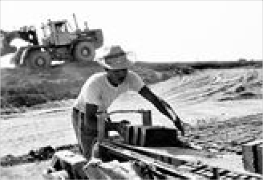
English Version:
Cyrillic Title
Prducr: Date:
Length:
English Version:
Cyrillic Title
Prducr: Date:
Length:
English Version:
Cyrillic Title
Prducr:
Date: Length:

Artifact
At a Bukharan synagogue

Artist:
Shavkat Boltaev
Picture

Item: 2335
Title: At a Bukharan synagogue on Yom Kippur
Category Language: Description:

Item: 2328
Title: At an Orthodox cemetary

Category Language: Description:

Artifact
At an Orthodox cemetary

Artist:
Zilola Saidova
Picture

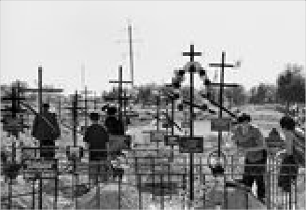
Item: 2350
English Version:
Cyrillic Title
Prducr: Date:
Length:
Artifact
At a Bukharan synagogue on Yom Kippur
Artist: Prducr: Date:
Length:
Shavkat Boltaev
Picture
English Version:
Cyrillic Title
English Version:
Cyrillic Title
Prducr: Date:
Length:
Title: At Bukharan synagogue

Category Language: Description:

Artifact
At Bukharan synagogue

Artist:
Shavkat Boltaev
Picture

Item: 2316
Title: At the bazaar

Category Language: Description:

Artifact
At the bazaar

Artist:
Zilola Saidova
Picture

Item: 2389
Title: At the nonvoykhona (bakery)

Category Language: Description:

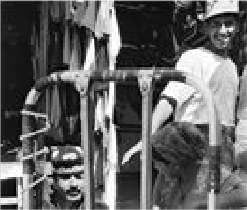
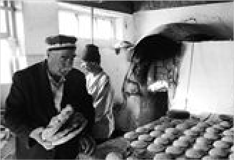
Artifact
English Version:
Cyrillic Title
Prducr: Date:
Length:
English Version:
Cyrillic Title
Prducr: Date:
Length:

Cyrillic Title

English Version:
At the nonvoykhona (bakery)

Artist: Prducr: Date: Length:
Shavkat Boltaev
Picture

Artifact
Bakhshi (epic poem teller)

Artist:
Shavkat Boltaev
Picture

Item: 2329
Title: Bar Mitzvah at a Bukharan synagogue
Category Language: Description:

Item: 2337
Title: Bibichakhona (women's room in the synagogue)

Category Language: Description:

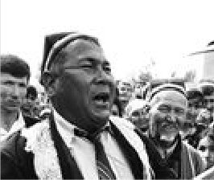
Artifact
English Version:
Cyrillic Title
Prducr: Date:
Length:
Artifact
Bar Mitzvah at a Bukharan synagogue
Artist: Prducr: Date:
Length:
Shavkat Boltaev
Picture
English Version:
Cyrillic Title

Cyrillic Title

English Version:
Bibichakhona (women's room in the synagogue)

Artist: Prducr: Date: Length:
Shavkat Boltaev
Picture

Item: 2405
Title: Boy selling chukori - local plant

Category Language: Description:

Artifact
Boy selling chukori - local plant

Artist:
Shavkat Boltaev
Picture

Item: 2311
Title: Boys during Qurban Hayit (the holiday of sacrifice)

Category Language: Description:

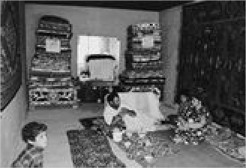
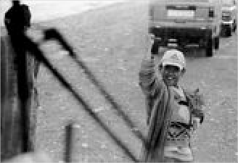
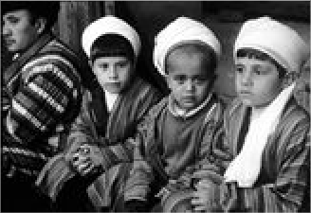
Artifact
Artifact
Bigamy in a Bukharan Gyspy's family
Artist: Prducr: Date:
Length:
Shavkat Boltaev
Picture
English Version:
Cyrillic Title
English Version:
Cyrillic Title
Prducr: Date:
Length:

Cyrillic Title

English Version:
Boys during Qurban Hayit (the holiday of sacrifice)

Artist: Prducr: Date: Length:
Shavkat Boltaev
Picture

Item: 2291
Title: Bread made in Avlod village, Boysun
Category Language: Description:

Item: 2387
Title: Bread making in Boysun, Tuda village

Category Language: Description:

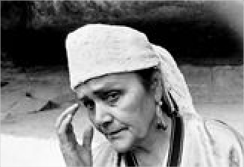
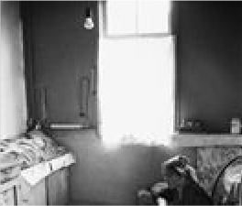
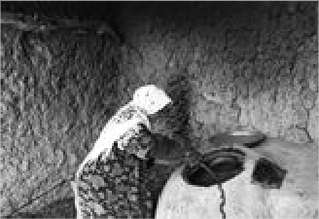
Artifact
Artifact
Boysun folklore festival participant
Artist: Prducr: Date:
Length:
Shavkat Boltaev
Picture
English Version:
Cyrillic Title
Artifact
Bread made in Avlod village, Boysun
Artist: Prducr: Date:
Length:
Shavkat Boltaev
Picture
English Version:
Cyrillic Title

Cyrillic Title

English Version:
Bread making in Boysun, Tuda village

Artist: Prducr: Date: Length:
Shavkat Boltaev
Picture

Item: 2382
Title: Bride changing her modern hairstyle
Category Language: Description:

Item: 2374
Title: Bride getting ready for wedding party

Category Language: Description:

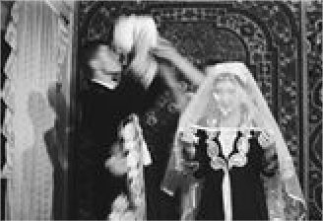
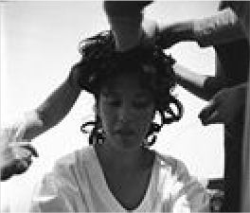
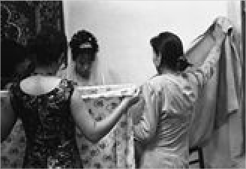
Artifact
Artifact
Bride & groom preparing for wedding
Artist: Prducr: Date:
Length:
Zilola Saidova
Picture
English Version:
Cyrillic Title
Artifact
Bride changing her modern hairstyle
Artist: Prducr: Date:
Length:
Zilola Saidova
Picture
English Version:
Cyrillic Title

Cyrillic Title

English Version:
Bride getting ready for wedding party

Artist: Prducr: Date: Length:
Zilola Saidova
Picture

Artifact
Bride in Boysun

Artist:
Shavkat Boltaev
Picture

Item: 2365
Title: Bride's father saying good-bye

Category Language: Description:

Artifact
Bride's father saying good-bye

Artist:
Zilola Saidova
Picture

Item: 2367
Title: Bride's mother saying good-bye

Category Language: Description:

Artifact
Bride's mother saying good-bye

Artist:
Zilola Saidova
Picture

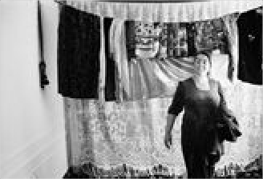
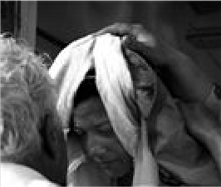
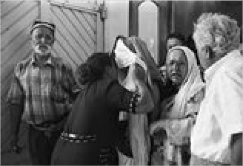
Item: 2246
English Version:
Cyrillic Title
Prducr: Date:
Length:
English Version:
Cyrillic Title
Prducr: Date:
Length:
English Version:
Cyrillic Title
Prducr: Date:
Length:
Title: Bukhara transparencies of the arc, a Madrasa, a lozim, clothing, a rug
Category Language: Description:

Item: 2320
Title: Bukharan folk music troop at rehearsal
Category Language: Description:

Item: 2304
Title: Bukharan folk music troop at rehersal
Category Language: Description:

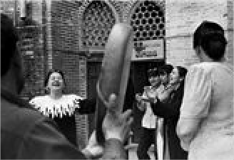
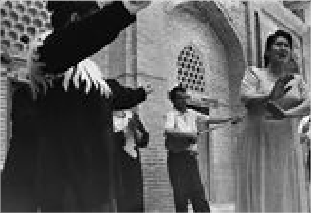
Item: 2419
Artifact
Bukhara transparencies of the arc, a Madrasa, a lozim, clothing, a rug
Artist: Prducr: Date:
Length:
Picture
English Version:
Cyrillic Title
Artifact
Bukharan folk music troop at rehearsal
Artist: Prducr: Date:
Length:
Zilola Saidova
Picture
English Version:
Cyrillic Title
Artifact
Bukharan folk music troop at rehersal
Artist: Prducr: Date:
Length:
Zilola Saidova
Picture
English Version:
Cyrillic Title
Title: Bukharan girl

Category Language: Description:

Artifact
Bukharan girl

Artist:
Shavkat Boltaev
Picture

Item: 2352
Title: Bukharan Jewish funeral ceremony
Category Language: Description:

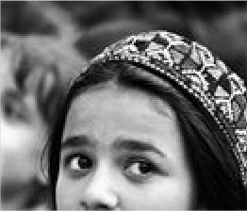
English Version:
Cyrillic Title
Prducr: Date:
Length:
Artifact
Bukharan Jewish funeral ceremony
Artist: Prducr: Date:
Length:
Shavkat Boltaev
Picture
English Version:
Cyrillic Title
Artifact
Bukharan Jewish funeral ceremony
Artist: Prducr: Date:
Length:
Shavkat Boltaev
Picture
English Version:
Cyrillic Title

Artifact
Bukharan Jewish funeral ceremony
Artist: Prducr: Date:
Length:
Shavkat Boltaev
Picture
English Version:
Cyrillic Title
Artifact
Bukharan Jewish funeral ceremony
Artist: Prducr: Date:
Length:
Shavkat Boltaev
Picture
English Version:
Cyrillic Title
Artifact
Bukharan Jewish funeral ceremony
Artist: Prducr: Date:
Length:
Shavkat Boltaev
Picture
English Version:
Cyrillic Title
Artifact
Bukharan Jewish funeral ceremony
Artist: Prducr: Date:
Length:
Shavkat Boltaev
Picture
English Version:
Cyrillic Title

Item: 2395
Title: Bukharan Turkmen family

Category Language: Description:

Artifact
Bukharan Turkmen family

Artist:
Shavkat Boltaev
Picture

Item: 2424
Title: Caretakers at Ismail Samani Mausoleum
Category Language: Description:

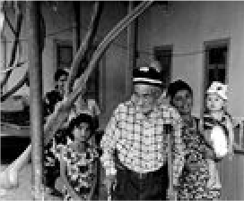
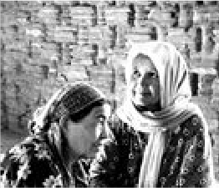
Item: 2349
Artifact
Bukharan Jewish funeral ceremony
Artist: Prducr: Date:
Length:
Shavkat Boltaev
Picture
English Version:
Cyrillic Title
English Version:
Cyrillic Title
Prducr: Date:
Length:
Artifact
Caretakers at Ismail Samani Mausoleum
Artist: Prducr: Date:
Length:
Shavkat Boltaev
Picture
English Version:
Cyrillic Title
Title: Carrying Sephardic Torah at the synagogue
Category Language: Description:

Item: 2275
Title: Changovuz - mouth instrument player
Category Language: Description:

Item: 2314
Title: Chatting at the Lyabi Hauz (Lyabi pool)
Category Language: Description:

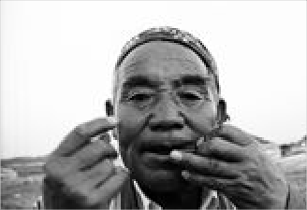
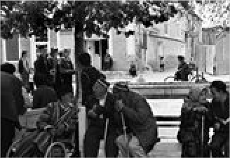
Item: 2301
Artifact
Carrying Sephardic Torah at the synagogue
Artist: Prducr: Date:
Length:
Shavkat Boltaev
Picture
English Version:
Cyrillic Title
Artifact
Changovuz - mouth instrument player
Artist: Prducr: Date:
Length:
Shavkat Boltaev
Picture
English Version:
Cyrillic Title
Artifact
Chatting at the Lyabi Hauz (Lyabi pool)
Artist: Prducr: Date:
Length:
Zilola Saidova
Picture
English Version:
Cyrillic Title
Title: Child and woman breaking dried clay fragments
Category Language: Description:

Item: 2452
Title: child playing

Category Language: Description:

Artifact
child playing

Artist:
Zilola Saidova
Picture

Item: 2338
Title: Children chatting

Category Language: Description:

Artifact
Children chatting

Artist:
Zilola Saidova
Picture

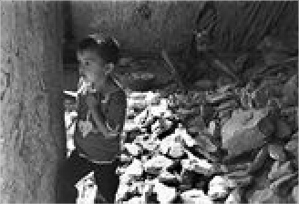
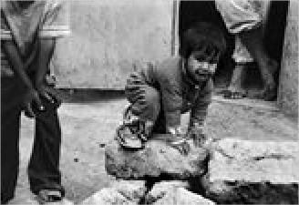
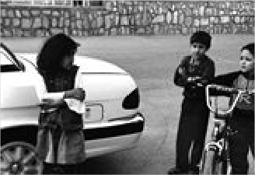
Item: 2399
Artifact
Child and woman breaking dried clay fragments
Artist: Prducr: Date:
Length:
Zilola Saidova
Picture
English Version:
Cyrillic Title
English Version:
Cyrillic Title
Prducr: Date:
Length:
English Version:
Cyrillic Title
Prducr: Date:
Length:
Title: Children in gypsies' neighborhood (series)
Category Language: Description:

Item: 2315
Title: Children in the Gypsies' neighborhood (series)

Category Language: Description:

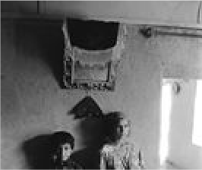
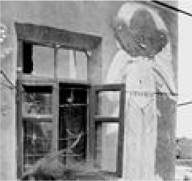
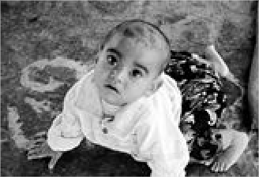
Artifact
Artifact
Children in gypsies' neighborhood (series)
Artist: Prducr: Date:
Length:
Shavkat Boltaev
Picture
English Version:
Cyrillic Title
Artifact
Children in the Gypsies' neighborhood (series)
Artist: Prducr: Date:
Length:
Shavkat Boltaev
Picture
English Version:
Cyrillic Title

Cyrillic Title

English Version:
Children in the Gypsies' neighborhood (series)

Artist: Prducr: Date: Length:
Shavkat Boltaev
Picture

Item: 2446
Title: Children selling qurut (dried, balls of yogurt) [companion to 2269]
Category Language: Description:

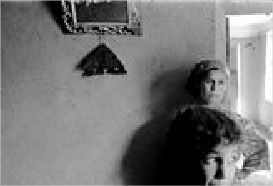
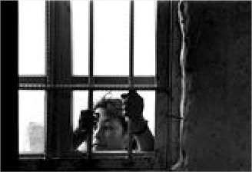
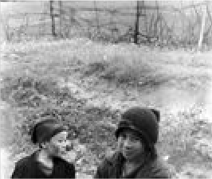
Item: 2269
Artifact
Children in the Gypsies' neighborhood (series)
Artist: Prducr: Date:
Length:
Shavkat Boltaev
Picture
English Version:
Cyrillic Title
Artifact
Children in the Gypsies' neighborhood (series)
Artist: Prducr: Date:
Length:
Shavkat Boltaev
Picture
English Version:
Cyrillic Title
Artifact
Children selling qurut (dried, balls of yogurt) [companion to 2269]
Artist: Prducr: Date:
Length:
Zilola Saidova
Picture
English Version:
Cyrillic Title
Title: Children selling qurut (dried, balls of yogurt) [companion to 2446]
Category Language: Description:

Item: 2375
Title: Churning milk to get sour cream

Category Language: Description:

Artifact
Churning milk to get sour cream

Artist:
Shavkat Boltaev
Picture

Item: 2463
Title: circumcision

Category Language: Description:

Artifact
circumcision

Artist:
Shavkat Boltaev
Picture

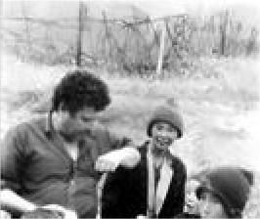
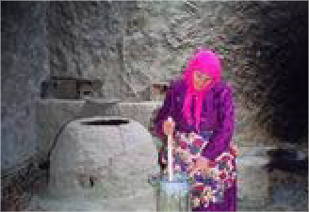
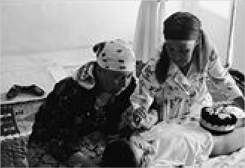
Item: 2289
Artifact
Children selling qurut (dried, balls of yogurt) [companion to 2446]
Artist: Prducr: Date:
Length:
Zilola Saidova
Picture
English Version:
Cyrillic Title
English Version:
Cyrillic Title
Prducr: Date:
Length:
English Version:
Cyrillic Title
Prducr: Date:
Length:
Title: Clay ovens of Uba Village

Category Language: Description:

Artifact
Clay ovens of Uba Village

Artist:
Shavkat Boltaev
Picture

Item: 2440
Title: countryside with horse

Category Language: Description:

Artifact
countryside with horse

Artist:
Zilola Saidova
Picture

Item: 2369
Title: Dying hair

Category Language: Description:

Artifact
Dying hair

Artist:
Zilola Saidova
Picture

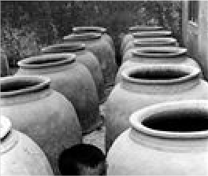
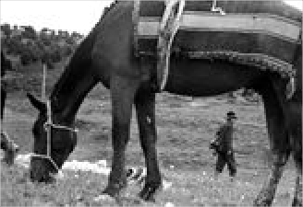
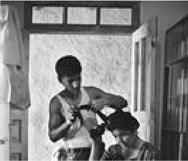
Item: 2353
English Version:
Cyrillic Title
Prducr: Date:
Length:
English Version:
Cyrillic Title
Prducr: Date:
Length:
English Version:
Cyrillic Title
Prducr: Date:
Length:
Title: Elizaveta Nekrosova

Category Language: Description:

Artifact
Elizaveta Nekrosova

Artist:
Zilola Saidova
Picture

Artifact
Elizaveta Nekrosova

Artist:
Zilola Saidova
Picture

Artifact
Elizaveta Nekrosova

Artist:
Zilola Saidova
Picture

Artifact
Elizaveta Nekrosova

Artist:
Zilola Saidova
Picture

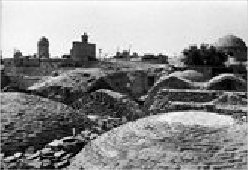
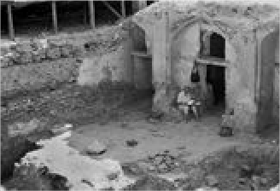
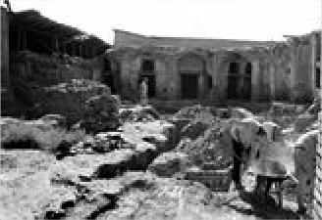
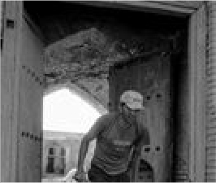
English Version:
Cyrillic Title
Prducr: Date:
Length:
English Version:
Cyrillic Title
Prducr: Date:
Length:
English Version:
Cyrillic Title
Prducr: Date:
Length:
English Version:
Cyrillic Title
Prducr:
Date: Length:

Artifact
Elizaveta Nekrosova

Artist:
Zilola Saidova
Picture

Artifact
Elizaveta Nekrosova

Artist:
Zilola Saidova
Picture

Artifact
Elizaveta Nekrosova

Artist:
Zilola Saidova
Picture

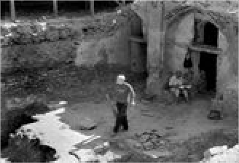
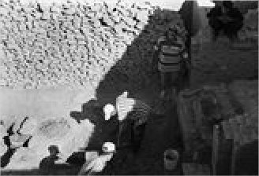
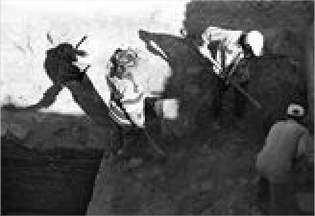
Item: 2434
English Version:
Cyrillic Title
Prducr: Date:
Length:
English Version:
Cyrillic Title
Prducr: Date:
Length:
English Version:
Cyrillic Title
Prducr: Date:
Length:
Title: Folk festival participants behind the scenes
Category Language: Description:

Item: 2396
Title: Fortune telling

Category Language: Description:

Artifact
Fortune telling

Artist:
Zilola Saidova
Picture

Item: 2300
Title: Future masters Gijduvan, Bukhara region
Category Language: Description:

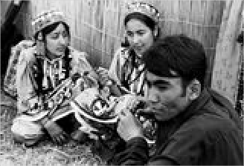
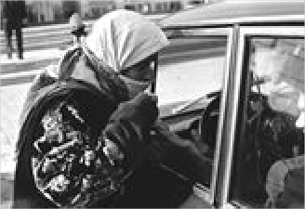
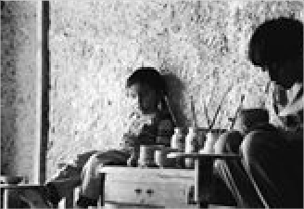
Item: 2421
Artifact
Folk festival participants behind the scenes
Artist: Prducr: Date:
Length:
Zilola Saidova
Picture
English Version:
Cyrillic Title
English Version:
Cyrillic Title
Prducr: Date:
Length:
Artifact
Future masters Gijduvan, Bukhara region
Artist: Prducr: Date:
Length:
Zilola Saidova
Picture
English Version:
Cyrillic Title
Title: Gavorabandon (a cradle ceremony)
Category Language: Description:

Item: 2407
Title: Girl selling yogurt made of goat/sheep milk
Category Language: Description:

Item: 2312
Title: Girls before the parade

Category Language: Description:

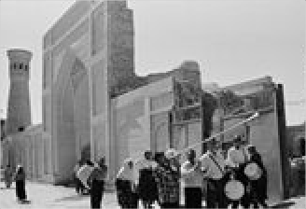
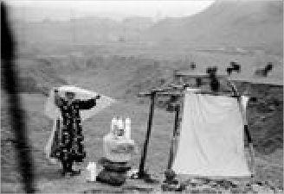
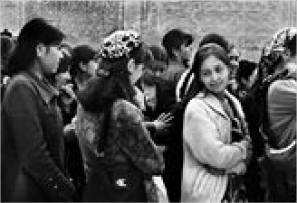
Artifact
Artifact
Gavorabandon (a cradle ceremony)
Artist: Prducr: Date:
Length:
Shavkat Boltaev
Picture
English Version:
Cyrillic Title
Artifact
Girl selling yogurt made of goat/sheep milk
Artist: Prducr: Date:
Length:
Shavkat Boltaev
Picture
English Version:
Cyrillic Title

Cyrillic Title

English Version:
Girls before the parade

Artist: Prducr: Date: Length:
Zilola Saidova
Picture

Item: 2276
Title: Grandmother and granddaughter. Tuda Village
Category Language: Description:

Item: 2410
Title: Grandparents and granddaughter

Category Language: Description:

Artifact
Grandparents and granddaughter

Artist:
Shavkat Boltaev
Picture

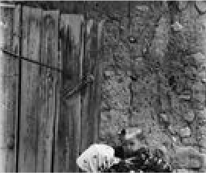
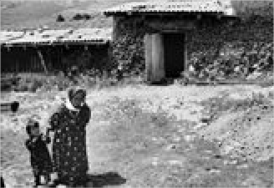
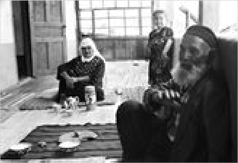
Item: 2324
Artifact
Grandmother and granddaughter. Tuda
Artist: Prducr: Date:
Length:
Zilola Saidova
Picture
English Version:
Cyrillic Title
Artifact
Grandmother and granddaughter. Tuda Village
Artist: Prducr: Date:
Length:
Zilola Saidova
Picture
English Version:
Cyrillic Title
English Version:
Cyrillic Title
Prducr: Date:
Length:
Title: Gypsy children in the Gypsies' neighborhood
Category Language: Description:

Item: 2386
Title: Gypsy girl

Category Language: Description:

Artifact
Gypsy girl

Artist:
Zilola Saidova
Picture

Item: 2404
Title: Gypsy girl and her sister

Category Language: Description:

Artifact
Gypsy girl and her sister

Artist:
Zilola Saidova
Picture

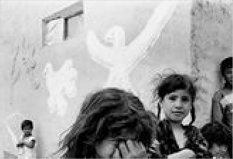
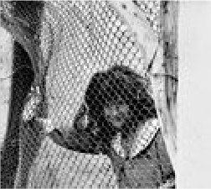
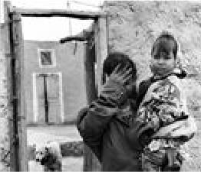
Item: 2408
Artifact
Gypsy children in the Gypsies' neighborhood
Artist: Prducr: Date:
Length:
Shavkat Boltaev
Picture
English Version:
Cyrillic Title
English Version:
Cyrillic Title
Prducr: Date:
Length:
English Version:
Cyrillic Title
Prducr: Date:
Length:
Title: Gypsy girl doing laundry

Category Language: Description:

Artifact
Gypsy girl doing laundry

Artist:
Zilola Saidova
Picture

Artifact
Gypsy girl doing laundry

Artist:
Zilola Saidova
Picture

Artifact
Gypsy girl doing laundry

Artist:
Zilola Saidova
Picture

Artifact
Gypsy girl doing laundry

Artist:
Zilola Saidova
Picture

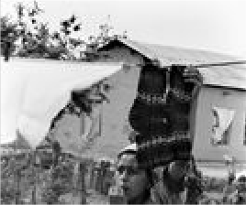
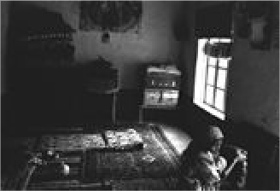
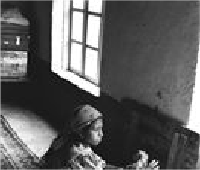
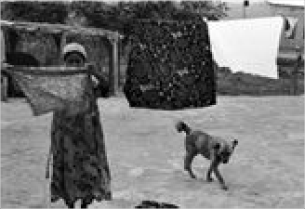
English Version:
Cyrillic Title
Prducr: Date:
Length:
English Version:
Cyrillic Title
Prducr: Date:
Length:
English Version:
Cyrillic Title
Prducr: Date:
Length:
English Version:
Cyrillic Title
Prducr:
Date: Length:

Artifact
Gypsy girl doing laundry

Artist:
Zilola Saidova
Picture

Artifact
Gypsy girl doing laundry

Artist:
Zilola Saidova
Picture

Artifact
Gypsy girl doing laundry

Artist:
Zilola Saidova
Picture

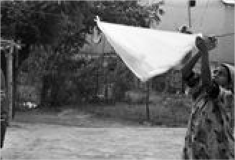
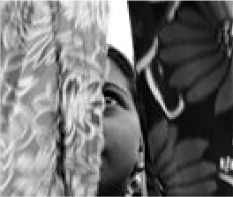
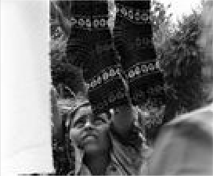
Item: 2406
English Version:
Cyrillic Title
Prducr: Date:
Length:
English Version:
Cyrillic Title
Prducr: Date:
Length:
English Version:
Cyrillic Title
Prducr: Date:
Length:
Title: Gypsy girl playing with her sheep

Category Language: Description:

Artifact
Gypsy girl playing with her sheep

Artist:
Zilola Saidova
Picture

Item: 2392
Title: Gypsy girls

Category Language: Description:

Artifact
Gypsy girls

Artist:
Zilola Saidova
Picture

Artifact
Gypsy girls

Artist:
Zilola Saidova
Picture

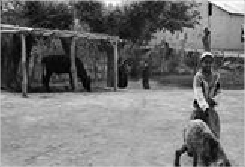
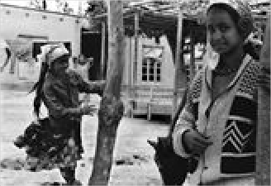
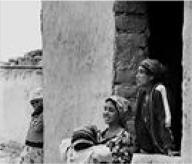
Item: 2390
English Version:
Cyrillic Title
Prducr: Date:
Length:
English Version:
Cyrillic Title
Prducr: Date:
Length:
English Version:
Cyrillic Title
Prducr:
Date: Length:
Title: Gypsy girls in old streets of Bukhara
Category Language: Description:

Item: 2397
Title: Gypsy man fond of pigeons

Category Language: Description:

Artifact
Gypsy man fond of pigeons

Artist:
Shavkat Boltaev
Picture

Item: 2317
Title: Gypsy man playing with quail

Category Language: Description:

Artifact
Gypsy man playing with quail

Artist:
Shavkat Boltaev
Picture

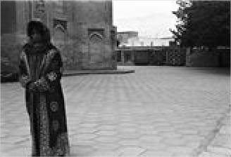
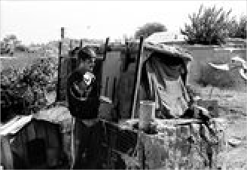
Item: 2398
Artifact
Gypsy girls in old streets of Bukhara
Artist: Prducr: Date:
Length:
Zilola Saidova
Picture
English Version:
Cyrillic Title
English Version:
Cyrillic Title
Prducr: Date:
Length:
English Version:
Cyrillic Title
Prducr: Date:
Length:
Title: Gypsy mother and her children

Category Language: Description:

Artifact
Gypsy mother and her children

Artist:
Zilola Saidova
Picture

Item: 2400
Title: Gypsy mother at Bolo Hauz Mosque
Category Language: Description:

Item: 2309
Title: Gypsy woman in street

Category Language: Description:

Artifact
Gypsy woman in street

Artist:
Shavkat Boltaev
Picture

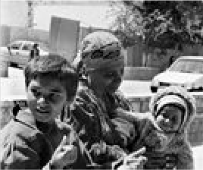
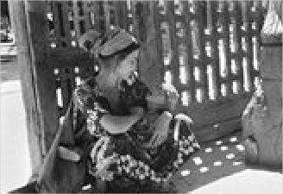
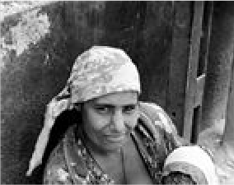
Item: 2351
English Version:
Cyrillic Title
Prducr: Date:
Length:
Artifact
Gypsy mother at Bolo Hauz Mosque
Artist: Prducr: Date:
Length:
Zilola Saidova
Picture
English Version:
Cyrillic Title
English Version:
Cyrillic Title
Prducr: Date:
Length:
Title: Hairdresser's contest

Category Language: Description:

Artifact
Hairdresser's contest

Artist:
Zilola Saidova
Picture

Artifact
Hairdresser's contest

Artist:
Zilola Saidova
Picture

Item: 2348
Title: Hairdressers' contest

Category Language: Description:

Artifact
Hairdressers' contest

Artist:
Zilola Saidova
Picture

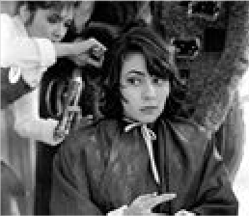
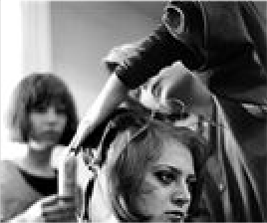
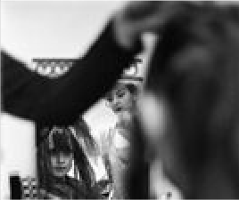
Item: 2393
English Version:
Cyrillic Title
Prducr: Date:
Length:
English Version:
Cyrillic Title
Prducr: Date:
Length:
English Version:
Cyrillic Title
Prducr:
Date: Length:
Title: Hungry photographer

Category Language: Description:

Artifact
Hungry photographer

Artist:
Shavkat Boltaev
Picture

Item: 2286
Title: In the kitchen

Category Language: Description:

Artifact
In the kitchen

Artist:
Zilola Saidova
Picture

Item: 2284
Title: Karaqalpak man & qobuz (string instrument)
Category Language: Description:

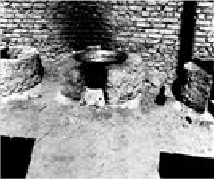
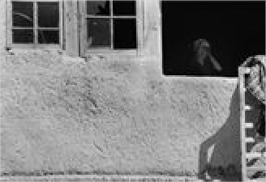
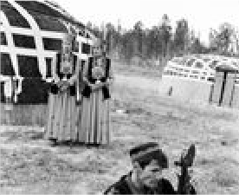
Item: 2381
English Version:
Cyrillic Title
Prducr: Date:
Length:
English Version:
Cyrillic Title
Prducr: Date:
Length:
Artifact
Karaqalpak man & qobuz (string instrument)
Artist: Prducr: Date:
Length:
Shavkat Boltaev
Picture
English Version:
Cyrillic Title
Title: Kelinbiyori (ceremony dedicated to bride)
Category Language: Description:

Item: 2457
Title: laundry

Category Language: Description:

Artifact
laundry

Artist:
Zilola Saidova
Picture

Item: 2383
Title: Local Mill, Osiyo

Category Language: Description:

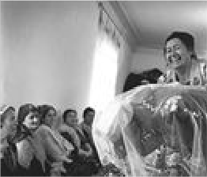
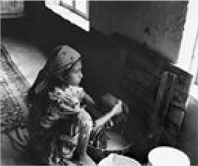
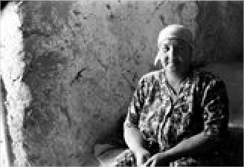
Artifact
Artifact
Kelinbiyori (ceremony dedicated to bride)
Artist: Prducr: Date:
Length:
Zilola Saidova
Picture
English Version:
Cyrillic Title
English Version:
Cyrillic Title
Prducr: Date:
Length:

Cyrillic Title

English Version:
Local Mill, Osiyo

Artist: Prducr: Date: Length:
Shavkat Boltaev
Picture

Artifact
Local Mill, Osiyo

Artist:
Shavkat Boltaev
Picture

Artifact
Local Mill, Osiyo

Artist:
Shavkat Boltaev
Picture

Item: 2200
Title: Long Photographic Calendar “Bukhara 2500”
Category Language: Description:

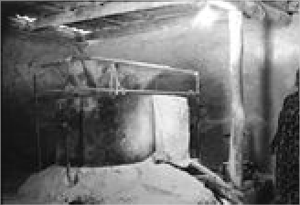
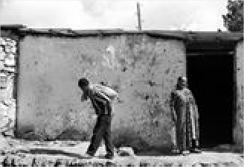
Item: 2331
English Version:
Cyrillic Title
Prducr: Date:
Length:
English Version:
Cyrillic Title
Prducr: Date:
Length:
Artifact
Long Photographic Calendar “Bukhara 2500”
Artist: Prducr: Date:
Length:
Picture
English Version:
Cyrillic Title
Title: Making bread in Gypsies' neighborhood
Category Language: Description:

Item: 2288
Title: Making clay ovens. Uba village

Category Language: Description:

Artifact
Making clay ovens. Uba village

Artist:
Shavkat Boltaev
Picture

Item: 2368
Title: Making matzo balls

Category Language: Description:

Artifact
Making matzo balls

Artist:
Shavkat Boltaev
Picture

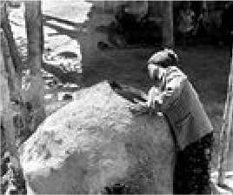
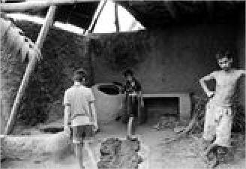
Item: 2372
Artifact
Making bread in Gypsies' neighborhood
Artist: Prducr: Date:
Length:
Shavkat Boltaev
Picture
English Version:
Cyrillic Title
English Version:
Cyrillic Title
Prducr: Date:
Length:
English Version:
Cyrillic Title
Prducr: Date:
Length:
Title: Making tea in samovar

Category Language: Description:

Artifact
Making tea in samovar

Artist:
Zilola Saidova
Picture

Item: 2298
Title: Man in an open-air kitchen

Category Language: Description:

Artifact
Man in an open-air kitchen

Artist:
Zilola Saidova
Picture

Item: 2308
Title: Man smoking nos

Category Language: Description:

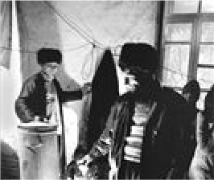
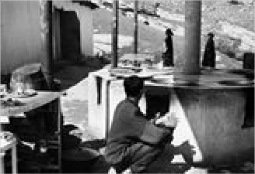
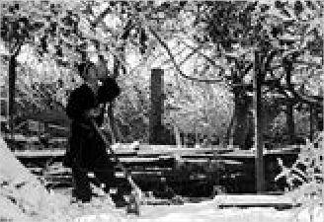
Artifact
English Version:
Cyrillic Title
Prducr: Date:
Length:
English Version:
Cyrillic Title
Prducr: Date:
Length:

Cyrillic Title

English Version:
Man smoking nos

Artist: Prducr: Date: Length:
Zilola Saidova
Picture

Artifact
man with book

Artist:
Shavkat Boltaev
Picture

Item: 2482
Title: market scene

Category Language: Description:

Artifact
market scene

Artist:
Shavkat Boltaev
Picture

Item: 2420
Title: Mother and son at Omonkhona resort
Category Language: Description:

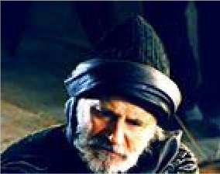
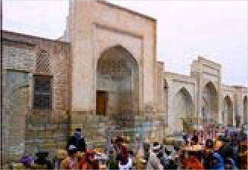
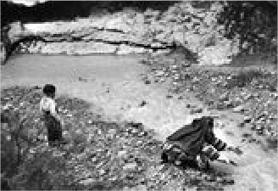
Item: 2279
English Version:
Cyrillic Title
Prducr: Date:
Length:
English Version:
Cyrillic Title
Prducr: Date:
Length:
Artifact
Mother and son at Omonkhona resort
Artist: Prducr: Date:
Length:
Zilola Saidova
Picture
English Version:
Cyrillic Title
Title: Mountains of Boysun

Category Language: Description:

Artifact
Mountains of Boysun

Artist:
Zilola Saidova
Picture

Item: 2330
Title: My Grandmother

Category Language: Description:

Artifact
My Grandmother

Artist:
Zilola Saidova
Picture

Item: 2340
Title: Old Bukharan man

Category Language: Description:

Artifact
Old Bukharan man

Artist:
Zilola Saidova
Picture

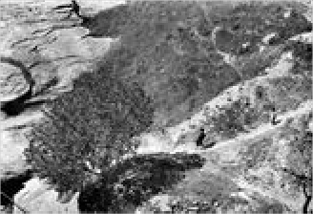
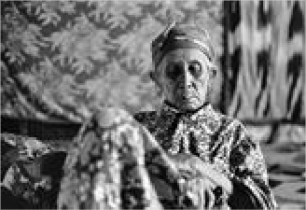
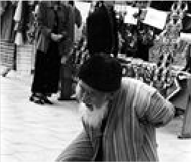
Item: 2313
English Version:
Cyrillic Title
Prducr: Date:
Length:
English Version:
Cyrillic Title
Prducr: Date:
Length:
English Version:
Cyrillic Title
Prducr: Date:
Length:
Title: Old Gypsy man

Category Language: Description:

Artifact
Old Gypsy man

Artist:
Shavkat Boltaev
Picture

Item: 2394
Title: Old gypsy woman

Category Language: Description:

Artifact
Old gypsy woman

Artist:
Zilola Saidova
Picture

Artifact
Old gypsy woman

Artist:
Shavkat Boltaev
Picture

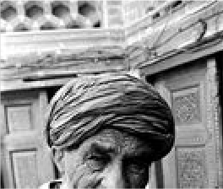
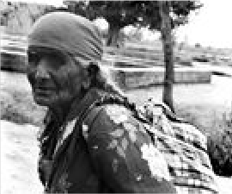
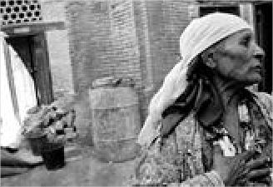
Item: 2318
English Version:
Cyrillic Title
Prducr: Date:
Length:
English Version:
Cyrillic Title
Prducr: Date:
Length:
English Version:
Cyrillic Title
Prducr:
Date: Length:
Title: Old Gypsy woman & pigeon

Category Language: Description:

Artifact
Old Gypsy woman & pigeon

Artist:
Shavkat Boltaev
Picture

Item: 2343
Title: Old Jewish woman

Category Language: Description:

Artifact
Old Jewish woman

Artist:
Shavkat Boltaev
Picture

Item: 2475
Title: old man

Category Language: Description:

Artifact
old man

Artist:
Shavkat Boltaev
Picture

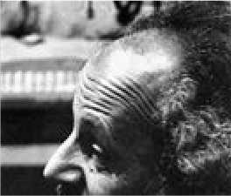
Item: 2281
English Version:
Cyrillic Title
Prducr: Date:
Length:
English Version:
Cyrillic Title
Prducr: Date:
Length:
English Version:
Cyrillic Title
Prducr: Date:
Length:
Title: Old man along the roads of Boysun
Category Language: Description:

Item: 2283
Title: Old man and stones. Hulod village, Boysun
Category Language: Description:

Item: 2346
Title: Old man at Chor Bakr necropolis

Category Language: Description:

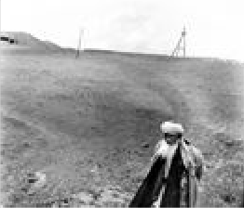
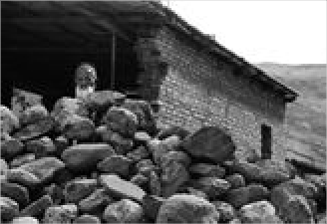
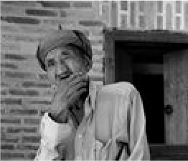
Artifact
Artifact
Old man along the roads of Boysun
Artist: Prducr: Date:
Length:
Zilola Saidova
Picture
English Version:
Cyrillic Title
Artifact
Old man and stones. Hulod village, Boysun
Artist: Prducr: Date:
Length:
Zilola Saidova
Picture
English Version:
Cyrillic Title

Cyrillic Title

English Version:
Old man at Chor Bakr necropolis

Artist: Prducr: Date: Length:
Zilola Saidova
Picture

Artifact
Old man at Chor Bakr necropolis

Artist:
Shavkat Boltaev
Picture

Item: 2302
Title: Old man at Lyabi Hauz

Category Language: Description:

Artifact
Old man at Lyabi Hauz

Artist:
Shavkat Boltaev
Picture

Item: 2425
Title: Old man at Omonkhona resort Boysun
Category Language: Description:

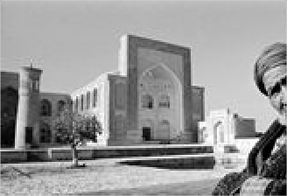
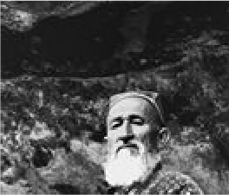
Item: 2430
English Version:
Cyrillic Title
Prducr: Date:
Length:
English Version:
Cyrillic Title
Prducr: Date:
Length:
Artifact
Old man at Omonkhona resort Boysun
Artist: Prducr: Date:
Length:
Zilola Saidova
Picture
English Version:
Cyrillic Title
Title: Old musician

Category Language: Description:

Artifact
Old musician

Artist:
Shavkat Boltaev
Picture

Item: 2202
Title: old postcards from Bukhara

Category Language: Description:

Artifact
old postcards from Bukhara

Artist:
Picture

Item: 2305
Title: Old Turkman man

Category Language: Description:

Artifact
Old Turkman man

Artist:
Shavkat Boltaev
Picture

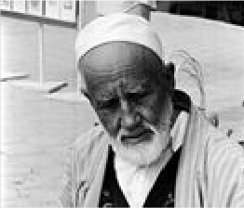
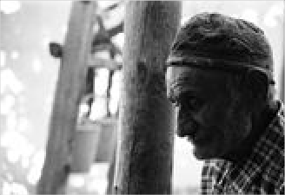
Item: 2422
English Version:
Cyrillic Title
Prducr: Date:
Length:
English Version:
Cyrillic Title
Prducr: Date:
Length:
English Version:
Cyrillic Title
Prducr: Date:
Length:
Title: Old woman

Category Language: Description:

Artifact
Old woman

Artist:
Shavkat Boltaev
Picture

Item: 2332
Title: Old woman selling nos (local tobacco)
Category Language: Description:

Item: 2436
Title: Old woman visiting Bukhara

Category Language: Description:

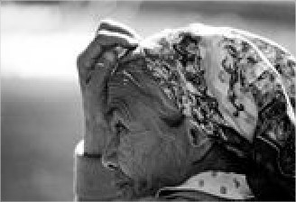
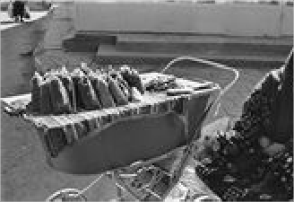
Artifact
English Version:
Cyrillic Title
Prducr: Date:
Length:
Artifact
Old woman selling nos (local tobacco)
Artist: Prducr: Date:
Length:
Zilola Saidova
Picture
English Version:
Cyrillic Title

Cyrillic Title

English Version:
Old woman visiting Bukhara

Artist: Prducr: Date: Length:
Shavkat Boltaev
Picture

Artifact
Old woman visiting Bukhara

Artist:
Shavkat Boltaev
Picture

Item: 2442
Title: open door

Category Language: Description:

Artifact
open door

Artist:
Zilola Saidova
Picture

Item: 2292
Title: Orchard. Tuda village, Boysun

Category Language: Description:

Artifact
Orchard. Tuda village, Boysun

Artist:
Zilola Saidova
Picture

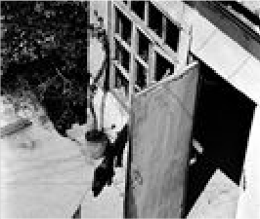
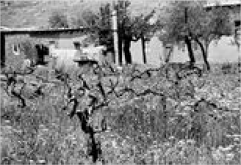
Item: 2274
English Version:
Cyrillic Title
Prducr: Date:
Length:
English Version:
Cyrillic Title
Prducr: Date:
Length:
English Version:
Cyrillic Title
Prducr: Date:
Length:
Title: Performing "Lyazgi" dance

Category Language: Description:

Artifact
Performing "Lyazgi" dance

Artist:
Zilola Saidova
Picture

Item: 2248
Title: Photographs of Bukhara

Category Language: Description:

Artifact
Photographs of Bukhara

Artist:
Picture

Item: 2262
Title: Photos by Zilola Saidova

Category Language: Description:

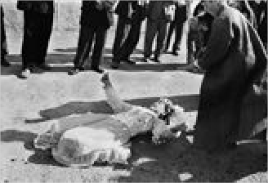
Artifact
English Version:
Cyrillic Title
Prducr: Date:
Length:
English Version:
Cyrillic Title
Prducr: Date:
Length:

Cyrillic Title

English Version:
Photos by Zilola Saidova

Artist: Prducr: Date: Length:
Picture

Artifact
postcard set of Samarkand

Artist:
Picture

Item: 2334
Title: Potato harvest

Category Language: Description:

Artifact
Potato harvest

Artist:
Zilola Saidova
Picture

Item: 2415
Title: Potter

Category Language: Description:

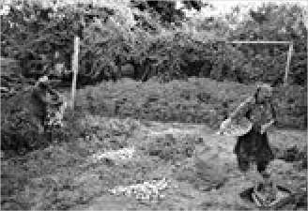
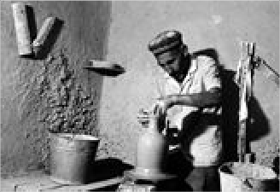
Artifact
English Version:
Cyrillic Title
Prducr: Date:
Length:
English Version:
Cyrillic Title
Prducr: Date:
Length:

Cyrillic Title

English Version:
Potter

Artist: Prducr: Date: Length:
Shavkat Boltaev
Picture

Artifact
Practicing "alas" (mystical ritual)

Artist:
Shavkat Boltaev
Picture

Item: 2342
Title: Preparing for lunch

Category Language: Description:

Artifact
Preparing for lunch

Artist:
Zilola Saidova
Picture

Item: 2347
Title: Rabbi slaughtering cow

Category Language: Description:

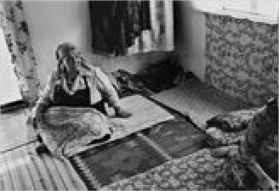
Artifact
English Version:
Cyrillic Title
Prducr: Date:
Length:
English Version:
Cyrillic Title
Prducr: Date:
Length:

Cyrillic Title

English Version:
Rabbi slaughtering cow

Artist: Prducr: Date: Length:
Shavkat Boltaev
Picture

Artifact
Rabbi testing meat (Kosher)

Artist:
Shavkat Boltaev
Picture

Item: 2391
Title: Remembrance Qaraqul district

Category Language: Description:

Artifact
Remembrance Qaraqul district

Artist:
Shavkat Boltaev
Picture

Item: 2370
Title: Sagyora Qoziyeva and Boysun men's folk music troop performing a folk s
Category Language: Description:

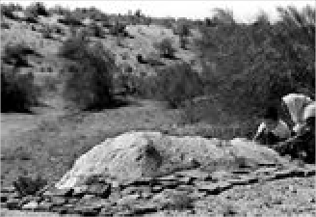
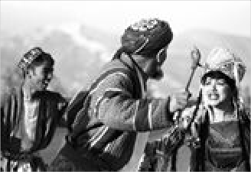
Item: 2428
English Version:
Cyrillic Title
Prducr: Date:
Length:
English Version:
Cyrillic Title
Prducr: Date:
Length:
Artifact
Sagyora Qoziyeva and Boysun men's folk music troop performing a folk song
Artist: Prducr: Date:
Length:
Shavkat Boltaev
Picture
English Version:
Cyrillic Title
Title: Sallabandon (women's ceremony)

Category Language: Description:

Artifact
Sallabandon (women's ceremony)

Artist:
Shavkat Boltaev
Picture

Item: 2282
Title: Sayyora Qoziyeva & men's folkdance troupe
Category Language: Description:

Item: 2448
Title: scene through narrow window

Category Language: Description:

Artifact
scene through narrow window

Artist:
Zilola Saidova
Picture

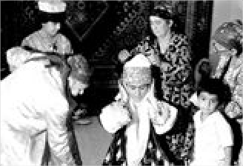
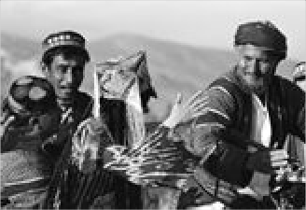
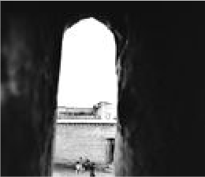
Item: 2411
English Version:
Cyrillic Title
Prducr: Date:
Length:
Artifact
Sayyora Qoziyeva & men's folkdance troop
Artist: Prducr: Date:
Length:
Shavkat Boltaev
Picture
English Version:
Cyrillic Title
English Version:
Cyrillic Title
Prducr: Date:
Length:
Title: Shahzod, a Gypsy boy

Category Language: Description:

Artifact
Shahzod, a Gypsy boy

Artist:
Zilola Saidova
Picture

Item: 2270
Title: Shepherds

Category Language: Description:

Artifact
Shepherds

Artist:
Zilola Saidova
Picture

Artifact
Shepherds

Artist:
Zilola Saidova
Picture

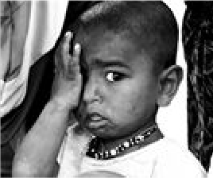
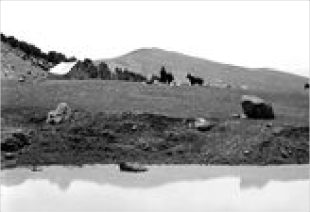
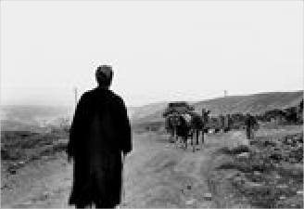
Item: 2307
English Version:
Cyrillic Title
Prducr: Date:
Length:
English Version:
Cyrillic Title
Prducr: Date:
Length:
English Version:
Cyrillic Title
Prducr:
Date: Length:
Title: Small sewing business

Category Language: Description:

Artifact
Small sewing business

Artist:
Shavkat Boltaev
Picture

Item: 2325
Title: Street scene (At a repair shop)

Category Language: Description:

Artifact
Street scene (At a repair shop)

Artist:
Zilola Saidova
Picture

Item: 2280
Title: Surkhan Darya folkdance

Category Language: Description:

Artifact
Surkhan Darya folkdance

Artist:
Shavkat Boltaev
Picture

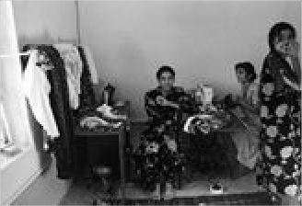
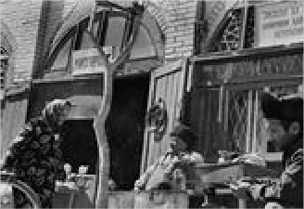
Item: 2285
English Version:
Cyrillic Title
Prducr: Date:
Length:
English Version:
Cyrillic Title
Prducr: Date:
Length:
English Version:
Cyrillic Title
Prducr: Date:
Length:
Title: Surnay - national wind instrument

Category Language: Description:

Artifact
Surnay - national wind instrument

Artist:
Zilola Saidova
Picture

Item: 2272
Title: Tajik dancer

Category Language: Description:

Artifact
Tajik dancer

Artist:
Zilola Saidova
Picture

Item: 2429
Title: Tajik woman Avlod village, Boysun
Category Language: Description:

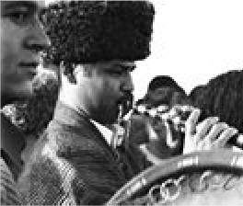
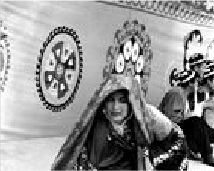
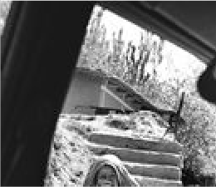
Item: 2204
English Version:
Cyrillic Title
Prducr: Date:
Length:
English Version:
Cyrillic Title
Prducr: Date:
Length:
Artifact
Tajik woman Avlod village, Boysun
Artist: Prducr: Date:
Length:
Zilola Saidova
Picture
English Version:
Cyrillic Title
Title: Tashkent postcards

Category Language: Description:

Artifact
Tashkent postcards

Artist:
Picture

Item: 2273
Title: Three faiths

Category Language: Description:

Artifact
Three faiths

Artist:
Shavkat Boltaev
Picture

Item: 2290
Title: To local secondary school

Category Language: Description:

Artifact
To local secondary school

Artist:
Zilola Saidova
Picture

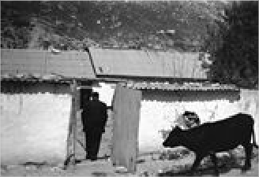
Item: 2345
English Version:
Cyrillic Title
Prducr: Date:
Length:
English Version:
Cyrillic Title
Prducr: Date:
Length:
English Version:
Cyrillic Title
Prducr: Date:
Length:
Title: Tombstone at Bukharan Jewish cemetary
Category Language: Description:

Item: 2464
Title: two men

Category Language: Description:

Artifact
two men

Artist:
Shavkat Boltaev
Picture

Item: 2439
Title: Untitled

Category Language: Description:

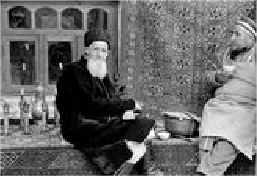
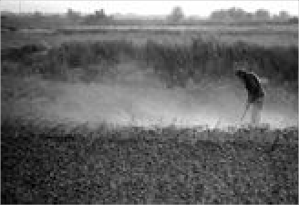
Artifact
Artifact
Tombstone at Bukharan Jewish cemetary
Artist: Prducr: Date:
Length:
Shavkat Boltaev
Picture
English Version:
Cyrillic Title
English Version:
Cyrillic Title
Prducr: Date:
Length:

Cyrillic Title

English Version:
Untitled

Artist: Prducr: Date: Length:
Zilola Saidova
Picture

Artifact
untitled

Artist:
Zilola Saidova
Picture

Artifact
untitled

Artist:
Zilola Saidova
Picture

Artifact
untitled

Artist:
Zilola Saidova
Picture

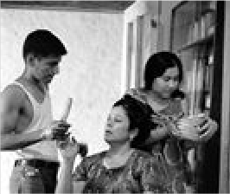
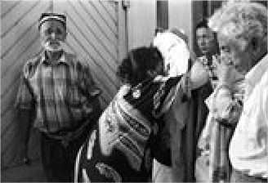
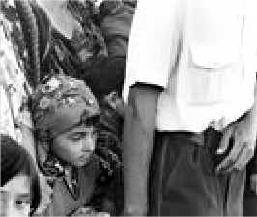
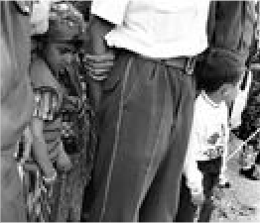
Artifact
English Version:
Cyrillic Title
Prducr: Date:
Length:
English Version:
Cyrillic Title
Prducr: Date:
Length:
English Version:
Cyrillic Title
Prducr: Date:
Length:

Cyrillic Title

English Version:
untitled

Artist: Prducr: Date: Length:
Zilola Saidova
Picture

Artifact
untitled

Artist:
Zilola Saidova
Picture

Artifact
untitled

Artist:
Zilola Saidova
Picture

Artifact
untitled

Artist:
Shavkat Boltaev
Picture

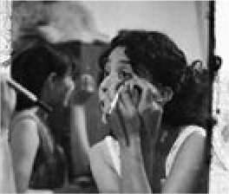
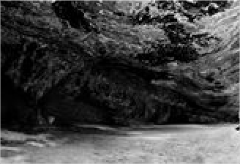
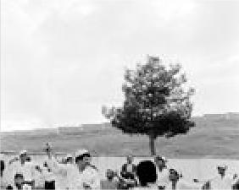
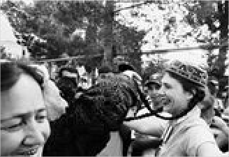
Artifact
English Version:
Cyrillic Title
Prducr: Date:
Length:
English Version:
Cyrillic Title
Prducr: Date:
Length:
English Version:
Cyrillic Title
Prducr: Date:
Length:

Cyrillic Title

English Version:
untitled

Artist: Prducr: Date: Length:
Shavkat Boltaev
Picture

Artifact
untitled

Artist:
Shavkat Boltaev
Picture

Artifact
untitled

Artist:
Shavkat Boltaev
Picture

Artifact
untitled

Artist:
Shavkat Boltaev
Picture

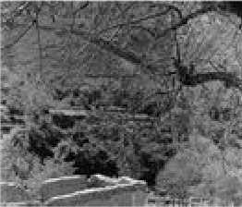
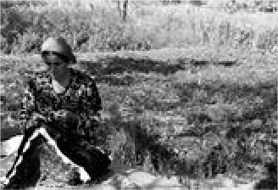
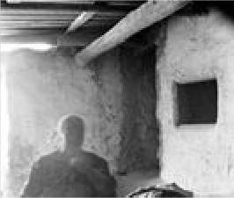
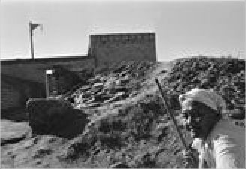
Artifact
English Version:
Cyrillic Title
Prducr: Date:
Length:
English Version:
Cyrillic Title
Prducr: Date:
Length:
English Version:
Cyrillic Title
Prducr: Date:
Length:

Cyrillic Title

English Version:
untitled

Artist: Prducr: Date: Length:
Shavkat Boltaev
Picture

Artifact
untitled

Artist:
Shavkat Boltaev
Picture

Artifact
untitled

Artist:
Shavkat Boltaev
Picture

Artifact
untitled

Artist:
Shavkat Boltaev
Picture

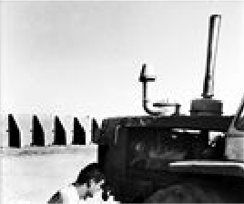
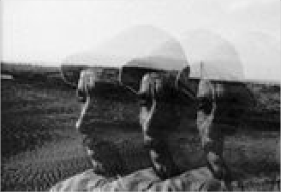
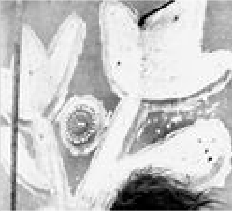
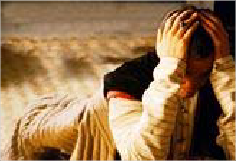
Artifact
English Version:
Cyrillic Title
Prducr: Date:
Length:
English Version:
Cyrillic Title
Prducr: Date:
Length:
English Version:
Cyrillic Title
Prducr: Date:
Length:

Cyrillic Title

English Version:
untitled

Artist: Prducr: Date: Length:
Shavkat Boltaev
Picture

Artifact
untitled

Artist:
Shavkat Boltaev
Picture

Artifact
untitled

Artist:
Shavkat Boltaev
Picture

Artifact
untitled

Artist:
Shavkat Boltaev
Picture

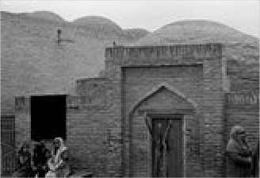
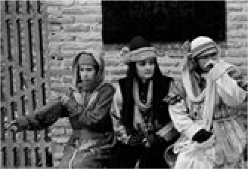
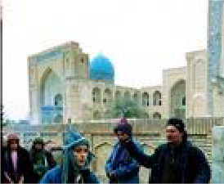
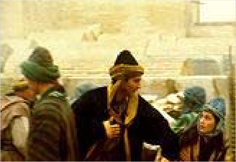
Artifact
English Version:
Cyrillic Title
Prducr: Date:
Length:
English Version:
Cyrillic Title
Prducr: Date:
Length:
English Version:
Cyrillic Title
Prducr: Date:
Length:

Cyrillic Title

English Version:
untitled

Artist: Prducr: Date: Length:
Shavkat Boltaev
Picture

Artifact
untitled

Artist:
Shavkat Boltaev
Picture

Artifact
untitled

Artist:
Shavkat Boltaev
Picture

Item: 2431
Title: Veiled woman

Category Language: Description:

Artifact
Veiled woman

Artist:
Shavkat Boltaev
Picture

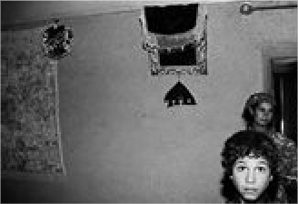
Item: 2441
English Version:
Cyrillic Title
Prducr: Date:
Length:
English Version:
Cyrillic Title
Prducr: Date:
Length:
English Version:
Cyrillic Title
Prducr:
Date: Length:
Title: view of alley

Category Language: Description:

Artifact
view of alley

Artist:
Zilola Saidova
Picture

Item: 2409
Title: Village landscape Boysun

Category Language: Description:

Artifact
Village landscape Boysun

Artist:
Shavkat Boltaev
Picture

Item: 2379
Title: Washing hair

Category Language: Description:

Artifact
Washing hair

Artist:
Shavkat Boltaev
Picture

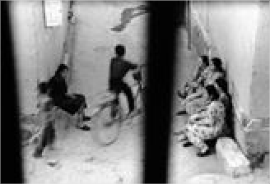
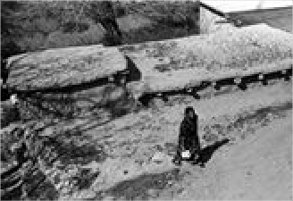
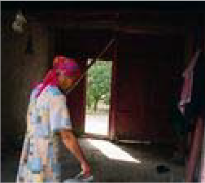
Item: 4593
English Version:
Cyrillic Title
Prducr: Date:
Length:
English Version:
Cyrillic Title
Prducr: Date:
Length:
English Version:
Cyrillic Title
Prducr: Date:
Length:
Title: water_3.jpg
Category Language: Description:

Item: 4594
Title: water_4.jpg
Category Language: Description:

Item: 2306
Title: Woman after sale

Category Language: Description:

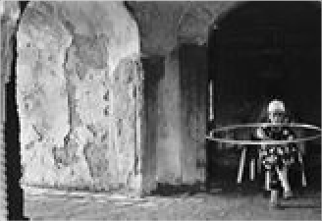
Artifact
Artifact
A grim legacy of colonial rule. The Aral Sea, once the world’s fourth largest lake, has largely disappeared. Water from Amu Darya and Syr Darya Rivers flow to the Aral Sea. During the Soviet period most of this water was diverted to grow cotton. No water can be seen from this stranded ship in Uzbekistan.
Artist: Prducr: Date:
Length:
Jackson Kellogg
Picture
English Version:
Cyrillic Title
Artifact
In many cities and towns of Central Asia, people gather their water from public taps like this one in Bukhara, Uzbekistan.
Artist: Prducr: Date:
Length:
Jackson Kellogg
Picture
English Version:
Cyrillic Title

Cyrillic Title

English Version:
Woman after sale

Artist: Prducr: Date: Length:
Zilola Saidova
Picture

Artifact
Woman and cradle

Artist:
Shavkat Boltaev
Picture

Item: 2336
Title: Woman baking bread Uba village, Vobkent district
Category Language: Description:

Item: 2373
Title: Woman holding guzapoya (dried bushels of cotton)

Category Language: Description:

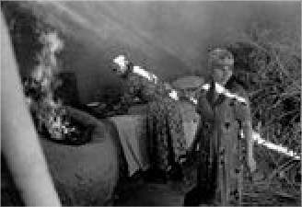
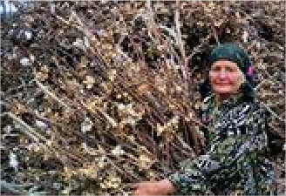
Artifact
English Version:
Cyrillic Title
Prducr: Date:
Length:
Artifact
Woman baking bread Uba village, Vobkent district
Artist: Prducr: Date:
Length:
Zilola Saidova
Picture
English Version:
Cyrillic Title

Cyrillic Title

English Version:
Woman holding guzapoya (dried bushels of cotton)

Artist: Prducr: Date: Length:
Shavkat Boltaev
Picture

Item: 2296
Title: Woman selling sunflower seeds Boysun
Category Language: Description:

Item: 2344
Title: Woman tasting food

Category Language: Description:

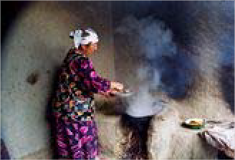
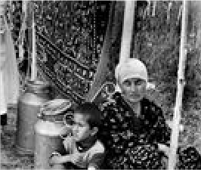
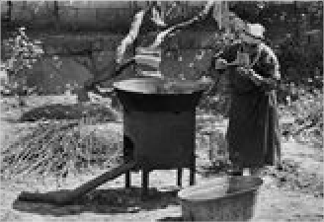
Artifact
Artifact
Woman making tukhumbarak (a traditional food made from eggs)
Artist: Prducr: Date:
Length:
Shavkat Boltaev
Picture
English Version:
Cyrillic Title
Artifact
Woman selling sunflower seeds Boysun
Artist: Prducr: Date:
Length:
Zilola Saidova
Picture
English Version:
Cyrillic Title

Cyrillic Title

English Version:
Woman tasting food

Artist: Prducr: Date: Length:
Zilola Saidova
Picture

Item: 2287
Title: Woman washing dishes. Tuda village, Boysun
Category Language: Description:

Item: 2427
Title: Woman with a kurpacha (mattress) Boysun.
Category Language: Description:

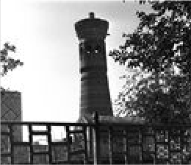
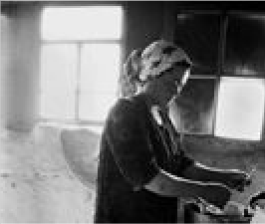
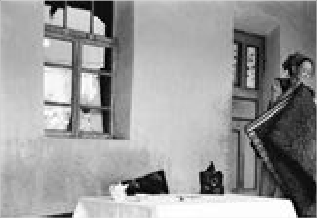
Item: 2310
Artifact
Woman visiting the Shrine of Abdulkholiq Gijduvoni
Artist: Prducr: Date:
Length:
Shavkat Boltaev
Picture
English Version:
Cyrillic Title
Artifact
Woman washing dishes. Tuda village, Boysun
Artist: Prducr: Date:
Length:
Zilola Saidova
Picture
English Version:
Cyrillic Title
Artifact
Woman with a kurpacha (mattress) Boysun.
Artist: Prducr: Date:
Length:
Zilola Saidova
Picture
English Version:
Cyrillic Title
Title: Women at Bahauddin Nagshband shrine
Category Language: Description:

Item: 2303
Title: Women coming from cotton refinery
Category Language: Description:

Item: 2378
Title: Women going to the bride's house

Category Language: Description:

Artifact
Women going to the bride's house

Artist:
Zilola Saidova
Picture

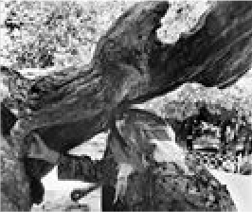
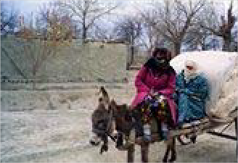
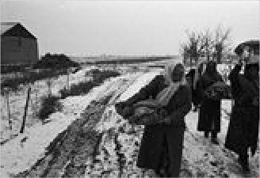
Item: 2359
Artifact
Women at Bahauddin Nagshband shrine
Artist: Prducr: Date:
Length:
Zilola Saidova
Picture
English Version:
Cyrillic Title
Artifact
Women coming from cotton refinery
Artist: Prducr: Date:
Length:
Shavkat Boltaev
Picture
English Version:
Cyrillic Title
English Version:
Cyrillic Title
Prducr: Date:
Length:
Title: Women's bathhouse

Category Language: Description:

Artifact
Women's bathhouse

Artist:
Zilola Saidova
Picture

Artifact
Women's bathhouse

Artist:
Zilola Saidova
Picture

Artifact
Women's bathhouse

Artist:
Zilola Saidova
Picture

Artifact
Women's bathhouse

Artist:
Zilola Saidova
Picture

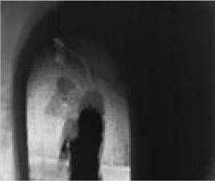
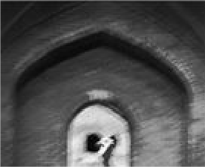
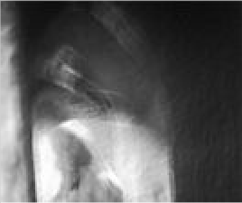
English Version:
Cyrillic Title
Prducr: Date:
Length:
English Version:
Cyrillic Title
Prducr: Date:
Length:
English Version:
Cyrillic Title
Prducr: Date:
Length:
English Version:
Cyrillic Title
Prducr:
Date: Length:

Item: 2295
Title: World of childhood Avlod village, Boysun
Category Language: Description:

Item: 2412
Title: Young couple in Boysun

Category Language: Description:

Artifact
Young couple in Boysun

Artist:
Shavkat Boltaev
Picture

Item: 2490
Title: young girl

Category Language: Description:

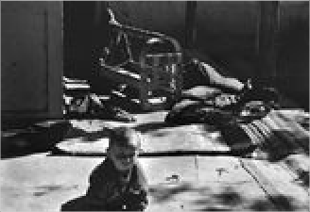
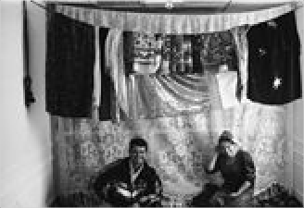
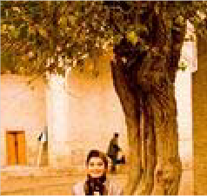
Artifact
Artifact
The world of childhood Avlod village, Boysun
Artist: Prducr: Date:
Length:
Zilola Saidova
Picture
English Version:
Cyrillic Title
English Version:
Cyrillic Title
Prducr: Date:
Length:

Cyrillic Title

English Version:
young girl

Artist: Prducr: Date: Length:
Shavkat Boltaev
Picture

Item: 2388
Title: Young gypsy woman

Category Language: Description:

Artifact
Young gypsy woman

Artist:
Zilola Saidova
Picture

Item: 2489
Title: young man with horse

Category Language: Description:

Artifact
young man with horse

Artist:
Shavkat Boltaev
Picture

Item: 2322
Title: Young visitor of Naqshband shrine

Category Language: Description:

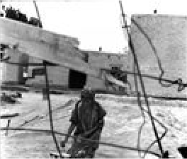
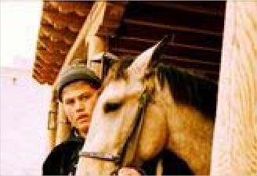
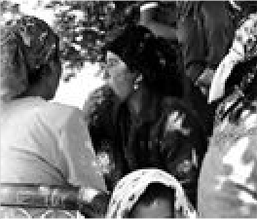
Artifact
English Version:
Cyrillic Title
Prducr:
Date: Length:
English Version:
Cyrillic Title
Prducr: Date:
Length:

Cyrillic Title

English Version:
Young visitor of Naqshband shrine

Artist: Prducr: Date: Length:
Zilola Saidova
Picture

Item: 2423
Title: Young woman selling spices at Omonkhona, Boysun
Category Language: Description:

Item: 2201
Title: ХИВА 16 ОТКРЬІТОК 16-card postcard set of Khiva
Category Language: Description:

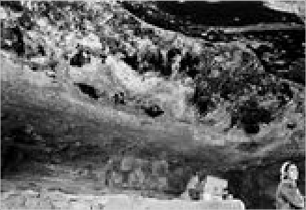
Poster
Artifact
Young woman selling spices at Omonkhona, Boysun
Artist: Prducr: Date:
Length:
Zilola Saidova
Picture
English Version:
Cyrillic Title
Artifact
ХИВА 16 ОТКРЬІТОК 16-card
postcard set of Khiva
Artist: Prducr: Date:
Length:
Picture
English Version:
Cyrillic Title

Item: 2220

Title: madrassa in Samarkand

Category Language: Description:

Artifact

Artist:
Picture

Item: 2221
Title: minoret in Khiva

Category Language: Description:
Artifact

Artist:

Picture

Item: 2222
Title: Uzbek 50th Anniversary

Category Language: Description:
Artifact

Artist:

Picture

English Version:
Cyrillic Title
Prducr: Date:
Length:
English Version:
Cyrillic Title
Prducr: Date:
Length:
English Version:
Cyrillic Title
Prducr: Date:
Length:

Stamps

Item: 2232
Title: envelope fragments

Category Language: Description:

Artifact

Xinjiang Uyghur Autonomous

Cassette
(11)

Artist:
Picture

Item: 2034
Title: Music
Category Language: Description:

Photo
English Version:
Cyrillic Title
Prducr:
Date: Length:
Artifact
Music tapes (labeled in Uyghur & Chinese)
Artist: Prducr: Date:
Length:
Picture
English Version:
Cyrillic Title

Item: 2206

Title: Baxhiski postcard

Category Language: Description:

Artifact
Baxhiski postcard

Artist:
Picture

Item: 2205
Title: Beer label - Kashgar piva

Category Language: Description:

Artifact
Beer label - Kashgar piva

Artist:
Picture

English Version:
Cyrillic Title
Prducr: Date:
Length:
English Version:
Cyrillic Title
Prducr: Date:
Length:

