Circulating Items Inventory - Azerbaijan
Art/Photo
Producer/Publisher Year Made Length Image
English? Artist/Author
Category of Item Item # Item Name
2175 Azerbaijan Landscapes No postcard set

2176 large postcard set No “Azerbaijan Miniatures”

2177 5 Azeri Novruz cards No

2178 postcard set No
“Azerbaijanian Jewellery Art” [sic]

2180 set of large cards No showing Azerbaijani
carpets

2209 Shaki. The Palace of No Shaki Khans postcard set

2214 Azeri philanthropist No Zeynalabdin Taghiyev

(Azeri poet)

4354 Baku State University: 1919-1994
Yes Aleskerov, Murtuz Baku 1994

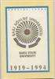
4604 water_14.jpg No Greg Burris

4605 water_15.jpg No Greg Burris

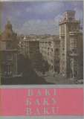

4764 Azerbaijan landscapes No Farid Mamedov Extima

4766 Azerbaijanian Jewellery Art
Yes Intourist 1989 28 pp.

4767 Azerbaijan Miniatures Yes Husseinzade, Huseyn
(photo & design)
Minaret Advertising Company
1996 20 pp.

4768 Azerbaijan Carpets Yes Husseinzade, Huseyn (photo & design)
Minaret Advertising Company
1996 20 pp.

4811 Azerbijanians Concert Yes

Book/Bound
2160 Azerbaijan Republic No (country survey)

2161 Seki (in Latinic Azeri) No

2162 Travel Brochure No “Gobustan”

2163 Azerbaijan State Theater No of Opera and Ballet

3096 The Azerbaijanis: People, Culture and History
Yes Editors Nicholas Awde and Fred James Hill
Bennett & Bloom 2009 255 pp.

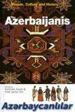

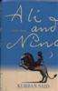
4000 Ali and Nino: A Love Story
Yes Said, Kurban
Woodstock: Overlook Press
1996

4001 Anlashilmaz
Muhasibatlarden Stratezhi Tarafdashligha Doghru (Oktjabr 1991-
Avgust 1997)

4002 Azerbaijan (Azerbaycan) Oil in the World Policy
No Hasanob, Ali, Azerbaijan-A.B.Sh

Yes Aliyev, Heidar (Heydar)
Baku: Azerbaijan Universiteti

Baku: Azerbaijan Publishing House
1997

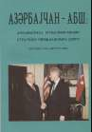
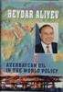
1997

4003 Azerbaijanis: a historico- ethnographic sketch
No Аббасов, А.А. Baku: Academy of
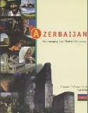
Sciences of Azerbaijan. Institute
1998

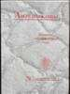
4019 Azerbaijan: An Emerging Free Market Democracy
Yes Embassy of the Republic of Azerbaijan
Washington: BSMG Worldwide
1998

4020 Azerbaijan's Application for Membership of the Council of Europe
Yes Council of Europe Council of Europe 2000 17 pp.

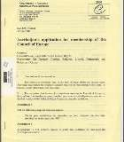
4021 Azerbaijan No Abdullazade, Fatma Baku 1998

4022 Baku State University 1919-1999

Yes Rasulzade, M.A. Baku 2000

4023 Constitution of the Azerbaijan Republic (European Commission for democracy through Law)

No European
Commission for Democracy Through Law

2000

4025 Gobustan No Maemaedov, Raccavi
M. Maemmaedov, Raeccavi
Baku: Ishig 1990 24 pp.

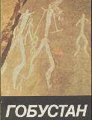
4026 Karabakh: Uncontolled Zone (In the occupied Azerbaijani Territory)
Yes Novruzoglu, Rovshan and Yunus Oguz
Baku: Ozan 2002

4027 1500 Years of Oghuz Poetry: an Anthology

No Anar, Ed Azerbaijan Nashriyyati: Baku

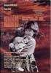
1999

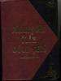
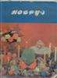
4028 Novruz No Baku 1989

4030 Prezident '93-'97 (Azeri President Heyder AliYEV)
No Weiss, Monika Baku: WestPrint 1998

4031 Problem of the Hero in the Prose of John Wayne

No Зейналова, С.А. Baku: Azerbaijan
State University: Baku

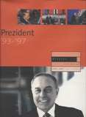
1993

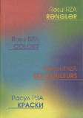
4032 Rasul RZA Colors No

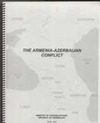
4033 Armenia-Azerbaijan Conflict
Yes Ministry of Foreign Affairs, Rep. of Azerbaijan
Ministry of Foreign Affairs. Republic of Azerbaij
1999

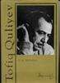
4034 Heart No Mahnilari, Urek Baku 2000

4035 Outstanding Men of Azerbaijan

Yes Safarova, Zemfira Baku: Yazychi 1985

4196 Molla Panah Vagif: An Outline of Life and Creative Activity

Yes Dadashzade, Araz Azerbaijan State
Publishing House: Baku

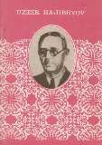
1968

4250 Azerbaijan State Theater of Opera and Ballet
No Shipton, James (ed.) Istanbul: UN
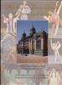
Development Programme

4251 Azerbaijan with Georgia No Elliott, Mark Surrey, UK:
Trailblazer Publications
1999

4252 An Analysis of Manufacturing Management in the Developing Countries with the Transition Economy
No Baqirov, H.S., et al Western University.
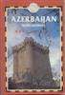
Baku-ELM
1999

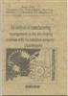
4297 Šeki No Intourist Moscow?: Intourist 1989
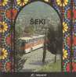

4299 Azerbaijan: An Emerging Free Market Democracy
Yes Embassy of the Republic of Azerbaijan
Washington: BSMG Worldwide
1998

4301 Eyes Which Have Seen Too Much: Refugee Children in Azerbaijan,
c. 2
Yes Graves, Edwin NAYORA 2000

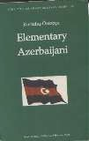
4304 Azerbaijan-USA No Haesaenov, Ali Baku: Azerbaijan University nashriyyati
4303 Elementary Azerbaijani,
c. 2
Yes Öztopçu, Kurtuluş
Santa Monica: Turk 2000 Dilleri
Arastirmalari Dizisi: 2

1997

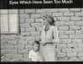
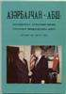
4305 Law on Parliamentary Elections of the Republic of Azerbaijan (European Commission for Democracy through Law)
Yes Nolte, G. Strasbourg: Council of Europe
2000

4331 Dried Up in Meetings & Other Short Stories
Yes Jalal, Mir Sherman Oaks: Azerbaijan International
1998

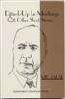
4333 Azerbaijani Language (c.
2)
No Gouliyeva, Mina Baku 2001

4334 Jaloliddin Manguberdi No Кагаматом,
Khavidulla

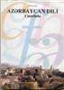
Tashkent 1999

4353 Nizami's Characters on the Carpets

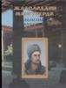
No 1991

4376 Salam Azerbaijan: Aitf 2002

4472 Nature Protection in the Caucasus
Yes

Yes Federal Ministry for Economic Coop. and Dev.

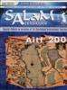

Germany 2006 18 pp. and map

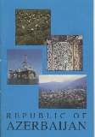
4639 USAID Azerbaijan: From Relief to Development
Yes Effendi, Rena USAID/Caucasus Azerbaijan
2002

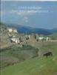
4684 Republic of Azerbaijan Yes Embassy of the
Republic of Azerbaijan
Embassy of the Republic of Azerbaijan
1993 30

4685 Nizami Gencevi Yes Israfilov, I. R. (ed) Kismet 1996 approx
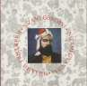
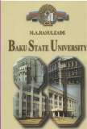
25

4687 Baku State University Yes Hasanov, Ayaz Minimax 2000 49pp

4690 Old Baku No Nazim Ibragimov Azerbaijan Press 1997 188pp

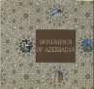
4731 Monuments of Azerbaijan
Yes Ministry of Culture and Tourism
2007 [38 pp.]

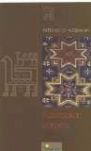
4732 Patterns of Azerbaijan: Azerbaijan Carpets
Yes Ministry of Culture and Tourism
2007
32 pp.
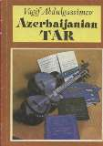
4733 Azerbaijanian Tar Yes Vagif Abdulgassimov 1990 112 pp.

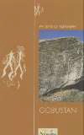
4734 Patterns of Azerbaijan: Gobustan
Yes Aida Amirova (editor)
2007
36 pp.

4772 Azerbaijan Republic Yes Housseynzade, Hafiz Tisamat Basim,
Ankara, Turkey
1998 95 pp.

4902 Patterns of Azerbaijan: Gobustan
Yes Ministry of Culture
and Tourism, Azerbaijan
2007

4903 Patterns of Azerbaijan: Azerbaijan carpets
Yes Ministry of Culture
and Tourism, Azerbaijan
2007

4905 Baku: photo album Yes Ministry of Culture and Tourism, Azerbaijan

Cassette
2028 Passion Plays No Moazzenzaadeh Ardabili

2037 Agadadash Agayev - No Karvan

CD

3005 Arezoo/Longing – with the Azerbaijan State Symphony Orchestra
No Yaqub Zoroofchi Ebrahim and
Mendi Ahmadi
1996

3009 Best of Zoroofchi No Yaqub Zoroofchi Ebrahim and Mehdi Ahmadi
1995

3011 Classical Music of Azerbaijan
No Azerbaijan State Chamber Orchestra

3019 Lights of Baku No Various Artists

3027 Three-CD Set No Rashid Beibutov

3029 With Love From Azerbaijan
No Fidon Kasimova, Khuraman Kasimova, Chingiz Sadykho
1997

3030 Jazz Tale No Vaqif Mustafa-Zadeh

3034 Azeri Rap Stars No various

3036 Classical Music of No Azerbaijan 1

3037 Classical Music of No Azerbaijan 2

3038 Classical Music of No Azerbaijan 3

3039 Classical Music of No Azerbaijan 4

3040 Classical Music of No Azerbaijan 5

3041 Classical Music of No Azerbaijan 6

3042 Classical Music of No Azerbaijan 7

3043 Elementary Azerbaijani I No Kurtulus Oztopcu

3044 Elementary Azerbaijani II No Kurtulus Oztopcu

3045 Elementary Azerbaijani III
No Kurtulus Oztopcu

3048 Tofiq Quliev No Mahnilari, Urek Azerbaijan Respublicas Medgninet Nazirliyi
2000

3049 2 CD set (copy 1) No Mamedov Family Ensemble
2003

3050 2 CD set (copy 2) No Mamedov Family Ensemble
2004

3057 Vaqif Mustafa-Zaden No Vaqif Mustafa-Zadeh

3062 World of the Rast No Rast Dunyasi R. Hasimov

3064 Dance of Fire No Aziza Mustafa Zadeh

3065 Rast No Rast Dunyasi

3073 Pearls of Azerbaijan No various

3074 Elementary Azerbaijani I No Kurtulus Oztopcu

3075 Elementary Azerbaijani II No Kurtulus Oztopcu

3076 Elementary Azerbaijani III
No Kurtulus Oztopcu

3086 Mamedov Family Ensemble of Azerbaijan
No Mamedov Family Ensemble
Shahyar Daneshgar 2003

4580 The Land of Fire: Music of Azerbaijan
No Alihan Samedov Mega Muzik 2002 74 min

4581 Icheri seherin nayillari No Eldar Mansurovun Shahin-R 2003

Cloth/Fabric
2043 Embroidered cloths (3) No

2224 Orange miniature rug No

4735 Miniature Azerbaijani No Rug

Clothing

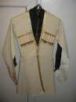
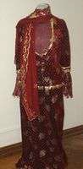
2045 Women's costume
No
2507 Slippers, red with cream No stripes

4362 Boys Costume No

4366 Women's Pants No

4587 Socks No

DVD
1004 Absurdistan Yes Helmer, Veit First Run Features 2008 90 min

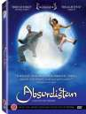
1084 Global Voices--Grade 3 No Goetze, Mary & Fern,
Jay
McGraw Hill 2005

1231 Azerbaijan Cooking Demonstration w/ Basti Bayramova

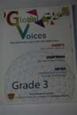
Yes 2002 50 min

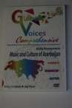
3098 TransCaucasus: Georgia, Armenia, Azerbaijan
Yes Globescope Expeditions
TravelVideoStore.co m

4620 Global Voices Comprehensive: Music & Culture of Azerbaijan
Yes Aida Huseynova Mary Goetze & Jay
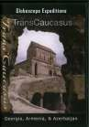
Fern
2007

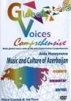
5036 Music and Culture of Azerbaijan
Yes Goetze, Mary
MJ & associates
2007
n/a
Flag
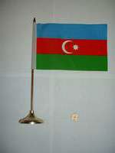
2070 flag on metal base No

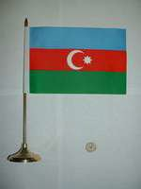
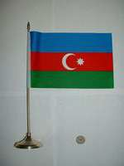
2071 small flag w/ metal stand No

2266 small flag w/ wooden No stand

2491 Azeri Flag No

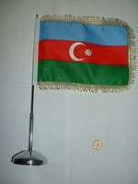
Hat
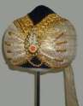
2112 Turban No

Map

4545 Map of the Azeribaijan Republic
No Republic of
Azerbaijan

4550 Map of Qafqaz No Azerbaijan Republic 2002

4560 Map of Azerbaijan No Azerbaijan Republic 1994

4563 Map of Azerbaijan No Azerbaijan Republic 2002

4565 Map of Azerbaijan No Azerbaijan Republic 2002

4638 Tourist map of Baku Yes Ministry of Youth, Sport, and Tourism
2003

4777 Azerbaijan Republic No Torgovlia Bayram Company, Baku

Misc.
2228 Kitabi-Dada Qorqud – No 1300

2229 Kitabi-Dada Qorqud – No 1300

2240 Azeri stamps No

4771 Scenes from Azerbaijan No

4773 Scenes from Azerbaijan No

4775 Baku Yes Mamedov, Farid Extima

4776 The Palace of Shaki Khans
Yes Memedov, Farid Extima

4904 Azerbaijan Brochure Yes Ministry of Culture and Tourism, Azerbaijan

Model
2130 Azeri female No

2268 Azeri female No

Periodical

4004 Azerbaijan Architecture International
No 1998

4005 Azerbaijan
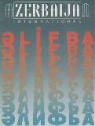
International - Quest for Independence

No Blair, Betty Sherman Oaks: Azerbaijan International

1998 102 pp.

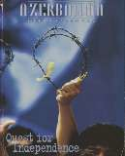
4006 Azerbaijan International No Blair, Betty Sherman Oaks:
Azerbaijan International
1993

4007 Azerbaijan International: Winter of Disbelief

4008 Azerbaijan International: Oil 100 Years Ago

4009 Azerbaijan International: Fixing the Future Environmental Challenges

4010 Azerbaijan International: Health and Medical Care
No Blair, Betty Sherman Oaks: Azerbaijan International

No Blair, Betty Sherman Oaks: Azerbaijan International

No Blair, Betty Sherman Oaks: Azerbaijan International

No Blair, Betty Sherman Oaks: Azerbaijan International
1994 64 pp.
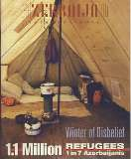

1994 78 pp.
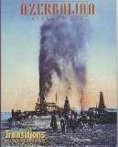

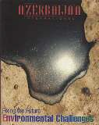
1994

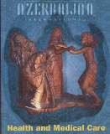
1995 94 pp.

4011 Azerbaijan International: Crisis in the Arts

4012 Azerbaijan International: Resources: Natural & Intellectual

4013 Azerbaijan International: Leisure & Play

4014 Azerbaijan International: Contemporary Literature
No Blair, Betty Sherman Oaks: Azerbaijan International

No Blair, Betty Sherman Oaks: Azerbaijan International

No Blair, Betty Sherman Oaks: Azerbaijan International

No Blair, Betty (editor) Sherman Oaks:
Azerbaijan International
1995 81 pp.
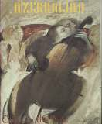

1995 88 pp.
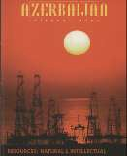

1995 88 pp.
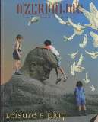

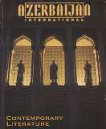
1996 88 pp.

4015 Azerbaijan International: Science That Made a Difference
No Blair, Betty Sherman Oaks: Azerbaijan International
1996

4016 Azerbaijan International: Verbal Folklore
No Blair, Betty Sherman Oaks: Azerbaijan International
1996 88 pp.

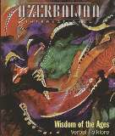
4017 Azerbaijan International No Blair, Betty Sherman Oaks:
Azerbaijan International
1997

4018 Azerbaijan International No Sherman Oaks: Azerbaijan International
2002

4029 Populyar: Azerbaijan beynalkhaq jurnaly

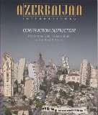
4359 Azerbaijan International: Pathfinders:Deciphermen t of the Caucasian Albanian Script
No 1997

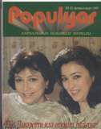
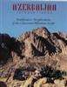
Yes Pirouz Khanlou 2003

4663 Azerbaijan International Yes Blair, Betty (editor) Azerbaijan
International
2005 100pp.

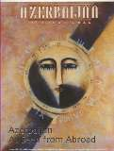

4686 | Azerbaijan International | Yes | Blair, Betty (ed) | Azerbaijan | 2002 | 88pp
 | Mazagine |  |  | International

4739 Azerbaijan International Yes Betty Blair, ed. Azerbaijan
International, Sherman Oaks, CA
4744 | Azerbaijan International | Yes | Blair, Betty (ed) | Azerbaijan | 2002 | 88 pp.
 | Magazine |  |  | International

1011 Azerbaijan Dance Show No
VHS
1998 96 p.

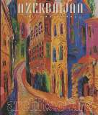

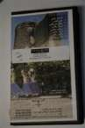
1013 Azeribaijan Cookery Part 2
No 2002 86 min

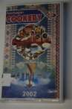
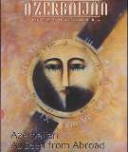

1015 Azerbaijani Traditional No and Folk Musiс

1086 Last Performance of: Rashid Behbodof & Shokat Ali Akbar Ova

1094 Memory of Taste, Parts I and II
No Rashid Behbodof & Shokat Ali Akbar Ova

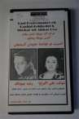
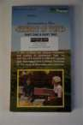
No Ayna-Media Group 1999 52 min

1121 Özge Ömür No Directed by R. Ocaqov
94 min

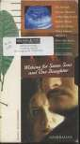
1175 Wishing for Seven Sons and One Daughter
No Soros Foundation
Gender Montage Series
2002
25 min
VCD

3007 Azerbaijan
Panorami/Panorama of Azerbaijan ’98
No Osman M.
Qunduzov Multimedia Center
1998

4901 Welcome to Azerbaijan Yes

