Circulating Items Inventory - Clothing Inner Asian & Uralic National Resource Center
January 2008

Azerbaijan Azerbaijan Clothing

Item: 4362

Title: Boys Costume
Category Language: Description:

Item: 2507
Title: Slippers, red with cream stripes
Category Language: Description:

Artifact
Artifact
cream-colored jacket with black pants Azeri (small), black & gold blouse
Artist: Prducr: Date:
Length:
Picture
English Version:
Cyrillic Title

Cyrillic Title

English Version:
red knitted woollen slippers with cream stripes

Artist: Prducr: Date: Length:
Picture

Item: 4587
Title: Socks
Category Language: Description:
Artifact

Artist:

Picture

Item: 2045
Title: Women's costume
Category Language: Description:

Item: 4366
Title: Women's Pants
Category Language: Description:

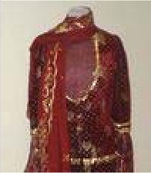
Artifact
English Version:
Cyrillic Title
Prducr:
Date: Length:
Artifact
Azeri wedding costume: red velvet skirt and jacket with gold trim, semi-sheer red and gold blouse, red and gold headscarf (4 parts total)
Artist: Prducr: Date:
Length:
Picture
English Version:
Cyrillic Title

Cyrillic Title

English Version:
Maroon with gold embroidery

Artist: Prducr: Date: Length:
Picture

Hat

Item: 2112

Title: Turban
Category Language: Description:

Artifact
blue and gold turban
Artist:
Picture

Central Asia

Accessories

Item: 4672

Title: Bag

Category Language: Description:

Artifact
Small blue bag with gold patter
Artist:
Picture

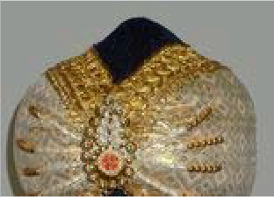
English Version:
Cyrillic Title
Prducr: Date:
Length:
English Version:
Cyrillic Title
Prducr:
Date: Length:

Item: 4673
Title: Hanging decoration
Category Language: Description:

Kazakhstan

Accessories

Item: 2000

Title: Amulet
Category Language: Description:

Artifact
leather Kazakh amulet
Artist:
Picture

Artifact
Small red bag with gold flower design
Artist: Prducr: Date:
Length:
Picture
English Version:
Cyrillic Title
Artifact
Black felt decoration with sliver design and tassels
Artist: Prducr: Date:
Length:
Picture
English Version:
Cyrillic Title
English Version:
Cyrillic Title
Prducr:
Date: Length:

Clothing

Item: 2504

Title: Hat (national costume)
Category Language: Description:

Item: 4627
Title: Kazakh men's hat - kalpak
Category Language: Description:

Artifact
Made of wool
Artist:
Picture

Item: 2051
Artifact
Green velveteen round hat w/ gold trim
Artist: Prducr: Date:
Length:
Picture
English Version:
Cyrillic Title
English Version:
Cyrillic Title
Prducr: Date:
Length:
Title: Man's robe
Category Language: Description:

Artifact
black men's robe
Artist:
Picture

Item: 2503
Title: Pants (national costume)
Category Language: Description:

Item: 2505
Title: shawl for covering women's head
Category Language: Description:

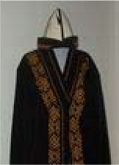
Item: 2502
English Version:
Cyrillic Title
Prducr: Date:
Length:
Artifact
Green velveteen boy's pants w/ gold trim
Artist: Prducr: Date:
Length:
Picture
English Version:
Cyrillic Title
Artifact
white shawl with sewn in head hole, blue, pink silver embroidery
Artist: Prducr: Date:
Length:
Picture
English Version:
Cyrillic Title
kimishek
Title: Shirt (national costume)
Category Language: Description:

Item: 2047
Title: Woman's vest
Category Language: Description:

Artifact
women's vest - red-silver
Artist:
Picture

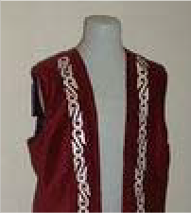
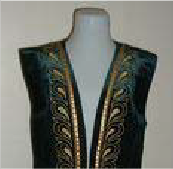
Artifact
Green velveteen boy's short- sleeved jacket w/ gold trim
Artist: Prducr: Date:
Length:
Picture
English Version:
Cyrillic Title
English Version:
Cyrillic Title
Prducr: Date:
Length:
Artifact
women's vest - green-gold with hat
Artist: Prducr: Date:
Length:
Picture
English Version:
Cyrillic Title

Hat

Item: 2102

Title: Kalpak
Category Language: Description:

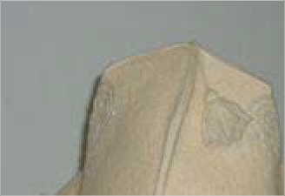
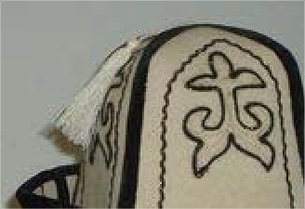
Item: 4475
Artifact
red woman’s vest, with gold trim and clasp
Artist: Prducr: Date:
Length:
Picture
English Version:
Cyrillic Title
Artifact
white plain felt kalpak with white tassel
Artist: Prducr: Date:
Length:
Picture
English Version:
Cyrillic Title
Artifact
White felt, black velvet borders, gold and black embroidery w/ white tassle
Artist: Prducr: Date:
Length:
Picture
English Version:
Cyrillic Title
Title: Kazakh green hat
Category Language: Description:

Artifact
Artist:
Picture

Item: 4670
Title: Kazakh women's hat
Category Language: Description:

Artifact
Red with gold pattern
Artist:
Picture

Item: 2086
Title: Man's hat
Category Language: Description:

Artifact
man's hat - black on white
Artist:
Picture

English Version:
Cyrillic Title
Prducr: Date:
Length:
English Version:
Cyrillic Title
Prducr: Date:
Length:
English Version:
Cyrillic Title
Prducr: Date:
Length:

Artifact
man's hat - gold on black
Artist:
Picture

Artifact
man's hat - gold on black
Artist:
Picture

Item: 2497
Title: Taqiya
Category Language: Description:

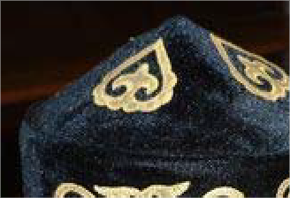
Kyrgyzstan
English Version:
Cyrillic Title
Prducr: Date:
Length:
English Version:
Cyrillic Title
Prducr: Date:
Length:
Artifact
Blue Kazakh hat, yurt-shaped with gold trim
Artist: Prducr: Date:
Length:
Picture
English Version:
Cyrillic Title

Accessories

Item: 2265

Title: horsewhip
Category Language: Description:

Artifact
Manas horsewhip
Artist:
Picture

Item: 2260
Title: whip
Category Language: Description:

Clothing

Item: 4626

Title: Kyrgyz men's hat - dopu (wool)
Category Language: Description:

Artifact
Made of wool
Artist:
Picture

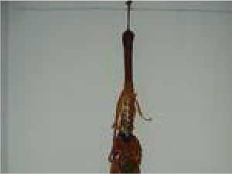
English Version:
Cyrillic Title
Prducr: Date:
Length:
Artifact
Manas 1000 year commemorative whip
Artist: Prducr: Date:
Length:
Picture
English Version:
Cyrillic Title
English Version:
Cyrillic Title
Prducr:
Date: Length:
2007

Item: 2053
Title: Man's robe
Category Language: Description:

Item: 2052
Title: Sholpan
Category Language: Description:

Item: 2056
Title: Woman's costume
Category Language: Description:

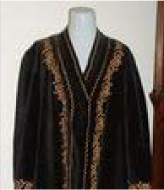
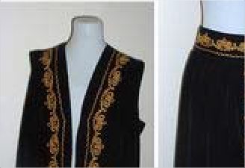
Artifact
Artifact
Black Kyrgyz male robe w/ gold trim
Artist: Prducr: Date:
Length:
Picture
English Version:
Cyrillic Title
Artifact
black sholpan with purple and orange decorative trim
Artist: Prducr: Date:
Length:
Picture
English Version:
Cyrillic Title

Cyrillic Title

English Version:
Black Kyrgyz Women's Costume: 2 parts, vest and skirt w/ gold trim

Artist: Prducr: Date: Length:
Picture

Item: 2054
Title: Woman's jacket
Category Language: Description:

Item: 4371
Title: Woman's short-sleeved jacket
Category Language: Description:

Artifact
Black jacket with gold embroidery
Artist:
Picture

Item: 2055
Title: Woman's vest
Category Language: Description:

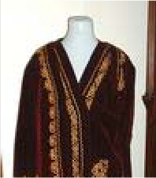
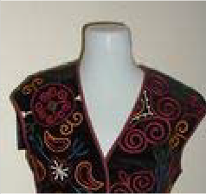
Artifact
Artifact
maroon Women's jacket w/ gold trim
Artist: Prducr: Date:
Length:
Picture
English Version:
Cyrillic Title
English Version:
Cyrillic Title
Prducr: Date:
Length:

Cyrillic Title

English Version:
women's vest w/ tassels: black w/ purple, blue, orange, cream and green embroidery
Artist: Prducr: Date: Length:
Picture

Item: 2633
Title: Woman's vest and skirt
Category Language: Description:

Hat

Item: 2090

Title: Kalpak
Category Language: Description:

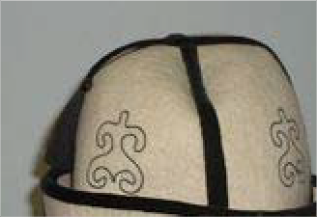
Artifact
maroon vest and skirt with gold trim in two threads, bull's horns pattern
Artist: Prducr: Date:
Length:
Picture
English Version:
Cyrillic Title
Artifact
all-white Kyrgyz kalpak with black trim and tassel
Artist: Prducr: Date:
Length:
Picture
English Version:
Cyrillic Title
Artifact
white Kyrgyz kalpak with black brim, trim, and tassel
Artist: Prducr: Date:
Length:
Picture
English Version:
Cyrillic Title

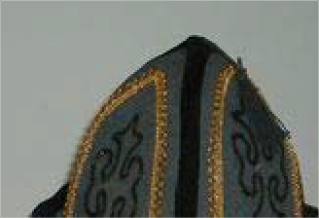
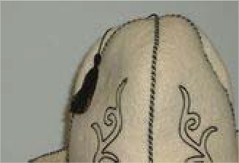
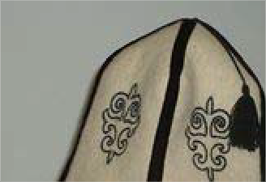
Item: 2089
Artifact
charcoal gray kalpak with velvet cuff, black & gold borders and black tassel
Artist: Prducr: Date:
Length:
Picture
English Version:
Cyrillic Title
Artifact
white kalpak with white cuff, black borders and black tassel
Artist: Prducr: Date:
Length:
Picture
English Version:
Cyrillic Title
Artifact
white kalpak with black velvet cuff, black velvet borders and black tassel
Artist: Prducr: Date:
Length:
Picture
English Version:
Cyrillic Title
Title: Man's hat
Category Language: Description:

Artifact
man's hat - black-white
Artist:
Picture

Item: 2093
Title: Woman's hat
Category Language: Description:

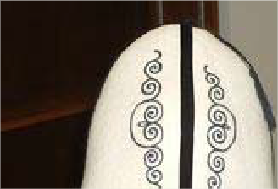
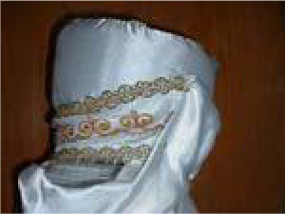
Mongolia
English Version:
Cyrillic Title
Prducr: Date:
Length:
Artifact
Male felt hat: white w/ black trim and gold trim on brim
Artist: Prducr: Date:
Length:
Picture
English Version:
Cyrillic Title
Artifact
Elechek (married female hat)
~white turban w/ gold trim w/ white scarf/veil w/ fringe
Artist: Prducr: Date:
Length:
Picture
English Version:
Cyrillic Title

Clothing

Item: 4610

Title: Mongolian Hat (Men's)
Category Language: Description:

Artifact
Artist:
Picture

Item: 4611
Title: Mongolian Hat (Women's)
Category Language: Description:
Artifact

Artist:

Picture

Item: 2060
Title: Woman's robe
Category Language: Description:

Artifact
women's purple quilted robe
Artist:
Picture

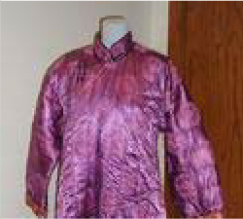
English Version:
Cyrillic Title
Prducr: Date:
Length:
2007
English Version:
Cyrillic Title
Prducr: Date:
Length:
2007
English Version:
Cyrillic Title
Prducr: Date:
Length:

Hat

Item: 2111
Title: Cone-shaped hat
Category Language: Description:

Regional

Accessories

Item: 2252

Title: Birds
Category Language: Description:

Artifact
set of blue and yellow birds
Artist:
Picture

Item: 2249
Artifact
blue/multi-colored soft cone- shaped hat with multi-colored fringe
Artist: Prducr: Date:
Length:
Picture
English Version:
Cyrillic Title
English Version:
Cyrillic Title
Prducr: Date:
Length:
Title: gourd naas-holder
Category Language: Description:

Artifact
Artist:
Picture

Item: 2244
Title: Knife
Category Language: Description:

Item: 4585
Title: Power Transmission Cable (From JVC Stereo)
Category Language: Description:

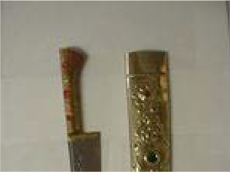
Item: 2241
English Version:
Cyrillic Title
Prducr: Date:
Length:
Artifact
knife w/ gold colored sheath and Arabic writing
Artist: Prducr: Date:
Length:
Picture
English Version:
Cyrillic Title
Artifact
Friction-based coupling. Polarized, ungrounded. Appears to be designed for use with 110v AC line current.
Artist: Prducr: Date:
Length:
Picture
English Version:
Cyrillic Title
Title: rosary
Category Language: Description:

Artifact
black and red
Artist:
Picture

Item: 2234
Title: Scabbard knives
Category Language: Description:

Artifact
(2)
Artist:
Picture

Item: 2236
Title: small black knife
Category Language: Description:

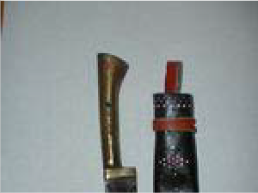
Item: 2250
English Version:
Cyrillic Title
Prducr: Date:
Length:
English Version:
Cyrillic Title
Prducr: Date:
Length:
Artifact
in black leather (stitched green, red) sheath
Artist: Prducr: Date:
Length:
Picture
English Version:
Cyrillic Title
Title: Spoons
Category Language: Description:

Artifact
2 wooden spoons
Artist:
Picture

Item: 2258
Title: tea cosy
Category Language: Description:

Item: 2251
Title: Wind Chime
Category Language: Description:

Artifact
silent wind chime
Artist:
Picture

English Version:
Cyrillic Title
Prducr: Date:
Length:
Artifact
Red, blue, black striped tea cosy w/ gold lamé and 3 yellow poofs
Artist: Prducr: Date:
Length:
Picture
English Version:
Cyrillic Title
English Version:
Cyrillic Title
Prducr: Date:
Length:

Turkey

Clothing

Item: 4589
Title: Bag/Purse
Category Language: Description:
Artifact

Artist:

Picture

Artifact
Artist:
Picture

Item: 4646
Title: Belly dancing wear
Category Language: Description:

Artifact
Blue with metal attachments
Artist:
Picture

Item: 4643
English Version:
Cyrillic Title
Prducr:
Date: Length:
English Version:
Cyrillic Title
Prducr: Date:
Length:
English Version:
Cyrillic Title
Prducr: Date:
Length:
2007
Title: Turkish fez
Category Language: Description:

Artifact
Maroon with black tassel
Artist:
Picture

Item: 4644
Title: Turkish hat
Category Language: Description:

Item: 4642
Title: Turkish slippers
Category Language: Description:

Artifact
Blue with yellow trim
Artist:
Picture

Item: 4645
English Version:
Cyrillic Title
Prducr: Date:
Length:
2007
Artifact
Black with gold and mirror trim (male?)
Artist: Prducr: Date:
Length:
Picture
English Version:
Cyrillic Title
2007
English Version:
Cyrillic Title
Prducr: Date:
Length:
2007
Title: Turkish woman's hat
Category Language: Description:

Turkmenistan

Accessories

Item: 2261

Title: bread decorator
Category Language: Description:

Artifact
bread-decorator
Artist:
Picture

Item: 2259
Title: coin purse
Category Language: Description:

Artifact
Yellow hat with integrated scarf. Coin trimming
Artist: Prducr: Date:
Length:
Picture
English Version:
Cyrillic Title
2007
English Version:
Cyrillic Title
Prducr: Date:
Length:
Artifact
black coin purse w/ multicolored stitching
Artist: Prducr: Date:
Length:
Picture
English Version:
Cyrillic Title

Item: 2004
Title: Handbag
Category Language: Description:

Artifact
Red carpet handbag
Artist:
Picture

Item: 2255
Title: Hot pad
Category Language: Description:

Item: 2256
Title: patch
Category Language: Description:

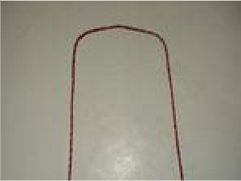
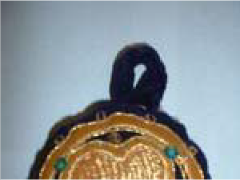
English Version:
Cyrillic Title
Prducr:
Date: Length:
Artifact
Blue hot pad w/ red, orange and white stitching
Artist: Prducr: Date:
Length:
Picture
English Version:
Cyrillic Title
Artifact
Black patch w/ mulitcolored embroidery
Artist: Prducr: Date:
Length:
Picture
English Version:
Cyrillic Title

Item: 2254
Title: Pillow Cover
Category Language: Description:

Artifact
Yellow/black pillow cover
Artist:
Picture

Item: 2001
Title: Pins

Category Language: Description:

Artifact
pins (6)
Artist:
Picture

Artifact
6 Turkmenistani pins
Artist:
Picture

English Version:
Cyrillic Title
Prducr:
Date: Length:
English Version:
Cyrillic Title
Prducr: Date:
Length:
English Version:
Cyrillic Title
Prducr: Date:
Length:

Clothing

Item: 2058
Title: Man's robe
Category Language: Description:

Artifact
Gray Man's Robe
Artist:
Picture

Item: 2059
Title: Man's shirt
Category Language: Description:

Artifact
white men's shirt
Artist:
Picture

Item: 2057
Title: T-shirts (2)
Category Language: Description:
Artifact

Artist:

Picture

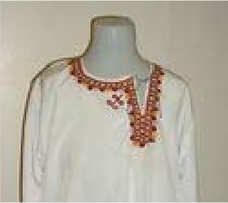
English Version:
Cyrillic Title
Prducr:
Date: Length:
English Version:
Cyrillic Title
Prducr: Date:
Length:
English Version:
Cyrillic Title
Prducr:
Date: Length:

Item: 4608
Title: Turkmen Hat (White & Wooly) Category Language: Description: Artifact

Artist:

Picture

Hat

Item: 2094

Title: Man's hat
Category Language: Description:

Artifact
man's hat - sheepskin (Turkmen)
Artist:
Picture

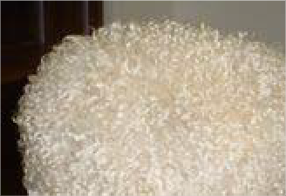
Item: 2095
English Version:
Cyrillic Title
Prducr:
Date: Length:
2007
English Version:
Cyrillic Title
Prducr: Date:
Length:
Title: Skullcap
Category Language: Description:

Item: 2096
Title: Woman's hat
Category Language: Description:

Artifact
White, black and red women's hat
Artist:
Picture

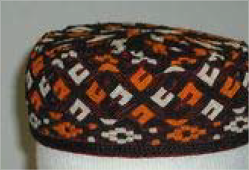
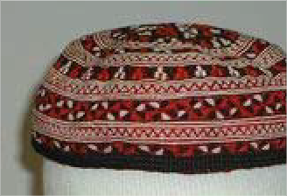
Tuvan
Artifact
black, orange and white Turkmen skullcap
Artist: Prducr: Date:
Length:
Picture
English Version:
Cyrillic Title
Artifact
Black skullcap w/ multicolored embroidery and braided edging
Artist: Prducr: Date:
Length:
Picture
English Version:
Cyrillic Title
English Version:
Cyrillic Title
Prducr:
Date: Length:

Clothing

Item: 2061

Title: Woman's vest
Category Language: Description:

Artifact
women's purple quilted vest
Artist:
Picture

Uzbekistan

Accessories

Item: 2003

Title: Scarf
Category Language: Description:

Artifact
Red Scarf with pink roses
Artist:
Picture

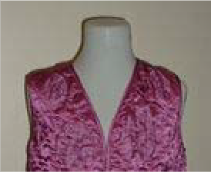
Clothing
English Version:
Cyrillic Title
Prducr: Date:
Length:
English Version:
Cyrillic Title
Prducr: Date:
Length:

Item: 2068

Title: Man's robe
Category Language: Description:

Item: 2063
Title: Robe
Category Language: Description:

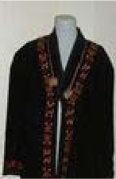
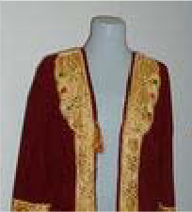
Item: 2065
Artifact
men's blue and black winter robe and belt sash
Artist: Prducr: Date:
Length:
Picture
English Version:
Cyrillic Title
Artifact
Black robe with multicolored embroidery and braided edging (Karakalpak)
Artist: Prducr: Date:
Length:
Picture
English Version:
Cyrillic Title
Artifact
Crimson Robe w/ golden embroidery MISSING AS OF 11/30/05
Artist: Prducr: Date:
Length:
Picture
English Version:
Cyrillic Title
Title: Slippers
Category Language: Description:

Item: 2046
Title: Woman's dress
Category Language: Description:

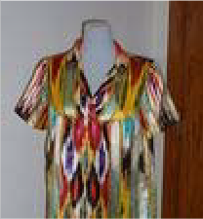
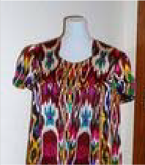
Hat
Artifact
Crimson with gold embroidered slippers
Artist: Prducr: Date:
Length:
Picture
English Version:
Cyrillic Title
Artifact
multicolored silk women's dress (Uzbek/Tajik: atlas)
Artist: Prducr: Date:
Length:
Picture
English Version:
Cyrillic Title
Artifact
Multi-colored dress w "shokh amir temur" in the fabric
Artist: Prducr: Date:
Length:
Picture
English Version:
Cyrillic Title

Item: 2105

Title: Karakalpak
Category Language: Description:

Item: 2097
Title: Man's hat
Category Language: Description:

Artifact
man's hat - black
Artist:
Picture

Item: 2109
Title: Skullap
Category Language: Description:

Item: 2098
Artifact
Karakalpak curly sheep hair hat (brown)
Artist: Prducr: Date:
Length:
Picture
English Version:
Cyrillic Title
English Version:
Cyrillic Title
Prducr: Date:
Length:
Artifact
soft black velvet tibiteka (skullcap) with gold decorations
Artist: Prducr: Date:
Length:
Picture
English Version:
Cyrillic Title
Title: Skullcap
Category Language: Description:

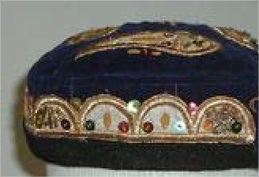
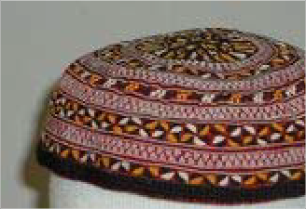
Artifact
Artifact
blue velvet skullcap w/ paisleys in gold embroidery for women
Artist: Prducr: Date:
Length:
Picture
English Version:
Cyrillic Title
Artifact
gold, red, and blue skullcap with gold tassel
Artist: Prducr: Date:
Length:
Picture
English Version:
Cyrillic Title
Artifact
soft red, black and white tibiteka (skullcap)
Artist: Prducr: Date:
Length:
Picture
English Version:
Cyrillic Title

Cyrillic Title

English Version:
soft maroon, yellow, white and black tibiteka (skullcap)

Artist: Prducr: Date: Length:
Picture

Artifact
Artifact
soft black velvet tibiteka (skullcap) with gold decorations
Artist: Prducr: Date:
Length:
Picture
English Version:
Cyrillic Title
Artifact
hard black tibiteka (skullcap) with white decorations
Artist: Prducr: Date:
Length:
Picture
English Version:
Cyrillic Title
Artifact
Black hat with multicolored embroidery and braided edging (Karakalpak)
Artist: Prducr: Date:
Length:
Picture
English Version:
Cyrillic Title

Cyrillic Title

English Version:
Dopi: black and white (made from paper)

Artist: Prducr: Date: Length:
Picture

Item: 2100
Title: Woman's hat
Category Language: Description:

Artifact
Dopi: black and white embroidered with teardrop design and bordered by small circles
Artist: Prducr: Date:
Length:
Picture
English Version:
Cyrillic Title
Artifact
Dopi: black and white embroidered with teardrop design and bordered by cloverleaf and curled "Y"s
Artist: Prducr: Date:
Length:
Picture
English Version:
Cyrillic Title
Artifact
blue w/ paisley women's Navruz hat
Artist: Prducr: Date:
Length:
Picture
English Version:
Cyrillic Title

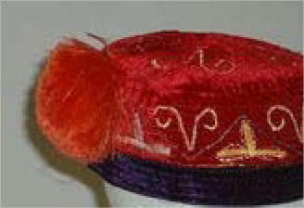
Artifact
Karakalpak red velvet, gold embroidered, purple bordered hat
Artist: Prducr: Date:
Length:
Picture
English Version:
Cyrillic Title

