Circulating Items Inventory - Finland

Book/Bound
Producer/Publisher Year Made Length Image
English? Artist/Author
Category of Item Item # Item Name

4066 Comparative
Governance: Politics in Finland

4067 Finland in the New Europe
Yes Shively, W. Phillips McGraw-Hill 1999

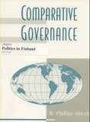
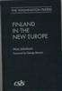
Yes Jakobson, Max Washington, DC:
The Center for Strategic and Inter

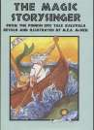
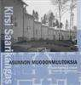

4573 | Asunnon | No | Kirsi Saarikangas | Suomalaisen | 2002 | 630pp
 | Muodonmuutoksia |  |  | Kirjallisuuden Seura

4899 The Magic Storysinger Yes M.E.A. McNeil Stemmer House 1993 111 pp.

CD
Producer/Publisher Year Made Length Image
English? Artist/Author
Category of Item Item # Item Name

3004 Archive Recordings of Ancient Finnish Songs
No The Kalevala Heritage Ondine, Inc 1995

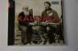

DVD
1010 Jade Warrior Yes Annila, Antti-Jussi Petri Jokiranta 2006 110 min

1017 Badding and Onnen Maa (Land of Happiness) (DVD)

1082 Kuutamolla (Lovers and Leavers) (DVD)
Yes Directed by
Markku Pölönen

Yes Directed by Aku
Louhimies
1993 59 min

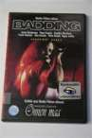
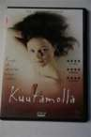
2002 114 min

1085 Lakeuden Kutsu (Return to the Plainlands) (DVD)
Yes Directed by: Ilkka
Vanne
2000 94 min

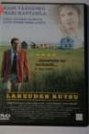
1088 Kites over Helsinki Yes Peter Lindholm Directed by Peter
Lindholm
2001 90 min

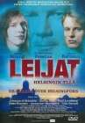
1095 Mies Vailla
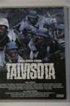
Menneisyytta (Man without a Past) (DVD)
Yes 2002 93 min

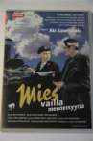
1145 Talvisota (The Winter War) (DVD)
Yes Directed by Pekka
Parikka
1989 191 min

1151 Tuntematon Sotilas (The Unknown Soldier) (DVD)
Yes Directed by Edvin
Laine
1955 169 min

4908 | Ambush | Yes | Tuuri, Antti and Olli | Marko Rohr and | 1999 | 123 min.
 |  |  | Saarela | Ilkka Matila

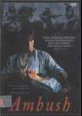
4916 The Cuckoo Yes Rogozhkin, Aleksandr Sony Pictures Classics
2002 103 min.

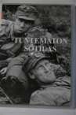

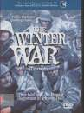
4961 The Winter War Yes Parikka, Pekka Nordisk 1990 125 min.

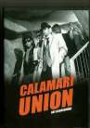
5030 Calamari Union Yes Kaurismäki, Aki Sputnik Oy 1985 78 min.

5031 Musta jää Yes Kotwican, Petri Making Movies Oy 2007 99 min.

5032 FC Venus Yes Tena, Joona Mongrel DVD 2005 111 min.

5035 Pearls and Pigs Yes Leppa, Pertu Nordisk Film 2003 107 min.

Misc.

4485 Cranium Game No 2006

Model
4500 Finnish Reindeer No

Periodical

4068 Form Function: Finland Yes Stenros, Anne (ed.) Helsinki: Design
Forum
1998

VHS

1039 Finland Yes International Video Network
1990 50 min

