Circulating Items Inventory - Hungary
Art/Photo
Producer/Publisher Year Made Length Image
English? Artist/Author
Category of Item Item # Item Name
2182 set of “Budapest” photo No slides

2183 Magyarorszag photo No slides set

4763 Hungary, Budapest 1969 II
Yes 1969

4765 Hungary, Buapest 1969 I Yes 1969

4786 Barokk No
Szoborgyuitemeny: Szepmuveszeti Muzeum, Budapest

Book/Bound

4328 Fall of the Red Star Yes Szablya, Helen & Peggy King Anderson
Boyds Mills Press 1996

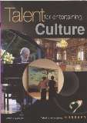
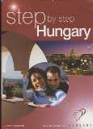
4653 Talent for Entertaining Yes Hungarian National Toursit Office

4654 Step by Step Hungary Yes Hungarian National Tourist Office

4655 Budapest Guide Yes Tourism Office of Budapest
2006

4658 A Dozen Reasons to Visit Hungary
Yes Hungarian
National Tourist Office

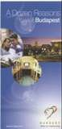
4659 A Doezen Reasons to Visit Budapest
DVD
Yes Hungarian
National Tourist Office

1018 Delta Yes Mundruczo, Kornel ICA Films 2008 92 min

4909 The Witness Yes Bacso, Peter Lajos Gyulyas and Otto Fold
1969 103 min.

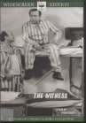
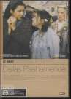
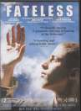
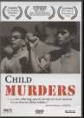
4918 Dallas Pashamende Yes Pejo, Robert Best Hollywood Kft. 2004 93 min.

4923 Fateless Yes Koltai, Lajos Thinkfilm 2005 140 min.

4924 Child Murders Yes Szabo, Ildiko Studio Alapitvany 1993 78 min.

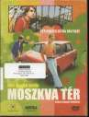
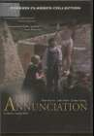
4928 Moszkva Ter Yes Buli Csajok Verda Hunnia Filmstudio 2001

4975 The Annunciation Yes Jeles, Andras Mafilm 1984 101 min.

4976 The Red and The White Yes Jancso, Miklos Mafilm and
Mosfilm
1968 92 min.

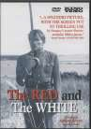
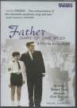
4977 Father - Diary of One Week
Yes Szabo, Istvan Hungarofilm 1966 85 min.

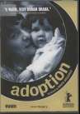
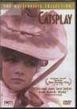
4978 Adoption Yes Meszaros, Marta Hungarofilm 1975 89 min.

4979 Catsplay Yes Makk, Karoly Facets Video 1974 98 min.

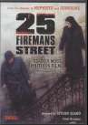
4980 25 Fireman's Street
Yes Szabo, Istvan
Kino Video
1973
97 min.
Map
4552 Map of Budapest No

4656 Budapest and Surroundings
Yes

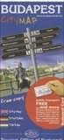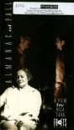
4657 Budapest City Map
Yes
Tourism Office of Budapest
1006 Almanac of Fall
No
Directed by Bela Tarr
1993
119 min
VHS
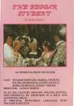
1023 Beggar Student, The Yes Milocker Seregi, Laszlo 1988 90 min

1029 Daniel Takes a Train No Directed by Pal Sandor

1036 Roncs Film No Directed by György Szomjas
1983 87 min

1992 90 min

1049 Girl, The No Directed by Marta Meszaros.

1053 Hanussen No Directed by Istvan Szabo.
1968 89 min

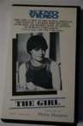
1989 117 min

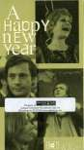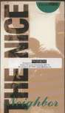
1054 Happy New Year, A
No
Directed by Reszo Szoreny
1979
184 min
1089 The Little Valentino
Yes Andras Jeles
Cinemagyar
1979
102 min
1110 Nice Neighbor, The
No
Directed by Zsolt Kesdi-Kovacs
1979
90 min

1111 Nobody's Daughter No Directed by Laszlo Ranody
1976 90 min

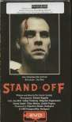
1122 Priceless Day, A No Directed by Peter Gothar
1139 Stand Off
No
Directed by Istvan Szabo
1990
103 min

1142 Sunday Daughters No Directed by Janosz Rozsa.
1980 87 min

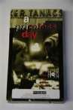
1989 100 min

1154 Valami Amerika No Directed by Gábor Herendi
2002 115 min

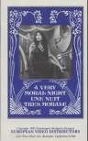
1168 A Very Moral Night
Yes
Directed by Karoly 1977 Makk
96 min

1267 Moszkva tér Yes Directed by Ferenc Török

1268 Kontroll No Directed by Nimród Antal
2001 88 min

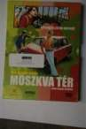
2003 105 min

1293 Songs of Hungary Yes Mary Goetze, Jay Fern, Erzsebet Gaal
Global Voices in Song
2002

1294 Songs of Hungary Yes Mary Goetze, Jay Fern, Erzsebet Gaal
Global Voices in Song
2002

1295 Songs of Hungary Yes Mary Goetze, Jay Fern, Erzsebet Gaal
Global Voices in Song
2002

1296 Songs of Hungary Yes Mary Goetze, Jay Fern, Erzsebet Gaal
Global Voices in Song
2002

1297 Songs of Hungary Yes Mary Goetze, Jay Fern, Erzsebet Gaal
Global Voices in Song
2002

1298 Songs of Hungary Yes Mary Goetze, Jay Fern, Erzsebet Gaal
Global Voices in Song
2002

