Circulating Items Inventory - Iran
CD
Producer/Publisher Year Made Length Image
English? Artist/Author
Category of Item Item # Item Name
5033 Message from a Friend No Zolfonoon Ensemble N/A 2007
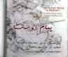

DVD
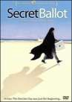
1002 Secret Ballot Yes Payami, Babak Fabrica Cinema 2001 144
minutes

1009 The Circle Yes Panahi, Jafar Jafar Panahi Film Productions

2000 91 min

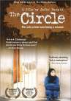

Category of Item | Item # | Item Name | English? | Artist/Author | Producer/Publisher | Year Made | Length | Image
 | 1012 | Taste of Cherry | Yes | Kiarostami, Abbas | Zeitgeist Films | 1997 | 95 min

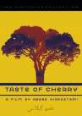
1024 The Color of Paradise Yes Majidi, Majid Varahonar
Company
1999 90 min

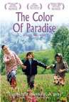
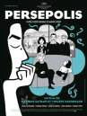
1030 Persepolis Yes Satrapi, Marjane Ile de France 2007 95 min.

1059 Blackboards Yes Makhmalbaf, Samira Makhmalbaf Film House
2003 85 min

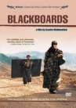

Category of Item | Item # | Item Name | English? | Artist/Author | Producer/Publisher | Year Made | Length | Image
 | 4914 | Leila | Yes | Mehrjui, Dariush | First Run Features | 1996 | 129 min.

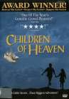
4969 Children of Heaven
Yes Majidi, Majid
Miramax Films
1997
88 min.
VHS

1037 Blackboards Yes Makhmalbaf, Samira Makhmalbaf Film House
2003 85 min

