Circulating Items Inventory - Kazakhstan
Art/Photo
Producer/Publisher Year Made Length Image
English? Artist/Author
Category of Item Item # Item Name
2005 Posters No

2208 Badkhyzskii Zapovednik No postcard set

4255 Borovoe No

4607 zhailau No C. Kozhokmatova 2007

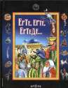
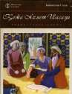
Printing House
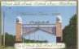

4784 Kazakh National Scholars No Deyir

Book/Bound
1048 Once Upon a Time… No Traditional Aruna 2007 72 pp

1051 Khoja Ahmad Yasavi No Baynietova, Saule Aruna 2007 96 pp

2169 Repetek Sandy Desert No Biosphere Reserve

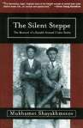
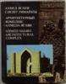
3090 The Silent Steppe: The Memoir of a Kazakh Nomad Under Stalin
Yes Shayakhmetov, Mukhamet
Rookery Press 2006 345 pp.

4069 Akhmed Yasawi Architectural Complex
No Almaty: “Oner” 1988

4071 Astana. Investment Catalogue
No Астана: Астана-
финанс

4072 Kazakh State University No Almaty: “Oner” 1984

4073 Fierce Grey No Auezov, Mukhtar Almaty: Zheti Zhargy

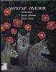
1997

4074 Teaching Kazakh Linguistics through Computer Programs
No Kурышжанова Алия Абжановна
Almaty 1999

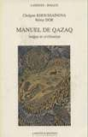
4076 Nursultan Nazarbayev No Press office of
4075 Manuel de Qazaq
No Khoussaïnova, Cholpan and Rémy Dor
Paris: Langues et Mondes
L’Asiathèque
1997
President Nazarbayev

London: Anglo- Caspian Services, Ltd.

2000

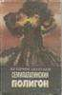
4078 Semipalatinsk Test Site
No Бозтаев, Кешрим
Alma-Ata: Kazakhstan
1992

4079 State Art Museum of A. Kasteev of the Republic of Kazakhstan
No Toulebai, Erbolat Almaty 1994

4081 Taraz State University named after M.Kh.
Dulaty
No Evero 2000

4082 Soul of Kazakhstan Yes Eastep, Wayne and Alma Kunanbay

New York: Eastern Press

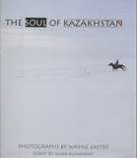
2001

4085 Welcome to Almaty: The Centre of Tourism in Kazakhstan
Yes Almaty: Dept. of
Tourism

4306 Erbolat Toulepbai No Toulepbai, Erbolat Almaty 1994

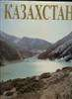
4337 Kazakhstan No Serikbaeva, Klara Flint River: London 1995

4339 Little Pearl of Kazakhstan No

4340 Kazakh Orchestra No Sopybekov, B. Almatykitap:
Astana
2002

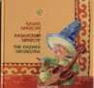
4349 Kazakh Language No Almaty 1998

4355 Ethnocultural Traditions in Modern Art of Kazakhstan
No Ергалиева, Р.А. Аlmaty: НИЦ
ГЫЛЫМ
2002

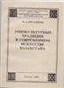
4356 Singer of the People No Ауэзов, Л.М. Alma-Ata: Наука 1977
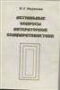
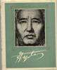

4357 Actual Questions of Comparative Literature
No Маданов, М.Х. Almaty: ГЫЛЫМ 1999

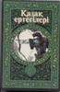
4444 Kazak Fairy Tales 6
No A. Esten
Kazak Khalyk Adebieti
2000
277 pp.

4445 Kazak Fairy Tales 5 No A. Esten Kazak Khalyk
Adebieti

4446 Kazak Fairy Tales 3 No A. Esten Kazak Khalyk
Adebieti
2000 271 pp.

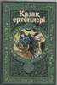
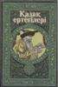
2000 270 pp.

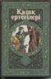
4447 Kazak Fairy Tales 2
No A. Esten
Kazak Khalyk Adebieti
2000
272 pp.
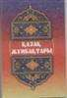
4448 Kazak Riddles No Zh. Malaisarin Ana tili 2005 127 pp.

4454 Kazakh Cuisine & Culture
Yes Wreath of Hope
and Project Sunshine, EAC, Inc.
2005 56 pp.

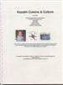
4455 Kazakh Traditions and Customs

4578 Kazakhstan Information Board
No 2006 284 pp.

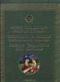
Yes IAUNRC 2000

4609 National Kitchen of Kazakhs

No Kenzheakhmetuly, Sejit

Almatykitap 2005 240
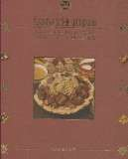
pages

4628 Ancient Kazakhstan Myths
No Zhanaidarov, O Aruna Baspasy 2006 252 pp.

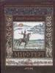
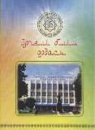
4688 Erlegi bilimi ordasy No Tuiakbaev, Gabit Evero Press 2002 140pp

4757 Eurasia Catalogue Yes Abikeeva, G. (editor) High Technology
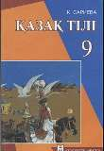
Printers, Almaty
2005 202 pp.

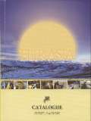
4821 Kazakh Language Textbook for 9th grade
No Sarieva, K Mektep, Almaty, Kazakhstan
2005 158 pp.

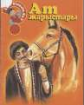
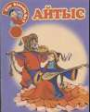
4822 Horse Competitions No Bayghabylova, Q Aruna, Kazakhstan 2001 10 pp.

4823 Singing Competition No Seyitzhanov, Z. Aruna, Kazakhstan 2002 10 pp.

4824 Kazakh house furnishings

4825 Nauryz - Persian New Year
No Matyzhanov, K. Aruna, Kazakhstan 2002 11 pp.

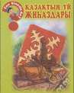
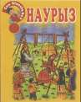
No Zhaubasova, T Aruna, Kazakhstan 2003 10 pp.

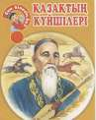
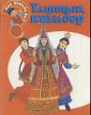
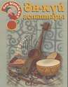
4826 Nauryz No Nurtazina Aruna, Kazakhstan 2001 10 pp.

4827 Altybaqan No Totenay, B. Aruna, Kazakhstan 2003 11 pp.
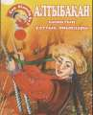

4828 National clothing No Matyzhan, K. Aruna, Kazakhstan 2001 11 pp.

4829 Musical Instruments No Zhaubasova, T. Aruna, Kazakhstan 2001 11 pp.

4830 20th century Kazakh Art Experts
No Zhaubasova, T. Aruna, Kazakhstan 2003 10 pp.

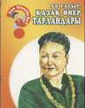
4831 Epic Lands No Bazilxan, N. Aruna, Kazakhstan 2001 11 pp.
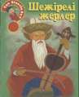

4832 Kazakhstan's Young Holidays
No Nurmaghambetova, R.
Aruna, Kazakhstan 2003 10 pp.

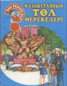
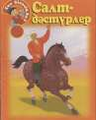
4833 Traditions and Customs No Seyitjanov, Z Aruna, Kazakhstan 2001 11 pp.

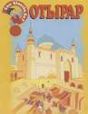
4834 Otrar No Doszhan, D. Aruna, Kazakhstan 2001 11 pp.

4835 Three Generations No Otetitleuuly, E. Aruna, Kazakhstan 2001 11 pp.
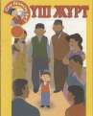

4836 A baby has entered the world!
No Nurtazina, L. Aruna, Kazakhstan 2001 11 pp.

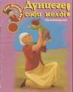
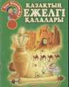
4837 Kazakh's ancient cities No Toqtabaev, A. Aruna, Kazakhstan 2002 11 pp.

4991 English-Kazakh Kazakh- English Dictionary
No Nuralieva, N Dayk Press 2008 434 pp.

Cassette
4424 Ake tolgauy No Asylbek Engsepov Dastan 2000 1
cassette

4427 Madina Eralieva: Missing my past years

No Madina Eralieva Malike 1998 1
cassette

4428 Madina Eralieva: Missing my past years

No Madina Eralieva Malike 1997 1
Cassette

4429 Zhanar Aizhanova: Salgan anim syrnaidai
No Zhanar Aizhanova Malike 1998 1
cassette

CD
3008 Beginning Kazakh No Ablahat Ibrahim Critical Language
Series
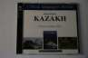

3020 Music of Kazakhstan Volume 1

3061 Kazakh Traditional Music
No World Music Library King Record Co 1992

No various Soros Foundation 2001

3089 Kazakh Traditional Music

4425 Zhyr keruengi III: Almas Almatov

4640 Songs from the Steppes: Kazakh Music Today

4641 Zhyr keruengi III: Almas Almatov 2
No Various III Project 2004 73 min.

No Almas Almatov Malike 2003 1 CD

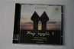

No Various Topic Records 2005 1 CD

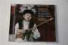

No Almas Almatov Malike 2003 1 CD

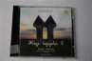

4680 Kazakh Music: Songs & Tunes from Across the Steppe

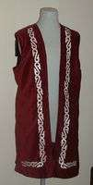
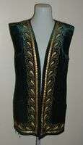
4681 Kazakh Music: Songs & Tunes from Across the Steppe
No Various artists SOAS, London 2007 1x72:34;
1x58:11

No Various artists SOAS, London 2007 1x72:34;
1x58:11

Clothing
2047 Woman's vest No

2048 Woman's vest No

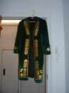
2050 Woman's vest No

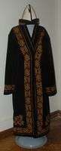
2051 Man's robe
No
2502 Shirt (national costume) No

2503 Pants (national costume) No

2505 shawl for covering No women's head

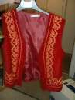
4712 Kazakh Girl's Vest
No
DVD

3116 Kazakh Documentary Films of Independence

3117 Kazakh Documentary Films of Soviet Epoch
Yes Abikeeva, Gulnara Open Society
Institute

Yes Abikeeva, Gulnara Open Society
Institute
2008
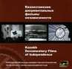

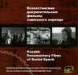
2008

3123 The Lord of the Flies: Film on the Border of Epochs
Yes Tyulkin, Vladimir Open Society
Institute
1990 50 min.

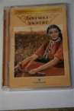

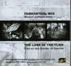
4414 Aksuat Yes Serik Aprymov Too East Films 1997 78 min.

4421 The Land of the Fathers Yes Shaken Aimanov Kazakhfilm 1966 86 min.

4432 Young lady - Young man No P. Bogoliubov Kazakhfil'm 1971 87 min

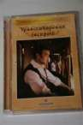
4433 Transsiberian Express No E. Urazbaev Kazakhfil'm 1977 86 min

4434 Sweet Juice Within the Grass
No A. Al'piev Kazakhfil'm 1984 63 min

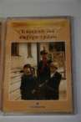
4435 Shot on the Karash pass No B. Shamshiev Kazakhfil'm &
Kirgizfil'm
1968 96 min

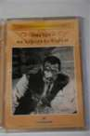
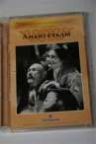
4436 Amangeldy No M. Levin Lenfil'm 1938 74 min

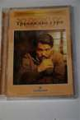
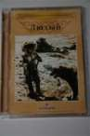
4437 Disturbing Morning No A. Karsakbaev Kazakhfil'm 1966 82 min

4438 Fierce No T. Okeev Kazakhfil'm 1973 92 min

4439 Someone Else's White and the Speckled Wild Pigeon
No S. Solov'ev Kazakhfil'm 1986 95 min

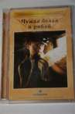
4440 My Name is Kozha No A. Karsakbaev Kazakhfil'm 1963 86 min.

4441 Shot on the Karash pass No B. Shamshiev Kazakhfil'm &
Kirgizfil'm
1968 96 min.

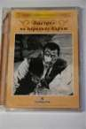
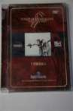
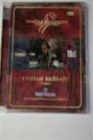
4442 Funeral Feast No B. Mansurov Kazakhfil'm 2008 81 min

4443 Sultan Beybars No B. Mansurov Kazakhfil'm 1989 141 min.

4606 Gold Collection of No Kazakh Film

4614 SD Process in the Republic of Kazakhstan
No UNEP, NESDCA, NORAD
2006

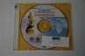

4621 Borovoe Legends: Burabai
No Globus Globus 2007

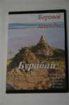
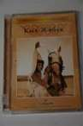
4630 Kyz-Zhibek No Musrepov, G. Kazakhfilm 1970 140 min

4675 Kek Mest' No Damira Manabaya 2006 85 min

4702 The Land of our Fathers Yes Shaken Aimanov Kazakhfilm 1966 86
minutes

4728 Aksuat Yes Serik Aprymov Too East Films 1997 78 min.
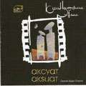

4818 4 in 1 DVD Collection: Zharaly Sezim, Kek, Eylekim, Aldar Kose
No Bootleg 2005

4819 Best 100 Kazakh Music Videos

No various Dastan Studio, Kazakhstan

2007

4820 Kazakh Stars, Volume 8 No various Raim Music Records, Kazakhstan
2006

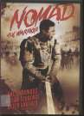
4913 The Recruiter Yes Omarova, Guka Palisades Pictures 2004 86 min.

4956 Nomad: The Warrior Yes Bodrov, Sergei Kazakhfilm 2006 112 min.

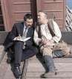
4981 Notes of a Railway Worker
Yes Zhetirov, Zhanabek Zhana Gasyr 2006 63 min.

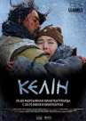
4982 Daughter-in-law Yes Tursynov, Ermek Kazakhfilm 2009 80 min.

4983 Oh my! Or My Dear Children
Yes Isabaeva, Zhanna Cosmos Art 2009 96 min.

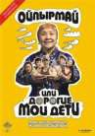
4984 Racketeer Yes Sataev, Akhan Sataifilm 2007 80 min.

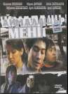
4987 Caress Me No Asanbaev, Baqbergen Jaidarman Studiyasy
2009 60 min.

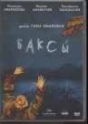
4988 Native Dancer [Shaman] Yes Omarova, Guka Kazakhfilm 2009 85 min.

4989 Mustafa Shokai Yes Narymbetov, Satybaldy
Kazakhfilm 2008 144 min.

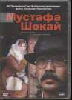
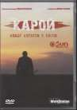
4990 Dark Thoughts Yes Isabaeva, Zhanna Sun Production 2007 95 min.

5022 Lord of the Eagles Yes Fougea, Frederic and Gilles Santantonio
Fougea, Frederic 1991 26 min.

5025 Tulpan Yes Dvortsevoy, Sergey Zeitgeist Films 2008 100 min.

Flag
2072 Large flag No

2073 small w/ stand No

2075 mini flag No

2076 medium-sized flag No

Hat
2086 Man's hat No

2087 Man's hat No
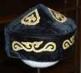

2088 Man's hat No

2102 Kalpak No
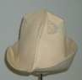

2114 Kalpak No

2497 Taqiya No

2504 Hat (national costume) No

4475 Kazakh green hat No

4627 Kazakh men's hat - No kalpak

4670 Kazakh women's hat No

4705 Kazakh Women's Hat No

Instrument

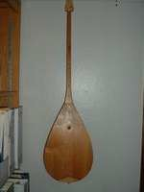
2115 Dombra No

2494 Dombra (Kazakh No national instrument, lute)

Map
2122 Map of Kazakhstan No (Cyrillic 1:2,500,000)

4536 Geographical Map of Kazakhstan
Yes Gizi Map

4537 Political Map of Kazakhstan
Yes Gizi Map

4538 Map of Kazakhstani No Provinces

4554 Map of Nature Reserves in Kazakhstan
No Typah 1998

4586 Republic of Kazakhstan Yes The Agency on Land Resources Management of the ROK

2006

Misc.

2154 9 bills No

2159 3 packets of photocopied No tenge

2230 envelope fragments No

Model
2131 small wooden dolls No

2132 small wooden dolls No

2133 Yurt No

2134 yurta No

2135 eagle-and-dombra figure No

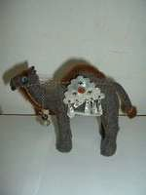
2267 camel No

2495 Doll, Kazakh female No

2496 Dolls, Pair of male and No female carved wooden
Kazakh

4501 Wooden Kazakh Warrior No Figurine

4503 Wooden Kazakh Woman No Figurine

4512 Small Kazakh Male No Figurine

4523 Orange Wooden Female No Figurine

4524 Orange Wooden Male No Figurine

4525 Small Bulbous Kazakh No Female Figurine with
Plume

4528 Small Wooden Kazakh No Female Figurine with
Plume

4530 Bulbous Kazakh Female No

4703 Nesting Yurts No 2008

Periodical

4070 Astana Magazine (In- flight magazine of Air Kazakhstan)
No Bekturov, Rustem Стамвул: Mac
studio
1998

4077 Passport to the New World: Special Issue: Passport to Kyrgyzstan
Yes Shashkov, Eugene (ed.)
Passport International Ltd.: Moscow
1994

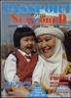
4080 Stolitsa (Astana Kazakhstan magazine)
No Balikanaov, B.B. (Editor)
Proxima: Almaty 2001

4083 US-Kazakhstan Monitor,
v. 4 no. 1, April 1997

Yes Cowan, Janice (ed.) US-Kazakhstan
Council

1997

4084 US-Kazakhstan Monitor,
v. 4 no. 2, June 1997
Yes Cowan, Janice (ed.) US-Kazakhstan
Council
1997

4343 National Geographic, v. 183, no. 3, March 1993
Yes Edwards, Mike National Geographic Society: Washington
1993

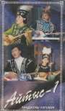
4661 Wild Fibers Yes Cortright, Linda 2007 88pp
1005 Aites - 1. Tandauli Ulgileri (Songs)
No
2000
VHS

1027 Chastie (Paradise) No Directed by Sergey Dvortsevoy

1033 East Kazakhstan Yes
1995 23 min

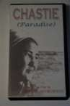

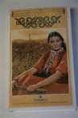
1040 Girl Rider No Kazakhfilm 1955 87 min

1042 Nauryz No 1998

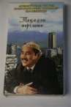
1065 Angel in a Tubeteika No

1067 Kazakh Film Collections: Series on Customs and Traditions of the Kazakhs

No 90 min

1100 My Name is Kozha (PAL) No

1135 Shankhai No

1200 ОПЬІТ КРЕСТА No

1219 Zauresh Yergalieva No 2000

1309 Gray Wolf (Kokserek) Yes Okeev, T. Алматы: World
Video

1974 92 min.

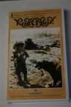
4449 Commander No Bolat Kalymbetov Kazakhfil'm 2004 92 min

4451 Beautiful Land No Gau Fyn Tian Shan Film Studi (China)
2000 94 min

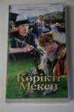
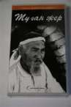
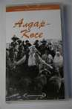
4452 The Girl from the City No R. Abdirashev Kazakhfil'm 2004 86 min

4453 Birthplace No Sh. Aimanov Kazakhfil'm 1966 87 min

4456 Aldar-Kose No Shaken Aimanov Kazakhfil'm 1964 88 min.

4464 The Kazakh Language No Uchebniy kompleks Fond "Soros-
Kazakstan"

4467 Kazakhstan's nature No The Tele-Radio complex of the President of the Rep
2001 81m

Accessory
2000 Amulet No

4510 Kazakhstan Button No

VCD

3058 Almaty Multi-media No Photo Album part 1

3059 Almaty Multi-media No Photo Album part 2

3072 Manuel de Quzaq - Disque compact No. 1
No Langues Mondes 1997

5021 Astana Yes RGB-Studio RGB-Studio 2008

