Circulating Items Inventory - Kyrgyzstan
Art/Photo
Producer/Publisher Year Made Length Image
English? Artist/Author
Category of Item Item # Item Name
2006 Painting No

2007 Painting No

2008 Watercolor No

2009 Watercolor No

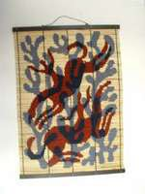
2010 Wall-hanging No

2011 Oil painting No

2018 Wood carving No
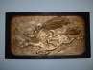

2019 Lithograph No Mataev

2020 Lithograph No Mataev

2021 Wooden screen No

2022 Wooden screen No

2023 Watercolor No Nargiza Buronova

2184 postcard No

2185 Calendar with Kyrghi No paintings (1996)

2186 2 “Kyrgyzstan: k 60 No letiyu obrazovaniya
Kyrgyzskoi SSR” postcard sets

2187 Po Kyrgyzii postcard set No

2188 Kyrgyzstan postcard set No

2207 Frunze postcard set No

2218 symbols of the 40 tribes No of Kyrgyzstan

4591 water_1.jpg No Jackson Kellogg

4592 water_2.jpg No Jackson Kellogg

4717 National Kyrgyz wall No hanging

4780 Muslim Women of Kyrgyzstan
Yes Kellogg, Jackson Jackson Kellogg

Book/Bound
2165 Kyrgyzstan: A Nomadic No Culture in the Modern
World.

2166 Kyrgyzstan – The Land No of Sky-High Mountains

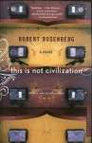
3091 This Is Not Civilization Yes Rosenburg, Robert Mariner
Books/Houghton Mifflin Company
2004 293 pp.

3094 | The Day Lasts More than | Yes | Chingiz Aitmatov | Indiana University | 1988 | 352 pp.
 | a Hundred Years |  |  | Press

4088 Gateway to Kyrgyzstan No Committee of the Kyrgyz Republic on Foreign Invest
1999

4089 Kyrgyz Language Manual for English Speakers
No Ryskulova, Chynarkul Bishkek 1996

4090 Kyrgyz Musical Instruments (includes CD)

No Prevost, Helen & Kadyrov, Ismail (ed.s)

Publishing Development Center: Bishkek

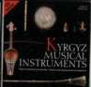
2002

4091 Kyrgyz Traditional Art No Rector, Mindi &
Garauyshenko (ed.s)
Foundation Publishing Development Center: Bishkek
2003

4092 Kyrgyzstan: A Nomadic Culture in the Modern World
Yes Tidwell, Mike Charles Sumner School: Washington, D.C.
1995

4093 Kyrgyzstan: Between Space and Earth
Yes Dudashvili, Sergey Rarity LTD: Bishkek 2000

4094 Kyrgyzstan: National Strategy of Sustainable Human Development, c. 1
Yes Ryspekov, S. (ed.) SHD President's
Council Secretariat: Bishkek
1998

4095 Kyrgyzstan:
Obshchestvo I Tsennosti No. 1
No Budnii, Aron Bishkek 2000

4096 Kyrgyzstan:
Obshchestvo I Tsennosti No. 2

No Budnii, Aron Bishkek 2000

4097 Kyrgyzstan: The Sacred Land of Manas
Yes Dudashvili, Sergey Rarity, Ltd: Bishkek 1999

4098 Kyrgyzstan: Under the Sky of Khan-Tengri

Yes Dudashvili, Sergey Rarity, Ltd: Bishkek 1998

4099 Kyrgyz & Their Ancestors

4100 Manas: The Great Kyrgyz Epos “Manas”
No Койчуев, Т. Bishkek: Главная редакция
Кыргызской Энциклопедии

Yes Bayjiev, M.T. (ed.) Bishkek: State
Directory for the Propogation of t
1994

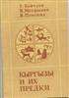
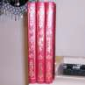
1999

4101 Manas: Volume 2 (Parts
2 & 3)
Yes Orozbakov, Sagymbai & May, Walter, trans
Moscow and Bishkek
1995

4102 Systematic Instruction in Botany
No Sultanova, R. M. Kyrgyz Agricultural Institute: Frunze
1990

4103 Phrase Book: Russian- Kyrgyz
No Bekdzhanova, Rabiga (?)
Bishkek 1991

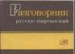

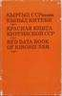
4104 Red Data Book of Kirghiz SSR: Rare & Endangered Species of Animals and Plants
No Vorob'ev, G. & Shukurov, D. (ed.s)
“Kyrgyzstan” Publishers:Frunze
1985

4105 Phrasebook [for travelling abroad] (copy 1)

4106 Phrasebook for Travelling Abroad [copy 2]
Yes Frunze 1990

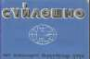

Yes Frunze 1990

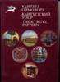
4107 Kyrgyz Pattern No 1998

4108 Main University Kyrghyztan

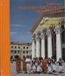
No Askanov, A. Bishkek 1996

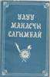
4109 Uluu Manaschi Sagymbai (The Great Manaschi Sagymbai)
No Bishkek: "Ala-Too" 1992

4110 Vestnik Administratsii Prezidenta Kyrgyzskoi Respubliki

No Erkin-Too: Bishkek 1998

4111 Kyrgyz Conversations No Рыскулова, Э.А. American
University in Kyrgyzstan
2002

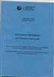
4253 Main University of Kyrgyzstan
No Bishkek: 1996

4294 Aramco World Yes

4307 Historical Development and Current Situation of the Mass Media in Kyrgyzstan
Yes Kulikova, Svetlana V., and Gulnara Ibraeva
Cimera Publications 2002

4308 Adventure & Trekking of Kyrgyzstan
Yes AKC Kyrgyz concept AKC Kyrgyz
Concept
2001

4309 Kyrgyz: Language Manual for English Speakers
No Ryskulova, Chynarkul Tabygla: Bishkek 1996

4310 Kyrgyzstan: National Strategy of Sustainable Human Development, c. 2
Yes Ryspekov, S. (ed.) SHD President's
Council Secretariat: Bishkek
1998

4311 Kyrgyzstan: the Land of the Sky-High Mountains

Yes Dudashvili, Sergey Rarity LTD.:
Bishkek

1997

4612 Manas: Volume 1 Yes Version by Sagymbai Orozbed: Rakhmanaliev, Rustan
Nat'l Academy of Sciences of the KR
1995 462
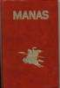
pages

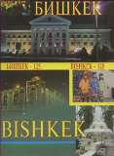
4689 Bishkek 125 No Koenaliev, Kylychbek Akyl Press 2003 120pp

5023 Jamilia Yes Aitmatov, Chinghiz Telegram Books 2007 96 pp.

CD
3022 Songs of Kyrgyzstan No World Music Library

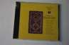

3085 Kyrgyz Folk Music on Komus (2 copies)
No Mailybekova, Munara Bloomington:
IAUNRC
2005

4409 Tengir-Too Mountain Music of Kyrgyzstan
No Various Aga Khan, Smithsonian Folkways
2005 66 min. (CD),
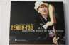
24 min. (DVD)

4704 Kyrgyzstan Music No 2008

Clothing
2052 Sholpan No

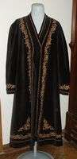
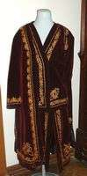
2053 Man's robe
No
2054 Woman's jacket
No

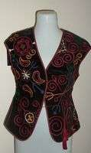
2055 Woman's vest
No
2056 Woman's costume No
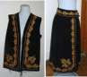

2633 Woman's vest and skirt No

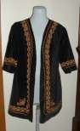
4371 Woman's short-sleeved jacket
No
DVD

1003 Adopted Son Yes Abdykalov, Aktan KyrgyzFilm 1998 91 min

3119 Kyrgyz Documentary Films of Independence
Yes Abikeeva, Gulnara Open Society
Institute
2008

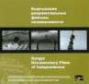
4413 Beshkempir / The Adopted Son
Yes Aktan Abdykalykov Kyrgyzfilm, NOE 1998 67 min.

4420 White Mountains Yes Meus Ubukeyev Kyrgyz Studio 1964 63 min.

4721 White Mountains Yes Meus Ubukeyev Kyrgyz Studio 1964 63 min.

4729 Beshkempir / The Adopted Son
Yes Aktan Abdykalykov Kyrgyzfilm, NOE 1998 67 min.

4920 Kyrgyzstan: The Land of Santa Claus
Yes Kyrgyzstan State
Agency for Tourism
2008

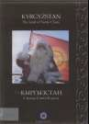
4927 Construction of a Yurt - Master
Yes 2004

5024 Dzhamiliya Yes Aitmatov, Chinghiz Mosfilm Studios 1969 83 min.

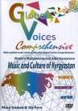
5037 Music and Culture of Kyrgyzstan
Yes Goetze, Mary
MJ & associates
2008
n/a
Flag
2074 flag w/ wooden base (2) No

2077 large flag No

2492 Flag of the Kyrgyz Republic

4693 Small Kyrgyz flag with stand
No

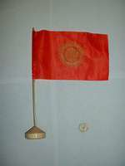
No 2008

Hat
2089 Man's hat No

2090 Kalpak No
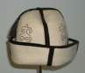

2092 Man's hat No

2093 Woman's hat No

2101 Kalpak No
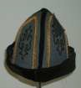

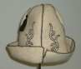

2104 Kalpak No
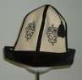

4626 Kyrgyz men's hat - dopu (wool)
No 2007

Instrument
2257 mouth harp No
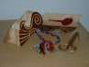

4579 Komuz - three stringed No instrument

Map

4629 Topographical map of Kyrgyzstan published by Ak-sai Travel
Yes Ak-Sai Travel 2000

Misc.
2155 5 bills No

4317 Bulletin of the Administration of the President of the Kyrgyz Republic
No Erkin-Too: Bishkek 1998

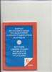
4318 Bulletin of the Administration of the President of the Kyrgyz Republic
Model
No Erkin-Too: Bishkek 1998

2136 wooden Kyrgyz couple No

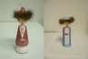

2137 wooden Kyrgyz couple No
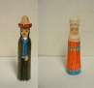

2237 Kyrgyz/Kazakh Yurt in No miniature

4493 Kyrgryz Doll No

4526 Wooden Kyrgyz Male No Figurine

4527 Small Wooden Kyrgyz No Female Figurine

4529 Kyrgyz Male Wooden No Stylus

4691 Wooden Doll (bamboo?) No 2008

4692 Wooden Doll with Bird No 2008

4898 Kyrygz Doll No

Periodical

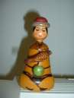
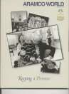
4086 Aramco World, v. 50 no. 2 w/ article on Kyrgyz composer Muratbek Begaliyev
Yes Arndt, Robert Aramco Services Company: Houston
1999

4279 Aramco World, v. 46 no.
4: Kyrgyzstan
Yes Arndt, Robert, ed. Aramco Services
Company: Houston
1995

4312 Aramco World, w/ article on Manas at 1000,
c. 2
Yes Arndt, Robert (ed.) Aramco Services
Company: Houston
1996

VHS

1047 Generous Manas, The No Funded by UNESCO
1995 30 min

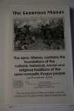
1060 Kyrgyzstan Karakol Tourism Video (3 copies)
Yes Made possible with
funds from USIA.
1996 15 min

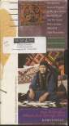
1129 Red Butterflies Where Two Springs Merge
No
Gender Montage Series
2002
15 min
1220 Kyrgyzstan 2002 No 2002

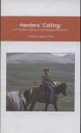
1250 Herder's Calling: A Tradition Dying in the Kyrgyz Republic

Yes Newyoke
Productions

2004 24 min

4849 Construction of a Yurt Yes

Accessory

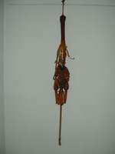
2260 whip No

2265 horsewhip No

4509 Manas Button No

VCD

3047 Unknown Land - Kyrgyzstan
No Vitaly and Igor
Korolyov
2003

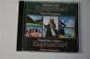

3067 Unknown Land - Kyrgyzstan - Video
Yes Vitaly and Igor
Korolyov
2003

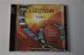

3078 CD about Kyrgyzstan No

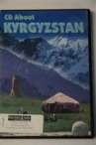
4361 Kyrgyz Landscapes Video Clips and Powerpoint Presentation
Yes Asan Saipov 2005

