Circulating Items Inventory - Mongolia
Art/Photo
Producer/Publisher Year Made Length Image
English? Artist/Author
Category of Item Item # Item Name
2173 large photo of Mongolian No woman and ger

2189 2000-2002 Mongolian No Calendar: “The Lunar
Calendar of XVII Jaran”

2190 set of small „Mongolia‟ No postcards

2191 set of large, „Welcome to No Gobi Desert‟ postcards

2192 Mongolia postcard set No

Book/Bound
1038 When Things Get Dark Yes Davis, Matthew St. Martin's Press 2010 306 pp
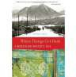

4112 Modern Mongolian- English Dictionary
No Altangerel, Damdinsuren
Altangerel Damdinsuren
1998

4113 Student Guide to Khalkha Mongolian Pronunciation
Yes Battulga, Tsh; , Mika Laiho
Ulaanbaatar 1999

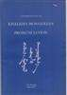

4114 Textbook for Foreign Speakers
No Ulaanbaatar 1999

4115 Cayn Baina Uu?: Mongolian Language Textbook One

No Tserenchunt L, & Sharon Luethy

Ulaanbaatar 2000

4116 Colloquial Mongolian: The Complete Course for Beginners

No Sanders, J. K. London. Routledge 1999

4117 English-Mongolian Dictionary
No Altangerel, Damdinsuren
Mongolia: Interpress Publishing & Printing Co. Ltd
1998

4118 English-Mongolian Minidictionary Mongolian-English
No Marsh, Pitir K & P Uvsh
Ulaanbaatar 1999

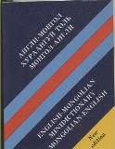
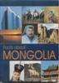
4119 Facts about Mongolia Yes Ganbold, Da Mongolia 2000

4120 Fifty Routes through Mongolia: a Guide for Tourists
Yes Shagdar, Sh MBDA & TACIS 1997

4121 Book No Olziydolgor,
Dar‟syrengiyn

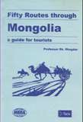
Ulaanbaatar 2000

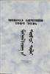
4122 Book No Ulaanbaatar 1992

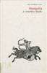
4124 Mongolian-English Dictionary
4123 Mongolia: A Country Study
Yes Worden, Robert, ed.
US Government Printing Office: Washington, DC
1991

No Altangerel, Damdinsuren

T&U Printing Co, LTD. Ulaanbaatar

1998

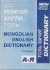
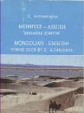
4125 Mongolian-English Phrase Book/English- Mongolian Phrase Book
No Altangerel, Damdinsuren
Ulaanbaatar 1999

4126 National Museum of Mongolian History
Yes Idshinnorov, S. National Museum
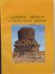
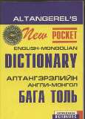
of Mongolian History

4127 New Pocket English- Mongolian Dictionary
No Altangerel, Damdinsuren
Interpress Dictionaries
1998

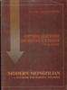
4128 Modern Mongolian: A Textbook for Foreign Speakers

4129 Panchatantra: The Dragon and the Monkey: Luu Sarmagchin Khoyor
No Shagdarsuren, Tseveliyn

No
Ulaanbaatar 1999

4130 Russia and the Dzhungarian Khanate in the 18th Century
No Moiseev, V. A. Barnaul 1998

4131 Lost Country: Mongolia Revealed

Yes Becker, Jasper Great Britain.
Sceptre

1993

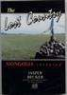
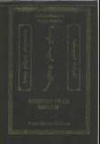
4254 Mongol Uran Bichleg No Olziybadrakh, D Ulaanbaatar 2000

4256 Mongolian Folktales and Legends

No Altangerel, D (Trans.) Ulaanbaatar 1999

4257 English-Mongolian Phrase Book
No Altangerel, Damdinsuren
Ulaanbaatar 1999

4258 Book No Damdinsuren, Ts Mongol Ulsyn Ikh Surguuliyn

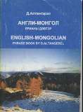
1999

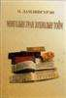
4259 Dragon and the Monkey: Stories from the Panchatantra
No 1999

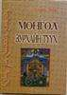
4338 Mongol No Моих-Очир, Д. Ulaanbaatar Khot 2000

4347 Throat Singers of Tuva Yes Levin, Theodore &
Edgerton, Michael
Scientific American 1999

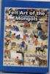
4348 Mongolian Language Textbook One
No Цэрэнчунт, Л. & Sharon Luethy
Ulaanbaatar 2000

4664 Felt Art of the Mongols Yes Batchuluun,
Luntengiin (Translated by Eric Thrift)

Mongolian University of Arts and Culture

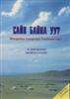
2000 291pp.

4665 | Mongolian Portrait: Land | Yes | Pax, Andrew | Five Corners | 1996 | 60pp.
 | of Big Skies |  |  | Publications, Ltd.

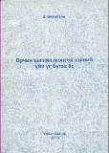
4761 Grammar of Mongolian No Önörbayan, Ts. Ulaanbaatar 2000 174 pp.

4887 Mongolian Folktales Yes Metternich, Hilary University of
Washington Press
1996 130 pp.

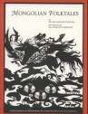
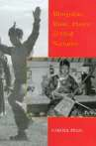

4890 | Mongolian music, dance, | Yes | Pegg, Carole | University of | 2001 | 377 pp.
 | & oral narrative |  |  | Washington Press

4985 | Mongolian Music, | Yes | Pegg, Carole | University of | 2001 | 376 pp.
 | Dance, & Oral Narrative |  |  | Washington Press

CD

3012 Fly Fly My Sadness No Bulgarian Voices Shanachie 1996

3016 Gone With the Wind – Songs of Mongolian Steppes

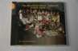

No Altai-Hangai Window to Europe 1996

3024 Orphan's Lament No Hunun-Huur-Tu Sharachie

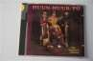

Clothing
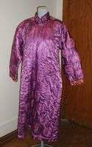
2060 Woman's robe No

DVD

1008 Khadak Yes Brosens, Peter Life Size Entertainment
2006 101
minutes

2235 Mongol Khans and their No Legacy

3102 A Pearl in the Forest Yes Agvaantseren, Enkhtaivan
Idugan Entertainment
2008 90 min.

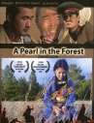
3105 Lotus Festival 2009 - Highlights
Yes Hanggai Lotus 2009 25 min.

4487 The Story of the Weeping Camel
Yes ThinkFilm/National
Geographic
2005 87 min.

4700 | The Cave of the Yellow | Yes | Byambasuren Davaa | Palisades Pictures | 2006 | 93
 | Dog |  |  |  |  | minutes

4701 My Beautiful Jinjimaa Yes Ochir Mashbat Cinema Epoch 2006 80
minutes

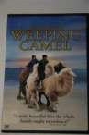
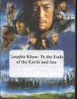

4926 Genghis Khan: To the Ends of the Earth and Sea

Yes Sawai, Shinichiro Shochiku 2007 140 min.

4957 Genghis Blues Yes Belic, Roko and Adrian
Roxie Releasing 2000 88 min.

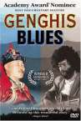
4974 Mongol: The Rise of Genghis Khan
Yes Bodrov, Sergei Picturehouse 2007 125 min.

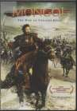
Flag
2078 small flag (hanging No banner)

2079 flag-banner No

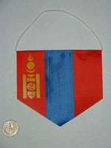
Hat

2111 Cone-shaped hat No

4610 Mongolian Hat (Men's) No 2007

4611 Mongolian Hat (Women's)

No 2007

Map
4624 map of Inner Mongolia No Sinomaps Press 2003

4625 Physical map of China, Mongolia, and Korea
Yes American Map
Company

Model
2152 toy ger No

4522 Lighted Minature Ger No

4669 Camel, stuffed. With metal ornamenting
No 2007

Periodical

4298 National Geographic, v.
167, no.2, Feb. 1985
Yes Allen, Thomas National Geographic Society: Washington
1985

4344 National Geographic, v.
196, no. 3, September
1999
Yes Millard, Candice National
Geographic Society: Washington
1999

VHS
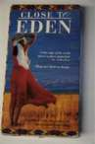
1028 Close to Eden (Urga) Yes Mikhalkov, Nikita 1992 109 min

1138 Silk Patterns No Gender Montage Series
2003 26 min

1171 Where is Mongolia? No 50 min

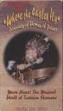
1173 Where the Eagles Fly (Moon Heart: The Magical World of Tuvinian Shamans
Yes Mystic Fire Video 1997 30 min

4618 | The Mongols and the | Yes | Professor Thomas | Primary Source | 2002 | 48 min
 | Spread of Islam |  | Barfield

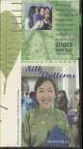
4894 Silk Patterns
No Soros Foundation
Gender Montage Series
2003
26 min.

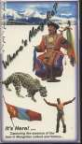
4897 Where's Mongolia? Yes 50 min.

Accessory

4577 Bone Game in Leather bag with four bones
No MonSoc

4671 Mongolian tea cup with No metal frame.

VCD

3018 Introducing Mongolia: CD-ROM
Yes MMM Production
Center. Ulaanbaatar
1998

