Circulating Items Inventory - Publications Inner Asian & Uralic National Resource Center
January 2008

Azerbaijan Azerbaijan

Book

Item: 4027

Title: 1500 Years of Oghuz Poetry: an Anthology
Category Language: Description:

Item: 4000
Title: Ali and Nino: A Love Story

Category Language: Description:

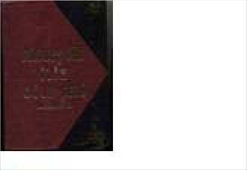
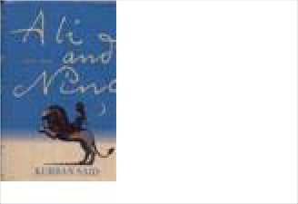
Publication English
Publication Azeri

English Version:
Artist: Prducr: Date:
Length:
Anar, Ed
Picture
Azerbaijan Nashr
Cyrillic Title
1999
Min Besh Juz Ilin Oghuz She

English Version:

Cyrillic Title
Azeri novel

Artist: Prducr: Date: Length:
Said, Kurban Woodstock: Over 1996
Picture

Item: 4252
Title: An Analysis of Manufacturing Management in the Developing Countries
Category Language: Description:

Item: 4001
Title: Anlashilmaz Muhasibatlarden Stratezhi Tarafdashligha Doghru (Oktjab
Category Language: Description:

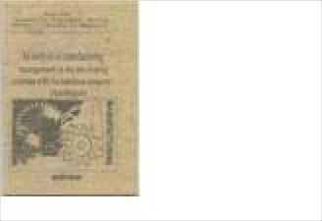
Item: 4033
Publication
English Version:
Artist: Prducr: Date:
Length:
Baqirov, H.S., et
Picture
Western Universi
Cyrillic Title
1999
Publication
English Version:
Artist: Prducr: Date:
Length:
Hasanob, Ali, Az
Picture
Baku: Azerbaijan
Cyrillic Title
1997
Anlashilmaz Muhasibatlarden
Title: Armenia-Azerbaijan Conflict

Category Language: Description:
Publication English

English Version:

Cyrillic Title

Artist: Prducr: Date: Length:

Ministry of Forei Ministry of Forei 1999

Picture

Item: 4021

Item: 4002
Title: Azerbaijan

Category Language: Description:
Publication Azeri

Title: Azerbaijan (Azerbaycan) Oil in the World Policy

Category Language: Description:

Artist:

Abdullazade, Fat

Picture

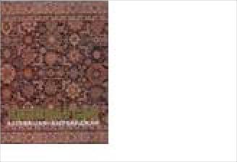
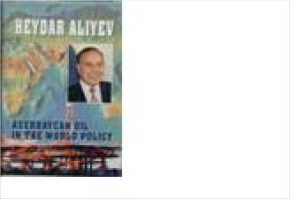
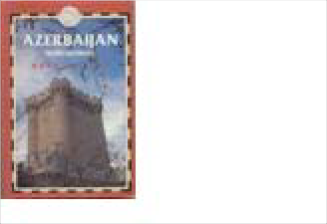
Item: 4251
English Version:
Prducr:
Date: Length:
Baku
Cyrillic Title
1998
Publication
English
Artist: Prducr: Date:
Length:
Aliyev, Heidar (H
Picture
English Version:
Baku: Azerbaijan
Cyrillic Title
1997
Title: Azerbaijan with Georgia

Category Language: Description:
Publication

English Version:

Cyrillic Title

Artist: Prducr: Date: Length:

Elliott, Mark Surrey, UK: Trai 1999

Picture

Item: 4003
Title: Azerbaijanis: a historico-ethnographic sketch

Category Language: Description:

Publication Russian
ethnographic history of Azeris

Artist:
Аббасов, А.А.
Picture

Item: 4304
Title: Azerbaijan-USA
Category Language: Description:

Item: 4023
Title: Constitution of the Azerbaijan Republic (European Commission for demo

Category Language: Description:

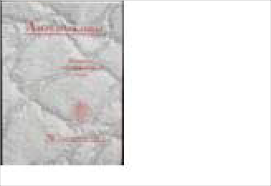
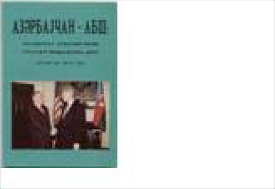
Publication
English Version:
Cyrillic Title Азербайджанцы: Историко
Azerbaidzhantsiy: Istoriko Et
Prducr:
Date: Length:
Baku: Academy o
1998
Publication
Azeri
Artist: Prducr: Date:
Length:
Haesaenov, Ali
Picture
English Version:
Baku: Azerbaijan
Cyrillic Title
1997

Cyrillic Title

English Version:

Artist: Prducr: Date: Length:

European Commi 2000
Picture

Item: 4331
Title: Dried Up in Meetings & Other Short Stories Category Language: Description: Publication English

Artist:

Jalal, Mir

Picture

Item: 4302
Title: Elementary Azerbaijani

Category Language: Description:
Publication English

Artist:

Öztopçu, Kurtulu

Picture

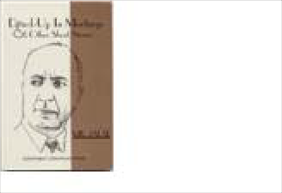
Item: 4303
English Version:
Prducr:
Date: Length:
Sherman Oaks: A
Cyrillic Title
1998
English Version:
Prducr: Date:
Length:
Santa Monica: Tu
Cyrillic Title
2000
Title: Elementary Azerbaijani, c. 2

Category Language: Description:
Publication English

English Version:

Cyrillic Title

Artist: Prducr: Date: Length:

Öztopçu, Kurtulu Santa Monica: Tu 2000

Picture

Item: 4301
Title: Eyes Which Have Seen Too Much: Refugee Children in Azerbaijan, c. 2
Category Language: Description:

Item: 4025
Title: Gobustan

Category Language: Description:
Publication

Artist:

Maemaedov, Rac

Picture

Item: 4334
Title: Jaloliddin Manguberdi

Category Language: Description:
Publication Russian

English Version:

Artist: Prducr:

Кагаматом, Kha Tashkent

Picture

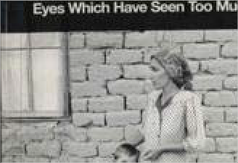
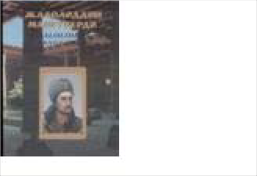
Cyrillic Title
Publication
English
Photos, letters from, and background on internally displaced children
Artist: Prducr: Date:
Length:
Graves, Edwin
Picture
English Version:
NAYORA
Cyrillic Title
2000
English Version:
Prducr: Date:
Length:
Baku: Ishig
Cyrillic Title
1990
Жалолиддин Мангуберди

Date: Length:
1999

Item: 4026
Title: Karabakh: Uncontolled Zone (In the occupied Azerbaijani Territory)

Category Language: Description:

Publication English

Artist:
Novruzoglu, Rov
Picture

Item: 4196
Title: Molla Panah Vagif: An Outline of Life and Creative Activity
Category Language: Description:

Item: 4353
Title: Nizami's Characters on the Carpets

Category Language: Description:

Publication Azeri

English Version:
essay on poet's influence on the arts

Artist: Prducr:
Picture

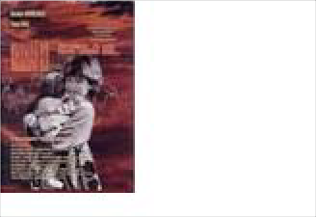
Cyrillic Title
English Version:
Prducr:
Date: Length:
Baku: Ozan
Cyrillic Title
2002
Publication
English
Artist: Prducr: Date:
Length:
Dadashzade, Ara
Picture
English Version:
Azerbaijan State
Cyrillic Title
1968
Ковровые образы низами

Kovrovye obrazy nizami

Date: Length:
1991

Item: 4028
Title: Novruz

Category Language: Description:

Publication Azeri
(Album in Cyrillic Azeri)

Artist:
Picture

Item: 4035
Title: Outstanding Men of Azerbaijan
Category Language: Description:

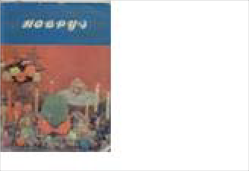
Item: 4030
English Version:
Prducr:
Date: Length:
Baku
Cyrillic Title
1989
Publication
English
short tract on Azerbaijani composer
Artist: Prducr: Date:
Length:
Safarova, Zemfira
Picture
English Version:
Baku: Yazychi
Cyrillic Title
1985
Uzeir Hajibeyov
Title: Prezident '93-'97 (Azeri President Heyder AliYEV)

Category Language: Description:
Publication Azeri

English Version:

Cyrillic Title

Artist: Prducr: Date: Length:

Weiss, Monika Baku: WestPrint 1998

Picture

Item: 4031
Title: Problem of the Hero in the Prose of John Wayne
Category Language: Description:

Item: 4032
Title: Rasul RZA Colors

Category Language: Description:

Publication Azeri
Azeri poetry

Artist:
Picture

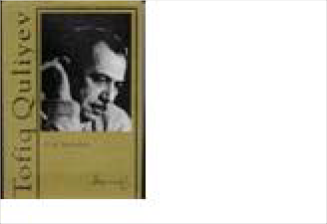
Item: 4034
Publication
Russian
Artist: Prducr: Date:
Length:
Зейналова, С.А.
Picture
English Version:
Cyrillic Title Проблема Героя в Прозе Д
Problema Geroia v proze Dzh
Baku: Azerbaijan
1993
English Version:
Cyrillic Title Расул РЗА Краски
Rasul RZA Kraski
Prducr: Date:
Length:
Title: Tofiq Quliyev

Category Language: Description:
Publication Azeri

English Version:

Cyrillic Title
Tofiq Quliyev

Artist: Prducr: Date: Length:

Mahnilari, Urek Baku
2000

Picture

Booklet

Item: 4472

Title: Nature Protection in the Caucasus
Category Language: Description:

DVD

Item: 4620

Title: Global Voices Comprehensive: Music & Culture of Azerbaijan

Category Language: Description:

Publication English
DVD for computers

Artist:
Aida Huseynova
Picture

Magazine
Publication
English
A booklet describing German- sponsored efforts to protect natural resources in the Caucasus region, including Azerbaijan.
This booklet includes a removable map of the region.
Artist: Prducr: Date:
Length:
Federal Ministry
Picture
English Version:
Germany
Cyrillic Title
2006
18 pp. and map
English Version:
Prducr: Date:
Length:
Mary Goetze & J
Cyrillic Title
2007

Item: 4663

Title: Azerbaijan International
Category Language: Description:

Item: 4359
Title: Azerbaijan International: Pathfinders:Decipherment of the Caucasian Alb

Category Language: Description:

Publication English
cultural magazine

Artist:
Picture

Map

Item: 4560

Title: Map of Azerbaijan

Category Language: Description:

Publication Azeri
Laminated; In Azeri

Artist:
Picture

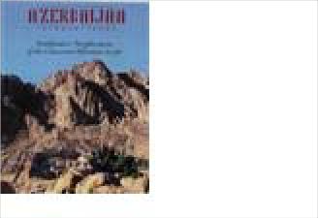
Publication
English
Azerbaijan International magazine is an independent publication committed to the discussion of issues related to Azerbaijanis around the world. Established in 1993.
Artist: Prducr: Date:
Length:
Blair, Betty (edit
Picture
English Version:
Azerbaijan Intern
Cyrillic Title
Autumn 2005
100pp.
English Version:
Prducr: Date:
Length:
Pirouz Khanlou
Cyrillic Title
2003
English Version:
Prducr:
Date: Length:
Azerbaijan Repu
Cyrillic Title
1994

Publication Azeri
In Azeri; Physical

Artist:
Picture

Item: 4550
Title: Map of Qafqaz

Category Language: Description:

Publication Azeri
Caucasus; In Azeri

Artist:
Picture

Item: 4545
English Version:
Prducr: Date:
Length:
Azerbaijan Repu
Cyrillic Title
2002
Publication
Azeri
In Azeri; Political; Political sub- divisions shown
Artist: Prducr: Date:
Length:
Picture
English Version:
Azerbaijan Repu
Cyrillic Title
2002
English Version:
Prducr:
Date: Length:
Azerbaijan Repu
Cyrillic Title
2002
Title: Map of the Azeribaijan Republic

Category Language: Description:

Publication Azeri
In Azeri

Artist:
Picture

Item: 4638
Title: Tourist map of Baku
Category Language: Description:

Miscellaneous

Item: 4354

Title: Baku State University: 1919-1994
Category Language: Description:

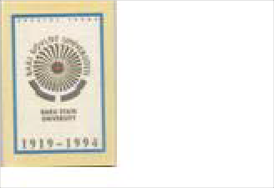
English Version:
Prducr: Date:
Length:
Republic of Azer
Cyrillic Title
Publication
English
Tourist map of Baku with pictures of historic sites in Baku on the reverse
Artist: Prducr: Date:
Length:
Picture
English Version:
Ministry of Yout
Cyrillic Title
2003
Publication
English
History of Univ. at its 75th anniversary
Artist: Prducr: Date:
Length:
Aleskerov, Murtu
Picture
English Version:
Baku
Cyrillic Title
1994

Pamphlet

Item: 4019
Title: Azerbaijan: An Emerging Free Market Democracy
Category Language: Description:

Item: 4020
Title: Azerbaijan's Application for Membership of the Council of Europe

Category Language: Description:

Publication English

Artist:
Council of Europ
Picture

Item: 4305
Publication
English
Embassy pamphlet with economic and political background
Artist: Prducr: Date:
Length:
Embassy of the R
Picture
English Version:
Washington: BS
Cyrillic Title
1998
Publication
English
Embassy pamphlet with economic and political background
Artist: Prducr: Date:
Length:
Embassy of the R
Picture
English Version:
Washington: BS
Cyrillic Title
1998
English Version:
Prducr: Date:
Length:
Council of Europ
Cyrillic Title
2000
Title: Law on Parliamentary Elections of the Republic of Azerbaijan (European
Category Language: Description:

Item: 4297
Title: Šeki

Category Language: Description:

Periodical

Item: 4004

Title: Azerbaijan Architecture International

Category Language: Description:

Publication
Winter 1998

Artist:
Picture

Publication
English
Artist: Prducr: Date:
Length:
Nolte, G.
Picture
English Version:
Strasbourg: Coun
Cyrillic Title
2000
Publication
Azeri
illustrated travel pamphlet
Artist: Prducr: Date:
Length:
Intourist
Picture
English Version:
Moscow?: Intouri
Cyrillic Title
1989
English Version:
Cyrillic Title
Prducr:
Date: Length:
1998

Item: 4005
Title: Azerbaijan International

Category Language: Description:

Publication Azeri
Fall 1993

Artist:
Blair, Betty
Picture

Publication
Publication
Azeri
Spring 1998 - Quest for Independence
Artist: Prducr: Date:
Length:
Blair, Betty
Picture
English Version:
Sherman Oaks: A
Cyrillic Title
1998
English Version:
Prducr: Date:
Length:
Sherman Oaks: A
Cyrillic Title
1993

Cyrillic Title

English Version:
Spring 1996

Artist: Prducr: Date: Length:

Sherman Oaks: A 1996
Picture

Publication Azeri

Publication
Spring 1997

Spring 2002

Artist:

Artist:
Blair, Betty
Picture

Picture

Item: 4011
Title: Azerbaijan International: Crisis in the Arts

Category Language: Description:

Publication Azeri
Spring 1995

Artist:
Blair, Betty
Picture

Item: 4009
English Version:
Prducr: Date:
Length:
Sherman Oaks: A
Cyrillic Title
1997
English Version:
Prducr: Date:
Length:
Sherman Oaks: A
Cyrillic Title
2002
English Version:
Prducr:
Date: Length:
Sherman Oaks: A
Cyrillic Title
1995
Title: Azerbaijan International: Fixing the Future Environmental Challenges

Category Language: Description:

Publication Azeri
Summer 1994

Artist:
Blair, Betty
Picture

Item: 4010
Title: Azerbaijan International: Health and Medical Care

Category Language: Description:

Publication Azeri
Winter 1995

Artist:
Blair, Betty
Picture

Item: 4013
Title: Azerbaijan International: Leisure & Play

Category Language: Description:

Publication Azeri
Autumn 1995

Artist:
Blair, Betty
Picture

Item: 4008
English Version:
Prducr: Date:
Length:
Sherman Oaks: A
Cyrillic Title
1994
English Version:
Prducr: Date:
Length:
Sherman Oaks: A
Cyrillic Title
1995
English Version:
Prducr: Date:
Length:
Sherman Oaks: A
Cyrillic Title
1995
Title: Azerbaijan International: Oil 100 Years Ago

Category Language: Description:

Publication Azeri
Spring 1994

Artist:
Blair, Betty
Picture

Item: 4012
Title: Azerbaijan International: Resources: Natural & Intellectual

Category Language: Description:

Publication Azeri
Summer 1995

Artist:
Blair, Betty
Picture

Item: 4015
Title: Azerbaijan International: Science That Made a Difference

Category Language: Description:

Publication Azeri
Summer 1996

Artist:
Blair, Betty
Picture

Item: 4016
English Version:
Prducr: Date:
Length:
Sherman Oaks: A
Cyrillic Title
1994
English Version:
Prducr: Date:
Length:
Sherman Oaks: A
Cyrillic Title
1995
English Version:
Prducr: Date:
Length:
Sherman Oaks: A
Cyrillic Title
1996
Title: Azerbaijan International: Verbal Folklore

Category Language: Description:

Publication Azeri
Autumn 1996

Artist:
Blair, Betty
Picture

Item: 4007
Title: Azerbaijan International: Winter of Disbelief

Category Language: Description:

Publication Azeri
Winter 1994

Artist:
Blair, Betty
Picture

Item: 4029
Title: Populyar: Azerbaijan beynalkhaq jurnaly

Category Language: Description:

Publication Azeri
No. 2. February-March 1997

Artist:
Picture

English Version:
Prducr: Date:
Length:
Sherman Oaks: A
Cyrillic Title
1996
English Version:
Prducr: Date:
Length:
Sherman Oaks: A
Cyrillic Title
1994
English Version:
Cyrillic Title
Prducr: Date:
Length:
1997
Populyar: Azerbaijan beynalk

Report

Item: 4639
Title: USAID Azerbaijan: From Relief to Development
Category Language: Description:

Textbook, Workbook

Item: 4333
Title: Azerbaijani Language (c. 2)

Category Language: Description:
Publication Azeri

Artist:

Gouliyeva, Mina

Picture

Textbook/Workbook

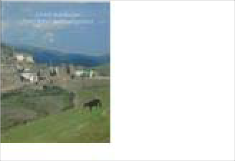
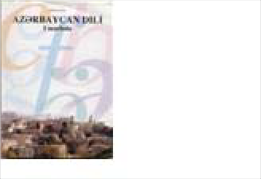
Item: 4332
Publication
English
Report on USAID accomplishments in Azerbaijan
Artist: Prducr: Date:
Length:
Effendi, Rena
Picture
English Version:
USAID/Caucasus
Cyrillic Title
2002
English Version:
Cyrillic Title
Prducr: Date:
Length:
Baku
2001
Azerbaijan dili
Title: Azerbaijani Language (c.1)

Category Language: Description:

Publication Azeri

Artist:
Gouliyeva, Mina
Picture

Viewbook

Item: 4250

Item: 4022

Title: Azerbaijan State Theater of Opera and Ballet Category Language: Description: Publication Azeri

Title: Baku State University 1919-1999

Category Language: Description:

Artist:

Shipton, James (e

Picture

Publication English
viewbook

Artist:
Rasulzade, M.A.
Picture

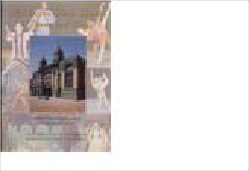
English Version:
Cyrillic Title
Prducr: Date:
Length:
Baku
2001
Azerbaijan dili
English Version:
Prducr:
Date: Length:
Istanbul: UN Dev
Cyrillic Title
English Version:
Prducr:
Date: Length:
Baku
Cyrillic Title
2000

Central Asia

Book

Item: 4036

Title: Along the Great Silk Road

Category Language: Description:

Publication Russian
Photo-album of land, architecture

Artist:
Talanova, Olga
Picture

Item: 4567
Title: Along the Silk Road

Category Language: Description:

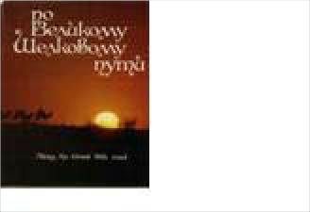
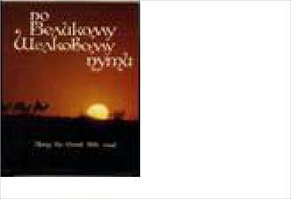
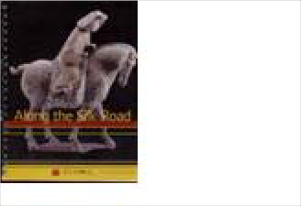
Publication English
English Version:
Prducr: Date:
Length:
Kramos
Cyrillic Title
1991
Publication
Russian
Picture book of Silk Road, some emphasis on Kazakhstan
Artist: Prducr: Date:
Length:
Baipakov, Karl &
Picture
English Version:
Cyrillic Title По Великому Шелкому пут
Po Velikomu Shelovomu puti
Alma-ata
1991

320 pp.

English Version:

Cyrillic Title
An education kit published by the Silk Road Project and the Asia Society. Includes Audio CD & DVD

Artist: Prducr: Date: Length:
SPICE and The S Stanford Program 2006
263pp
Picture

Item: 4037
Title: Arab World Almanac 1993

Category Language: Description:
Publication

Artist:

Picture

Item: 4059
Title: Aral Sea Basin Problems: Research and Recommendations

Category Language: Description:

Publication English

Artist:
Picture

Item: 4060
Title: Aral Sea Tragedy, c.1

Category Language: Description:

Publication English
Diary of an Expedition

Artist:
Reznichenko, Gri
Picture

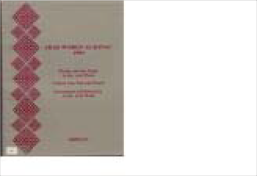
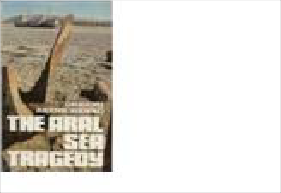
English Version:
Prducr:
Date: Length:
AMIDEAST. Wa
Cyrillic Title
1993
English Version:
Prducr: Date:
Length:
Tashkent
Cyrillic Title
1998
English Version:
Prducr:
Date: Length:
Moscow: Novosti
Cyrillic Title
1992

Item: 4280
Title: Aral Sea Tragedy, c.2

Category Language: Description:

Publication English
Diary of an Expedition

Artist:
Reznichenko, Gri
Picture

Item: 4061
Title: Baburnama: Memoirs of Babur, Prince and Emperor

Category Language: Description:

Publication

Artist:
Thackston, Whee
Picture

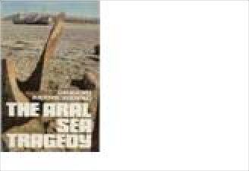
Item: 4575
English Version:
Prducr:
Date: Length:
Moscow: Novosti
Cyrillic Title
1992
English Version:
Prducr: Date:
Length:
New York and O
Cyrillic Title
1996
Publication
English
Illustrated memoirs of 1st Mughal Emperor
Artist: Prducr: Date:
Length:
Thackston, Whee
Picture
English Version:
New York: Oxfor
Cyrillic Title
1996
Title: Bringing the Stans and Central Asia into the Classroom

Category Language: Description:

Publication English
3 ring binder

Artist:
Chris Foley, Bart
Picture

Item: 4039
Title: Caravan to America: Living Arts of the Silk Road
Category Language: Description:

Item: 4040
Title: Central Asia

Category Language: Description:

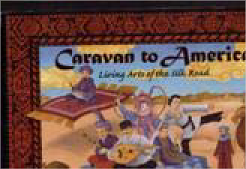
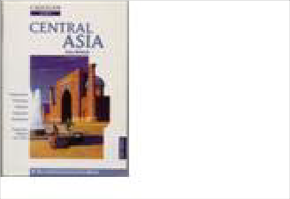
Publication English
English Version:
Cyrillic Title
Prducr: Date:
Length:
IAUNRC, Indian
2004

74pp
Publication
English
young reader's illustrated guide to silk road arts as practiced in U.S.
Artist: Prducr: Date:
Length:
Major, John S. an
Picture
English Version:
Chicago: Cricket
Cyrillic Title
2002

English Version:

Cyrillic Title
Cadogan Guides, 2nd edition

Artist: Prducr: Date: Length:
Whittell, Chris London: Cadogan 1996
Picture

Publication Russian

Artist:
Региональное Б
Picture

Item: 4277
Title: Central Asia and the World: Kazakhstan, Uzbekistan, Tajikistan, Kyrgyzs

Category Language: Description:

Publication

Artist:
Mandelbaum, Mi
Picture

Item: 4041
Title: Central Asia: Its Strategic Importance and Future Prospects

Category Language: Description:

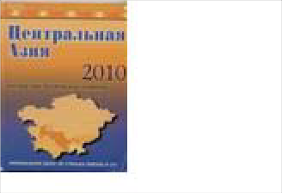
Publication English
English Version:
Cyrillic Title Цeнтральная Азия 2010
Tsentral'naia Aziia 2010
Prducr: Date:
Length:
Finland: ScanWe
English Version:
Prducr: Date:
Length:
New York: Coun
Cyrillic Title
1994

English Version:

Cyrillic Title
modern history

Artist: Prducr: Date: Length:
Malik, Hafeez New York, St.Ma 1996
Picture

Publication English
modern history

Artist:
Malik, Hafeez
Picture

Item: 4492
Title: Central Asian Art
Category Language: Description:

Item: 4042
Title: Circle Houses: Yurts, Tipis and Benders Category Language: Description: Publication English

Artist:

Pearson, David

Picture

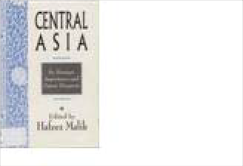
Item: 4043
English Version:
Prducr: Date:
Length:
New York, St.Ma
Cyrillic Title
1996
Publication English

English Version:
Artist: Prducr: Date:
Length:
Julien Depaulis
Picture
Greenwich Editio
Cyrillic Title
2003
256 pp
English Version:
Prducr: Date:
Length:
White River Junc
Cyrillic Title
2001
Title: Cultural Handbook for the New Independent States

Category Language: Description:

Publication

Artist:
Choate, Lisa A an
Picture

Item: 4053
Title: First Reader in Orientalistics: dedicated to the memory of S.G. Livshits (T
Category Language: Description:

Item: 4047
Title: Globalization and the Challenges of a New Century (copy 1)
Category Language: Description:

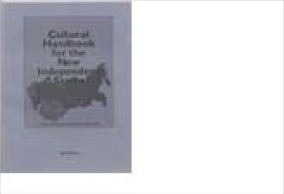
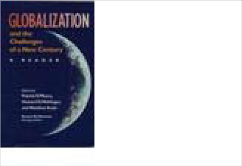
Item: 4048
English Version:
Prducr: Date:
Length:
American Counci
Cyrillic Title
2000
Publication
Russian
First east… lesson…in memory of S.G. Livshitz
Artist: Prducr: Date:
Length:
Livshitsa, S.G.
Picture
English Version:
Cyrillic Title Первые Востоковедческие ч
Pervye Voctokovedcheskie ch
Barnaul: Izdatel'st
1996
Publication
English
Artist: Prducr: Date:
Length:
O’Meara, P, Meh
Picture
English Version:
Indianapolis and
Cyrillic Title
2000
Title: Globalization and the Challenges of a New Century (copy 2)
Category Language: Description:

Item: 4045
Title: Hundred Thousand Fools of God: Musical Travels in Central Asia (and Q
Category Language: Description:

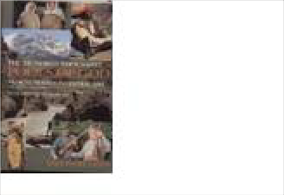
Item: 4394
Publication
English Version:
Artist: Prducr: Date:
Length:
O’Meara, P, Meh
Picture
Indianapolis and
Cyrillic Title
2000
Publication
English
Ethnographic travelogue about the music and people of Soviet & Post-Soviet Central Asia w/ CD
Artist: Prducr: Date:
Length:
Levin, Theodore
Picture
English Version:
Bloomington: Ind
Cyrillic Title
1996
318 pp.
Title: Islam: A thousand years of faith and power
Category Language: Description:

Item: 4050
Publication English

English Version:
Cyrillic Title

Title: Life Along the Silk Road
In its first thousand years—from the revelations to Muhammad in the seventh century to the great Islamic empires of the sixteenth-- Islamic civilization flourished.
While Europeans suffered through the Dark Ages, Muslims in such cities as Jerusalem, Damascus, Alexandria, Fez, Tunis, Cairo, and Baghdad made remarkable advances in philosophy, science,medicine, literature, and art. This engrossing and accessible book explores the first millennium of Islamic culture, shattering stereotypes and enlightening readers about the events and achievements that have shaped contemporary Islamic civilization.

Artist: Prducr: Date: Length:
Bloom, Jonathan Yale University P 2002
304 pp.
Picture

Category Language: Description:

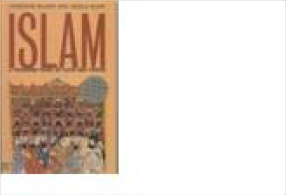
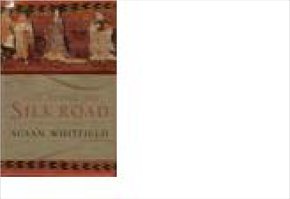
Item: 4051
Publication
English
Artist: Prducr: Date:
Length:
Whitfield, Susan
Picture
English Version:
Berkeley: Univers
Cyrillic Title
1999
Title: Navruz 2001 Photos

Category Language: Description:

Publication

Artist:
Picture

Item: 4052
Title: Parliamentarism in the Countries of Central Asia
Category Language: Description:

Item: 4054
Title: Political Reform and Human Rights in Uzbekistan, Kyrgyzstan, and Kaza

Category Language: Description:

Publication English

Artist:
Commission on S
Picture

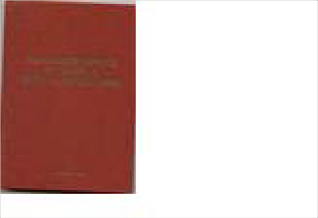
Item: 4261
English Version:
Cyrillic Title
Prducr: Date:
Length:
2001
Publication
Russian
Parliamentary Systems in Central Asian Countries
Artist: Prducr: Date:
Length:
Eshmambetov, N.
Picture
English Version:
Cyrillic Title Парламентаризм в Странах
Parlamentarizm v Ctranakh T
Bishkek: КРСУ
1999
English Version:
Prducr: Date:
Length:
Commissionon S
Cyrillic Title
1998
Title: Post-Soviet Handbook: A guide to Grassroots Organizations and Internet
Category Language: Description:

Item: 4055
Title: Russia, Siberia and State Central Asia: Interaction of Nationalities & Cult
Category Language: Description:

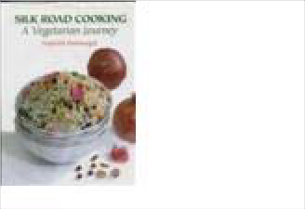
Item: 4056
Publication
Artist: Prducr: Date:
Length:
Ruffin, M Holt,
Picture
English Version:
Seattle: Civil So
Cyrillic Title
Publication
Russia, Siberia and the Government of Central Asia
Artist: Prducr: Date:
Length:
Picture
English Version:
Cyrillic Title Россия, Сибирь и Государст
Rossiya, Sibir' I Gosudarstva
Баурнал: Издате
1997
Title: Silk Road Cooking: A Vegetarian Journey Category Language: Description: Publication
English Version:

Cyrillic Title

Artist: Prducr: Date: Length:

Batmanglij, Najm

Picture

Publication English

Artist:
Bakshi, Akhil
Picture

Item: 4062
Title: Silk Road: Art and History

Category Language: Description:
Publication

Artist:

Tucker, Jonathan

Picture

Item: 4489
Title: Stories from the Silk Road

Category Language: Description:

Publication English
Illustrated children's book

Artist:
Cherry Gilchrist
Picture

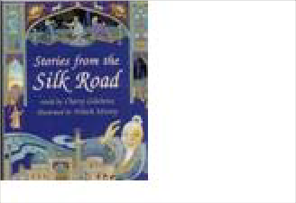
Item: 4058
English Version:
Prducr: Date:
Length:
New Delhi: Odys
Cyrillic Title
2001
English Version:
Prducr: Date:
Length:
Chicago: Art Me
Cyrillic Title
2003
English Version:
Cyrillic Title
Prducr: Date:
Length:
Barefoot Books
1999

80 pp
Title: Therapy for several liver conditions

Category Language: Description:

Publication Russian

Artist:
Dzhamanbaev, E
Picture

Item: 4491
Title: Traditional Textiles of Central Asia Category Language: Description: Publication English

Artist:

Janet Harvey

Picture

Item: 4490
Title: Traveling Man: The Journey of Ibn Battuta

Category Language: Description:

Publication English
Illustrated children's book

Artist:
Picture

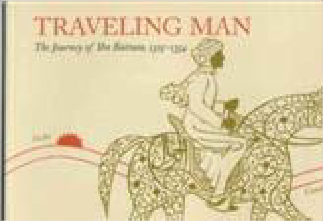
Item: 4063
English Version:
Cyrillic Title Терапия некоторых ургентн
Terapiya nekotoryx urgentny
Prducr: Date:
Length:
Bishkek
1991
English Version:
Cyrillic Title
Prducr: Date:
Length:
Thames & Hudso
1996

160 pp
English Version:
Cyrillic Title
Prducr: Date:
Length:
Title: Uralic Fairy Tales

Category Language: Description:

Publication Russian
Uralic Fairy Tales in Russian

Artist:
П. БАЖОВ
Picture

Booklet

Item: 4412

Title: Two Epochs of National Self-Determination in Central Asian Cinema: The
Category Language: Description:

Brochure

Item: 4300

Title: Services along the Silk Road

Category Language: Description:

Publication English
Travel brochure

Artist:
Bestway Tours &
Picture

English Version:
Cyrillic Title Уральские Сказки
Ural'skie Skazki
Prducr: Date:
Length:
ДЕТГИЗ
1953
Publication
Russian
A booklet accompanying a 10 DVD set of Central Asian films with information relating to each. See ID# 4413-#4422 for films.
Artist: Prducr: Date:
Length:
Gulnara Abikeye
Picture
English Version:
OSI
Cyrillic Title
2006
104 pp.
English Version:
Prducr:
Date: Length:
Burnaby: Bestwa
Cyrillic Title
2001

Dictionary

Item: 4044

Title: Dictionary of the Turkic Languages
Category Language: Description:

Magazine

Item: 4342

Title: National Geographic, v. 184, no. 4, October 1993
Category Language: Description:

Item: 4286
Publication
English
includes Azeri, Kazakh, Kyrgyz, Tatar, Turkish, Turkmen, Uighur, Uzbek
Artist: Prducr: Date:
Length:
Öztopçu, Kurtulu
Picture
English Version:
New York: Routl
Cyrillic Title
1999
Publication
English
Includes article: Afghanistan's Uneasy Peace
Artist: Prducr: Date:
Length:
Mackenzie, Rich
Picture
English Version:
National Geograp
Cyrillic Title
1993
Title: National Geographic, v. 190, no. 6, December 1996
Category Language: Description:

Item: 4345
Title: National Geographic, v. 195, no. 5, May 1999
Category Language: Description:

Item: 4285
Title: National Geographic, v. 91, no. 2, February 1997
Category Language: Description:

Publication
English
Includes article: Genghis Khan
Artist: Prducr: Date:
Length:
Edwards, Mike
Picture
English Version:
National Geograp
Cyrillic Title
1996
Publication
English
Includes article: Caspian Sea
Artist: Prducr: Date:
Length:
Cullen, Robert
Picture
English Version:
National Geograp
Cyrillic Title
1999
Publication
English
Includes article: The Great Khans
Artist: Prducr: Date:
Length:
Edwards, Mike
Picture
English Version:
National Geograp
Cyrillic Title
1997

Map

Item: 4543
Title: Caspian Sea Map
Category Language: Description:

Item: 4542
Title: Communism to Capitalism Map
Category Language: Description:

Item: 4539
Publication
English
Artist: Prducr: Date:
Length:
Picture
English Version:
National Geograp
Cyrillic Title
Publication
English
Artist: Prducr: Date:
Length:
Picture
English Version:
National Geograp
Cyrillic Title
Publication
English
The Economic Evolution of the Former Soviet Union
Artist: Prducr: Date:
Length:
Picture
English Version:
National Geograp
Cyrillic Title
1993
Title: Energy Map of Central Asia
Category Language: Description:

Item: 4531
Title: Geographical Map of Central Asia

Category Language: Description:

Publication English
1:1750000

Artist:
Picture

Item: 4532
Title: Geographical Map of Silk Road Countries

Category Language: Description:

Publication English
1:3000000

Artist:
Picture

Item: 4558
Publication
English
Petroleum Economist Energy Map Series no. 18, 4th Edition
Artist: Prducr: Date:
Length:
Picture
English Version:
Ernest & Young,
Cyrillic Title
English Version:
Prducr: Date:
Length:
Gizi Map
Cyrillic Title
English Version:
Prducr: Date:
Length:
Gizi Map
Cyrillic Title
Title: Map of Central Asia and Kazakhstan, 2 Pieces
Category Language: Description:

Item: 4551
Title: Map of Kazakhstan and Central Asia
Category Language: Description:

Miscellaneous
Publication
Uzbek
Laminated; Cyrillic; 2 pieces
Artist: Prducr: Date:
Length:
Picture
English Version:
Tashkent Catogra
Cyrillic Title
1999
Publication
Russian
Cyrillic; Laminated; 1/2 see 4557
Artist: Prducr: Date:
Length:
Picture
English Version:
Tashkent Catogra
Cyrillic Title
1999
Publication
Russian
Laminated; Cyrillic; 2/2 see 4551
Artist: Prducr: Date:
Length:
Picture
English Version:
Cyrillic Title Cредняя Азия
Tashkent Catogra
1999

Item: 4351

Title: Free Trade, Free Markets: Central Asia on the Edge of Globalization
Category Language: Description:

Periodical

Item: 4038

Title: Arid Ecosystems Vol. 4, No. 8

Category Language: Description:
Publication

Artist:

Zalibekov, Z

Picture

Item: 4283
Title: Education About Asia, v. 5 n. 2

Category Language: Description:

Publication English
Fall issue

Artist:
Ellington, Lucien
Picture

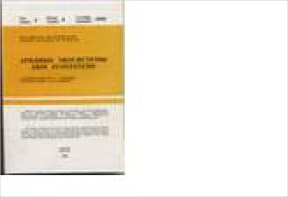
Publication
English
article from Challenge July- August 2004
Artist: Prducr: Date:
Length:
Spechler, Martin
Picture
English Version:
M. E. Sharpe
Cyrillic Title
2004
English Version:
Cyrillic Title
Prducr:
Date: Length:
Russian Academy
1998
Aridnye Ekosistemi
English Version:
Prducr:
Date: Length:
Ann Arbor: Asso
Cyrillic Title
2000

Item: 4284
Title: Education About Asia, v. 5 n. 3

Category Language: Description:

Publication English
Winter issue

Artist:
Ellington, Lucien
Picture

Item: 4287
Title: Education About Asia, v. 6 n. 2

Category Language: Description:

Publication English
Fall issue

Artist:
Ellington, Lucien
Picture

Item: 4288
Title: Education About Asia, v. 6 n. 3

Category Language: Description:

Publication English
English Version:
Prducr:
Date: Length:
Ann Arbor: Asso
Cyrillic Title
2000
English Version:
Prducr: Date:
Length:
Ann Arbor: Asso
Cyrillic Title
2001

English Version:

Cyrillic Title
Winter issue

Artist: Prducr: Date: Length:
Ellington, Lucien Ann Arbor: Asso 2001
Picture

Item: 4289
Title: Education About Asia, v. 7 n. 1

Category Language: Description:

Publication English
Spring issue

Artist:
Ellington, Lucien
Picture

Item: 4290
Title: Education About Asia, v. 7 n. 2

Category Language: Description:

Publication English
Fall issue

Artist:
Ellington, Lucien
Picture

Item: 4291
Title: Education About Asia, v. 7 n. 3

Category Language: Description:

Publication English
English Version:
Prducr:
Date: Length:
Ann Arbor: Asso
Cyrillic Title
2002
English Version:
Prducr: Date:
Length:
Ann Arbor: Asso
Cyrillic Title
2002

English Version:

Cyrillic Title
Winter issue

Artist: Prducr: Date: Length:
Ellington, Lucien Ann Arbor: Asso 2002
Picture

Item: 4292
Title: Education About Asia, v. 8 n. 1

Category Language: Description:

Publication English
Spring issue

Artist:
Ellington, Lucien
Picture

Item: 4293
Title: Education About Asia, v. 8 n. 2

Category Language: Description:

Publication English
Fall issue

Artist:
Ellington, Lucien
Picture

Item: 4046
Title: FACES: Central Asia

Category Language: Description:

Publication English
English Version:
Prducr:
Date: Length:
Ann Arbor: Asso
Cyrillic Title
2003
English Version:
Prducr: Date:
Length:
Ann Arbor: Asso
Cyrillic Title
2003

English Version:

Cyrillic Title
Magazine for young readers

Artist: Prducr: Date: Length:
Babcock, Denise FACES
1996
Picture

Item: 4049
Title: International Journal of Social Education
Category Language: Description:

Photo

Item: 4483

Title: Stanorama: Kazakhstan - Turkmenistan - Uzbekistan - Tajikistan - Kyrgy

Category Language: Description:

Publication English

Artist:
Herwig, Christop
Picture

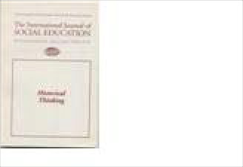
Estonia
Publication
English
Volume 12, Number 2,
Fall/Winter 1997-98
Artist: Prducr: Date:
Length:
Cantu, D. Antoni
Picture
English Version:
Muncie: Ball Stat
Cyrillic Title
1997-98
English Version:
Cyrillic Title
Prducr: Date:
Length:
2006
97 pp.

Book

Item: 4065

Title: Mari Folk Art

Category Language: Description:

Publication Russian

Artist:
Medzhitova, Elmi
Picture

Magazine

Item: 4024

Title: National Geographic, v. 157, no. 4, April 1980
Category Language: Description:

Pamphlet

Item: 4064

Title: Integrating Non-Estonians in Estonian Society: Setting the Course

Category Language: Description:

Publication English

Artist:
Picture

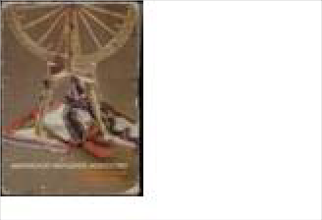
English Version:
Cyrillic Title Марийское народное искусс
Mariiskoe Narodnoe Iskusstv
Prducr: Date:
Length:
Mari State
1985
Publication
English
Includes article: Return to Estonia
Artist: Prducr: Date:
Length:
Vesilind, Priit J.
Picture
English Version:
National Geograp
Cyrillic Title
1980
English Version:
Prducr:
Date: Length:
Tallinn
Cyrillic Title
1997

Europe

Map

Item: 4555

Title: Map of Europe
Category Language: Description:

Finland

Book

Item: 4573

Title: Asunnon Muodonmuutoksia
Category Language: Description:

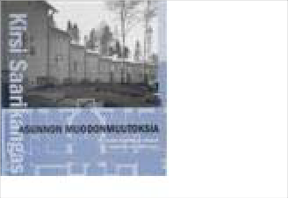
Item: 4066
Publication
Turkish
In Turkish; One side with text labels; One side with no labels; Hanging
Artist: Prducr: Date:
Length:
Picture
English Version:
Typah
Cyrillic Title
Publication
Finnish
Modern architecture
Artist: Prducr: Date:
Length:
Kirsi Saarikangas
Picture
English Version:
Suomalaisen Kirj
Cyrillic Title
2002
630pp
Title: Comparative Governance: Politics in Finland
Category Language: Description:

Item: 4067
Title: Finland in the New Europe

Category Language: Description:
Publication English

Artist:

Jakobson, Max

Picture

Miscellaneous

Item: 4485

Title: Cranium Game

Category Language: Description:

Publication Finnish
Cranium Game in Finnish

Artist:
Picture

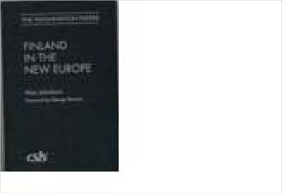
Publication
English
Finnish Ministry of Foreign Affairs
Artist: Prducr: Date:
Length:
Shively, W. Philli
Picture
English Version:
McGraw-Hill
Cyrillic Title
1999
English Version:
Prducr: Date:
Length:
Washington, DC:
Cyrillic Title
English Version:
Cyrillic Title
Prducr:
Date: Length:
2006

Periodical

Item: 4068
Title: Form Function: Finland
Category Language: Description:

Hungary

Book

Item: 4328

Title: Fall of the Red Star
Category Language: Description:

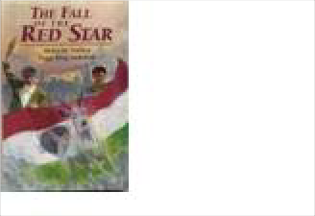
Map
Publication
English
no. 72 April 1998
Artist: Prducr: Date:
Length:
Stenros, Anne (ed
Picture
English Version:
Helsinki: Design
Cyrillic Title
1998
Publication
English
True fiction about 1956 Hungarian uprising
Artist: Prducr: Date:
Length:
Szablya, Helen &
Picture
English Version:
Boyds Mills Press
Cyrillic Title
1996

Item: 4656

Title: Budapest and Surroundings
Category Language: Description:

Item: 4657
Title: Budapest City Map
Category Language: Description:

Item: 4552
Title: Map of Budapest

Category Language: Description:

Publication Hungarian
In Hungarian

Artist:
Picture

Publication English

English Version:
Maps to Budapest and surroundings, including hiking tours
Cyrillic Title
Artist: Prducr: Date:
Length:
Picture
Publication
English
Budapest city map
Artist: Prducr: Date:
Length:
Picture
English Version:
Tourism Office of
Cyrillic Title
English Version:
Cyrillic Title
Prducr: Date:
Length:

Travel Brochure

Item: 4659
Title: A Doezen Reasons to Visit Budapest
Category Language: Description:

Item: 4658
Title: A Dozen Reasons to Visit Hungary
Category Language: Description:

Item: 4655
Title: Budapest Guide
Category Language: Description:

Publication
English
Budapest guide
Artist: Prducr: Date:
Length:
Picture
English Version:
Hungarian Nation
Cyrillic Title
Publication
English
Hungary guide
Artist: Prducr: Date:
Length:
Picture
English Version:
Hungarian Nation
Cyrillic Title
Publication English

English Version:
Guide to Budapest including maps Artist:
Prducr: Date: Length:
Picture
Tourism Office of
Cyrillic Title
2006

Item: 4654
Title: Step by Step Hungary
Category Language: Description:

Item: 4653
Title: Talent for Entertaining
Category Language: Description:

Kazakhstan
Publication
English
Hungary travel brochure
Artist: Prducr: Date:
Length:
Picture
English Version:
Hungarian Nation
Cyrillic Title
Publication
English
Hungary travel brochure
Artist: Prducr: Date:
Length:
Picture
English Version:
Hungarian Nation
Cyrillic Title

Book

Item: 4357

Title: Actual Questions of Comparative Literature

Category Language: Description:

Publication Russian

Artist:
Маданов, М.Х.
Picture

Item: 4069
Title: Akhmed Yasawi Architectural Complex
Category Language: Description:

Item: 4628
Title: Ancient Kazakhstan Myths
Category Language: Description:

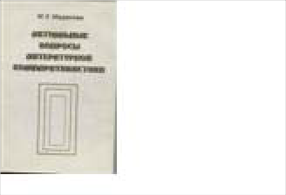
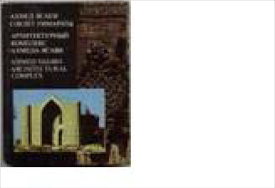
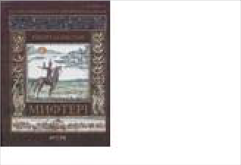
Item: 4355
English Version:
Cyrillic Title Актуальные Вопросы Литер
Aktualnye Voprosy Literaturn
Prducr: Date:
Length:
Almaty: ГЫЛЫ
1999
Publication
Kazakh
Photo-album in Kazakh, Russian, English
Artist: Prducr: Date:
Length:
Picture
English Version:
Cyrillic Title Архитектурный комплекс А
Arkhitekturnii kompleks Akh
Almaty: “Oner”
1988
Publication
Kazakh
Illustrated children's encyclopedia of ancient Kazakh myths
Artist: Prducr: Date:
Length:
Zhanaidarov, O
Picture
English Version:
Cyrillic Title ЕЖЕЛГІ ҚАЗАҚСТАН МИ
Ezhelgi Kazakhstan Mifteri
Aruna Baspasy
2006

252pp
Title: Ethnocultural Traditions in Modern Art of Kazakhstan

Category Language: Description:

Publication Russian

Artist:
Ергалиева, Р.А.
Picture

Item: 4073
Title: Fierce Grey
Category Language: Description:

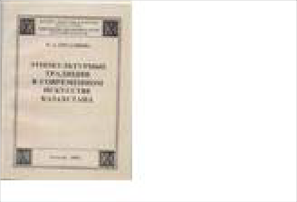
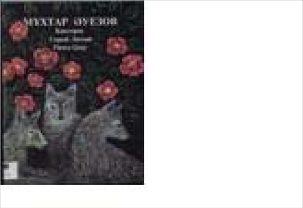
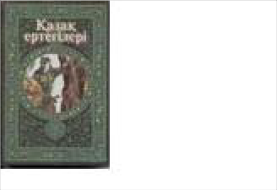
Item: 4447
English Version:
Cyrillic Title Этнокультурные Традиции
Etnokul'turnye Traditsii v Co
Prducr: Date:
Length:
Аlmaty: НИЦ Г
2002
Publication
Kazakh
short story by classic Kazakhstani author about a wolf
Artist: Prducr: Date:
Length:
Auezov, Mukhta
Picture
English Version:
Almaty: Zheti Zh
Cyrillic Title
1997
Title: Kazak Fairy Tales 2

Category Language: Description:
Publication Kazakh

English Version:

Cyrillic Title

Artist: Prducr: Date: Length:

A. Esten

Kazak Khalyk Ad 2000
272 pp.

Picture

Publication Kazakh

Artist:
A. Esten
Picture

Item: 4445
Title: Kazak Fairy Tales 5

Category Language: Description:
Publication Kazakh

Artist:

A. Esten

Picture

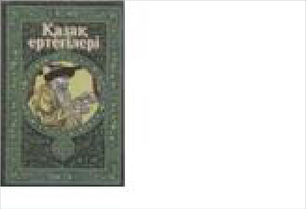
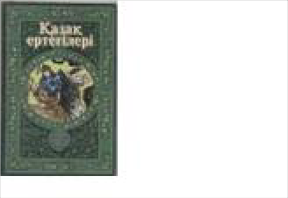
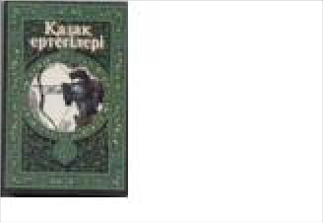
Item: 4444
English Version:
Cyrillic Title
Prducr: Date:
Length:
Kazak Khalyk Ad
2000

270 pp.
English Version:
Cyrillic Title
Prducr: Date:
Length:
Kazak Khalyk Ad
2000

271 pp.
Title: Kazak Fairy Tales 6

Category Language: Description:
Publication Kazakh

English Version:

Cyrillic Title

Artist: Prducr: Date: Length:

A. Esten

Kazak Khalyk Ad 2000
277 pp.

Picture

Publication Kazakh

Artist:
Zh. Malaisarin
Picture

Item: 4454
Title: Kazakh Cuisine & Culture
Category Language: Description:

Item: 4340
Title: Kazakh Orchestra

Category Language: Description:

Publication Kazakh

English Version:
children's book

Artist: Prducr:
Sopybekov, B. Almatykitap: Ast
Picture

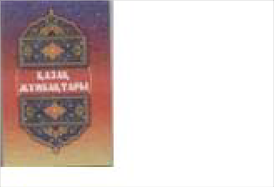
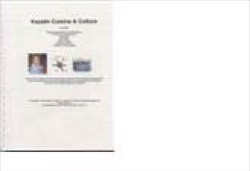
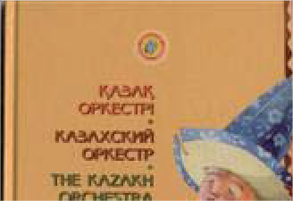
Cyrillic Title
English Version:
Cyrillic Title
Prducr: Date:
Length:
Ana tili
2005

127 pp.
Publication English

English Version:
A booklet including Kazakh folk games for small children, cooking and cleaning tips, language, appetizers, and recipes
Artist: Prducr: Date:
Length:
Picture
Wreath of Hope a
Cyrillic Title
2005
56 pp.
Казахский Оркестр

Kazakhskiy Orkestr

Date: Length:
2002

Item: 4455

Item: 4337
Title: Kazakh Traditions and Customs Category Language: Description: Publication Kazakh

Title: Kazakhstan

Category Language: Description:

Artist:

Picture

Publication Russian

English Version:
coffee table book w/ extensive text

Artist: Prducr:
Serikbaeva, Klara Flint River: Lond
Picture

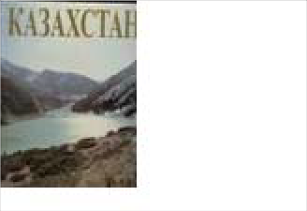
Cyrillic Title
Publication
Kazakh
Kazakh State University album in Kazakh/Russian)
Artist: Prducr: Date:
Length:
Picture
English Version:
Cyrillic Title Казахский государственный
Kazakhskii Gosudarstvennii
Almaty: “Oner”
1984
English Version:
Cyrillic Title
Prducr: Date:
Length:
2006
284 pp.
Казахстан

Date: Length:
1995

Item: 4609
Title: National Kitchen of Kazakhs

Category Language: Description:

Publication Kazakh
Cookbook. Red Cover

Artist:
Kenzheakhmetuly
Picture

Item: 4076
Title: Nursultan Nazarbayev

Category Language: Description:

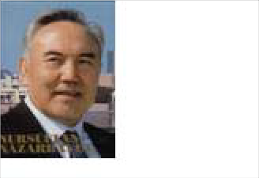
Publication Kazakh
Publication
French
Accompanied by two CDs, marked 4075a and 4075b; should be loaned with CDs as a unit.
MP3 backups exist.
Artist: Prducr: Date:
Length:
Khoussaïnova, C
Picture
English Version:
Paris: Langues et
Cyrillic Title
1997
English Version:
Cyrillic Title
Prducr: Date:
Length:
Almatykitap
2005
Kazakhtyng darkan dastarkha
240 pages

English Version:

Cyrillic Title
coffee table book with pictures of the man

Artist: Prducr: Date: Length:
Press office of Pr London: Anglo-C 2000
Picture

Publication Russian

Artist:
Бозтаев, Кешри
Picture

Item: 4356
Title: Singer of the People
Category Language: Description:

Item: 4082
Title: Soul of Kazakhstan
Category Language: Description:

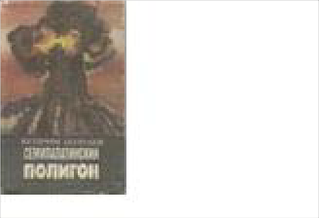
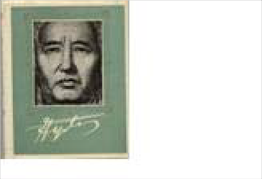
Item: 4079
English Version:
Cyrillic Title Семипалатинский Полигон
Semipalatinskii Poligon
Prducr: Date:
Length:
Alma-Ata: Kazak
1992
Publication
Russian
Volume commemorating Kazakh national author M.O. Ayezov
Artist: Prducr: Date:
Length:
Ауэзов, Л.М.
Picture
English Version:
Cyrillic Title Певец Народа
Pevets Naroda
Alma-Ata: Наука
1977
Publication
English
Photgraphs by Eastep with essays by Kunanbay
Artist: Prducr: Date:
Length:
Eastep, Wayne an
Picture
English Version:
New York: Easter
Cyrillic Title
2001
Title: State Art Museum of A. Kasteev of the Republic of Kazakhstan

Category Language: Description:

Publication Russian
Album of paintings by the artist

Artist:
Toulebai, Erbolat
Picture

Item: 4081
Title: Taraz State University named after M.Kh. Dulaty
Category Language: Description:

Item: 4074
Title: Teaching Kazakh Linguistics through Computer Programs

Category Language: Description:

Publication Russian

Artist:
Kурышжанова А
Picture

English Version:
Prducr: Date:
Length:
Almaty
Cyrillic Title
1994
Publication
Kazakh
picture catalog of Taraz State University
Artist: Prducr: Date:
Length:
Picture
English Version:
Evero
Cyrillic Title
2000
English Version:
Cyrillic Title Лингвистическое Обеспече
Lingvisticheskoe Obespechen
Prducr: Date:
Length:
Almaty
1999

Brochure

Item: 4071
Title: Astana. Investment Catalogue

Category Language: Description:
Publication Russian

Artist:

Picture

Catalog

Item: 4306

Title: Erbolat Toulepbai
Category Language: Description:

Exhibit Brochure
English Version:
Prducr:
Date: Length:
Астана: Астана-
Cyrillic Title
Publication
Kazakh
catalog of paintings by Erbolat Toulepbai
Artist: Prducr: Date:
Length:
Toulepbai, Erbola
Picture
English Version:
Almaty
Cyrillic Title
1994

Item: 4578

Title: Kazakhstan Information Board

Category Language: Description:

Publication English

Artist:
IAUNRC
Picture

Magazine

Item: 4343

Title: National Geographic, v. 183, no. 3, March 1993
Category Language: Description:

Item: 4077
Title: Passport to the New World: Special Issue: Passport to Kyrgyzstan
Category Language: Description:

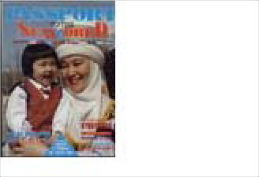
English Version:
Cyrillic Title
Prducr: Date:
Length:
2000
Publication
English
Includes article: Kazakhstan: Facing the Nightmare
Artist: Prducr: Date:
Length:
Edwards, Mike
Picture
English Version:
National Geograp
Cyrillic Title
1993
Publication
English
May/June 1994
Artist: Prducr: Date:
Length:
Shashkov, Eugen
Picture
English Version:
Passport Internati
Cyrillic Title
1994

Item: 4661
Title: Wild Fibers
Category Language: Description:

Map

Item: 4536

Title: Geographical Map of Kazakhstan

Category Language: Description:

Publication English
1:3000000

Artist:
Picture

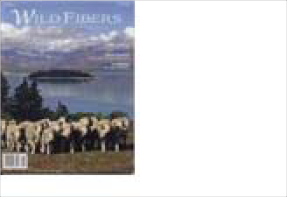
Item: 4538
Publication
English
Contains an article discussing the effects of Stalin's colletivization policies on kulak farmers in Kazakhstan
Artist: Prducr: Date:
Length:
Cortright, Linda
Picture
English Version:
Cyrillic Title
Summer 2007 (V
88pp
English Version:
Prducr: Date:
Length:
Gizi Map
Cyrillic Title
Title: Map of Kazakhstani Provinces
Category Language: Description:

Item: 4554
Title: Map of Nature Reserves in Kazakhstan

Category Language: Description:

Publication Russian
In Russian, Laminated

Artist:
Picture

Item: 4537
Title: Political Map of Kazakhstan

Category Language: Description:

Publication English
1:3000000

Artist:
Picture

Item: 4586
Publication
Kazakh
Flimsy; colorful political map; plastic film; Cyrillic
English Version:
Cyrillic Title
Artist: Prducr: Date:
Length:
Picture
English Version:
Prducr: Date:
Length:
Typah
Cyrillic Title
1998
English Version:
Prducr: Date:
Length:
Gizi Map
Cyrillic Title
Title: Republic of Kazakhstan

Category Language: Description:

Publication English
Large. Laminated

Artist:
Picture

Miscellaneous

Item: 4255

Title: Borovoe
Category Language: Description:

Item: 4349
Title: Kazakh Language

Category Language: Description:

Publication Kazakh
Textbook

Artist:
Picture

English Version:
Prducr: Date:
Length:
The Agency on L
Cyrillic Title
2006
Publication
photographs of Borovoe, mountain lake resort
Artist: Prducr: Date:
Length:
Picture
English Version:
Cyrillic Title Боровое
English Version:
Prducr:
Date: Length:
Almaty
Cyrillic Title
1998

Item: 4339
Title: Little Pearl of Kazakhstan
Category Language: Description:

Periodical

Item: 4070

Title: Astana Magazine (In-flight magazine of Air Kazakhstan)

Category Language: Description:

Publication Kazakh
February 1998

Artist:
Бектуров, Русте
Picture

Item: 4080
Publication
Postcards of Kazkakhstan resort Borovoe
Artist: Prducr: Date:
Length:
Picture
English Version:
Cyrillic Title Жемчужина Казахстана
Zhemchyzhina Kazakhstana
English Version:
Prducr: Date:
Length:
Стамвул: Mac st
Cyrillic Title
1998
Title: Stolitsa (Astana Kazakhstan magazine)

Category Language: Description:

Publication Russian
7/01

Artist:
Balikanaov, B.B.
Picture

Item: 4083
Title: US-Kazakhstan Monitor, v. 4 no. 1, April 1997

Category Language: Description:

Publication English
Caspian Sea issue

Artist:
Cowan, Janice (e
Picture

Item: 4084
Title: US-Kazakhstan Monitor, v. 4 no. 2, June 1997

Category Language: Description:

Publication English
Investment issue

Artist:
Cowan, Janice (e
Picture

English Version:
Prducr: Date:
Length:
Proxima: Almaty
Cyrillic Title
2001
English Version:
Prducr: Date:
Length:
US-Kazakhstan C
Cyrillic Title
1997
English Version:
Prducr: Date:
Length:
US-Kazakhstan C
Cyrillic Title
1997

Viewbook

Item: 4085
Title: Welcome to Almaty: The Centre of Tourism in Kazakhstan

Category Language: Description:

Publication English

Kazakhstan and Kyrgyzstan

Book

Artist:
Picture

Item: 4341
Title: Plaint of the Hunter Above the Abyss
Category Language: Description:

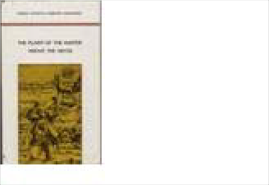
Kyrgyzstan
English Version:
Prducr:
Date: Length:
Almaty: Dept. of
Cyrillic Title
Publication
English
dialogue between Kyrgyz writer Chingiz Aitmatov and Kazakh poet Mukhtar Shakhanov
Artist: Prducr: Date:
Length:
Aitmatov, Ch. &
Picture
English Version:
Atamura: Almaty
Cyrillic Title
1998

Book

Item: 4294

Title: Aramco World

Category Language: Description:

Publication English

Artist:
Picture

Item: 4088
Title: Gateway to Kyrgyzstan

Category Language: Description:
Publication

Artist:

Picture

Item: 4307
Title: Historical Development and Current Situation of the Mass Media in Kyrg
Category Language: Description:

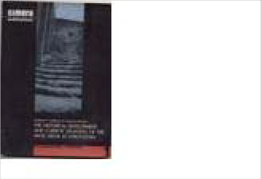
Item: 4099
English Version:
Cyrillic Title
Prducr: Date:
Length:
English Version:
Prducr: Date:
Length:
Committee of the
Cyrillic Title
1999
Publication
English
publication of large-scale research project on Kyrgyz mass media
Artist: Prducr: Date:
Length:
Kulikova, Svetlan
Picture
English Version:
Cimera Publicati
Cyrillic Title
2002
Title: Kyrgyz & Their Ancestors

Category Language: Description:

Publication Russian

Artist:
Койчуев, Т.
Picture

Item: 4111
Title: Kyrgyz Conversations

Category Language: Description:

Publication Kyrgyz
Kyrgyz conversation texts

Artist:
Рыскулова, Э.А.
Picture

Item: 4089
Title: Kyrgyz Language Manual for English Speakers

Category Language: Description:

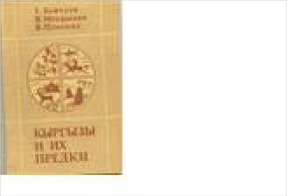
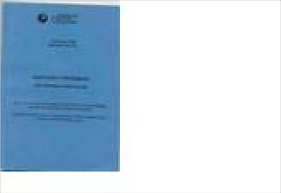
Publication
English Version:
Cyrillic Title Кыргызы и их Предки
Kyrgyzy I ikh Predki
Prducr: Date:
Length:
Bishkek: Главна
1994
English Version:
Cyrillic Title КЬІРГЬІЗЧА СУЙЛΘШΘЛ
Kyrgyzcha Suilosholu
Prducr: Date:
Length:
American Univer
2002

Cyrillic Title

English Version:
First Edition

Artist: Prducr: Date: Length:
Ryskulova, Chyn Bishkek
1996
Picture

Publication Russian
Кьіргьіз музьікальік аспаптарьі

Artist:
Prevost, Helen &
Picture

Item: 4107
Title: Kyrgyz Pattern

Category Language: Description:

Publication Kyrgyz
КЬІРГЬІЗ ОЙМОЛОУ

Artist:
Picture

Item: 4091
Title: Kyrgyz Traditional Art

Category Language: Description:

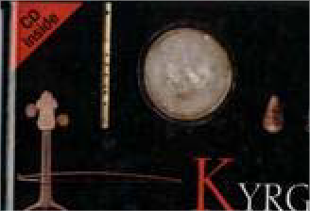
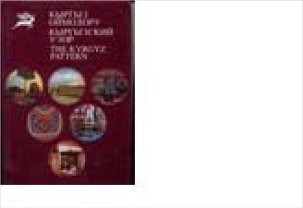
Publication Russian
English Version:
Кьіргьізские музьікальньіе инструментьі with CD-ROM
Prducr: Date:
Length:
Publishing Devel
Cyrillic Title
2002
КЬІРГЬІЗСКИЙ УЗОР
English Version:
Cyrillic Title Кыргызский Узор
Kyrgyzskii Uzor
Prducr: Date:
Length:
1998

English Version:

Cyrillic Title
Кьіргьізское традиционное искусство

Artist: Prducr: Date: Length:
Rector, Mindi & Foundation Publi 2003
Picture

Item: 4095
Title: Kyrgyzstan: Obshchestvo I Tsennosti No. 1
Category Language: Description:

Item: 4096
Title: Kyrgyzstan: Obshchestvo I Tsennosti No. 2

Category Language: Description:

Publication Russian
Publication
Kyrgyz
Artist: Prducr: Date:
Length:
Ryskulova, Chyn
Picture
English Version:
Tabygla: Bishkek
Cyrillic Title
1996
Publication
Russian
bulletin of the business seminar of American University in Kyrgysztan
Artist: Prducr: Date:
Length:
Budnii, Aron
Picture
English Version:
Bishkek
Cyrillic Title
2000

English Version:

Cyrillic Title
bulletin of the business seminar at American University in Kyrgysztan

Artist: Prducr: Date: Length:
Budnii, Aron Bishkek 2000
Picture

Item: 4098
Title: Kyrgyzstan: Under the Sky of Khan-Tengri
Category Language: Description:

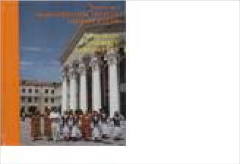
Item: 4108
Publication
English
Overview of geography & culture of northern Kyrgyzstan
Artist: Prducr: Date:
Length:
Dudashvili, Serge
Picture
English Version:
Rarity, Ltd: Bish
Cyrillic Title
1999
Publication
English
Tourist brochure on ysyk-kol region
Artist: Prducr: Date:
Length:
Dudashvili, Serge
Picture
English Version:
Rarity, Ltd: Bish
Cyrillic Title
1998
Title: Main University Kyrghyztan

Category Language: Description:
Publication Kyrgyz

English Version:

Cyrillic Title

Artist: Prducr: Date: Length:

Askanov, A. Bishkek 1996

Picture

Publication Russian
album in Russian and English

Artist:
Picture

Item: 4100
Title: Manas: The Great Kyrgyz Epos “Manas”
Category Language: Description:

Item: 4612
Title: Manas: Volume 1
Category Language: Description:

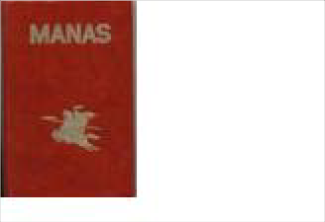
Item: 4101
English Version:
Prducr: Date:
Length:
Bishkek: 1996
Cyrillic Title
Kyrgyz Mamlekettik Uluttuk
Publication
Russian
Three volumes set: I Manas, II Semeteij, III Seitek; in Russian and English
Artist: Prducr: Date:
Length:
Bayjiev, M.T. (ed
Picture
English Version:
Cyrillic Title Манас: Великий кыргызски
Manas: Velikii kyrgyzskii ep
Bishkek: State Di
1999
Publication
English
Volume 1 of English translation of Manas by Walter May
Artist: Prducr: Date:
Length:
Version by Sagy
Picture
English Version:
Nat'l Academy of
Cyrillic Title
1995
462 pages
Title: Manas: Volume 2 (Parts 2 & 3)

Category Language: Description:

Publication English
Three volumes

Artist:
Orozbakov, Sagy
Picture

Item: 4104
Title: Red Data Book of Kirghiz SSR: Rare & Endangered Species of Animals a
Category Language: Description:

Item: 4109
Title: Uluu Manaschi Sagymbai (The Great Manaschi Sagymbai)
Category Language: Description:

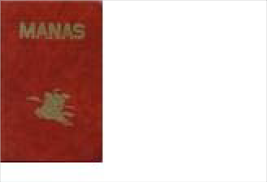
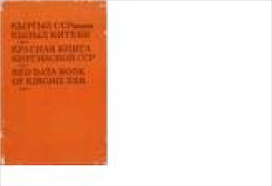
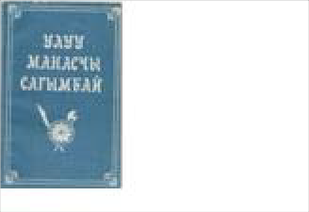
Item: 4110
English Version:
Prducr: Date:
Length:
Moscow and Bish
Cyrillic Title
1995
Publication
Russian
scientific catalogue w/ drawings of endangered species
Artist: Prducr: Date:
Length:
Vorob'ev, G. & S
Picture
English Version:
“Kyrgyzstan” Pu
Cyrillic Title
1985
Publication Kyrgyz

English Version:
Artist: Prducr: Date:
Length:
Picture
Bishkek: "Ala-To
Cyrillic Title
1992
Title: Vestnik Administratsii Prezidenta Kyrgyzskoi Respubliki
Category Language: Description:

Dictionary

Item: 4103

Title: Razgovornik: Russko-Kyrgyzskii Category Language: Description: Publication Russian

Artist:

Bekdzhanova, Ra

Picture

Item: 4105
Title: Suiloshmo (copy 1)

Category Language: Description:

Publication
Phrasebook for Kyrgyz Travelers

Artist:
Picture

Publication
Russian
v.7 Bulletin of the Adminstration of the Kyrgyz President
Artist: Prducr: Date:
Length:
Picture
English Version:
Erkin-Too: Bishk
Cyrillic Title
1998
English Version:
Prducr:
Date: Length:
Bishkek
Cyrillic Title
1991
English Version:
Prducr:
Date: Length:
Frunze
Cyrillic Title
1990

Item: 4106
Title: Suiloshmo (copy 2)

Category Language: Description:

Publication
Phrasebook for Kyrgyz Travelers

Artist:
Picture

Item: 4102
Title: Systematic Instruction in Botany
Category Language: Description:

Exhibit brochure
English Version:
Prducr:
Date: Length:
Frunze
Cyrillic Title
1990
Publication
Russian
Russian, Latin, and Kyrgyz botanical dictionary
Artist: Prducr: Date:
Length:
Sultanova, R. M.
Picture
English Version:
Kyrgyz Agricultu
Cyrillic Title
1990
Metodicheskoe ukazanie po b

Item: 4092

Title: Kyrgyzstan: A Nomadic Culture in the Modern World

Category Language: Description:

Publication English
Art exhibit brochure

Artist:
Tidwell, Mike
Picture

Gov doc

Item: 4317

Title: Bulletin of the Administration of the President of the Kyrgyz Republic
Category Language: Description:

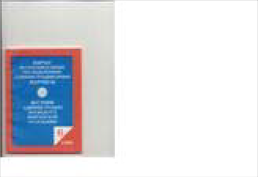
Map
English Version:
Prducr: Date:
Length:
Charles Sumner S
Cyrillic Title
1995
Publication Russian

English Version:
Artist: Prducr: Date:
Length:
Picture
Erkin-Too: Bishk
Cyrillic Title
1998
Vestnik Administratsii Prezid
Publication Russian

English Version:
Artist: Prducr: Date:
Length:
Picture
Erkin-Too: Bishk
Cyrillic Title
1998
Vestnik Administratsii Prezid

Item: 4629

Title: Topographical map of Kyrgyzstan published by Ak-sai Travel
Category Language: Description:

Pamphlet

Item: 4308

Title: Adventure & Trekking of Kyrgyzstan

Category Language: Description:

Publication English
tour plans for Kyrgyzstan

Artist:
AKC Kyrgyz con
Picture

Periodical

Item: 4279

Title: Aramco World, v. 46 no. 4: Kyrgyzstan

Category Language: Description:

Publication English
July/Aug 1995

Artist:
Arndt, Robert, ed
Picture

Publication
English
Folded, includes photos of Kyrgyzstan's scenery
Artist: Prducr: Date:
Length:
Picture
English Version:
Ak-Sai Travel
Cyrillic Title
2000
English Version:
Prducr:
Date: Length:
AKC Kyrgyz Con
Cyrillic Title
2001
English Version:
Prducr:
Date: Length:
Aramco Services
Cyrillic Title
1995

Item: 4086
Title: Aramco World, v. 50 no. 2 w/ article on Kyrgyz composer Muratbek Begal

Category Language: Description:

Publication English
March/April 1999

Artist:
Arndt, Robert
Picture

Item: 4312
Title: Aramco World, w/ article on Manas at 1000, c. 2

Category Language: Description:

Publication English
May/June 1996

Artist:
Arndt, Robert (ed
Picture

Report
English Version:
Prducr:
Date: Length:
Aramco Services
Cyrillic Title
1999
English Version:
Prducr: Date:
Length:
Aramco Services
Cyrillic Title
1996

Item: 4094

Title: Kyrgyzstan: National Strategy of Sustainable Human Development, c. 1

Category Language: Description:

Publication English
Government publication

Artist:
Ryspekov, S. (ed.
Picture

Item: 4310
Title: Kyrgyzstan: National Strategy of Sustainable Human Development, c. 2

Category Language: Description:

Publication English
government publication

Artist:
Ryspekov, S. (ed.
Picture

Travel brochure

Item: 4093

Title: Kyrgyzstan: Between Space and Earth

Category Language: Description:

Publication English
Tourist brochure

Artist:
Dudashvili, Serge
Picture

English Version:
Prducr: Date:
Length:
SHD President's
Cyrillic Title
1998
English Version:
Prducr: Date:
Length:
SHD President's
Cyrillic Title
1998
English Version:
Prducr:
Date: Length:
Rarity LTD: Bish
Cyrillic Title
2000

Item: 4311
Title: Kyrgyzstan: the Land of the Sky-High Mountains

Category Language: Description:

Publication English
Tourist brochure

Artist:
Dudashvili, Serge
Picture

Mongolia

Book

Item: 4121

Title: Book

Category Language: Description:
Publication Mongolian

Artist:

Olziydolgor, Dar’

Picture

Publication Mongolian

Artist:
Picture

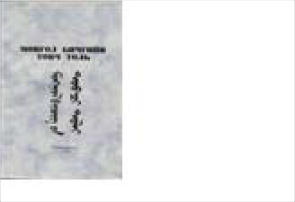
English Version:
Prducr:
Date: Length:
Rarity LTD.: Bis
Cyrillic Title
1997
English Version:
Cyrillic Title Хадаг эрхэмжлэх ёс
Khadag Epkhemzhlekh Yos
Prducr: Date:
Length:
Ulaanbaatar
2000
English Version:
Cyrillic Title Монгол Бичгийн товч толь
Mongol Bichgiyn Tovch Tol’
Prducr:
Date: Length:
Ulaanbaatar
1992

Publication Mongolian

Artist:
Damdinsuren, Ts
Picture

Item: 4115
Title: Cayn Baina Uu?: Mongolian Language Textbook One

Category Language: Description:

Publication

Artist:
Tserenchunt L, &
Picture

Item: 4116
Title: Colloquial Mongolian: The Complete Course for Beginners

Category Language: Description:

Publication Mongolian
with 2 tapes

Artist:
Sanders, J. K.
Picture

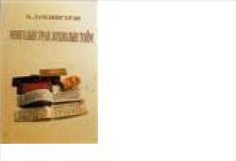
Item: 4259
English Version:
Cyrillic Title Монголын Уран Зохиолын
Mongolyn Uran Zokhiolyn T
Prducr: Date:
Length:
Mongol Ulsyn I
1999
English Version:
Prducr: Date:
Length:
Ulaanbaatar
Cyrillic Title
2000
English Version:
Prducr: Date:
Length:
London. Routled
Cyrillic Title
1999
Title: Dragon and the Monkey: Stories from the Panchatantra

Category Language: Description:

Publication Mongolian

Artist:
Picture

Item: 4119
Title: Facts about Mongolia

Category Language: Description:
Publication English

Artist:

Ganbold, Da

Picture

Item: 4664
Title: Felt Art of the Mongols

Category Language: Description:

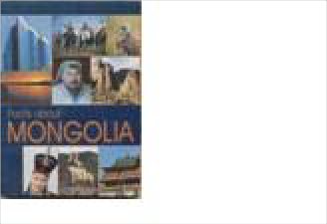
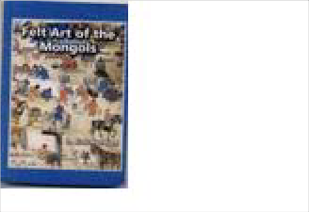
Publication English
English Version:
Cyrillic Title Луу Сармагичин хоёр
Luu Sarmagchin Khoyor
Prducr: Date:
Length:
1999
English Version:
Prducr: Date:
Length:
Mongolia
Cyrillic Title
2000

English Version:

Cyrillic Title
The book explores the origins and semiology of Mongolian "felt culture", discussing in turn the emergence of felt technology, contemporary feltmaking traditions, and the significance of the patterns and symbols encountered in Mongolian felt embroidery.

Artist: Prducr: Date: Length:
Batchuluun, Lunt Mongolian Unive 2000
291pp.
Picture

Publication English

Artist:
Shagdar, Sh
Picture

Item: 4131
Title: Lost Country: Mongolia Revealed
Category Language: Description:

Item: 4128
Title: Modern Mongolian: A Textbook for Foreign Speakers

Category Language: Description:

Publication Mongolian

English Version:

Artist: Prducr:
Shagdarsuren, Ts Ulaanbaatar
Picture

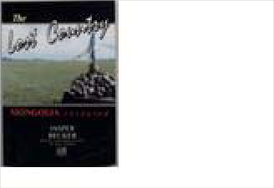
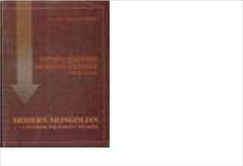
Cyrillic Title
English Version:
Prducr: Date:
Length:
MBDA & TACIS
Cyrillic Title
1997
Publication
English
Artist: Prducr: Date:
Length:
Becker, Jasper
Picture
English Version:
Great Britain. Sce
Cyrillic Title
1993
Oрчин цагийн монгол хэлни

Orchin Tsagiyn Mongol Khel

Date: Length:
1999

Item: 4254
Title: Mongol Uran Bichleg

Category Language: Description:
Publication Mongolian

Artist:

Olziybadrakh, D

Picture

Item: 4123
Title: Mongolia: A Country Study

Category Language: Description:

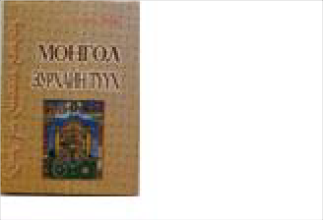
Publication English
Publication
Mongolian
Artist: Prducr: Date:
Length:
Моих-Очир, Д.
Picture
English Version:
Cyrillic Title Монгол Зурхайн туух
Mongol Zurhayn Tuukh
Ulaanbaatar Khot
2000
English Version:
Cyrillic Title Монгол Уран Бичлэг
Mongol Uran Bichleg
Prducr: Date:
Length:
Ulaanbaatar
2000

English Version:

Cyrillic Title
country study from area handbook series

Artist: Prducr: Date: Length:
Worden, Robert, US Government 1991
Picture

Publication Mongolian

Artist:
Altangerel, D (Tr
Picture

Item: 4348

Item: 4665
Title: Mongolian Language Textbook One Category Language: Description: Publication Mongolian

Title: Mongolian Portrait: Land of Big Skies

Category Language: Description:

Artist:

Цэрэнчунт, Л. &

Picture

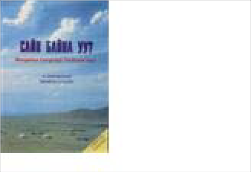
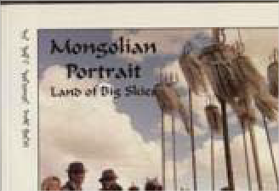
Item: 4126
English Version:
Cyrillic Title Монгол Ардын Углэр Домг
Mongol Ardyn Ugler Domgu
Prducr: Date:
Length:
Ulaanbaatar
1999
English Version:
Cyrillic Title Сайн Байна уу?
Sayn Bayna uu?
Prducr: Date:
Length:
Ulaanbaatar
2000
Publication
English
A photographic essay
Artist: Prducr: Date:
Length:
Pax, Andrew
Picture
English Version:
Five Corners Publ
Cyrillic Title
1996
60pp.
Title: National Museum of Mongolian History

Category Language: Description:

Publication English
Catalog/Viewbook

Artist:
Idshinnorov, S.
Picture

Item: 4129
Title: Panchatantra: The Dragon and the Monkey: Luu Sarmagchin Khoyor

Category Language: Description:

Publication

Artist:
Picture

Item: 4130
Title: Russia and the Dzhungarian Khanate in the 18th Century

Category Language: Description:

Publication

Artist:
Moiseev, V. A.
Picture

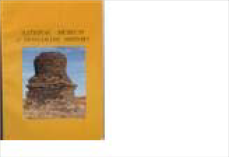
Item: 4114
English Version:
Prducr: Date:
Length:
National Museum
Cyrillic Title
English Version:
Cyrillic Title
Prducr: Date:
Length:
English Version:
Cyrillic Title
Prducr: Date:
Length:
Barnaul
1998
Rossia i Djungarskoe Khanst
Title: Textbook for Foreign Speakers

Category Language: Description:

Publication

Artist:
Picture

Dictionary

Item: 4117

Title: English-Mongolian Dictionary
Category Language: Description:

Item: 4118
Title: English-Mongolian Minidictionary Mongolian-English

Category Language: Description:

Publication Mongolian

Artist:
Marsh, Pitir K &
Picture

English Version:
Prducr: Date:
Length:
Ulaanbaatar
Cyrillic Title
1999
Publication
Mongolian
Artist: Prducr: Date:
Length:
Altangerel, Damd
Picture
English Version:
Cyrillic Title Англи-Монгол Толь
Аngli-Mongol Tol'
Mongolia: Interpr
1998
English Version:
Cyrillic Title Англи-Монгол хураангуй то
Prducr:
Date: Length:
Ulaanbaatar
1999

Item: 4257

Item: 4112
Title: English-Mongolian Phrase Book Category Language: Description: Publication Mongolian

Title: Modern Mongolian-English Dictionary

Category Language: Description:

Artist:

Altangerel, Damd

Picture

Item: 4124
Title: Mongolian-English Dictionary

Category Language: Description:
Publication Mongolian

English Version:

Artist: Prducr:

Altangerel, Damd T&U Printing Co,

Picture

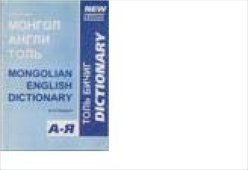
Cyrillic Title
English Version:
Cyrillic Title Англи-Монгол Ярианы Дэв
Prducr:
Date: Length:
Ulaanbaatar
1999
Publication
Mongolian
Artist: Prducr: Date:
Length:
Altangerel, Damd
Picture
English Version:
Cyrillic Title Монгол Англи Толь
Mongol-Angli Tol'
Altangerel Damdi
1998
Монгол англи толь

Date: Length:
1998

Item: 4125
Title: Mongolian-English Phrase Book/English-Mongolian Phrase Book
Category Language: Description:

Item: 4127
Publication Mongolian

Title: New Pocket English-Mongolian Dictionary

Category Language: Description:
Artist:
Altangerel, Damd
Picture

Item: 4113
Title: Student Guide to Khalkha Mongolian Pronunciation

Category Language: Description:

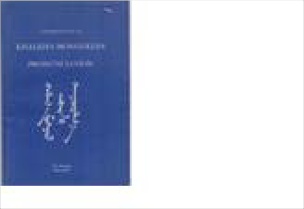
Publication English
English Version:
Cyrillic Title Монгол-Англи Ярианы девт
Mongol-Angli Iariany Devter
Prducr:
Date: Length:
Ulaanbaatar
1999
Publication
Mongolian
Artist: Prducr: Date:
Length:
Altangerel, Damd
Picture
English Version:
Cyrillic Title Англи-Монгол Бага Толь
Interpress Diction
1998

English Version:

Cyrillic Title
Artist: Prducr: Date: Length:
Battulga, Tsh; , Ulaanbaatar 1999
Picture

Magazine

Item: 4298

Title: National Geographic, v. 167, no.2, Feb. 1985
Category Language: Description:

Item: 4344
Title: National Geographic, v. 196, no. 3, September 1999
Category Language: Description:

Map
Publication
English
Includes article:Time Catches up with Mongolia
Artist: Prducr: Date:
Length:
Allen, Thomas
Picture
English Version:
National Geograp
Cyrillic Title
1985
Publication
English
Includes article: Hunting with Eagles
Artist: Prducr: Date:
Length:
Millard, Candice
Picture
English Version:
National Geograp
Cyrillic Title
1999

Item: 4624

Title: map of Inner Mongolia

Category Language: Description:

Publication Mandarin

Artist:
Picture

Item: 4625
Title: Physical map of China, Mongolia, and Korea Category Language: Description: Publication English

Artist:

Picture

Pamphlet

Item: 4347

Title: Throat Singers of Tuva
Category Language: Description:

English Version:
Prducr: Date:
Length:
Sinomaps Press
Cyrillic Title
2003
English Version:
Prducr: Date:
Length:
American Map C
Cyrillic Title
Publication
English
Scientific American article, September 1999
Artist: Prducr: Date:
Length:
Levin, Theodore
Picture
English Version:
Scientific Americ
Cyrillic Title
1999

Periodical

Item: 4323
Title: Saudi Aramco World: Agadez: Sultanate of the Sahara

Category Language: Description:

Publication English
includes arts of Mongols article

Artist:
Picture

Regional

Magazine

Item: 4662

Title: Saudi Aramco World
Category Language: Description:

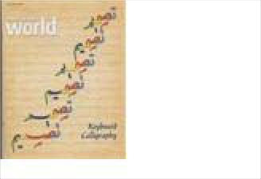
Map
English Version:
Prducr:
Date: Length:
Houston: Aramco
Cyrillic Title
2003
Publication
English
Saudi Aramco, the oil company born as an international enterprise 75 years ago, distributes Saudi Aramco World to increase cross- cultural understanding. The bimonthly magazine's goal is to broaden knowledge of the cultures, history and geography of the Arab and Muslim worlds and their connections with the West.
Artist: Prducr: Date:
Length:
Arndt, Robert (ed
Picture
English Version:
Aramco Services
Cyrillic Title
July/August 2007
49pp.

Item: 4549

Title: Map of Afghanistan, Pakistan and the Middle East
Category Language: Description:

Item: 4548
Title: Map of Asia
Category Language: Description:

Item: 4556
Publication
English
Political and physical; Iran prominent
Artist: Prducr: Date:
Length:
Picture
English Version:
National Geograp
Cyrillic Title
2001
Publication
English
Political and physical; Iran prominent
Artist: Prducr: Date:
Length:
Picture
English Version:
National Geograp
Cyrillic Title
2001
Publication
English
Political and physical; children's map exercises on reverse of map
Artist: Prducr: Date:
Length:
Picture
English Version:
Milliken
Cyrillic Title
2001
Title: Map of Mongol-Turkish Conquest

Category Language: Description:

Publication English

Artist:
Picture

Item: 4540
Title: Two-sided World Map
Category Language: Description:

Pamphlet
English Version:
Prducr: Date:
Length:
AJ Nystrom
Cyrillic Title
Publication
English
Side 1: Political, Side 2: Topographical
Artist: Prducr: Date:
Length:
Picture
English Version:
National Geograp
Cyrillic Title
Publication
English
Side 1: Political, Side 2: Topographical
Artist: Prducr: Date:
Length:
Picture
English Version:
National Geograp
Cyrillic Title

Item: 4320

Title: Gender Montage: Paradigms in Post Soviet Space
Category Language: Description:

Russia

Map

Item: 4546

Title: Map of Russia
Category Language: Description:

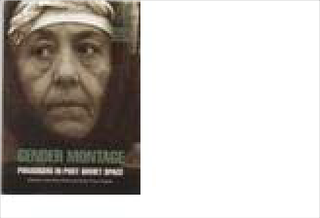
Publication
English
Materials of the Mass Media and Gender Policy Program
Artist: Prducr: Date:
Length:
Schreiner, Phoeb
Picture
English Version:
Zvezda Magazine
Cyrillic Title
2003
Publication
English
Laminated; Central Asia (including Xinjiang), Mongolia and Azerbaijan visible; political and physical
Artist: Prducr: Date:
Length:
Picture
English Version:
National Geograp
Cyrillic Title
2002
Publication
English
Central Asia (including Xinjiang), Mongolia and Azerbaijan visible; political and physical
Artist: Prducr: Date:
Length:
Picture
English Version:
National Geograp
Cyrillic Title
2002

Item: 4547
Title: Map of the Former Soviet Union
Category Language: Description:

Russia, Bashkorstan

Booklet

Item: 4408
Publication
Azeri
Dual-language in Azeri and Russian
Artist: Prducr: Date:
Length:
Picture
English Version:
Azerbaijan Repu
Cyrillic Title
2002
Publication
English
Central Asia (including Xinjiang), Mongolia and Azerbaijan visible; political and physical
Artist: Prducr: Date:
Length:
Picture
English Version:
National Geograp
Cyrillic Title
2002
Publication
English
Laminated; Central Asia visible; political and physical
Artist: Prducr: Date:
Length:
Picture
English Version:
National Geograp
Cyrillic Title
1998
Title: The Country of White River, Volume 1
Category Language: Description:

Tajikistan

Book

Item: 4135

Title: American Government
Category Language: Description:

Item: 4134
Title: Book
Category Language: Description:

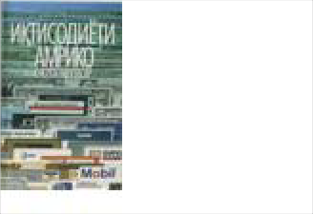
Publication
English
A collection of short essays on Bashkort customs and traditions by journalism students in Bashkort State Univeristy, Republic of Bashkortostan in the Russian Federation
Artist: Prducr: Date:
Length:
Cindy Hawkins
Picture
English Version:
Bashkort State U
Cyrillic Title
1998
24pp.
Publication
Tajik
Artist: Prducr: Date:
Length:
Picture
English Version:
Cyrillic Title Хукуматы Америко
Khukumati Amriko
U.S. Information
1989
Publication Tajik

English Version:
Artist: Prducr: Date:
Length:
Holden, Jeanne
Picture
U.S. Information
Cyrillic Title
1991
Iktisodeti Amriko

Item: 4133
Title: Mirzo Tursun-Zadeh: Colletcted Poems Category Language: Description: Publication Tajik

Artist:

Tursun-Zadeh, M

Picture

Item: 4393
English Version:
Prducr:
Date: Length:
B. Gafurov
Cyrillic Title
2000
Title: Muslim Youth: Tensions and Transitions in Tajikistan
Category Language: Description:

Item: 4137
Publication English

English Version:
Cyrillic Title

Title: Outline of American History
Since the breakup of the Soviet Union, the peoples of Central Asia (Tajikistan, Kazakhstan, Kyrgyzstan, Turkmenistan, and Uzbekistan) have been exposed to new, Western influences that stress individualism at the expense Central Asian traditions of family and communalism.
Young men in particular are exposed to new ideas and lifestyles as they travel in large numbers outside their native republics for the first time, even as contemporary Islam exerts itself as a potent force for cultural conservatism, especially for women. As a result, young Central Asians today confront a complex mixture of the old and the new that strains personal relations, especially within the family, between generations, and between spouses. Relying on the author’s extensive fieldwork, Muslim Youth devotes separate chapters to family life, education, dating, and marriage and the family in Dushanbe, the capital of Tajikistan. Throughout the book, emblematic life stories vividly portray the hopes and concerns of Tajiks, teasing out the complexity of modernity versus tradition and individualism versus collectivism.

Artist: Prducr: Date: Length:
Harris, Collette Westview Press 2006
192 pp.
Picture

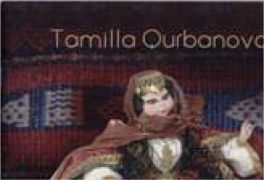
Category Language: Description:

Item: 4136
Title: Soviet Tajikistan

Category Language: Description:

Publication Russian
picture book

Artist:
Picture

Brochure

Item: 4132

Title: Republic of Tajikistan

Category Language: Description:
Publication Tajik

Artist:

Picture

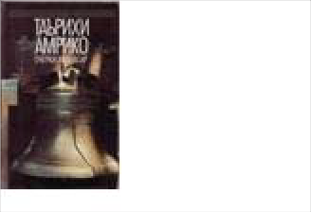
Publication
Tajik
Artist: Prducr: Date:
Length:
Sinkotta, Khovar
Picture
English Version:
United States Inf
Cyrillic Title
Tarikhi Amriko: Ocherki My
English Version:
Cyrillic Title
Prducr: Date:
Length:
English Version:
Cyrillic Title
Chumkhurii Tojikiston
Prducr:
Date: Length:

Teacher's Guide

Book

Item: 4352

Title: Changing Perspectives on International Education
Category Language: Description:

Item: 4278
Title: Classroom-Based Evaluation in Second Language Education

Category Language: Description:

Publication English

Artist:
Genesee, Fred an
Picture

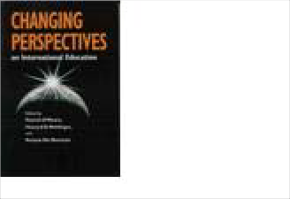
Item: 4138
Publication
English
Artist: Prducr: Date:
Length:
O'Meara, Patrick,
Picture
English Version:
Bloomington: Ind
Cyrillic Title
2001
English Version:
Prducr: Date:
Length:
Cambridge Unive
Cyrillic Title
2002
Title: Foreign Language Teacher's Guide to Active Learning

Category Language: Description:

Publication

Artist:
Blaz, Deborah
Picture

Item: 4140
Title: Polishing the Mirror: A Curriculum Unit on Central and Inner Eurasia (c
Category Language: Description:

Item: 4233
Title: Spotlight on Inner Asia: The Bizarre Bazaar Category Language: Description: Publication English

Artist:

American Forum

Picture

English Version:
Prducr: Date:
Length:
Larchmont: Eye o
Cyrillic Title
1999
Publication
English Version:
Artist: Prducr: Date:
Length:
Gardner, Vika an
Picture
University of Mic
Cyrillic Title
2000
English Version:
Prducr: Date:
Length:
New York: Ameri
Cyrillic Title
2000

Miscellaneous

Item: 4139
Title: Polishing the Mirror: A Curriculum Unit on Central and Inner Eurasia (c
Category Language: Description:

Pamphlet

Item: 4249

Title: Ibn Battuta: A View of the Fourteenth-Century World. A unit of study for

Category Language: Description:

Publication English
Study Unit for grades 7-10

Artist:
Arno, Joan and H
Picture

Tibet
Publication
English
Artist: Prducr: Date:
Length:
Gardner, Vika an
Picture
English Version:
University of Mic
Cyrillic Title
2000
English Version:
Prducr: Date:
Length:
LA: National Cen
Cyrillic Title
1998

Book

Item: 4568

Title: A Tibetan Family
Category Language: Description:

Item: 4145
Title: Art of Exile: Paintings by Tibetan Children in India

Category Language: Description:

Publication English
paintings with text and photos

Artist:
Lukas, Sarah & K
Picture

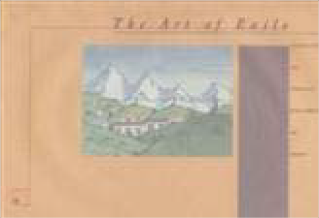
Item: 4142
Publication English

English Version:
Artist: Prducr: Date:
Length:
Stephen Chicoine
Picture
Lener Publication
Cyrillic Title
1998
56pp
English Version:
Prducr: Date:
Length:
Museum of New
Cyrillic Title
Title: Cultures of the World: Tibet

Category Language: Description:
Publication

English Version:

Cyrillic Title

Artist: Prducr: Date: Length:

Levy, Patricia New York: Marsh 1997

Picture

Item: 4146
Title: Dalai Lama

Category Language: Description:
Publication

Artist:

Demi

Picture

Item: 4143
Title: Kundun: A biography of the family of the Dalai Lama

Category Language: Description:

Publication

Artist:
Craig, Mary
Picture

Item: 4144
Publication English

English Version:
Artist: Prducr: Date:
Length:
Patricia Levy
Picture
Marshall Cavendi
Cyrillic Title
1997
128pp
English Version:
Prducr: Date:
Length:
New York: Henry
Cyrillic Title
1998
English Version:
Prducr: Date:
Length:
Washington, DC:
Cyrillic Title
1997
Title: Sacred Tibet

Category Language: Description:

Publication English
softbound; 18 color illus., 118 b/w

Artist:
Rawson, Philip
Picture

Item: 4147
Title: Spirit of Tibet: Portrait of a Culture in Exile Category Language: Description: Publication

Artist:

Wright, Allison

Picture

Item: 4486
Title: Tangkas: Buddhist Paintings from Tibet

Category Language: Description:

Publication English
A book of Postcards

Artist:
American Museu
Picture

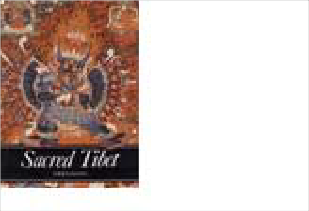
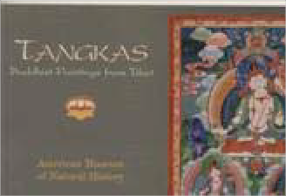
Item: 4570
English Version:
Prducr: Date:
Length:
London: Thames
Cyrillic Title
1991
English Version:
Prducr: Date:
Length:
Ithaca, NY: Snow
Cyrillic Title
1998
English Version:
Cyrillic Title
Prducr: Date:
Length:
Pomegranate
1998

30pp
Title: The Dalai Lama A Biography of the Tibetan Spiritual Leader

Category Language: Description:

Publication English

Artist:
Demi
Picture

Item: 4571
Title: The Spirit of Tibet: Portrait of a Culture Category Language: Description: Publication English

Artist:

Alison Wright

Picture

Item: 4149
Title: Tibet
Category Language: Description:

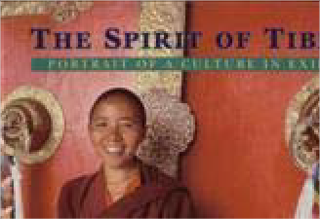
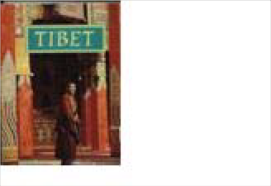
Item: 4150
English Version:
Cyrillic Title
Prducr: Date:
Length:
Henry Holt
1998

32pp
English Version:
Cyrillic Title
Prducr: Date:
Length:
Snow Lion Public
1998

192pp
Publication
English
coffee table book
Artist: Prducr: Date:
Length:
Choedon, Yeshi a
Picture
English Version:
Tiger Books Inter
Cyrillic Title
Title: Tibet Through the Red Box

Category Language: Description:

Publication

Artist:
Sis, Peter
Picture

Item: 4141
Title: Tibetan Family
Category Language: Description:

Map
English Version:
Prducr: Date:
Length:
New York: Franc
Cyrillic Title
1998
Publication English

English Version:
Artist: Prducr: Date:
Length:
Peter Sis
Picture
Farrar Straus Giro
Cyrillic Title
1998
64pp
Publication
Journey Between Two Worlds Series
Artist: Prducr: Date:
Length:
Chicoine, Stephe
Picture
English Version:
Minneapolis: Ler
Cyrillic Title
1998

Item: 4535

Title: Geographical Map of Tibet Autonomous Region

Category Language: Description:

Publication English
1:2000000

Artist:
Picture

Item: 4623
Title: map of Tibet

Category Language: Description:
Publication Mandarin

Artist:

Picture

Item: 4534
Title: Road Map of Tibet Autonomous Region

Category Language: Description:

Publication English
1:2000000

Artist:
Picture

English Version:
Prducr: Date:
Length:
Gizi Map
Cyrillic Title
English Version:
Prducr: Date:
Length:
Sinomaps Press
Cyrillic Title
2007
English Version:
Prducr: Date:
Length:
Gizi Map
Cyrillic Title

Pamphlet

Item: 4148
Title: Tibetan Art Coloring Book: A joyful path to right brain enlightenment

Category Language: Description:

Publication English
Thangka artwork

Artist:
Singe, J. Jamyang
Picture

Tibet and Mongolia

Book

Item: 4622
Title: Demons & Protectors: Folk Religion in Tibetan & Mongolian Buddhism

Category Language: Description:

Publication English

Artist:
Edited by Belen
Picture

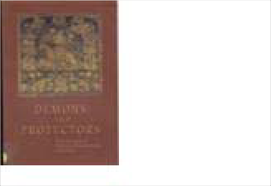
Turkey
English Version:
Prducr:
Date: Length:
New York: Harry
Cyrillic Title
1999
English Version:
Prducr: Date:
Length:
Ferenc Hopp Mus
Cyrillic Title
2003

Book

Item: 4154

Title: At Home

Category Language: Description:

Publication

Artist:
Picture

Publication Turkish
children's book

Artist:
Dizisi, Cevremiz
Picture

Item: 4396
Title: Elementary Turkish: A Complete Course for Beginners

Category Language: Description:

Publication English
Textbook

Artist:
Öztopçu, Kurtulu
Picture

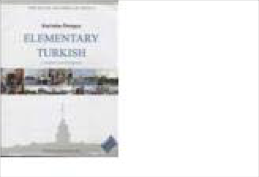
Item: 4153
English Version:
Cyrillic Title
Evde
Prducr: Date:
Length:
English Version:
Cyrillic Title
Prducr: Date:
Length:
Yayin Pazarlama
1990
Evde
English Version:
Cyrillic Title
Prducr:
Date: Length:
Santa Monica
2006

750 pp.
Title: Grandpa and I

Category Language: Description:

Publication

Artist:
Sakpinar, Leyla
Picture

Item: 4156
Title: Lemon Girl

Category Language: Description:
Publication

Artist:

Picture

Publication Turkish
children's book

Artist:
Cikrikci, Semra
Picture

Item: 4158
English Version:
Cyrillic Title
Dedem Ve Ben
Prducr: Date:
Length:
English Version:
Cyrillic Title
Limon Kiz
Prducr: Date:
Length:
English Version:
Cyrillic Title
Prducr:
Date: Length:
Kok Yayincilik
1995
Limon Kiz
Title: Let's Listen to Turkish

Category Language: Description:

Publication

Artist:
Ozsoy, A. Sumru
Picture

Item: 4155
Title: Missing Briefcase: Turkish as a Foreign Language Elementary Level

Category Language: Description:

Publication

Artist:
Taylan, Eser E. a
Picture

Item: 4314
Title: My Grandfather & I

Category Language: Description:

Publication Turkish
children's book

Artist:
Sakpinar, Leyla
Picture

Item: 4087
English Version:
Cyrillic Title
Turce Dinleyelim
Prducr: Date:
Length:
English Version:
Cyrillic Title
Kayip Canta
Prducr: Date:
Length:
English Version:
Cyrillic Title
Prducr: Date:
Length:
Mavibulut
1995
Dedem ve Ben
Title: Playful Cloud

Category Language: Description:

Publication Turkish
children's book

Artist:
Birden, Nural
Picture

Publication

Artist:
Picture

Item: 4395
Title: Turkey: A Comprehensive Grammar Category Language: Description: Publication English

Artist:

Göksel, Aslı & C

Picture

Item: 4160
English Version:
Cyrillic Title
Prducr: Date:
Length:
Kok Yayincilik
1997
Oyuncu Bulut
English Version:
Cyrillic Title
Oyunco Bulut
Prducr: Date:
Length:
English Version:
Cyrillic Title
Prducr:
Date: Length:
London: Routled
2005

580 pp.
Title: Turkish
Category Language: Description:

Item: 4161
Title: Turkish Cuisine

Category Language: Description:

Publication
Travel brochure

Artist:
Picture

Item: 4162
Title: Turkish for Foreigners Workbook (Vol. 1) Category Language: Description: Publication

Artist:

Serin, Muammer

Picture

Item: 4163
Publication
Turkish
analysis/teaching grammar of Turkish
Artist: Prducr: Date:
Length:
Ozsoy, A. Sumru
Picture
English Version:
Her Hakki Saklid
Cyrillic Title
1999
Turkce
English Version:
Cyrillic Title
Prducr: Date:
Length:
English Version:
Cyrillic Title
Prducr: Date:
Length:
Title: Turkish Games for Health and Recreation

Category Language: Description:

Publication English

Artist:
Walker, Barbara
Picture

Item: 4152
Title: What Am I

Category Language: Description:
Publication

Artist:

Gurman, Aysel a

Picture

Item: 4315
Title: Who am I
Category Language: Description:

English Version:
Prducr: Date:
Length:
Texas
Cyrillic Title
1983
English Version:
Cyrillic Title
Ben Neyim
Prducr: Date:
Length:
Publication
Turkish
children's book
Artist: Prducr: Date:
Length:
Gurmen, Aysel
Picture
English Version:
Ucanbalik Yayinl
Cyrillic Title
1997
Ben Neyim

Map

Item: 4553
Title: Map of Turkey
Category Language: Description:

Pamphlet

Item: 4151

Title: Antalya and the Mediterranean Region
Category Language: Description:

Item: 4326
Publication
Turkish
In Turkish; Political sub-divisions highlighted; One side with text labels; One side with no labels; Hanging
Artist: Prducr: Date:
Length:
Picture
English Version:
Gurbuz
Cyrillic Title
1998
Publication
English
Travel brochure
Artist: Prducr: Date:
Length:
Picture
English Version:
Istanbul: Ministry
Cyrillic Title
2002
Title: Black Sea Region

Category Language: Description:

Publication English

Artist:
Ministry of Touri
Picture

Item: 4327
Title: Turkey
Category Language: Description:

Item: 4159
Title: Turkey: the Travel Directory
Category Language: Description:

Item: 4324
English Version:
Prducr: Date:
Length:
Ankara
Cyrillic Title
2001
Publication
English
Artist: Prducr: Date:
Length:
Ministry of Touri
Picture
English Version:
Ankara or Istanbu
Cyrillic Title
2004
Publication
English
Turkish Ministry of Tourism brochures (4 versions)
Artist: Prducr: Date:
Length:
Picture
English Version:
New York: Turki
Cyrillic Title
Title: Turkish Cuisine

Category Language: Description:

Publication English
Tourism pamphlet

Artist:
Sancar, Fahriye
Picture

Item: 4325
Title: Yatching

Category Language: Description:
Publication English

Artist:

Ministry of Touri

Picture

Turkish

Book

Item: 4321

Title: Red Button that Fell

Category Language: Description:
Publication Turkish

Artist:

Ogmel, Umit

Picture

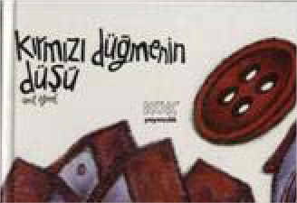
English Version:
Prducr: Date:
Length:
Istanbul
Cyrillic Title
2002
English Version:
Prducr: Date:
Length:
Ankara
Cyrillic Title
English Version:
Cyrillic Title
Prducr:
Date: Length:
Ankara: Kok Yay
1998
Kirmizi Dugmenin Dusu

Turkmenistan

Art

Item: 4584

Title: Dogs of Turkmenistan

Category Language: Description:

Publication Turkmen
Postcard set; 18 cards

Artist:
Chary Shirliyev
Picture

Item: 4583
Title: Horses of Turkmenistan

Category Language: Description:

Publication Turkmen
Postcard set; 18 cards

Artist:
Chary Shirliyev
Picture

Book
English Version:
Cyrillic Title
Prducr: Date:
Length:
2006
English Version:
Cyrillic Title
Prducr: Date:
Length:
2006

Item: 4167

Title: Address of Saparmurat Turkmenbashi to the Peoples of Turkmenistan
Category Language: Description:

Item: 4168
Title: Akpamyk

Category Language: Description:

Publication Turkmen
A Turkmen Folk Tale

Artist:
Ismayilowa, W. (
Picture

Item: 4169
Title: Ashkhabad
Category Language: Description:

Item: 4175
Publication
English
Artist: Prducr: Date:
Length:
Picture
English Version:
Ankara: Nurol Pri
Cyrillic Title
English Version:
Cyrillic Title
Prducr: Date:
Length:
Ashgabat: Turkm
2001
Akpamyk
Publication
Turkmen
Artist: Prducr: Date:
Length:
Кленова, Е.
Picture
English Version:
Cyrillic Title Ашхабад
Askhabad
Moskva: Izdatel's
1976
Title: Book

Category Language: Description:

Publication Turkmen

Artist:
Tϋrkmenbasy, Sa
Picture

Item: 4166
Title: Görogly
Category Language: Description:

Item: 4164
Title: Görogly (copy 1)

Category Language: Description:

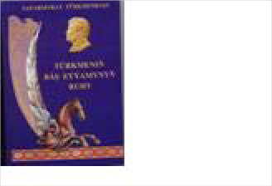
Publication Turkmen
English Version:
Cyrillic Title
Prducr: Date:
Length:
Ashgabat: Turkm
2003
Tϋrkmeniň Bäs Eyyamynyň
Publication
Turkmen
A Fairly Tale in Turkmen and English
Artist: Prducr: Date:
Length:
Nepesova, R.G. (
Picture
English Version:
Turkmen State Pu
Cyrillic Title
2002

English Version:

Cyrillic Title
A Fairly Tale in Turkmen and English

Artist: Prducr: Date: Length:
Picture

Item: 4177
Title: Korpe Dogan

Category Language: Description:

Publication Turkmen
Turkmen fairytale/picturebook

Artist:
Picture

Item: 4188
Title: Land of Turkmenbashi

Category Language: Description:
Publication Turkmen

English Version:

Artist: Prducr:

Hramow, W. Experimental Pri

Picture

Cyrillic Title
Publication
Turkmen
A Fairly Tale in Turkmen and English
English Version:
Cyrillic Title
Artist: Prducr: Date:
Length:
Picture
English Version:
Prducr: Date:
Length:
Ashgabat
Cyrillic Title
1999
Cтрана Туркменбаши

Turkmenbashin Yurdi

Date: Length:

Publication Turkmen

Artist:
Saparmyrat Türk
Picture

Item: 4182
Title: Nature of Turkmenistan

Category Language: Description:
Publication Turkmen

Artist:

Khakiev, Akmirat

Picture

Item: 4193
Title: Red Data Book of Turkmenistan: Invertebrate & Vertebrate Animals

Category Language: Description:

Publication Turmen

English Version:

Artist: Prducr:
Atamuradov, Kh. Ashgabat
Picture

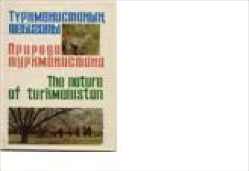
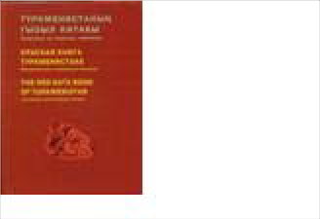
Cyrillic Title
English Version:
Cyrillic Title
Prducr: Date:
Length:
Türkmen döwlet
2005

360 pp.
English Version:
Prducr: Date:
Length:
Turkmenistan Ne
Cyrillic Title
1978
Красная книга Туркмениста

Krasnaya Kniga Turkmenista

Date: Length:
1999

Publication English

Artist:
Foregin Tourism
Picture

Item: 4179
Title: Ruhnama

Category Language: Description:
Publication

Artist:

Turkmenbashi, S

Picture

Item: 4613
Title: Ruhnama Volume 1
Category Language: Description:

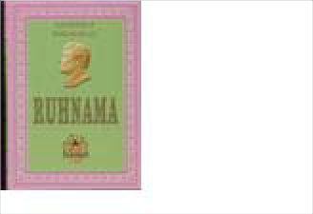
Item: 4403
English Version:
Prducr: Date:
Length:
Ashkhabad
Cyrillic Title
1982
English Version:
Cyrillic Title
Prducr: Date:
Length:
Publication
English
Volume 1 of English translation of the Rukhnama
Artist: Prducr: Date:
Length:
Saparmurat Turk
Picture
English Version:
Guzel Sanatlar M
Cyrillic Title
2002
406 pages
Title: Ruhnama, Ikinji Kitap
Category Language: Description:

Item: 4404
Title: Ruhnama, Second Book
Category Language: Description:

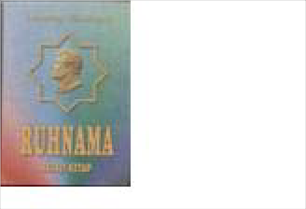
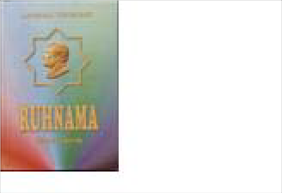
Item: 4184
Publication
Turkmen
Book two of the Ruhnama, the national textbook of Turkmen people, in Turkmen language written by Turkmenistan's President for Life, Saparmyrat Niyazov/Türkmenbaşy.
Artist: Prducr: Date:
Length:
Saparmyrat Türk
Picture
English Version:
Türkmen döwlet
Cyrillic Title
2004
464 pp.
Publication
English
Book two of the Ruhnama, the national textbook of Turkmen people, in English language written by Turkmenistan's President for Life, Saparmyrat Niyazov/Türkmenbaşy.
Artist: Prducr: Date:
Length:
Saparmyrat Türk
Picture
English Version:
Turkmen State Pu
Cyrillic Title
2004
440 pp.
English Version:
Cyrillic Title Туркменские Ковры
Turkmenskie kovry
Prducr: Date:
Length:
Turkmenhaly
1995

Item: 4374
Title: Turkmen Carpets

Category Language: Description:
Publication Turkmen

Title: Turkmen Language Course

Category Language: Description:

Artist:

Karadjaeva, G.

Picture

Publication Turkmen
Units 7-12

Artist:
Picture

Publication Turkmen
Units 13-18

Artist:
Picture

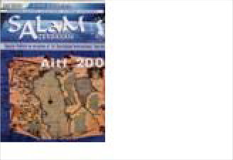
Publication Turkmen
English Version:
Cyrillic Title
Prducr: Date:
Length:
English Version:
Cyrillic Title
Prducr: Date:
Length:
Publication
Turkmen
Transcripts II, Workbooks 1-18, Appendices
English Version:
Cyrillic Title
Artist: Prducr: Date:
Length:
Picture

English Version:

Cyrillic Title
Turkmen Teacher's Guide

Artist: Prducr: Date: Length:
Picture

Publication Turkmen
workbook 13-18

Artist:
Picture

Publication Turkmen
Turkmen Glossary

Artist:
Picture

Publication Turkmen
Units 1-6

Artist:
Picture

Publication Turkmen
English Version:
Cyrillic Title
Prducr: Date:
Length:
English Version:
Cyrillic Title
Prducr: Date:
Length:
English Version:
Cyrillic Title
Prducr: Date:
Length:

English Version:

Cyrillic Title
reference grammar

Artist: Prducr: Date: Length:
Picture

Publication Turkmen
workbook 1-6

Artist:
Picture

Publication Turkmen
workbook 7-12

Artist:
Picture

Publication Turkmen
Transcripts I - 1-18

Artist:
Picture

Item: 4186
English Version:
Cyrillic Title
Prducr: Date:
Length:
English Version:
Cyrillic Title
Prducr: Date:
Length:
English Version:
Cyrillic Title
Prducr: Date:
Length:
Title: Turkmen Melons: Color Atlas (2nd Edition),
Category Language: Description:

Item: 4191
Title: Turkmenin Shai-Seplen (Turkmen Jewelry) Category Language: Description: Publication Turkmen

Artist:

Picture

Item: 4194
Title: Turkmenistan: Human Development Report 1997

Category Language: Description:
Publication English

Artist:

UNDP

Picture

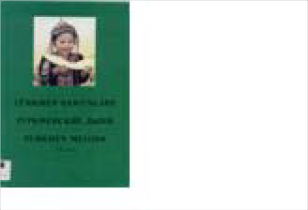
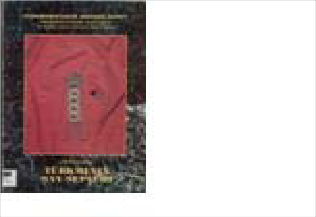
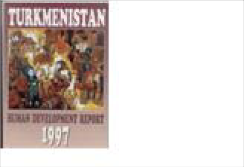
Item: 4195
Publication
Turkmen
Illus. Atlas of Turkmen melon varieties
Artist: Prducr: Date:
Length:
Allamyrat, Eseno
Picture
English Version:
Cyrillic Title Туркменские дыни
Turkmenskie dyni
Ashgabat: Rukh
1999
English Version:
Cyrillic Title
Prducr: Date:
Length:
English Version:
Prducr: Date:
Length:
Ankara: UNDP
Cyrillic Title
1997
Title: Turkmenistan: Human Development Report 1998

Category Language: Description:

Publication Russian

Artist:
Bairamov, D. (co
Picture

Item: 4180
Title: Turkment fairy tale in Russian

Category Language: Description:

Publication Russian
Turkmen fairytale

Artist:
Annakurbanova,
Picture

Item: 4197
Title: Tϋrkmenistan: Ancient Oriental Kingdom in the Old Delta of the Murgha
Category Language: Description:

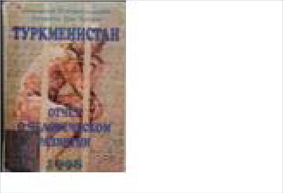
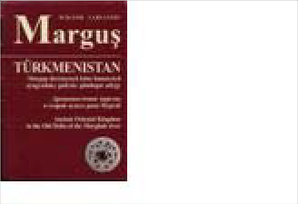
English Version:
Prducr: Date:
Length:
Ajans-Turk: Ank
Cyrillic Title
1998
English Version:
Cyrillic Title
Prducr: Date:
Length:
Magafir: Ashkha
1989
Sto Zolotykh
English Version:
Cyrillic Title Туркменистан: Древневосто
Turkmenistan: Drevnevostoc
Prducr: Date:
Length:
Ashgabat, Tϋrkm
2002

Booklet
Publication Turkmen

Artist:
Marguş, Wiktor S
Picture

Item: 4319
Title: Oglanzhik ve Iagshilik
Category Language: Description:

Item: 4423
Title: Türkmen milli naharlary

Category Language: Description:

Publication Turkmen
Turkmen Cookbook

Artist:
N. Yusupov, Dj.
Picture

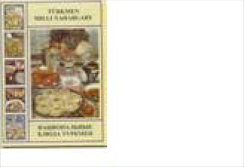
Dictionary
Publication
Turkmen
Nursery Rhymes
Artist: Prducr: Date:
Length:
Rakhmanov, Azat
Picture
English Version:
Magarif: Ashgaba
Cyrillic Title
1997
English Version:
Cyrillic Title
Prducr: Date:
Length:
GKPT
2005

60 pp.

Item: 4189

Title: Turkmen-English Dictionary (copy 1)

Category Language: Description:

Publication Turkmen

Artist:
Frank, Allen J, &
Picture

Item: 4190

Magazine

Item: 4330
Title: Turkmen-English Dictionary (copy 2) Category Language: Description: Publication Turkmen

Title: Diyar

Category Language: Description:
Publication Turkmen

Artist:

Artist:

Frank, Allen J, &

Mamijikow, D.

Picture

Picture

English Version:
Prducr: Date:
Length:
Kensington, MD:
Cyrillic Title
1999
English Version:
Prducr: Date:
Length:
Kensington, MD:
Cyrillic Title
1999
English Version:
Prducr:
Date: Length:
Ashgabat
Cyrillic Title
2002

Pamphlet

Item: 4170
Title: Chardjou

Category Language: Description:
Publication Russian

Artist:

Бектасов, М.Ж.

Picture

Publication English
Tourist pamphlet

Artist:
Picture

Item: 4181
Title: Ten Years of Prosperity: An Economic Program

Category Language: Description:
Publication English

Artist:

Turkmenbashi, S

Picture

Item: 4192
English Version:
Cyrillic Title Чарджоу
Chardzhou
Prducr:
Date: Length:
English Version:
Prducr: Date:
Length:
USSR: Intourist
Cyrillic Title
English Version:
Prducr: Date:
Length:
Baski: Ankara
Cyrillic Title
1994
Title: Turkmenistan
Category Language: Description:

Periodical

Item: 4172
Publication Russian

Title: Diyar

Category Language: Description:
Artist:
Nurklychev, N &
Picture

Publication Turkmen
February

Artist:
Picture

Publication Turkmen
May

Artist:
Picture

English Version:
Cyrillic Title Туркменистан
Turkmenistan
Prducr: Date:
Length:
Novosti: Moscow
English Version:
Cyrillic Title
Prducr:
Date: Length:
1994
English Version:
Cyrillic Title
Prducr: Date:
Length:
1994

Publication
December

Artist:
Picture

Item: 4176
Title: Gurbansoltan Eje

Category Language: Description:

Publication Turkmen
April

Artist:
Picture

Item: 4183
Title: Tourism and Development No. 1, 2' 2000
Category Language: Description:

Item: 4187
English Version:
Cyrillic Title
Prducr: Date:
Length:
1999
English Version:
Cyrillic Title
Prducr: Date:
Length:
2001
Publication
English
Artist: Prducr: Date:
Length:
Baidjaev, A (ed.)
Picture
English Version:
Ashkhabad: "Pres
Cyrillic Title
2000
Title: Turkmen Newpapers

Category Language: Description:

Publication
Various dates

Artist:
Picture

Uzbekistan

Book

Item: 4392

Title: 125 Years of the Uzbek Photography, v. 1
Category Language: Description:

Item: 4199
Title: Academy of Arts Uzbekistan: Board of Art Exhibitions

Category Language: Description:

Publication Uzbek

Artist:
Kodzaeva, L
Picture

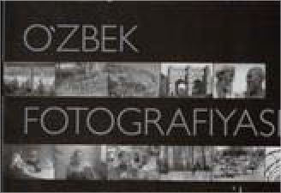
English Version:
Cyrillic Title
Prducr: Date:
Length:
Publication
Uzbek
photos of mostly human subjects, 1879-1940
English Version:
Artist: Prducr: Date:
Length:
Qo'ziev, Tursunal
Picture
O'zbekistan Badii
Cyrillic Title
2005
O'zbek Fotografiyasi 125 yil
200 pp.
English Version:
Cyrillic Title Академия художеств Узбек
Akademia khudozhestvennyk
Prducr:
Date: Length:
Tashkent: Shark
2000

Item: 4200

Item: 4201
Title: Andijan: All about the City

Category Language: Description:
Publication Uzbek

Title: Azhiniyaz

Category Language: Description:

Artist:

Shokarimov, Sobi

Picture

Publication Karakalpak
poetry collection

Artist:
Picture

Item: 4202
English Version:
Cyrillic Title Андижон
Andizhan
Prducr:
Date: Length:
Tashkent
2000
English Version:
Cyrillic Title
Prducr: Date:
Length:
Nukus: “Karakal
1994
Azhiniyaz: Tanlamaly Shygha
Title: Beginning of Spring

Category Language: Description:
Publication Karakalpak

English Version:

Cyrillic Title
Bahorning Boshlanishi

Artist: Prducr: Date: Length:

Afoqova, Nadira Bukhara: Bukhar 1997

Picture

Item: 4208
Title: Book
Category Language: Description:

Item: 4217
Title: Book of Uzbek poetry

Category Language: Description:

Publication Uzbek
book of verse

Artist:
Vokhidov, Saman
Picture

Item: 4248
Title: Bukhara - A Museum in the Open Category Language: Description: Publication Uzbek
English Version:

Artist: Prducr:

Pulatov, T. Tashkent Gafur G

Picture

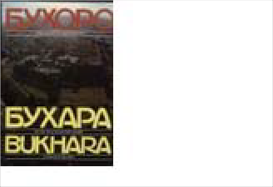
Cyrillic Title
Publication Karakalpak

English Version:
Artist: Prducr: Date:
Length:
Shomukhamedov
Picture
Tashkent: "Yozuv
Cyrillic Title
1992
Gulbogh nasimi
English Version:
Cyrillic Title Хаёлинг мен билан
Khayling Men Bilan
Prducr: Date:
Length:
Bukhara
1997
Бухaрa: Музей под открыты

Bukhara

Date: Length:
1991

Item: 4399
Title: Bukhara: A Museum in the Open
Category Language: Description:

Item: 4216
Title: Bulletin #4 of the Karkalpak Division of the Academy of Sciences

Category Language: Description:

Publication Russian

Artist:
Kamalov, S.K.
Picture

Item: 4398
Title: Decorative Painting of Uzbekistan

Category Language: Description:

Publication Uzbek

English Version:
picture book with photos of painted furniture, archictecture and other surfaces

Artist: Prducr:
Azimov, I Tashkent: Gafur
Picture

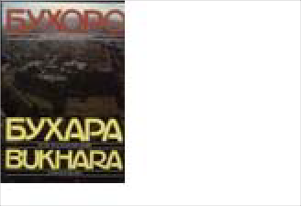
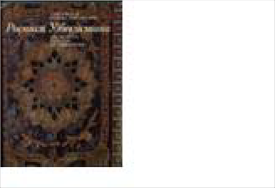
Cyrillic Title
Publication
Uzbek
Picture book with minimal text
Artist: Prducr: Date:
Length:
Маньковская, Л.
Picture
English Version:
Cyrillic Title Бухара: Музей под открыты
Buxoro: Ochiq Osmon Ostida
Tashkent: Uzbeki
2000
English Version:
Cyrillic Title Хабаршысы/Вестник № 4 К
Khabarshysy/Vestnik #4 Kara
Prducr: Date:
Length:
Kkoan
1995
Росписи Узбекистана

Rospisi Uzbekistana

Date: Length:
1987

142 pp.

Item: 4205
Title: Ecological

Category Language: Description:
Publication Uzbek

Artist:

Nosirov, Z. N. &

Picture

Item: 4260
Title: Etirof/Recognition/Priznanie
Category Language: Description:

Item: 4242
Title: Foreign and Indigenous Historiography of the History of Turkestan, Khor

Category Language: Description:

Publication Russian

English Version:

Artist: Prducr:
Koshchanov, B.A Nukus: “Karakal
Picture

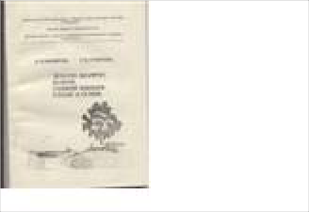
Cyrillic Title
English Version:
Cyrillic Title Екологик Маърифат: Мазму
Ekologik Ma'rifat: Mazmuni
Prducr:
Date: Length:
Uzbek Davlat Un
1998
Publication
Uzbek
(Album celebrating Uzbek Independence In Cyrillic Uzbek, Russian, and English)
Artist: Prducr: Date:
Length:
Picture
English Version:
Tashkent: “Uzb
Cyrillic Title
1995
Зарубежная и отечественна

Zarubezhnaya I Otechestvenn

Date: Length:
1997

Publication Russian

Artist:
Koshchanov, B.A
Picture

Publication Russian

Artist:
Koshchanov, B.A
Picture

Publication Russian

Artist:
Koshchanov, B.A
Picture

Publication Russian

Artist:
Koshchanov, B.A
Picture

English Version:
Cyrillic Title Зарубежная и отечественна
Zarubezhnaya I Otechestvenn
Prducr: Date:
Length:
Nukus: “Karakal
1997
English Version:
Cyrillic Title Зарубежная и отечественна
Zarubezhnaya I Otechestvenn
Prducr: Date:
Length:
Nukus: “Karakal
1997
English Version:
Cyrillic Title Зарубежная и отечественна
Zarubezhnaya I Otechestvenn
Prducr: Date:
Length:
Nukus: “Karakal
1997
English Version:
Cyrillic Title Зарубежная и отечественна
Zarubezhnaya I Otechestvenn
Prducr:
Date: Length:
Nukus: “Karakal
1997

Publication Russian

Artist:
Koshchanov, B.A
Picture

Item: 4203
Title: Gold-Embroidery Art of Bukhara
Category Language: Description:

Item: 4219
Title: Heritage
Category Language: Description:

Item: 4211
English Version:
Cyrillic Title Зарубежная и отечественна
Zarubezhnaya I Otechestvenn
Prducr: Date:
Length:
Nukus: “Karakal
1997
Publication
Uzbek
Bukharan Gold Embroidery Art, photo album in Uzbek and Russian
Artist: Prducr: Date:
Length:
Goncharova, P.A.
Picture
English Version:
Cyrillic Title Золотошевейное искусство
Bukhoro Zaraduzlik Canhati/
Tashkent
1986
Publication
Uzbek
Artist: Prducr: Date:
Length:
Tilewbergenova,
Picture
English Version:
Cyrillic Title Мийрас
Miiras
Karakalpakstan B
1997
Title: History of Karakalpakistan in government documents, 1932-1941

Category Language: Description:

Publication Russian

Artist:
Dzhumashev, As
Picture

Item: 4210
Title: Islom Karimov Steers Uzbekistan on its Way
Category Language: Description:

Item: 4213
Title: Karakalpak Embroidery

Category Language: Description:

Publication English
English Version:
Cyrillic Title История Каракалпалстана в
Istoriya Karakalpakstana v Pr
Prducr: Date:
Length:
Publication
English
Narrative of policy of Islom Karimov
Artist: Prducr: Date:
Length:
Alt, Elisabeth
Picture
English Version:
Harnisch Verlags:
Cyrillic Title

English Version:

Cyrillic Title
exhibit booklet

Artist: Prducr: Date: Length:
Uteulieva, Periuz Mathers Museum 2002
Picture

Publication

Artist:
Picture

Item: 4220
Title: Mammals Southern Region

Category Language: Description:
Publication

Artist:

Rimov, R

Picture

Item: 4221
English Version:
Cyrillic Title
Prducr: Date:
Length:
Nukus: “Karakal
1995
Karakalpak Khalyk Angizdarl
English Version:
Cyrillic Title Млекопитающие Южного
Mlekopitaushie Yuzhnogo Pri
Prducr: Date:
Length:
Tashkent: "Fan"
1985
Title: Modern Literary Uzbek I

Category Language: Description:
Publication Uzbek

English Version:

Cyrillic Title

Artist: Prducr: Date: Length:

Ismatulla, Khairul Bloomington, IN 1995

Picture

Item: 4222
Title: National Report: About the status of the surrounding natural environment

Category Language: Description:

Publication Russian
report with statistics

Artist:
Abdurakhmanov,
Picture

Item: 4215
Publication
Uzbek
Text from the museum exhibit texts
Artist: Prducr: Date:
Length:
Sadullaev, Azimb
Picture
English Version:
Cyrillic Title Ал-Хоразмий Музейи
Al-Khorazmiy muzeyi
Urganch
2001
English Version:
Cyrillic Title Национальный доклад: О С
Natsionalnii Doklad: O Sosto
Prducr: Date:
Length:
Tashkent
1998
Title: News archive

Category Language: Description:
Publication

English Version:

Cyrillic Title
Khabarshisi Vestnik #2

Artist: Prducr: Date: Length:

1996

Picture

Item: 4223
Title: Reflections in the Legends and Oral History of the Karakalpaks, 13th-17t

Category Language: Description:

Publication Russian

Artist:
Berdiyev, Jamiyet
Picture

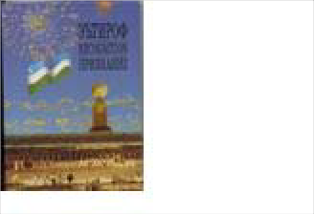
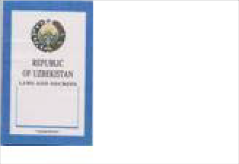
Item: 4227
Publication
Uzbek
Artist: Prducr: Date:
Length:
Picture
English Version:
Cyrillic Title Признание
Priznanie
Tashkent: "Uzbek
1995
English Version:
Cyrillic Title Отражение в легендах и нар
Otrazhenie v legendakh I naro
Prducr: Date:
Length:
Нукус
1996
Title: Republic of Uzbekistan: Laws and Decrees Category Language: Description: Publication English
English Version:

Cyrillic Title

Artist: Prducr: Date: Length:

Mozgacheva, Z. ( Uzbekistan: Tash 1992

Picture

Publication

Artist:
Picture

Item: 4207
Title: Rodents of the South Sub-Aral Region Category Language: Description: Publication Russian

Artist:

Reimov, R.

Picture

Item: 4229
Title: Shaytanat 1

Category Language: Description:
Publication Uzbek

Artist:

Malik, Tohir

Picture

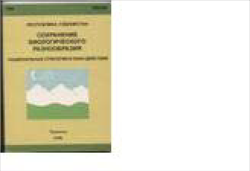
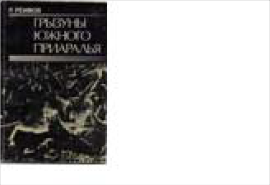
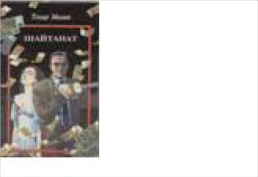
Item: 4230
English Version:
Cyrillic Title Республика Узбекистан: Со
Respublika Uzbekistan: Sokh
Prducr: Date:
Length:
UNDP/GEF. Tas
1998
English Version:
Cyrillic Title Грызуны Южного Приараль
Gryzuny Yuzhnogo Priaral'ya
Prducr: Date:
Length:
Tashkent: "Fan"
1987
English Version:
Cyrillic Title Шайтанат
Prducr: Date:
Length:
Shark: Tashkent
2001
Title: Shaytanat 2

Category Language: Description:

Publication Uzbek

Artist:
Malik, Tohir
Picture

Item: 4231
Title: Shaytanat 3

Category Language: Description:
Publication Uzbek

Artist:

Malik, Tohir

Picture

Item: 4232
Title: Shaytanat 4

Category Language: Description:
Publication Uzbek

Artist:

Malik, Tohir

Picture

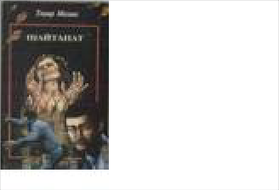
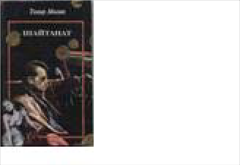
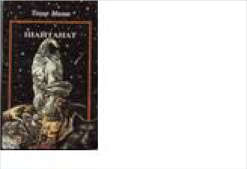
Item: 4218
English Version:
Cyrillic Title Шайтанат
Prducr: Date:
Length:
Shark: Tashkent
2001
English Version:
Cyrillic Title Шайтанат
Prducr: Date:
Length:
Shark: Tashkent
2001
English Version:
Cyrillic Title Шайтанат
Prducr: Date:
Length:
Shark: Tashkent
2001
Title: Short Russian-Uzbek-English Dictionary of Business Terminology

Category Language: Description:

Publication Russian
pocket dictionary

Artist:
Dzhuraev, T.
Picture

Item: 4206
Title: State Art Museum of the Karakalpak ASSR Category Language: Description: Publication

Artist:

Picture

Publication Russian
Hardback Museum Catalog

Artist:
Савицкии, И.В.
Picture

Item: 4234
English Version:
Cyrillic Title Краткий русско-узбекско-а
Kratkii Russko-Uzbeksko-An
Prducr: Date:
Length:
Tashkent
1992
English Version:
Cyrillic Title
Gosudarstvennyi Muzei Iskys
Prducr: Date:
Length:
English Version:
Cyrillic Title Государственный Музей Ис
Gosudarstvennyi Muzei Usky
Prducr:
Date: Length:
Москва: Советск
1976
Title: Tashkent
Category Language: Description:

Item: 4237
Title: University of World Economy and Diplomacy (UWED)
Category Language: Description:

Item: 4198
Publication
Uzbek
photo album of Tashkent
Artist: Prducr: Date:
Length:
Ходаев, С.Х.
Picture
English Version:
Cyrillic Title Ташкент
Tashkent
Tashkent: Izdaltel
1977
Publication English

English Version:
Artist: Prducr: Date:
Length:
Picture
Ministry of Forei
Cyrillic Title
2002
English Version:
Cyrillic Title Узбекская Кухня
Uzbekskaia kuchnia
Prducr: Date:
Length:
"Mexhat": Tashk
1996

Item: 4238
Title: Uzbek Cuisine

Category Language: Description:
Publication Uzbek

Title: Uzbek Favorite Cuisine

Category Language: Description:

Artist:

Madrakhimov, A.

Picture

Item: 4224
Title: Uzbek Language

Category Language: Description:
Publication Uzbek

Artist:

Azizxonova, Yu.

Picture

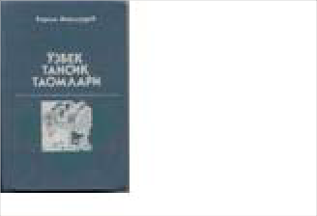
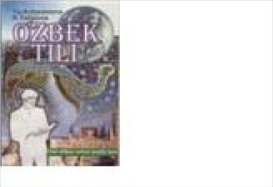
Item: 4212
Publication
Uzbek
Artist: Prducr: Date:
Length:
Mahmudov, Kari
Picture
English Version:
Cyrillic Title Узбек тансик таомлари
Uzbek Tansiq Taomlari
Tashkent: Tashke
1989
English Version:
Cyrillic Title
Prducr: Date:
Length:
Tashkent
1999
Ozbek Tili
Title: Uzbek language book

Category Language: Description:
Publication Uzbek

English Version:

Cyrillic Title
Jalolidoin Manguberdi

Artist: Prducr: Date: Length:

Picture

Publication Uzbek

Artist:
Ismatulla, Khayru
Picture

Item: 4271
English Version:
Prducr: Date:
Length:
Newmount Minin
Cyrillic Title
1996
English Version:
Prducr: Date:
Length:
Newmount Minin
Cyrillic Title
1996

Item: 4272
Title: Uzbek/English Language Guide (copy 10) Category Language: Description: Publication Uzbek

Title: Uzbek/English Language Guide (copy 11) Category Language: Description: Publication Uzbek
English Version:

Cyrillic Title

Artist:

Artist: Prducr: Date: Length:

Ismatulla, Khayru

Ismatulla, Khayru Newmount Minin 1996

Picture

Picture

Publication Uzbek

Artist:
Ismatulla, Khayru
Picture

Item: 4274
English Version:
Prducr: Date:
Length:
Newmount Minin
Cyrillic Title
1996
English Version:
Prducr: Date:
Length:
Newmount Minin
Cyrillic Title
1996

Item: 4275
Title: Uzbek/English Language Guide (copy 13) Category Language: Description: Publication Uzbek

Title: Uzbek/English Language Guide (copy 14) Category Language: Description: Publication Uzbek
English Version:

Cyrillic Title

Artist:

Artist: Prducr: Date: Length:

Ismatulla, Khayru

Ismatulla, Khayru Newmount Minin 1996

Picture

Picture

Publication Uzbek

Artist:
Ismatulla, Khayru
Picture

Item: 4262
English Version:
Prducr: Date:
Length:
Newmount Minin
Cyrillic Title
1996
English Version:
Prducr: Date:
Length:
Newmount Minin
Cyrillic Title
1996

Item: 4264
Title: Uzbek/English Language Guide (copy 2) Category Language: Description: Publication Uzbek

Title: Uzbek/English Language Guide (copy 3) Category Language: Description: Publication Uzbek
English Version:

Cyrillic Title

Artist:

Artist: Prducr: Date: Length:

Ismatulla, Khayru

Ismatulla, Khayru Newmount Minin 1996

Picture

Picture

Publication Uzbek

Artist:
Ismatulla, Khayru
Picture

Item: 4266
English Version:
Prducr: Date:
Length:
Newmount Minin
Cyrillic Title
1996
English Version:
Prducr: Date:
Length:
Newmount Minin
Cyrillic Title
1996

Item: 4267
Title: Uzbek/English Language Guide (copy 5) Category Language: Description: Publication Uzbek

Title: Uzbek/English Language Guide (copy 6) Category Language: Description: Publication Uzbek
English Version:

Cyrillic Title

Artist:

Artist: Prducr: Date: Length:

Ismatulla, Khayru

Ismatulla, Khayru Newmount Minin 1996

Picture

Picture

Publication Uzbek

Artist:
Ismatulla, Khayru
Picture

Item: 4269
English Version:
Prducr: Date:
Length:
Newmount Minin
Cyrillic Title
1996
English Version:
Prducr: Date:
Length:
Newmount Minin
Cyrillic Title
1996
English Version:
Prducr: Date:
Length:
Newmount Minin
Cyrillic Title
1996

Item: 4270

Item: 4209
Title: Uzbek/English Language Guide (copy 8) Category Language: Description: Publication Uzbek

Title: Uzbek/English Language Guide (copy 9) Category Language: Description: Publication Uzbek

Title: UZBEKISTAN - On the Road of Progress

Category Language: Description:

Artist:

Artist:

Ismatulla, Khayru

Ismatulla, Khayru

Picture

Picture

Publication Uzbek

Artist:
Picture

Item: 4225
Title: Uzbekistan and Uzbeks

Category Language: Description:
Publication Uzbek

Artist:

Bobokhonova, L.

Picture

Item: 4239
Title: Uzbekistan on the Threshold of the Twenty-First Century

Category Language: Description:

Publication English

Artist:
Karimov, Islom
Picture

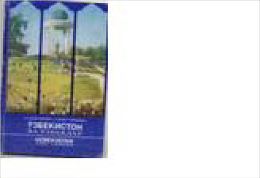
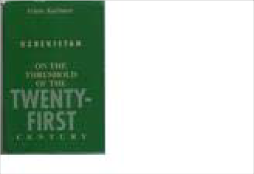
Item: 4241
English Version:
Prducr: Date:
Length:
Tashkent
Cyrillic Title
2001
English Version:
Cyrillic Title Узбекистон ва узбеклар
O'zbekiston va O'zbeklar
Prducr: Date:
Length:
Tashkent
1996
English Version:
Prducr: Date:
Length:
Cambridge, MA
Cyrillic Title
1998
Title: Zain al-Akhbar: Adornment of the newscast

Category Language: Description:

Publication

Artist:
Gardizi, Abus'id
Picture

Booklet

Item: 4363

Title: Basic Uzbek Alphabet and Knowledge (Theory) for Writing in Latin

Category Language: Description:

Publication Uzbek
Turquoise booklet

Artist:
Abduroziq Rafiye
Picture

Item: 4402
Title: Bukhara 2500
Category Language: Description:

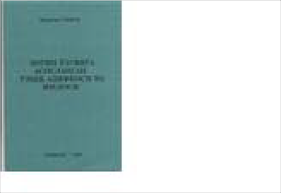
English Version:
Cyrillic Title Зайн ал-Ахбар: Украшение
Zain al-Akhbar: Ukrashenie i
Prducr: Date:
Length:
Uzbek Academy
1991
English Version:
Cyrillic Title Лотин Ёзувига Асосланган
Lotin yozuviga asoslangan o'z
Prducr:
Date: Length:
Tashkent
2003
Publication
Uzbek
Pictures of Bukhara and a calendar
Artist: Prducr: Date:
Length:
Picture
English Version:
Cyrillic Title
13 pp.

CD-Rom

Item: 4637
Title: Video CD of Zilola's Photos
Category Language: Description:

Magazine

Item: 4322

Title: Economic Review: 10 Years of Uzbekistani Independence

Category Language: Description:

Publication Russian
magazine

Artist:
Golyshev, V.A.
Picture

Miscellaneous
Publication
Slideshow of Zilola's photos produced by Zilola set to music
Artist: Prducr: Date:
Length:
Saidova, Zilola
Picture
English Version:
Saidova, Zilola
Cyrillic Title
2003
English Version:
Cyrillic Title Экономическое Обозрение:
Ekonomicheskoe Obozrenie:
Prducr: Date:
Length:
Tashkent:
2001

Item: 4350

Title: English-Uzbek Dictionary

Category Language: Description:

Publication Uzbek

Artist:
Буронов, Ж.
Picture

Pamphlet

Item: 4235

Title: Avesta has Found Its Native Land Category Language: Description: Publication English

Artist:

Satlikov, A. and I

Picture

Item: 4346
Title: Band of Satan against God

Category Language: Description:
Publication Russian

Artist:

Фитрат, А.

Picture

English Version:
Cyrillic Title Инглизча-
Prducr: Date:
Length:
Tashkent
1977
English Version:
Prducr:
Date: Length:
Urganch: Urganc
Cyrillic Title
2001
English Version:
Cyrillic Title Бунт Сатаны Против Бога
Bunt Satany Protiv Boga
Prducr:
Date: Length:
NISIM: Tashkent
2001

Item: 4204
Title: Holy Bukhoro: Essays about some of the ancient historical monuments of

Category Language: Description:

Publication English

Artist:
Naimov, Nustarill
Picture

Item: 4226
Title: Republic of Uzbekistan: Architectural Monuments of Samarkand

Category Language: Description:

Publication Russian
Guide to Bibi-khanym mosque

Artist:
Nazaryan, Ruben
Picture

Report
English Version:
Cyrillic Title Бухоройи Шариф
Bukhoroii Sharif
Prducr:
Date: Length:
Bukhoro
1997
English Version:
Cyrillic Title Республика Узбекистан: Ар
Respublika Uzbekistan: Arkh
Prducr: Date:
Length:
Samarkand: Asia

Item: 4329

Title: Human Development Report: Uzbekistan 2000

Category Language: Description:

Publication English

Xinjiang Uyghur Autonomous

Book

Artist:
Glenn, John
Picture

Item: 4488
Title: Painted Buddhas of Xinjiang
Category Language: Description:

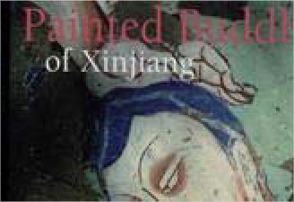
CD (music)
English Version:
Prducr: Date:
Length:
Center for Econo
Cyrillic Title
2001
Publication
English
Photographs by Reza with accompanying essays
Artist: Prducr: Date:
Length:
Jacuqes Gies, Lau
Picture
English Version:
Editions de la Ma
Cyrillic Title
2002
167 pp

Item: 4615

Title: Sultan Memet - Veten`
Category Language: Description:

Magazine

Item: 4296

Title: National Geographic, v. 189, no. 3
Category Language: Description:

Map

Item: 4533

Title: Geographical Map of Northwest China

Category Language: Description:

Publication English
1:2000000

Artist:
Picture

Publication
Uyghur
Autographed limited edition copy of Sultan Memet's album
Artist: Prducr: Date:
Length:
Sultan Memet
Picture
English Version:
World Flight Pro
Cyrillic Title
2006
13 tracks
Publication
English
Includes articles: Xingjiang & The Silk Road's Lost World (on mummies)
Artist: Prducr: Date:
Length:
Allen, Thomas
Picture
English Version:
National Geograp
Cyrillic Title
1996
English Version:
Prducr:
Date: Length:
Gizi Map
Cyrillic Title

Item: 4566
Title: Map of Xinjiang Uyghur Autonomous Region

Category Language: Description:

Publication Uyghur
Laminated; In Uyghur

Artist:
Picture

English Version:
Cyrillic Title
Prducr:
Date: Length:

