**Circulating Items Inventory - Regional (Central Asia)**

**Art/Photo**

**Producer/Publisher Year Made Length Image**

**English? Artist/Author**

**Category of Item Item # Item Name**

2017 Plaque No

2181 1992 Photographic No Calendar: “Silk Road”

2212 1001 Nights postcard set No

2213 2 Navruz cards No

2215 Caspian Sea Region: No Promise and Peril.

2223 famous Russian painting No montage

2243 Hanging No

2247 Pin No

4483 Stanorama: Kazakhstan - Turkmenistan - Uzbekistan - Tajikistan - Kyrgyzstan

Yes Herwig, Christopher 2006 97 pp.

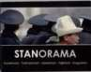4673 Hanging decoration No

**Book/Bound**

3112 Tales from the Steppes Yes Cynthia Jameson Coward, McCann

& Geoghegan, Inc.

1975 64 pp.

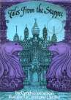

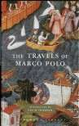

3127 The Travels of Marco Polo

Yes Polo, Marco

Dent Everyman

2008

421 pp

4036 Along the Great Silk Road

Yes Talanova, Olga Kramos 1991

4037 Arab World Almanac 1993

No AMIDEAST.

Washington, D.C.

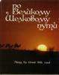1993

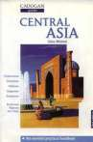4039 Caravan to America: Living Arts of the Silk Road

Yes Major, John S. and Betty J. Belanus

Chicago: Cricket Books

2002

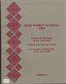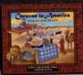4040 Central Asia Yes Whittell, Chris London: Cadogan Books, Ltd

1996

4041 Central Asia: Its Strategic Importance and Future Prospects

4042 Circle Houses: Yurts, Tipis and Benders

Yes Malik, Hafeez New York, St.Martin’s Press

Yes Pearson, David White River Junction: Chelsea Green Publishing Com

1996

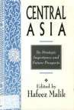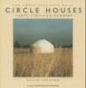2001

4043 Cultural Handbook for the New Independent States

4044 Dictionary of the Turkic Languages

No Choate, Lisa A and Davidson, Dan E, eds.

Yes Öztopçu, Kurtuluş, et. Al

American Councils for International Education (ACT

New York: Routledge

2000

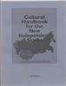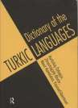1999

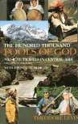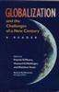

4045 Hundred Thousand Fools of God: Musical Travels in Central Asia (and Queens, New York)

Yes Levin, Theodore

Bloomington: Indiana University Press

1996

318 pp.

4047 Globalization and the Challenges of a New Century (copy 1)

Yes O’Meara, P, Mehlinger, H, Krain, M, eds.

Indianapolis and Bloomington: Indiana University P

2000

4048 Globalization and the Challenges of a New Century (copy 2)

No O’Meara, P, Mehlinger, H, Krain, M, eds.

Indianapolis and Bloomington: Indiana University P

2000

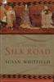4050 Life Along the Silk Road Yes Whitfield, Susan Berkeley:

University of California Press

1999

4051 Navruz 2001 Photos No 2001

4052 Parliamentarism in the Countries of Central Asia

No Eshmambetov, N. A,

A. O. Cholponkulova et al (eds)

Bishkek: КРСУ 1999

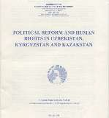4053 First Reader in Orientalistics: dedicated to the memory of S.G. Livshits (Theses, Lectures and Reports)

No Livshitsa, S.G. Barnaul: Izdatel'stvo BGPU

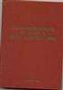1996

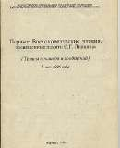4054 Political Reform and Human Rights in Uzbekistan, Kyrgyzstan, and Kazakhstan

Yes Commission on Security and Cooperation in Europe

Commissionon Security and Cooperation in Europe

1998 42 pp.

4055 Russia, Siberia and State Central Asia: Interaction of Nationalities & Cultures

4056 Silk Road Cooking: A Vegetarian Journey

No Баурнал:

Издательство БГПУ

No Batmanglij, Najmieh

1997

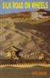

4057 Silk Road on Wheels: Travels through Central Asia, Turkestan, and Tibet

Yes Bakshi, Akhil

New Delhi: Odyssey Books

2001

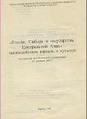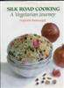4058 Therapy for several liver conditions

No Dzhamanbaev, E A Bishkek 1991

4059 Aral Sea Basin Problems: Research and Recommendations

Yes Rafikov, A. A. (editor) Chinor ENK,

Tashkent

1998 75 pp.

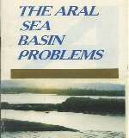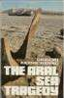4060 Aral Sea Tragedy, c.1 Yes Reznichenko, Grigori Moscow: Novosti 1992

4061 Baburnama: Memoirs of Babur, Prince and Emperor

No Thackston, Wheeler M, trans

New York and Oxford: Oxford University Press

1996

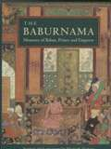4062 Silk Road: Art and History

No Tucker, Jonathan Chicago: Art Media

Resources

2003

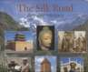

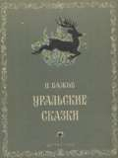4063 Uralic Fairy Tales No Bazhov, P. Detgiz 1953

4138 Foreign Language Teacher's Guide to Active Learning

No Blaz, Deborah Larchmont: Eye on Education

1999

4139 Polishing the Mirror: A Curriculum Unit on Central and Inner Eurasia (copy 1)

4140 Polishing the Mirror: A Curriculum Unit on Central and Inner Eurasia (copy 2 - not in binder)

Yes Gardner, Vika and R.

T. Steponaitis

Yes Gardner, Vika and R.

T. Steponaitis

University of Michigan: Center for Middle Eastern

University of Michigan: Center for Middle Eastern

2000

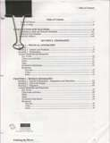2000

4233 Spotlight on Inner Asia: The Bizarre Bazaar

4249 Ibn Battuta: A View of the Fourteenth-Century World. A unit of study for Grades 7-10

4261 Post-Soviet Handbook: A guide to Grassroots Organizations and Internet Resources (Revised Edition)

Yes American Forum for Global Education

Yes Arno, Joan and Helen Grady

No Ruffin, M Holt, Deutscheler, Alyssa, Logan, Catrio

New York: American Forum for Global Education

LA: National Center for History in Schools

Seattle: Civil Society International, 1999

2000

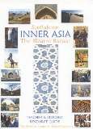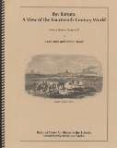1998

4277 Central Asia and the World: Kazakhstan, Uzbekistan, Tajikistan, Kyrgyzstan, Turkmenistan

Yes Mandelbaum, Michael (ed.)

New York: Council on Foreign Relations Press

1994

4278 Classroom-Based Evaluation in Second Language Education

Yes Genesee, Fred and John A. Upshur

Cambridge University Press

2002

4280 Aral Sea Tragedy, c.2 Yes Reznichenko, Grigori Moscow: Novosti 1992

4281 Central Asia 2010 No Региональное Бюро по странам европы и снг

Finland: ScanWeb

4282 Baburnama: Memoirs of Babur, Prince and Emperor

Yes Thackston, Wheeler New York: Oxford

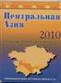University Press

1996

4295 Central Asia: Its Strategic Importance and Future Prospects, c. 2

Yes Malik, Hafeez New York, St.Martin’s Press

1996

4300 Services along the Silk Road

4320 Gender Montage: Paradigms in Post Soviet Space

Yes Bestway Tours & Safaris

Yes Schreiner, Phoebe, et.al. (ed.s)

Burnaby: Bestway Tours & Safaris

Zvezda Magazine Publishing House: St. Petersburg

2001

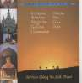

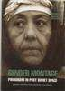2003

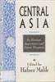4341 Plaint of the Hunter Above the Abyss



Yes Aitmatov, Ch. & M. Shakhanov; Walter May, trans.

Atamura: Almaty 1998

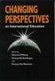4351 Free Trade, Free Markets: Central Asia on the Edge of Globalization

Yes Spechler, Martin M. E. Sharpe 2004

4352 Changing Perspectives on International Education

Yes O'Meara, Patrick, et al (eds)

Bloomington: Indiana University Press

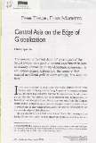2001

|  |  |  |  |  |  |  |
| --- | --- | --- | --- | --- | --- | --- |
| 4394 | Islam: A thousand years | Yes | Bloom, Jonathan and | Yale University | 2002 | 304 pp. |
|  | of faith and power |  | Sheila Blair | Press |  |  |

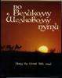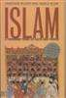4397 Along the Great Silk Road

No Baipakov, Karl & Nasyrov, Rakip; Talanova, O (ed.)

Alma-ata 1991 320 pp.

4489 Stories from the Silk Road Yes Cherry Gilchrist Barefoot Books 1999 80 pp

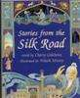

4490 Traveling Man: The Journey of Ibn Battuta

4491 Traditional Textiles of Central Asia

Yes

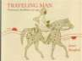

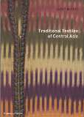Yes Janet Harvey Thames & Hudson 1996 160 pp

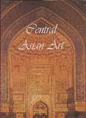4492 Central Asian Art Yes Julien Depaulis Greenwich Editions 2003 256 pp

4567 Along the Silk Road Yes SPICE and The Silk Road Project

Stanford Program on International & x-cultural edu

2006 263pp

4575 Bringing the Stans and Central Asia into the Classroom

Yes Chris Foley, Bart Quinet, Mary Thurlkill

IAUNRC, Indiana University

2004 74pp

4622 Demons & Protectors: Folk Religion in Tibetan & Mongolian Buddhism

Yes Edited by Belen Kelenyi

Ferenc Hopp Museum of Eastern Asiatic Art

2003

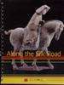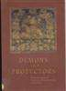4730 Two Epochs of National Self-Determination in Central Asian Cinema: The 60s and 90s

No Gulnara Abikeyeva OSI 2006 104 pp.

4756 The Aral Sea No Glantz, Michael United Nations Publications

2005 37 pp.

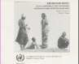

4798 World Atlas Yes Kania, Matthew (ed) Nystrom 1993 85 pp.

4881 Celebrating Norouz: Persian New Year

4882 Happy Nowruz: Cooking with Children to Celebrate the Persian New Year

Yes Jalali, Yassaman Saman Publishing 2003 28 pp.

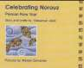

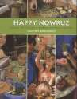Yes Batmanglij, Najmieh Mage Publishers 2008 119 pp.

4883 Stranger on the Silk Road: A Story of Ancient China

Yes Gunderson, Jessica Picture Window

Books

2009 64 pp.

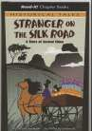4884 The Adventures of Marco Polo

Yes Smalley, Roger Capstone Press 2005 32 pp.

4885 Marco Polo's silk purse Yes Bailey, Gerry Crabtree Publishing

Company

4886 Tales Told in Tents Yes Clayton, Sally Frances Lincoln

Children's Books

2008 37 pp.

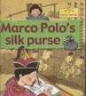

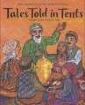2004 60 pp.

4888 The Silk Route: 7,000 Miles of History

Yes Major, John Harper Collins 1995 32 pp.

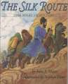4891 Tales Told in Tents Yes Clayton, Sally Frances Lincoln

Children's Books

2004 60 pp.

4929 How the Camel Got His Hump

Yes Walt Disney

Productions

1968 24 pp.

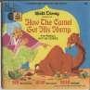5034 Irregular Migration from the Former Soviet Union to the United States

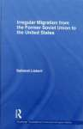

**Cassette**

Yes Lieber, Saltanat Routledge 2010 153 pp.

2029 Education in Central Asia No

2035 Bebeho Meros 2 No

**CD**

3000 Altaic Epos (2-disc set) No

3001 Anthology of Buryat Folklore

No varoius

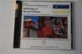

3002 Anthology of Kalmyk Folklore

3003 Anthology of Yakutsk Folklore

No various

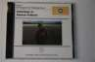

No

3010 Chuvash Folklore No

3014 Folklore of Kyrgyzstan No

3021 Ngansans No various Norman Ross Publishing, Inc

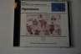

3025 Secret Museum of Mankind – Central Asia Ethnic Music Classic 1925-48 copy 1

No various Yazoo

3026 Secret Museum of Mankind – Central Asia Ethnic Music Classic 1925-48 copy 2

No various Yazoo 1996

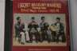3031 Nazgul Urdavletova No various Jackson Kellogg

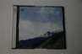

3033 Asie Centrale Traditions No Classiques

3063 Fikret Amirov No Fikret Amirov

3077 Anthology of Tuvan and Ude Folklore

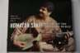4400 Homayun Sakhi: The Art of the Afghan Rubab

No various Norman Ross Publishing, Inc

Yes Homayun Sakhi Smithsonian

Folkways Recording, US

2000

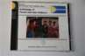

2005

4410 Invisible Face of the Beloved, Classical Music of the Tajiks and Uzbeks

No Various Aga Khan, Smithsonian Folkways

2005 70 min. (CD),

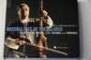24 min. (DVD)

# Cloth/Fabric

2042 Decorative design cloth No

2227 red miniature rug No

2263 cotton No

# Clothing

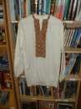4711 Men's shirt (Russian?) No

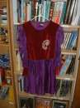

4714 Women's or girl's dress and pants outfit

No

**DVD**

1014 The Adventures of Marco Polo

Yes Mayo, Archie Samuel Goldwyn 1938 104 min.

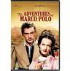1025 Central Asia: Kyrgyzstan and Uzbekistan

Yes Lonely Planet

Publications.

1996 45 min

1192 Constructing a Yurt (DVD)

Yes

1278 Navruz Festival 2005 Yes Navruz Student Association

2005

1299 Silk Road October Performance - 10/16/04

Yes Community Access

Television Services

2005

1300 Silk Road 7/24/05 Yes Community Access Television Services

2005

1303 Navruz Celebration 2006 No 2006

1306 Islam: Empire of Faith Yes Gardner Films/PBS 2000 180 min

1308 Navruz Festival 2004 (2 copies)

Yes Navruz Student

Association

2004

1400 Silk Road October Performfance 10-16-04

Yes Shahyar Daneshgar CATS 1994 ~2 h

3092 Ultimate Scandinavia Yes Globe Trekker series DVD Masters 2007 233 min.

3097 Luna Papa Yes Bakhtiar Khudojnazarov

Alliance Atlantis 1999 105 min.

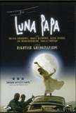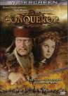3125 The Conqueror Yes Powell, Dick Howard Hughes 1956 111 min

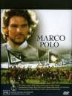3126 Marco Polo (Television Miniseries)

Yes Montaldo, Giuliano Vincenzo Labella 1982 473 min

4458 Navruz 2003 Yes 2003

4576 Navruz Student Association's Navruz Festival: 24 March 2007

No IAUNRC IAUNRC, Indiana University

2007 124 min

4631 Islam, Asia, and Modernity: Introduction and Panel 1 of 6

Yes Rorlich, Lelyveld, Othman

Henry M. Jackson School of International Studies

2005

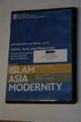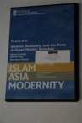4632 Islam, Asia, and Modernity: Gender, Sexuality, and the Body in Asian Muslim Societies

Yes Jaschok, Haq, Kamp Henry M. Jackson

School of International Studies

2005

4633 Islam, Asia, and Modernity: Islamic Arts & National Cultures

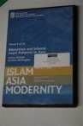4634 Islam, Asia, and Modernity: The Crisis of Masculine Identities in Post Societ & Post 9-11 Muslim Asia

Yes Kochumkulkizi, Suanda

Yes Rigi, Shahrani, Abdalla

Henry M. Jackson School of International Studies

Henry M. Jackson School of International Studies

2005

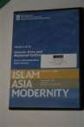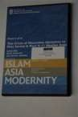2005

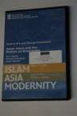4635 Islam, Asia, and Modernity: Education & Islamic Legal Subjects in Asia

Yes Ahmed, Bovingdon Henry M. Jackson

School of International Studies

2005

4636 Islam, Asia, and Modernity: Asian Islam and the Politics of Knowledge

Yes Igmen, Chatterjee, Mandal

Henry M. Jackson School of International Studies

2005

4660 15th Annual Silk Road Festival (15 July 2007)

Yes Community Access

Television Services

2007 2:18

4694 12th Annual Navruz Festival, March 22 2008

Yes Sponsored by the IAUNRC

Indiana University 2008

4707 Lotus World Music Festival 2000: Alim Qasimov

Yes CATS 2008

4770 Novruz 2008 Yes IAUNRC IAUNRC 2008

4774 The Former Soviet Union: Bringing the Stans and Central Asia into the Classroom

Yes IAUNRC 2004

4838 The Spring Festival, Navruz Concert and Exhibition, March 24,

2001

Yes Instructional

Support Services

2001 1hr 44m

4917 Ararat Yes Egoyan, Atom Miramax Films 2002 115 min.

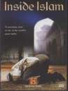4958 Inside Islam Yes The History Channel A&E Television Networks

2002 100 min.

4959 In This World Yes Winterbottom, Michael

Sundance Channel 2003 88 min.

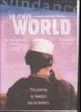4964 Silk Road Adventure: Istanbul, Turkey to Xian, China

|  |  |  |  |  |  |  |
| --- | --- | --- | --- | --- | --- | --- |
| 4966 | Journey Along the Silk | Yes | Kusakabe, Minoru, | TBS | 2005 | 120 min. |
|  | Road |  | and Masaya Shimizu. |  |  |  |

4973 Gender Montage: 7 Films

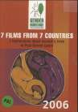

**Flag**

from 7 Countries - 7 Testimonies about Women's Lives in Post- Soviet Space

Yes Noren, Sterling Globeriders 2007 240 min.

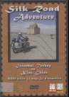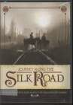Yes various Gender Montage 2006 180 min.

2084 2 small komosomol flags No

2085 small decorative banner No

# Instrument

2239 metal bell No

4479 Mouth organ in wooden No box

# Map

2116 Energy Map of Central No Asia

2117 China No

2118 Russian revolution No

2119 Map of Russia at the No beginning of the 20th

Century

2120 map of Caspian sea basin No

2121 Asia political and No physical map

2127 National Geographic No World (Political) map

2128 National Geographic No World (Political) map

2129 Caspian Sea oil and gas No reserves

4531 Geographical Map of Central Asia

Yes Gizi Map

4532 Geographical Map of Silk Road Countries

Yes Gizi Map

4539 Energy Map of Central Asia

Yes Ernest & Young,

Petroleum Economist

4540 Two-sided World Map Yes National Geographic Society

4541 Two-sided World Map Yes National Geographic Society

4542 Communism to Capitalism Map

Yes National

Geographic Society

1993

4543 Caspian Sea Map Yes National Geographic Society

4544 Caspian Sea Map Yes National Geographic Society

4548 Map of Asia Yes Milliken 2001

4549 Map of Afghanistan, Pakistan and the Middle East

Yes National

Geographic Society

2001

4551 Map of Kazakhstan and Central Asia

No Tashkent

Catography

1999

4556 Map of Mongol-Turkish Conquest

Yes AJ Nystrom

4557 Map of Kazakhstan and Central Asia

No Tashkent

Catography

1999

4558 Map of Central Asia and Kazakhstan, 2 Pieces

No Tashkent

Catography

1999

4562 Map of Afghanistan, Pakistan and the Middle East

Yes National

Geographic Society

2001

4779 Mongol Khans and Their Legacy

Yes National

Geographic Society

4787 Kazakhstan and Central Asia

No 1987

4794 The Caspian Sea, Khiva, and the Surrounding Country

No 1951

4795 Yes John Arrowsmith Published in London

1841

**Misc.**

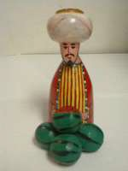2233 various stamp fragments No

**Model**

2138 wooden Kyrgyz/Kazakh No queen and king

2148 wooden turbaned male No

2149 ceramic turbaned female No

2150 small wooden female No

2151 wooden couple No

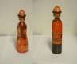

2153 figure of an old man No

2264 camel No

4476 Small yurt No

4477 Watermelon Vendor No Figurine

4481 Miniature felt camel No

4484 Figurine of Woman No Making Plov

4494 Minitature Yurt No

4515 Miniature Yurt No

4521 Doll in Ethnic Dress No

**Periodical**

3095 Saudi Aramco World November/December 2009

Yes Arndt, Robert (editor) Aramco Services

Company

2009 49 pp.

4038 Arid Ecosystems Vol. 4,

No. 8

No Zalibekov, Z Russian Academy of Sciences. Moscow

1998

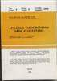4046 FACES: Central Asia Yes Babcock, Denise FACES 1996

4049 International Journal of Social Education

4283 Education About Asia, v.

5 n. 2

Yes Cantu, D. Antonio Muncie: Ball State

University

Yes Ellington, Lucien Ann Arbor: Assoc.

for Asian Studies

1998

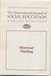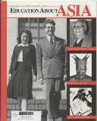2000

4284 Education About Asia, v.

5 n. 3

4285 National Geographic, v. 91, no. 2, February 1997

Yes Ellington, Lucien Ann Arbor: Assoc.

for Asian Studies

Yes Edwards, Mike National Geographic Society: Washington

2000

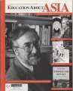

1997

4286 National Geographic, v. 190, no. 6, December 1996

Yes Edwards, Mike National Geographic Society: Washington

1996

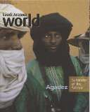4323 Saudi Aramco World Yes Arndt, Robert (editor) Houston: Aramco

Services Co.

2003 49 pp.

4342 National Geographic, v. 184, no. 4, October 1993

Yes Mackenzie, Richard National

Geographic Society: Washington

1993

4345 National Geographic, v.

195, no. 5, May 1999

Yes Cullen, Robert National Geographic Society: Washington

1999

4662 Saudi Aramco World Yes Arndt, Robert (editor) Aramco Services

Company

4740 Saudi Aramco World Yes Arndt, Robert (editor) Aramco Services

Company

2007 49pp.

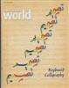2006 49 pp.

4745 Saudi Aramco World Yes Arndt, Robert (editor) Aramco Services

Company

4746 Saudi Aramco World Yes Arndt, Robert (editor) Aramco Services

Company

4747 Saudi Aramco World Yes Arndt, Robert (editor) Aramco Services

Company

4748 Saudi Aramco World Yes Arndt, Robert (editor) Aramco Services

Company

2007 49 pp.

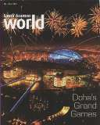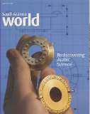2007 49 pp.

2008 49 pp.

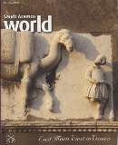

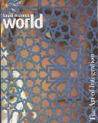2007 49 pp.

4749 Saudi Aramco World Yes Arndt, Robert (editor) Aramco Services

Company

4750 Saudi Aramco World Yes Arndt, Robert (editor) Aramco Services

Company

4751 Saudi Aramco World Yes Arndt, Robert (editor) Aramco Services

Company

4752 Saudi Aramco World Yes Arndt, Robert (editor) Aramco Services

Company

2005 49 pp.

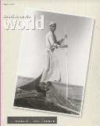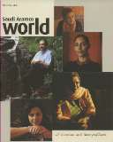2005 49 pp.

2004 41 pp.

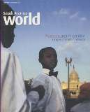

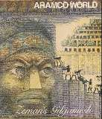1996 41 pp.

4753 Saudi Aramco World Yes Arndt, Robert (editor) Aramco Services

Company

4754 Saudi Aramco World Yes Arndt, Robert (editor) Aramco Services

Company

4755 Saudi Aramco World Yes Arndt, Robert (editor) Aramco Services

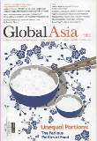Company

1996 41 pp.



1996 41 pp.



1996 41 pp.

4760 Global Asia Yes Moon, Chung-in (editor)

Ro-Myung Group 2008 101 pp.

4845 Saudi Aramco World September/October 2008

Yes Aramco Services

Company

2008 49 pp.

|  |  |  |  |  |  |  |
| --- | --- | --- | --- | --- | --- | --- |
| 4906 | Saudi Aramco World | Yes | Arndt, Robert (editor) | Aramco Services | 2009 | 49 pp. |
|  | March/April 2009 |  |  | Company |  |  |

4948 Saudi Aramco World January/February 2009

Yes 2009 49 pp.

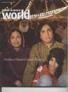4949 REECAS Newsletter Fall 2008

Yes Jackson School of

International Studies

2008 24 pp.

4950 REEI Center Newsletter Number 112 Fall 2008

Yes University of

Illinois at Urbana- Champaign

2008 12 pp.

4951 CEERES News Yes University of Chicago

2008 16 pp.

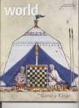

|  |  |  |  |  |  |  |
| --- | --- | --- | --- | --- | --- | --- |
| 5002 | Saudi Aramco World | Yes | Arndt, Robert (editor) | Aramco Services | 2008 | 49 pp. |
|  | January/February 2008 |  |  | Company |  |  |

|  |  |  |  |  |  |  |
| --- | --- | --- | --- | --- | --- | --- |
| 5003 | Saudi Aramco World | Yes | Arndt, Robert (editor) | Aramco Services | 2009 | 49 pp. |
|  | July/August 2009 |  |  | Company |  |  |

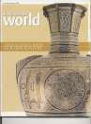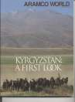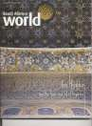

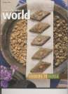

|  |  |  |  |  |  |  |
| --- | --- | --- | --- | --- | --- | --- |
| 5004 | Saudi Aramco World | Yes | Arndt, Robert (editor) | Aramco Services | 2006 | 49 pp. |
|  | May/June 2006 |  |  | Company |  |  |

|  |  |  |  |  |  |  |
| --- | --- | --- | --- | --- | --- | --- |
| 5005 | Saudi Aramco World | Yes | Arndt, Robert (editor) | Aramco Services | 2006 | 49 pp. |
|  | January/February 2006 |  |  | Company |  |  |

|  |  |  |  |  |  |  |
| --- | --- | --- | --- | --- | --- | --- |
| 5006 | Saudi Aramco World | Yes | Arndt, Robert (editor) | Aramco Services | 1995 | 49 pp. |
|  | July/August 1995 |  |  | Company |  |  |

|  |  |  |  |  |  |  |
| --- | --- | --- | --- | --- | --- | --- |
| 5007 | Saudi Aramco World | Yes | Arndt, Robert (editor) | Aramco Services | 2006 | 49 pp. |
|  | September/October 2006 |  |  | Company |  |  |

5008 Saudi Aramco World November/December 1999

|  |  |  |  |  |  |  |
| --- | --- | --- | --- | --- | --- | --- |
| 5009 | Saudi Aramco World | Yes | Arndt, Robert (editor) | Aramco Services | 1998 | 33 pp. |
|  | July/August 1998 |  |  | Company |  |  |

5011 Saudi Aramco World November/December 1998

|  |  |  |  |  |  |  |
| --- | --- | --- | --- | --- | --- | --- |
| 5010 | Saudi Aramco World | Yes | Arndt, Robert (editor) | Aramco Services | 1996 | 41 pp. |
|  | March/April 1996 |  |  | Company |  |  |

Yes Arndt, Robert (editor) Aramco Services

Company

Yes Arndt, Robert (editor) Aramco Services

Company

1999 45 pp.

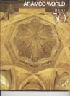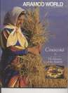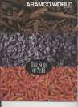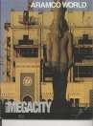1998 33 pp.

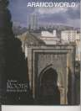5012 Saudi Aramco World November/December 2001

Yes Arndt, Robert (editor) Aramco Services

Company

2001 49 pp.

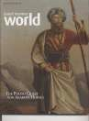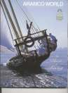

|  |  |  |  |  |  |  |
| --- | --- | --- | --- | --- | --- | --- |
| 5013 | Saudi Aramco World | Yes | Arndt, Robert (editor) | Aramco Services | 2000 | 37 pp. |
|  | January/February 2000 |  |  | Company |  |  |

|  |  |  |  |  |  |  |
| --- | --- | --- | --- | --- | --- | --- |
| 5014 | Saudi Aramco World | Yes | Arndt, Robert (editor) | Aramco Services | 2000 | 63 pp. |
|  | July/August 2000 |  |  | Company |  |  |

|  |  |  |  |  |  |  |
| --- | --- | --- | --- | --- | --- | --- |
| 5015 | Saudi Aramco World | Yes | Arndt, Robert (editor) | Aramco Services | 1999 | 53 pp. |
|  | May/June 1999 |  |  | Company |  |  |

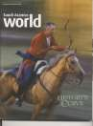

|  |  |  |  |  |  |  |
| --- | --- | --- | --- | --- | --- | --- |
| 5016 | Saudi Aramco World | Yes | Arndt, Robert (editor) | Aramco Services | 2003 | 49 pp. |
|  | September/October 2003 |  |  | Company |  |  |

5017 Saudi Aramco World November/December 2002

Yes Arndt, Robert (editor) Aramco Services

Company

2002 49 pp.

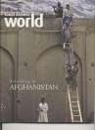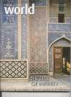

|  |  |  |  |  |  |  |
| --- | --- | --- | --- | --- | --- | --- |
| 5018 | Saudi Aramco World | Yes | Arndt, Robert (editor) | Aramco Services | 2009 | 49 pp. |
|  | September/October 2009 |  |  | Company |  |  |

|  |  |  |  |  |  |  |
| --- | --- | --- | --- | --- | --- | --- |
| 5020 | Saudi Aramco World | Yes | Arndt, Robert (editor) | Aramco Services | 2009 | 49 pp. |
|  | September/October 2009 |  |  | Company |  |  |

**VHS**

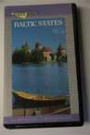1019 Baltic States Yes Video Visits 1992 54 min

1050 Great Decisions (2 of 2) Yes 1993

1061 I Poslednie Budut No Pervymi & Olit Kresta

1101 Navruz Festival 2000 (copy1)

Yes IAUNRC 2000 1 hr. 15

min

1102 Navruz Festival 2000

(copy 2)

Yes Navruz Student

Association

2000

1103 Navruz Festival 2000

(copy 3)

Yes Navruz Student

Association

2000

1104 Navruz Festival 2000

(copy 4)

Yes Navruz Student

Association

2000

1105 Navruz Festival 2001 Yes IAUNRC 2001 1 hr. 44 min

1108 Navruz Festival 2003

(copy 2)

Yes 2003

1118 Great Deserts of the World: Central Asia: the Desert of Tamerlane

Yes 16 min

1123 Programs, The No

1125 Puteshestvie k Tsentru No Zetsli v Lovushke

Tsentre Zemli

1127 Realms of the Russian Bear (The Red Deserts volume 3)

Yes BBC Television

Production

1992 60 min

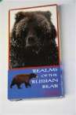1153 Turkestan Today Yes curriculum supplement

1994

1188 Bunyadkorlik No

1189 Chicago Folkloric Ensemble

No 2002

1190 Chimlidik No

(ЧИМИЛДИҚ)

1191 Constructing a Yurt No (VHS)

1208 БГ КВН и ТРК "Space" No Moscow TV 2000

1218 Where the Eagles Fly No "Portraits of Women in

Power"

1221 60 Minutes

Turkmenbashi

No 2004

1222 Aleksei Kolpakov Dance No 1

1223 Aleksei Kolpakov Dance No 2

1224 Test of Love No

1277 Navruz Festival 2005 Yes Navruz Student Association

2005

|  |  |  |  |  |  |  |
| --- | --- | --- | --- | --- | --- | --- |
| 1280 | Central Asia: Islamic | Yes | Pamela Kachurin and | Nat'l Resource Cntr | 2003 | 49 min; |
|  | Diversity from the |  | Mary Giles | for Russ, E. Euro & |  | 27:15 |
|  | Mongols to the Present |  |  | Cntrl Asia |  | min |

|  |  |  |  |  |  |  |
| --- | --- | --- | --- | --- | --- | --- |
| 1281 | Central Asia: Islamic | Yes | Pamela Kachurin and | Nat'l Resource Cntr | 2003 | 49 min; |
|  | Diversity from the |  | Mary Giles | for Russ, E. Euro & |  | 27:15 |
|  | Mongols to the Present |  |  | Cntrl Asia |  | min |

|  |  |  |  |  |  |  |
| --- | --- | --- | --- | --- | --- | --- |
| 1282 | Central Asia: Islamic | Yes | Pamela Kachurin and | Nat'l Resource Cntr | 2003 | 49 min; |
|  | Diversity from the |  | Mary Giles | for Russ, E. Euro & |  | 27:15 |
|  | Mongols to the Present |  |  | Cntrl Asia |  | min |

|  |  |  |  |  |  |  |
| --- | --- | --- | --- | --- | --- | --- |
| 1283 | Central Asia: Islamic | Yes | Pamela Kachurin and | Nat'l Resource Cntr | 2003 | 36:30 |
|  | Diversity from the |  | Mary Giles | for Russ, E. Euro & |  | min; 41 |
|  | Mongols to the Present |  |  | Cntrl Asia |  | min |

|  |  |  |  |  |  |  |
| --- | --- | --- | --- | --- | --- | --- |
| 1284 | Central Asia: Islamic | Yes | Pamela Kachurin and | Nat'l Resource Cntr | 2003 | 36:30 |
|  | Diversity from the |  | Mary Giles | for Russ, E. Euro & |  | min; 41 |
|  | Mongols to the Present |  |  | Cntrl Asia |  | min |

|  |  |  |  |  |  |  |
| --- | --- | --- | --- | --- | --- | --- |
| 1285 | Central Asia: Islamic | Yes | Pamela Kachurin and | Nat'l Resource Cntr | 2003 | 36:30 |
|  | Diversity from the |  | Mary Giles | for Russ, E. Euro & |  | min; 41 |
|  | Mongols to the Present |  |  | Cntrl Asia |  | min |

|  |  |  |  |  |  |  |
| --- | --- | --- | --- | --- | --- | --- |
| 1286 | Central Asia: Islamic | Yes | Pamela Kachurin and | Nat'l Resource Cntr | 2003 | 49 min; |
|  | Diversity from the |  | Mary Giles | for Russ, E. Euro & |  | 27:15 |
|  | Mongols to the Present |  |  | Cntrl Asia |  | min |

1287 Central Asia: Islamic Diversity from the Mongols to the Present

Yes Pamela Kachurin and Mary Giles

Nat'l Resource Cntr for Russ, E. Euro & Cntrl Asia

2003 48 min

1288 Central Asia: Islamic Diversity from the Mongols to the Present

Yes Pamela Kachurin and Mary Giles

Nat'l Resource Cntr for Russ, E. Euro & Cntrl Asia

2003 48 min

1289 Central Asia: Islamic Diversity from the Mongols to the Present

Yes Pamela Kachurin and Mary Giles

Nat'l Resource Cntr for Russ, E. Euro & Cntrl Asia

2003 48 min

1307 Islam: Empire of Faith Yes Gardner Films/PBS 2000 180 min

1310 Invisible Yes

4859 Navruz Student Association 3/23/02

Yes 2002

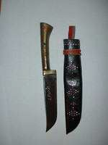

**Accessory**

2234 Scabbard knives No

2236 small black knife No

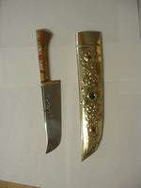2241 rosary No

2244 Knife No

2249 gourd naas-holder No

2250 Spoons No

2251 Wind Chime No

2252 Birds No

2258 tea cosy No

4478 Small wooden container No with carved design

4480 Decorative plate No

4482 Metal bowl No

4496 Central Asian Design No Rug Bag

4498 Bread Poker No

4502 Knife with Sheath No

4519 Felt Camel Pendant No

4520 Clay Camel Pendant No

4585 Power Transmission No Cable (From JVC Stereo)

4672 Bag No

4674 Bag No

4736 Tea Cosy No

4737 Hot Pad No

4738 Koran-stand No

4889 Haji Firuz Cookie cutter No



**VCD**

3023 State of the Environment Reports Sampler: Cookbook for State of the Environment Reporting on the Internet

No Phare/UNEP/GRI

D-Arendal

1998

3032 After the Fact Interactive No Tracing the Silk Roads

3046 Journeys Along the Silk Roads Cross-Cultural Encounter and Exchange

No Asia Society

3056 Silk Road Digital Journey No

3068 Summer 2003 Caligraphy Workshop and Silk Road Concert

No IAUNRC 2003

3081 From Silk to Oil: Cross- cultural Connections Along the Silk Roads

Yes China Institute China Institute 2005

3088 Silk Road Bayram - 7/24/05

Yes

4955 Silk Road Ensemble at University of Wisconsin - Madison, April 2, 2009

Yes Daneshgar, Shahyar, et al.

2009