Circulating Items Inventory - Tibet
Art/Photo
Producer/Publisher Year Made Length Image
English? Artist/Author
Category of Item Item # Item Name
2193 1991 Photographic No Calendar: “My Tibet”

2194 1998 Photographic No Calendar: “Tibetan
Voices”

4720 Wall Hanging No

Book/Bound

4141 Tibetan Family Yes Chicoine, Stephen Minneapolis: Lerner Publications
1998

4142 Cultures of the World: Tibet
Yes Levy, Patricia New York: Marshall Cavendish
1997

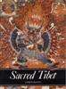
4143 Kundun: A biography of the family of the Dalai Lama
Yes Craig, Mary Washington, DC: Counterpoint
1997

4144 Sacred Tibet Yes Rawson, Philip London: Thames & Hudson
1991

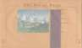
4145 Art of Exile: Paintings by Tibetan Children in India
Yes Lukas, Sarah & Kitty Leaken & Clare Harris
Museum of New Mexico Press Santa Fe

4146 Dalai Lama Yes Demi New York: Henry Holt & Co
1998

4147 Spirit of Tibet: Portrait of a Culture in Exile
Yes Wright, Allison Ithaca, NY: Snow
Lion Publications
1998

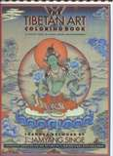
4148 Tibetan Art Coloring Book: A joyful path to right brain enlightenment
Yes Singe, J. Jamyang New York: Harry
Abrams
1999

4149 Tibet Yes Choedon, Yeshi and Dawa Norbu
Tiger Books International, London

4150 Tibet Through the Red Box
Yes Sis, Peter New York: Frances Foster Books
1998

4486 | Tangkas: Buddhist | Yes | American Museum of | Pomegranate | 1998 | 30pp
 | Paintings from Tibet |  | Natural History
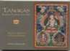

4568 A Tibetan Family Yes Stephen Chicoine Lener Publications 1998 56pp
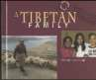

4569 Cultures of the World: Tibet

4570 The Dalai Lama A Biography of the Tibetan Spiritual Leader
Yes Patricia Levy Marshall Cavendish 1997 128pp

Yes Demi Henry Holt 1998 32pp

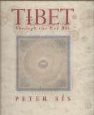

4571 | The Spirit of Tibet: | Yes | Alison Wright | Snow Lion | 1998 | 192pp
 | Portrait of a Culture |  |  | Publications
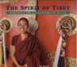

4572 | Tibet through the Red | Yes | Peter Sis | Farrar Straus | 1998 | 64pp
 | Box |  |  | Giroux

Cloth/Fabric

4668 Tibetan fabric No

DVD

1016 Journey into Buddhism: Vajra Sky Over Tibet
Yes Bush, John WGBH Boston 2006 89 min

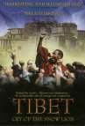

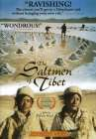
3103 The Saltmen of Tibet Yes Ulrike Koch Zeitgeist Video 1998 109 min.

3104 | Tibet: Cry of the Snow | Yes | Tom Piozet | Earthworks Films, | 2003 | 104 min.
 | Lion |  |  | Inc

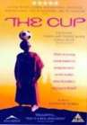
3109 The Cup Yes Khyentse Norbu Palm Pictures 2000 93 min.

3110 Mountain Patrol Kekexili Yes Lu Chuan National
Geographic World Films
2006 85 min.

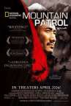
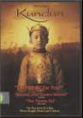
4967 Kundun Yes Scorsese, Martin Touchstone Pictures 1998 135 min.

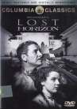
4968 Lost Horizon
Yes Capra, Frank
Columbia Pictures 1937
134 min.
Map

4534 Road Map of Tibet Autonomous Region
Yes Gizi Map

4535 Geographical Map of Tibet Autonomous Region
Yes Gizi Map

4623 map of Tibet No Sinomaps Press 2007

1045 General Assembly of Tibetans in Exile
VHS

Yes

1046 General Assembly of Tibetans in Exile

1055 His Holiness the Dalai Lama Visits Europe 1986 (ENG)
Yes

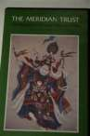
Yes

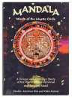
1056 His Holiness the Dalai Lama Visits Europe 1986 (TIB)
No 1986

1092 Mandala: World of the mystic circle

Yes Produced by
Martin McGee and Cathy Steffan

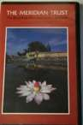
1998 55 min

1132 Secret Heart of Asia: Inside Tibet
Yes Mystic Fire Video 1998 60 min

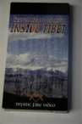
Accessory
4499 Vajra No

4504 Om Mani Padme Hum No Rock

4667 Prayer wheel No 2007

VCD

3055 Sacred Tibetan Chant No The Monks of Sherab
Ling Monastery
Naxos World 2003

