Circulating Items Inventory - Turkey
Art/Photo
Producer/Publisher Year Made Length Image
English? Artist/Author
Category of Item Item # Item Name
2195 Hande's slide picture set No

4595 water_5.jpg No Jackson Kellogg

4596 water_6.jpg No Greg Burris

4597 water_7.jpg No Greg Burris

4598 water_8.jpg No Greg Burris

4599 water_9.jpg No Donny Smith

4600 water_10.jpg No Donny Smith

4601 water_11.jpg No Donny Smith

4602 water_12.jpg No Greg Burris

4603 water_13.jpg No Donny Smith

Book/Bound
4087 Playful Cloud No Birden, Nural Kok Yayincilik 1997

4151 Antalya and the Mediterranean Region

Yes Istanbul: Ministry
of Tourism

2002

4152 What Am I Yes Gurman, Aysel and Korman Huban

4153 Grandpa and I Yes Sakpinar, Leyla

4154 At Home Yes

4155 Missing Briefcase: Turkish as a Foreign Language Elementary Level
Yes Taylan, Eser E. and Didar Akar

4156 Lemon Girl Yes

4157 Playful Cloud Yes

4158 Let's Listen to Turkish Yes Ozsoy, A. Sumru and
Meltem Kelepir

4159 Turkey: the Travel Directory
Yes New York: Turkish
Tourist Offices

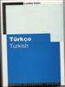
4160 Turkish No Ozsoy, A. Sumru Her Hakki Saklidir 1999

4161 Turkish Cuisine No

4162 Turkish for Foreigners Workbook (Vol. 1)
No Serin, Muammer and Eser E. Taylan

4163 Turkish Games for Health and Recreation
Yes Walker, Barbara K. and Warren S. Walker
Texas 1983

4313 Lemon Girl No Cikrikci, Semra Kok Yayincilik 1995

4314 My Grandfather & I No Sakpinar, Leyla Mavibulut 1995

4315 Who am I No Gurmen, Aysel Ucanbalik Yayinlari 1997

4316 At home No Dizisi, Cevremiz Yayin Pazarlama 1990

4321 Red Button that Fell No Ogmel, Umit Ankara: Kok
Yayincilik
1998

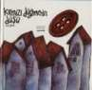
4324 Turkish Cuisine Yes Sancar, Fahriye Istanbul 2002

4325 Yatching Yes Ministry of Tourism Ankara

4326 Black Sea Region Yes Ministry of Tourism Ankara 2001

4327 Turkey Yes Ministry of Tourism Ankara or Istanbul 2004

4395 Turkey: A
Comprehensive Grammar

Yes Göksel, Aslı & Celia Kerslake

London: Routledge 2005 580 pp.

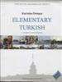
4396 Elementary Turkish: A Complete Course for Beginners
Cassette
Yes Öztopçu, Kurtuluş Santa Monica 2006 750 pp.

2499 Koranic Recitation No (Turkish Hafiz)

2500 Kirim Turk Muzigi No

CD

3052 Meeting Turkish
Students copy 2
Yes

3070 Beginning Turkish Yes Critical Language Series

3083 Kirim Turk Muzigi No Akbikey
1999

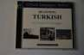

3087 Turkish Music on Piano No Hakan Toker 2005

4360 Dance of Fire No Aziza Mustafa Zadeh

4457 Teach Yourself Turkish No David Pollard,
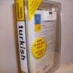
Asuman Celen Pollard
Cloth/Fabric
Teach Yourself 2003 270 pp.
and 2 CDs

4647 Miniature Turkish Rug No 2007 5 x 7 inches

4648 Miniature Turkish Rug No 2007 8 x 10 inches

Clothing
4642 Turkish slippers No 2007

4646 Belly dancing wear No 2007

DVD
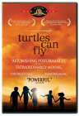
1020 Turtles Can Fly Yes Ghobadi, Bahman IFC Films 2005 97 min

1271 Her Sey Guzel Olacak (Everything is Gonna be Great)
Yes Directed by Omer
Vargi
1998 105 min

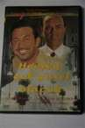
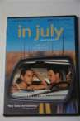
1272 In July Yes Akin, Fatih Bavaria Film 2000 96 min

1273 Everything about Mustafa
Yes Irmak, Cagan ANS International 2004 116 min.

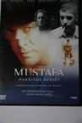
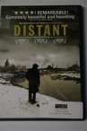
1274 Distant Yes Ceylan, Nuri Bilge 2002 105 min.

1292 Sevgili Murat Yes NMELRC, Fulbright-Hays GPA, AATT, Bilgi
Univ
2004

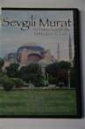
1301 Hidden Turkey Yes PBS Home Video 2005 60 min
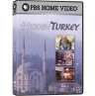

3080 Turkey Yes Turkish Ministry of Culture & Tourism
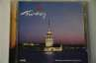

3093 | Turkey: Travel Guide | Yes | Globe Trekker series | Escapi New Media | 2004 | 60 min.
 | DVD |  |  | Studios

4922 Takva: A Man's Fear of God
Yes Kiziltan, Ozer Yeni Sinemacilar 2006 96 min.

4965 Times and Winds Yes Erdem, Reha Atlantik Film
Yapim, Ltd.
2006 111 min.

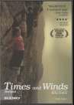
5019 PBS Home Video: Hidden Turkey
Yes Thompson, Jan PBS Home Video 2005 60 min.

5026 | Globe Trekker City | Yes | Bingham, Estelle | Escapi/Globe | 2004 | 60 min.
 | Guide: Istanbul |  |  | Trekker

Hat

4643 Turkish fez No 2007

4644 Turkish hat No 2007

4645 Turkish woman's hat No 2007

Map
4553 Map of Turkey No Gurbuz 1998

4555 Map of Europe No Typah

Model
4574 Turkish Polyglot Doll No 2000

4649 Turkish Dolls - man, woman, and girl
No 2007

4650 Turkish Dolls - man and woman; woman in pink headscarf, man with red fez, yellow trim

No 2007

4651 Turkish Dolls - man and woman; woman in green headscarf, man with red fez
No 2007

Periodical

4952 ARIT Newsletter, No. 46,
Fall 2008
Yes American Research
Institute in Turkey
2008 12 pp.

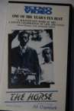
VHS

1058 The Horse Yes Directed by Ali Ozgenturk
1983 116 min

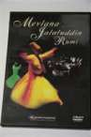
1119 Mevlana Jalaluddin Rumi No Niagara Foundation 2004

1170 The Wall Yes Directed by Yilmaz Guney
1983 117 min

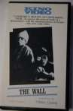
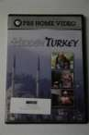
1302 Hidden Turkey Yes PBS Home Video 2005 60 min

Accessory
4589 Bag/Purse No

4590 Bag/Purse No

VCD

1270 Yer Demir Gok Bakir (VCD)
Yes Directed by Omer
Zulfu Livanelli
1987 104 min

1275 Bus Yes Tunç Okan Tunç Okan 1974 90 min.

1276 Nasreddin Hoca Yes Animation Ekrem Bektas

3051 Meeting Turkish No Students copy 1

3082 Koranic Recitation No (Turkish Hafiz)

