Circulating Items Inventory - Turkmenistan
Art/Photo
Producer/Publisher Year Made Length Image
English? Artist/Author
Category of Item Item # Item Name
2013 Wall-hanging No

2014 Talisman No

2196 1994 picture calendar No

2197 Ashkhabad postcard No

2198 Turkmen card “Garassyz No Bayramynyz Mubarek
Bolsun!”

2199 Postcards from Ashkabad No

2219 Turkmen 60th No Anniversary

2498 Turkmenistan: Ancient Merv
No Magadov, H.

4507 Turkmen Woman No Serving Nan Figurine

4812 Adamova Yevgeniya Mixailovna
No Teze Aydym Turkmenistan Medeniet Fondy

Book/Bound
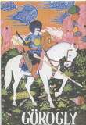
2025 Storybook No

2026 Storybook No

2027 Storybook No

2168 Turkmenistan No

2171 Chardjou No

4164 Görogly (copy 1) No

4165 Görogly (copy 2) No Nepesova, R.G. (ed.) Turkmen State Publishing Service: Ashgabat

4166 Görogly No Nepesova, R.G. (ed.) Turkmen State Publishing Service: Ashgabat
2002

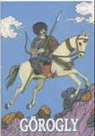
2002

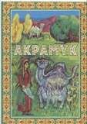
4167 Address of Saparmurat Turkmenbashi to the Peoples of Turkmenistan
Yes Ankara: Nurol
Printing Co.

4168 Akpamyk No Ismayilowa, W. (ed.) Ashgabat: Turkmen State Publishing House
2001

4169 Ashkhabad [Capitals of the Union Republics]
Yes Кленова, Е. Moskva: Izdatel'stva "Progress"
1976

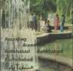
4170 Chardjou No Бектасов, М.Ж.

4171 Chardjou Yes USSR: Intourist

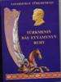
4175 Book No Tϋrkmenbasy, Saparmurat
Ashgabat: Turkmen National Publishing House
2003

4177 Korpe Dogan No Ashgabat 1999

4178 Repetek Sandy Desert Biospheric Reserve

Yes Foregin Tourism Administration for the TSSR Counci

Ashkhabad 1982

4179 Ruhnama No Turkmenbashi, Sapamyrat

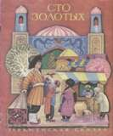
4180 100 Gold Coins No Annakurbanova, V. Magafir: Ashkhabad
1989

4181 Ten Years of Prosperity: An Economic Program
Yes Turkmenbashi, Sapamurat
Baski: Ankara 1994

4182 Nature of Turkmenistan No Khakiev, Akmirat Turkmenistan
Neshiriati: Ashgabat

1978

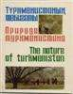
4184 Turkmen Carpets No Karadjaeva, G. Turkmenhaly 1995

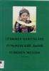

4186 Turkmen Melons: Color Atlas (2nd Edition),

No Allamyrat, Esenow & Karow Durdy

Ashgabat: Rukh 1999

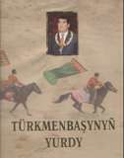
4188 Land of Turkmenbashi No Hramow, W. Experimental
Printhouse

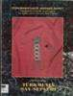

4189 Turkmen-English
Dictionary (copy 1)

4190 Turkmen-English
Dictionary (copy 2)

4191 Turkmenin Shai-Seplen (Turkmen Jewelry)

No Frank, Allen J, & Touch-Werner, Jeren

No Frank, Allen J, & Touch-Werner, Jeren

No

Kensington, MD: Dunwoody Press

Kensington, MD: Dunwoody Press

1999

1999

4192 Turkmenistan No Nurklychev, N & Shikhmuradov, B (ed.s)
Novosti: Moscow

4193 Red Data Book of Turkmenistan: Invertebrate & Vertebrate Animals

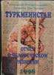
4194 Turkmenistan: Human Development Report 1997
No Atamuradov, Kh. I. Ashgabat 1999

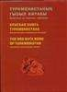
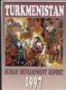
Yes UNDP Ankara: UNDP 1997

4195 Turkmenistan: Human Development Report 1998
No Bairamov, D. (coordinator)
Ajans-Turk: Ankara 1998

4197 Tϋrkmenistan: Ancient Oriental Kingdom in the Old Delta of the Murghab River
No Marguş, Wiktor Sariandi
Ashgabat, Tϋrkmendöwlethab arlary
2002

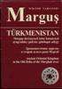
4319 Oglanzhik ve Iagshilik No Rakhmanov, Azat Magarif: Ashgabat 1997

4374 Turkmen Language No Course

4375 Turkmen Language No Course

4384 Turkmen Language No Course

4385 Turkmen Language No Course

4386 Turkmen Language No Course

4387 Turkmen Language No Course

4388 Turkmen Language No Course

4389 Turkmen Language No Course

4390 Turkmen Language No Course

4391 Turkmen Language No Course

4403 Ruhnama, Ikinji Kitap No Saparmyrat Türkmenbaşy

4404 Ruhnama, Second Book Yes Saparmyrat
Türkmenbaşy

4405 Mähribanlarym No Saparmyrat Türkmenbaşy

4406 Mähribanlarym No Saparmyrat Türkmenbaşy
Türkmen döwlet neşirýat gullugy

Turkmen State Publication Services

Türkmen döwlet neşirýat gullugy

Türkmen döwlet neşirýat gullugy
2004 464 pp.

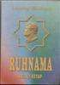
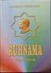
2004 440 pp.

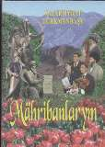
2005 360 pp.

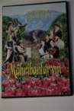
2005 1 CD

4407 Ruhnama, Ikinji Kitap No Saparmyrat Türkmenbaşy
Türkmen döwlet neşirýat gullugy
2004 2 CD

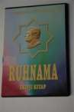
4423 Türkmen milli naharlary No N. Yusupov, Dj.
Yusupova
GKPT 2005 60 pp.

4613 | Ruhnama Volume 1 | Yes | Saparmurat | Guzel Sanatlar | 2002 | 406
 |  |  | Turkmenbashi | Matbaasi A.S. |  | pages

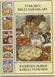
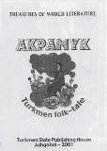
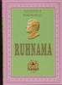
4741 Treasures of World Literature: Akpamyk, Turkmen folk-tale
Yes Turkmen State
Publishing House, Ashgabat
2001 19p

4758 | Turkmen Language | Yes | Tyson, David and | Peace Corps | 1993 | 178 pp.
 | Manual |  | Clark, Larry | Turkmenistan

4759 Akpamyk [White fluff] Yes Nepesowa, R Ruh, Ashkhabat 2001 29 pp.

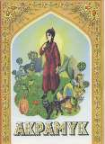
Cassette
2493 Turkmen Language No Cassettes

CD
3017 Instrumental Music of No the Turkmen and Uzbeks

4380 Turkmen Language No Course

Cloth/Fabric
2225 small rug No
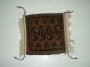

2226 small rug No

2253 Small Red rug No

4719 Small Red Rug No

5039 Two sided cloth sample with rug pattern
No donated by John McCall
2009

Clothing
2057 T-shirts (2) No

2058 Man's robe No

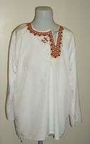
2059 Man's shirt
No
4365 Scarf No

4713 Men's scarf/sash No

4715 Men's scarf/sash No

4716 Men's scarf/sash No

4718 Men's robe No

5038 Small Turkmen bag No donated by John McCall

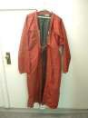

2009

5040 Turkmen socks (pair) No donated by John McCall
2009

5041 Turkmen socks (pair) No donated by John McCall
2009

5042 Medium Turkmen bag No donated by John
McCall
2009

5043 Medium Turkmen bag No donated by John
McCall
2009

5044 Turkmen socks No donated by John McCall
2009

5045 Small Turkmen bag No donated by John McCall
2009

5046 Large Turkmen bag No donated by John McCall
2009

5048 Small Turkmen bag No donated by John McCall
2009

DVD

1115 On the Trail of the Caravans
Yes

3122 Turkmen Documentary Films (Soviet and Independent Epochs)
Yes Abikeeva, Gulnara Open Society
Institute
2008

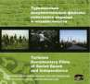
4416 Daughter in Law Yes Hodzhakuu Naruev Turkmenfilm 1972 75 min.

4419 Little Angel, Make Me Happy
Yes Usman Saparov Turkmenian Center
of Children's Films, TV Nisa
1992 77 min.

4723 Daughter in Law Yes Hodzhakuu Naruev Turkmenfilm 1972 75 min.

4724 Little Angel, Make Me Happy
Yes Usman Saparov Turkmenian Center
of Children's Films, TV Nisa
1992 77 min.

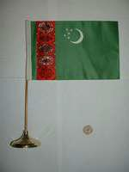

Flag
2081 large flag No

2082 small (hand-held) flag No

2083 Pink banner No

Hat

2094 Man's hat No
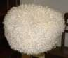

2095 Skullcap No
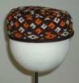

2096 Woman's hat No

2113 Skullcap No
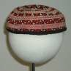

4608 Turkmen Hat (White & Wooly)
No 2007

Map
2124 industries No

4809 No Konichieskaya ravnopromiezhutoc hnaya kartografiche

Misc.
2156 13 bills No

2157 9 coins No

2231 Turkmen stamps No

4583 Horses of Turkmenistan No Chary Shirliyev 2006

4584 Dogs of Turkmenistan No Chary Shirliyev 2006

Model

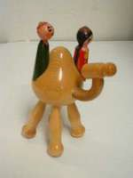
2139 wooden camel No

2140 wooden Turkmen female No

2141 wooden woman No

2142 Small wooden statue No

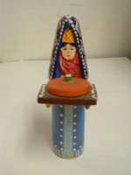
2143 yurt No

2144 sitting camel No
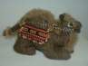

2145 wooden woman No

2146 woman No

2508 Female Turkmen No Figurine

2509 Small Male Turkmen No Figurine

4505 Turkmen Woman No Weaving Rug

4506 Turkmen Woman No Figurine

4511 Turkmen Watermelon No Seller Figurine

4513 Small Turkmen Female No Figurine

4514 Miniature Turkmen Yurt No

4516 Turkmens Riding Camel No Figurine

Periodical

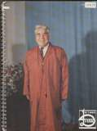
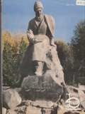
4172 Diyar No 1994

4173 Diyar No 1994

4174 Diyar No 1999

4176 Gurbansoltan Eje No 2001

4183 Tourism and
Development No. 1, 2'
2000
Yes Baidjaev, A (ed.) Ashkhabad: "Press-
Voyage"
2000

4187 Turkmen Newpapers No

4330 Diyar No Mamijikow, D. Ashgabat 2002

VHS
1026 Turkmen News No

1112 Nowruz: Turkmenistan No News Progarms & TV

1212 Turkmen TV Programs No

4465 The Daughter-in-Law No Khoojakuli Narliev 81m

4861 Turkmen TV Programs No 5hrs

Accessory

2001 Pins No

2002 Pins No

2004 Handbag No

2015 Bread decorator No

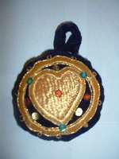
2254 Pillow Cover No

2255 Hot pad No

2256 patch No

2259 coin purse No

2261 bread decorator No

4495 Turkmen Design Bag No

4497 Turkmen Bread Poker No

4588 Shoulder Bag No

VCD

4377 Turkmen Language No Course

4378 Turkmen Language No Course

4379 Turkmen Language No Course

4381 Turkmen Language No Course

4382 Turkmen Language No Course

4383 Turkmen Language No Course

4411 Döwlet ýetimow Yes Döwlet ýetimow Turkmen Halk
Aýdymlary

4430 Best of Turkmen Clips Collection
No various artists Gamma Records 2000 1 VCD

