Circulating Items Inventory - Uzbekistan
Art/Photo
Producer/Publisher Year Made Length Image
English? Artist/Author
Category of Item Item # Item Name
1031 Great Silk Road plate No 2009
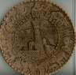

1034 Uzbekistan wall-hanging No 2009
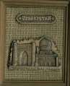

2016 Watercolor No

2174 black and white photo of No an old woman making a
blanket

2200 Long Photographic No Calendar “Bukhara
2500”

2201 ХИВА 16 ОТКРЬІТОК No
16-card postcard set of Khiva

2202 old postcards from No Bukhara

2203 postcard set of No Samarkand

2204 Tashkent postcards No

2220 madrassa in Samarkand No

2221 minoret in Khiva No

2222 Uzbek 50th Anniversary No

2245 Tile No

2246 Bukhara transparencies No

2248 Photographs of Bukhara No

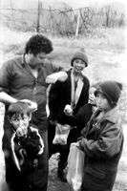
2269 Children selling qurut (dried, balls of yogurt) [companion to 2462]
No Zilola Saidova Framed

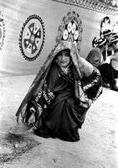
2270 Shepherds No Zilola Saidova Framed

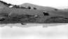

2271 Shepherds No Zilola Saidova Framed

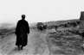

2272 Tajik dancer No Zilola Saidova Framed

2273 Three faiths No Shavkat Boltaev Framed

2274 Performing "Lyazgi" dance

2275 Changovuz - mouth instrument player

2276 Grandmother and granddaughter. Tuda Village

2277 Bakhshi (epic poem teller)
No Zilola Saidova Framed

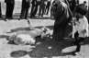

No Shavkat Boltaev Framed

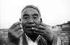

No Zilola Saidova Framed

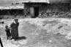

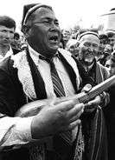
No Shavkat Boltaev Framed

2278 Grandmother and granddaughter. Tuda
No Zilola Saidova Framed

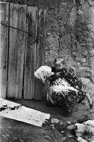
2279 Mountains of Boysun No Zilola Saidova Framed

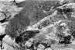

2280 Surkhan Darya folkdance No Shavkat Boltaev Framed

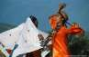

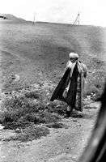
2281 Old man along the roads of Boysun
No Zilola Saidova Framed

2282 Sayyora Qoziyeva & men's folkdance troupe

2283 Old man and stones. Hulod village, Boysun

2284 Karaqalpak man & qobuz (string instrument)

2285 Surnay - national wind instrument
No Shavkat Boltaev Framed

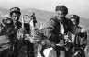

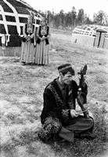
No Zilola Saidova Framed

No Shavkat Boltaev Framed

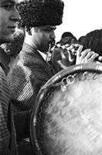
No Zilola Saidova Framed

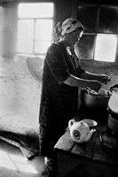
2286 In the kitchen No Zilola Saidova Framed

2287 Woman washing dishes.
Tuda village, Boysun

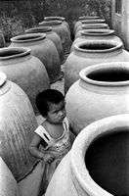
2288 Making clay ovens. Uba village
No Zilola Saidova Framed

No Shavkat Boltaev Framed

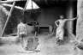

2289 Clay ovens of Uba Village No Shavkat Boltaev Framed

2290 To local secondary school No Zilola Saidova Framed

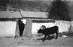

2291 Bread made in Avlod village, Boysun

2292 Orchard. Tuda village, Boysun

2293 At a brick producing plant (series)
No Shavkat Boltaev Framed

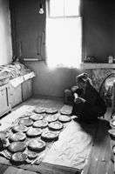
No Zilola Saidova Framed

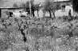

No Shavkat Boltaev Framed

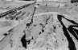

2294 At a brick producing plant (series)

2295 World of childhood Avlod village, Boysun

2296 Woman selling sunflower seeds Boysun

2297 At a brick producing plant (series)
No Shavkat Boltaev Framed

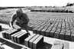

No Zilola Saidova Framed

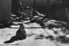

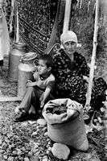
No Zilola Saidova Framed

No Shavkat Boltaev Framed

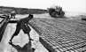

2298 Man in an open-air kitchen

2299 At a brick producing plant (series)

2300 Future masters
Gijduvan, Bukhara region

2301 Child and woman breaking dried clay fragments
No Zilola Saidova Framed

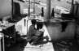

No Shavkat Boltaev Framed
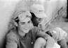

No Zilola Saidova Framed

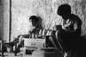

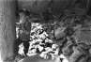
No Zilola Saidova Framed

2302 Old man at Lyabi Hauz No Shavkat Boltaev Framed

2303 Women coming from cotton refinery

2304 Bukharan folk music troop at rehersal
No Shavkat Boltaev Framed

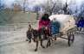

No Zilola Saidova Framed

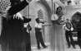

2305 Old Turkman man No Shavkat Boltaev Framed

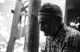

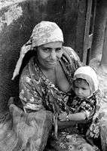
2306 Woman after sale No Zilola Saidova Framed

2307 Small sewing business No Shavkat Boltaev Framed

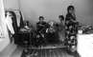

2308 Man smoking nos No Zilola Saidova Framed

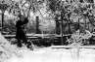

2309 Gypsy woman in street No Shavkat Boltaev Framed

2310 Women at Bahauddin Nagshband shrine

2311 Boys during Qurban Hayit (the holiday of sacrifice)
No Zilola Saidova Framed

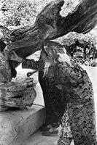
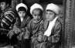
No Shavkat Boltaev Framed

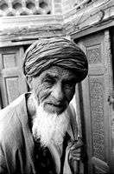

2312 Girls before the parade No Zilola Saidova Framed

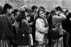

2313 Old Gypsy man No Shavkat Boltaev Framed

2314 Chatting at the Lyabi Hauz (Lyabi pool)
No Zilola Saidova Framed

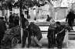

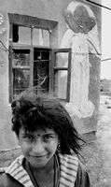
2315 Children in the Gypsies' neighborhood (series)
No Shavkat Boltaev
Framed
2316 At the bazaar No Zilola Saidova Framed

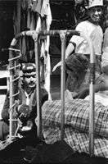
2317 Gypsy man playing with quail
No Shavkat Boltaev Framed

2318 Old Gypsy woman & pigeon
No Shavkat Boltaev Framed

2319 Children in the Gypsies' neighborhood (series)

2320 Bukharan folk music troop at rehearsal

2321 Children in the Gypsies' neighborhood (series)
No Shavkat Boltaev Framed
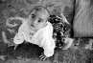

No Zilola Saidova Framed

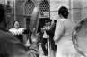

No Shavkat Boltaev Framed

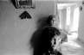

2322 Young visitor of Naqshband shrine

2323 Children in the Gypsies' neighborhood (series)

2324 Gypsy children in the Gypsies' neighborhood

2325 Street scene (At a repair shop)
No Zilola Saidova Framed

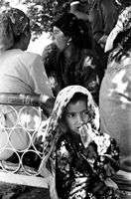
No Shavkat Boltaev Framed

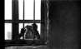

No Shavkat Boltaev Framed
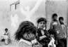

No Zilola Saidova Framed

2326 Bigamy in a Bukharan Gyspy's family

2327 Rabbi testing meat (Kosher)
No Shavkat Boltaev Framed

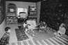

No Shavkat Boltaev Framed

2328 At an Orthodox cemetary No Zilola Saidova Framed

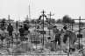

2329 Bar Mitzvah at a Bukharan synagogue
No Shavkat Boltaev Framed

2330 My Grandmother No Zilola Saidova Framed

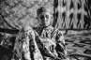

2331 Making bread in Gypsies' neighborhood

2332 Old woman selling nos (local tobacco)
No Shavkat Boltaev Framed

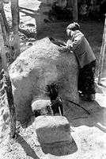
No Zilola Saidova Framed

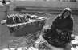

2333 At a Bukharan synagogue No Shavkat Boltaev Framed

2334 Potato harvest No Zilola Saidova Framed

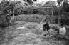

2335 At a Bukharan synagogue on Yom Kippur
No Shavkat Boltaev Framed

2336 Woman baking bread Uba village, Vobkent district

2337 Bibichakhona (women's room in the synagogue)
No Zilola Saidova Framed
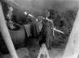

No Shavkat Boltaev Framed

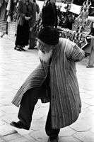
2338 Children chatting No Zilola Saidova Framed

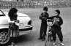

2339 At a Bukharan synagogue No Shavkat Boltaev Framed

2340 Old Bukharan man No Zilola Saidova Framed

2341 At a Bukharan synagogue No Shavkat Boltaev Framed

2342 Preparing for lunch No Zilola Saidova Framed

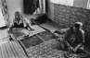

2343 Old Jewish woman No Shavkat Boltaev Framed

2344 Woman tasting food No Zilola Saidova Framed

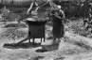

2345 Tombstone at Bukharan Jewish cemetary
No Shavkat Boltaev Framed

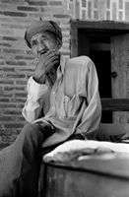
2346 Old man at Chor Bakr necropolis
No Zilola Saidova
Framed
2347 Rabbi slaughtering cow No Shavkat Boltaev Framed

2348 Hairdressers' contest No Zilola Saidova Framed

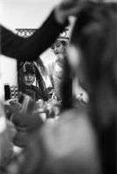
2349 Carrying Sephardic Torah at the synagogue
No Shavkat Boltaev Framed

2350 At Bukharan synagogue No Shavkat Boltaev Framed

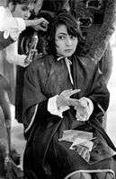
2351 Hairdresser's contest
No Zilola Saidova
Framed

2352 Bukharan Jewish funeral ceremony
No Shavkat Boltaev Framed

2353 Elizaveta Nekrosova No Zilola Saidova Framed

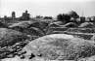

2354 Bukharan Jewish funeral ceremony
No Shavkat Boltaev Framed

2355 Elizaveta Nekrosova No Zilola Saidova Framed

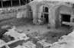

2356 Bukharan Jewish funeral ceremony
No Shavkat Boltaev Framed

2357 Bukharan Jewish funeral ceremony
No Shavkat Boltaev Framed

2358 Elizaveta Nekrosova No Zilola Saidova Framed

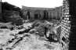

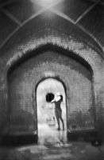
2359 Women's bathhouse
No Zilola Saidova
Framed

2360 Bukharan Jewish funeral ceremony
No Shavkat Boltaev Framed

2361 Bukharan Jewish funeral ceremony
No Shavkat Boltaev Framed

2362 Bukharan Jewish funeral ceremony
No Shavkat Boltaev Framed

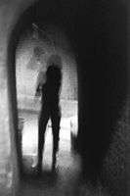
2363 Women's bathhouse No Zilola Saidova Framed

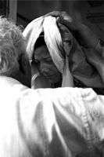
2364 Abra chinon (ceremony for shaping the bride's eyebrows)
No Shavkat Boltaev Framed

2365 Bride's father saying good-bye
No Zilola Saidova Framed

2366 Practicing "alas" (mystical ritual)
No Shavkat Boltaev Framed

2367 Bride's mother saying good-bye
No Zilola Saidova Framed

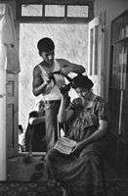
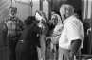

2368 Making matzo balls No Shavkat Boltaev Framed

2369 Dying hair No Zilola Saidova Framed

2370 Sagyora Qoziyeva and Boysun men's folk music troop performing a folk song

2371 Boysun folklore festival participant
No Shavkat Boltaev Framed

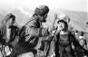

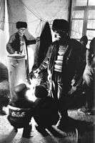
No Shavkat Boltaev Framed

2372 Making tea in samovar No Zilola Saidova Framed

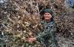
2373 Woman holding guzapoya (dried bushels of cotton)
No Shavkat Boltaev Framed

2374 Bride getting ready for wedding party

2375 Churning milk to get sour cream

2376 Bride & groom preparing for wedding

2377 Woman making tukhumbarak (a traditional food made from eggs)
No Zilola Saidova Framed

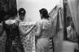

No Shavkat Boltaev Framed

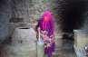

No Zilola Saidova Framed

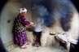
No Shavkat Boltaev Framed

2378 Women going to the bride's house
No Zilola Saidova Framed

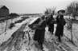

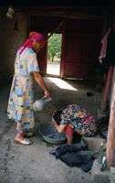
2379 Washing hair
No Shavkat Boltaev
Framed
2380 Woman and cradle No Shavkat Boltaev Framed

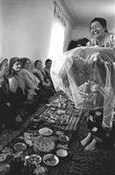
2381 Kelinbiyori (ceremony dedicated to bride)
No Zilola Saidova Framed

2382 Bride changing her modern hairstyle
No Zilola Saidova Framed

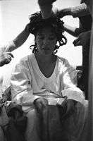
2383 Local Mill, Osiyo No Shavkat Boltaev Framed

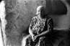

2384 Local Mill, Osiyo No Shavkat Boltaev Framed

2385 Local Mill, Osiyo No Shavkat Boltaev Framed

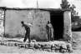

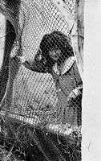
2386 Gypsy girl
No Zilola Saidova
Framed

2387 Bread making in Boysun, Tuda village
No Shavkat Boltaev Framed

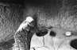

2388 Young gypsy woman No Zilola Saidova Framed

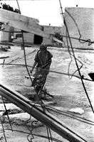
2389 At the nonvoykhona (bakery)
No Shavkat Boltaev Framed

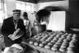

2390 Gypsy girls in old streets of Bukhara

2391 Remembrance Qaraqul district
No Zilola Saidova Framed

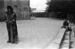

No Shavkat Boltaev Framed

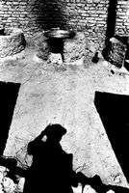
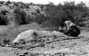

2392 Gypsy girls No Zilola Saidova Framed

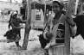

2393 Hungry photographer No Shavkat Boltaev Framed

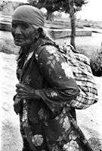
2394 Old gypsy woman No Zilola Saidova Framed

2395 Bukharan Turkmen family
No Shavkat Boltaev Framed

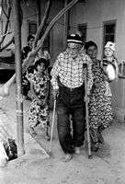
2396 Fortune telling No Zilola Saidova Framed

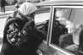

2397 Gypsy man fond of pigeons
No Shavkat Boltaev Framed

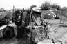

2398 Gypsy mother and her children

2399 Children in gypsies' neighborhood (series)

2400 Gypsy mother at Bolo Hauz Mosque

2401 A Gypsy child sleeping in an alvonch (type of cradle)
No Zilola Saidova Framed

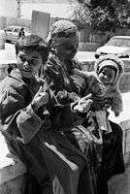
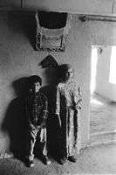
No Shavkat Boltaev Framed

No Zilola Saidova Framed

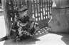

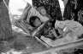
No Shavkat Boltaev Framed

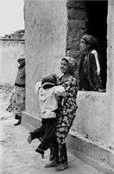
2402 Gypsy girls No Zilola Saidova Framed

2403 Old gypsy woman No Shavkat Boltaev Framed

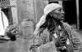

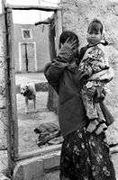
2404 Gypsy girl and her sister
No Zilola Saidova
Framed

2405 Boy selling chukori - local plant
No Shavkat Boltaev Framed

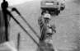

2406 Gypsy girl playing with her sheep

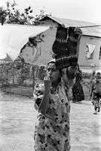
2407 Girl selling yogurt made of goat/sheep milk
No Zilola Saidova Framed

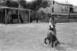

No Shavkat Boltaev Framed

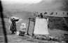

2408 Gypsy girl doing laundry No Zilola Saidova Framed

2409 Village landscape Boysun No Shavkat Boltaev Framed

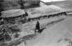

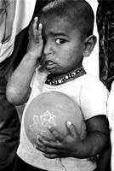
2410 Grandparents and granddaughter
No Shavkat Boltaev Framed

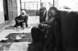

2411 Shahzod, a Gypsy boy No Zilola Saidova Framed

2412 Young couple in Boysun No Shavkat Boltaev Framed

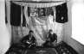

2413 Bride in Boysun No Shavkat Boltaev Framed

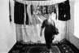

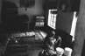

2415 Potter No Shavkat Boltaev Framed

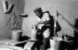

2416 Gypsy girl doing laundry No Zilola Saidova Framed

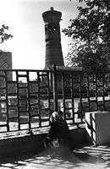
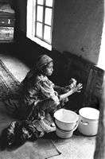
2417 Woman visiting the Shrine of Abdulkholiq Gijduvoni
No Shavkat Boltaev Framed

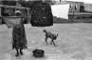

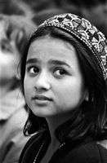
2419 Bukharan girl
No Shavkat Boltaev
Framed

2420 Mother and son at Omonkhona resort

2421 Gavorabandon (a cradle ceremony)
No Zilola Saidova Framed

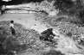

No Shavkat Boltaev Framed

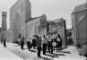

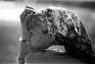

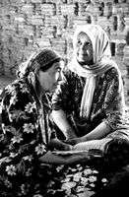
2423 Young woman selling spices at Omonkhona, Boysun
2424 Caretakers at Ismail Samani Mausoleum
No Shavkat Boltaev
Framed

2425 Old man at Omonkhona resort Boysun
No Zilola Saidova Framed

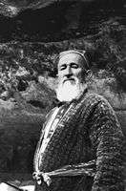
No Zilola Saidova Framed

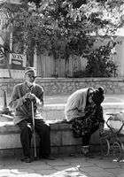

2427 Woman with a kurpacha (mattress) Boysun.

2428 Sallabandon (women's ceremony)
No Zilola Saidova Framed

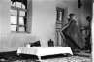

No Shavkat Boltaev Framed

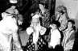

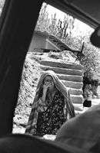
2429 Tajik woman Avlod village, Boysun
No Zilola Saidova
Framed

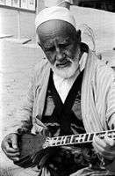
2431 Veiled woman No Shavkat Boltaev Framed

2432 92 year old woman Tuda village, Boysun

2433 Old man at Chor Bakr necropolis
No Zilola Saidova Framed

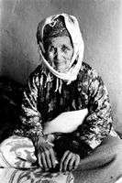
No Shavkat Boltaev Framed

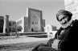

behind the scenes
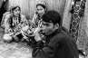

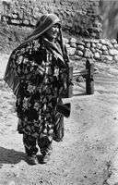
2435 A Tajik woman Sarosiyo village, Boysun.
No Zilola Saidova
Framed

2436 Old woman visiting Bukhara
No Shavkat Boltaev Framed

2437 Old woman visiting Bukhara
No Shavkat Boltaev Framed

2439 Man in cotton field No Zilola Saidova Framed

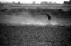

2440 "The Keeper" Movie Series

2441 "The Keeper" Movie Series
Yes Shavkat Boltaev

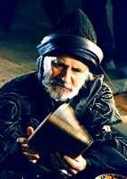
Yes Shavkat Boltaev

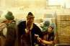

2442 "The Keeper" Movie Series

2443 "The Keeper" Movie Series

2444 "The Keeper" Movie Series

2445 "The Keeper" Movie Series
Yes Shavkat Boltaev
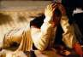

Yes Shavkat Boltaev
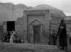

Yes Shavkat Boltaev

Yes Shavkat Boltaev

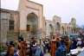

2446 "The Keeper" Movie Series

2447 Children watching performances during folk festival
Yes Shavkat Boltaev
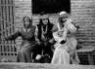

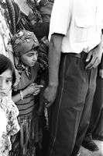
Yes Zilola Saidova

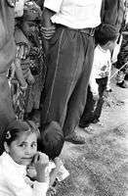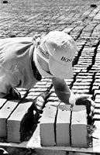
2448 Children watching performances during folk festival
Yes Zilola Saidova
2449 At brick producing plant (series)
Yes Shavkat Boltaev

2450 At brick producing plant (series)

2451 At brick producing plant (series)
Yes Shavkat Boltaev

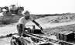

Yes Shavkat Boltaev

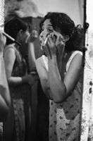
2452 Bride's aunt saying good- bye
Yes Zilola Saidova

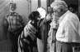

2453 Preparation for wedding Yes Zilola Saidova

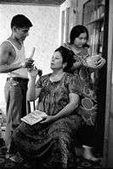
2454 Dyeing hair Yes Zilola Saidova

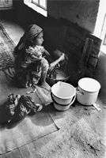
2455 Gypsy boy named Alpomish
Yes Zilola Saidova

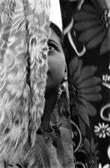
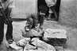

2456 Gypsy girl doing laundry Yes Zilola Saidova

2457 Gypsy girl doing laundry Yes Zilola Saidova

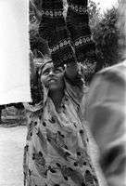
2458 Gypsy girl doing laundry Yes Zilola Saidova
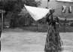

2459 Gypsy girl doing laundry Yes Zilola Saidova

2460 Drying clothes in open- air
Yes Zilola Saidova

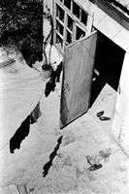
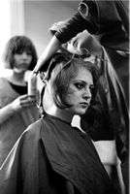
2461 Hairdressers' contest Yes Zilola Saidova

2462 Children selling qurut (dried, round yogurt) [companion to 2269]
Yes Zilola Saidova

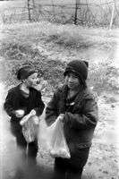
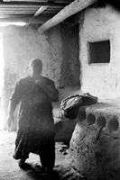
2463 Local Mill, Osiyo Yes Shavkat Boltaev

2464 Caretaker of Khodja Ismat Bulchory's shrine
Yes Shavkat Boltaev

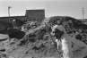

2465 Elizaveta Nekrosova Yes Zilola Saidova

2466 Father and son at Omonkhona Desert
Yes Zilola Saidova

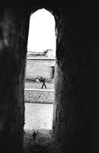
2467 Through the window of chor minor madrasah
Yes Zilola Saidova
2468 Street scene Yes Zilola Saidova

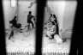

2469 Miss Katherine of Switzerland
Yes Shavkat Boltaev

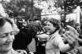

2470 Funeral ceremony of Bukharan Jews
Yes Shavkat Boltaev

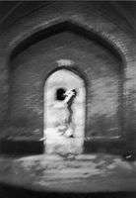

2471 Sheperds Yes Zilola Saidova

2472 Sheperds Yes Zilola Saidova

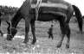

2473 Women's bath house Yes Zilola Saidova

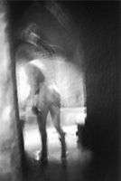
2474 Women's bath house Yes Zilola Saidova

4593 water_3.jpg No Jackson Kellogg

4594 water_4.jpg No Jackson Kellogg

4762 Village Life No Bo'ronova, Nargiza

4781 Khiva Yes

4782 Samarkand Yes

4783 Samarkand Yes

4788 I. V. Savitsky KKASSR State Art Museum
Yes

4789 Protect bread like the pupil of your eye - justify the labor the farmers!
No Ruscha Nashriyot 1981

4790 Bread's Name is Great, and Bread is Greater than its Name

No Ruscha Nashriyot 1981

4791 "Women Celebrating Navruz"

No Xusannova, Katya

4792 No Ranneva, Natal'ya

4793 Central Asia and Kazakhstan
No Ranneva, Natal'ya

4796 Calendar No Open Society Institute

4797 Happy Jubilee, our Republic, the little brother of the 15 republics
No Mushtum 1973

4800 No Oraz Dzhumaev

4801 No Saida Redzhepova

4802 No Renata Sviridova

4803 No Axmed Xallyev

4804 No Yevgyeni Kasymov

4805 No Natasha Rannyeva

4806 No Mehry Babanazarova

4807 No Alisher Syeidov

4810 Bukhara Yes "O'zbekiston" nashriioti

4813 Abu Abdullo
Muhammad Ibn Muso, Al-Xorazmiy, 783-1983
No Ofset Bosma
Qog'ozi No. 1
1982

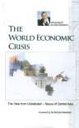
1041 The World Economic Crisis
Yes Karimov, Islam
Signature Book Printing
2009
53 pp
Book/Bound
2172 Bibi-Khanym Mosque No

4198 Uzbek Cuisine No Madrakhimov, A.S. "Mexhat": Tashkent 1996

4199 Academy of Arts Uzbekistan: Board of Art Exhibitions
No Kodzaeva, L Tashkent: Shark 2000

4200 Andijan: All about the City

No Shokarimov, Sobirjon Tashkent 2000

4201 Azhiniyaz No Nukus: “Karakalpakstan”

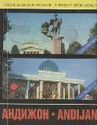
1994

4202 Beginning of Spring No Afoqova, Nadira Bukhara: Bukhara
Nashriyota
1997

4203 Gold-Embroidery Art of Bukhara

4204 Holy Bukhoro: Essays about some of the ancient historical
monuments of Bukhoro-i- Sharif
No Goncharova, P.A. Tashkent 1986

Yes Naimov, Nustarillo Bukhoro 1997

4205 Ecological No Nosirov, Z. N. & R. B. Ochilova
Uzbek Davlat Universiteti. Bukhara
1998

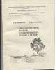
4206 State Art Museum of the No Karakalpak ASSR

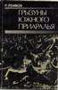
4207 Rodents of the South Sub- Aral Region
No Reimov, R.
Tashkent: "Fan"
1987

4208 Book No Shomukhamedov, Shoislom
Tashkent: "Yozuvchi" Nashriyoti
1992

4209 UZBEKISTAN - On the
Road of Progress
No Tashkent 2001

4210 Islom Karimov Steers Uzbekistan on its Way

Yes Alt, Elisabeth Harnisch Verlags: Nurnberg

4211 History of
Karakalpakistan in government documents, 1932-1941
No Dzhumashev, Askar Mambetovich

4212 Uzbek language book No

4213 Karakalpak Embroidery Yes Uteulieva, Periuza Mathers Museum:
Bloomington
2002

4214 Karakalpak folk songs and tales
No Nukus:
“Karakalpakstan”
1995

4215 News archive No 1996

4216 Bulletin #4 of the Karkalpak Division of the Academy of Sciences

No Kamalov, S.K. Kkoan 1995

4217 Book of Uzbek poetry No Vokhidov, Samandar Bukhara 1997

4218 Short Russian-Uzbek- English Dictionary of Business Terminology
No Dzhuraev, T. Tashkent 1992

4219 Heritage No Tilewbergenova, N.A. Karakalpakstan Baspasy
1997

4220 Mammals Southern Region

No Rimov, R Tashkent: "Fan" 1985

4221 Modern Literary Uzbek I No Ismatulla, Khairulla Bloomington, IN:
RIFIAS

1995

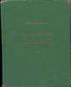
4222 National Report: About the status of the surrounding natural environment and the use of natural resources in the republic of Uzbekistan
No Abdurakhmanov, A.A.
Tashkent 1998

4223 Reflections in the Legends and Oral History of the Karakalpaks, 13th-17th C.
No Berdiyev, Jamiyet Turemuratovich
Нукус 1996

4224 Uzbek Language No Azizxonova, Yu. & R. Tolipova

4225 Uzbekistan and Uzbeks No Bobokhonova, L.T. &
C.D. Bekturganova

Tashkent 1999

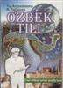
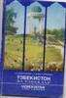
Tashkent 1996

4226 Republic of Uzbekistan: Architectural Monuments of Samarkand
No Nazaryan, Ruben Samarkand: Asia
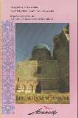
Air

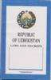
4227 Republic of Uzbekistan: Laws and Decrees
Yes Mozgacheva, Z. (ed.)
Uzbekistan: Tashkent
1992

4228 Republic of Uzbekistan: Preservation of Biological Diversity: National Strategy and Plan of Action
No UNDP/GEF.
Tashkent
1998

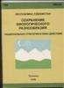

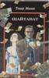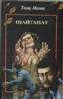
4229 Shaytanat 1
No Malik, Tohir
Shark: Tashkent
2001
4230 Shaytanat 2
No Malik, Tohir
Shark: Tashkent
2001

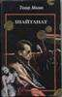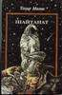
4231 Shaytanat 3
No Malik, Tohir
Shark: Tashkent
2001
4232 Shaytanat 4
No Malik, Tohir
Shark: Tashkent
2001

4234 Tashkent No Ходаев, С.Х. Tashkent: Izdaltelstva Tsk KP Uzbekistan
1977

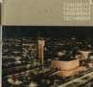
4235 Avesta has Found Its Native Land
Yes Satlikov, A. and I. Jumaniyazov
Urganch: Urganch State University Publishing
2001

4236 Monument of Al- Khorazmi
No Sadullaev, Azimboy Urganch 2001

4237 University of World Economy and Diplomacy (UWED)

Yes Ministry of Foreign
Affairs. Republic of Uzbekist

2002

4238 Uzbek Favorite Cuisine No Mahmudov, Karim Tashkent: Tashkent
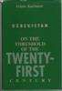
Mehnad
1989

4239 Uzbekistan on the Threshold of the Twenty- First Century
Yes Karimov, Islom Cambridge, MA:
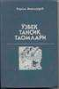
1998
1998

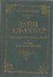
4240 Recognition No Tashkent: "Uzbekistan"
1995

4241 Zain al-Akhbar: Adornment of the newscast
No Gardizi, Abus'id Uzbek Academy of
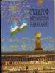
Science: Tashkent
1991

4242 | Foreign and Indigenous Historiography of the History of Turkestan, Khorezm and Karakalpakistan in the first quarter of the 20th Century | No Koshchanov, B.A. | Nukus: “Karakalpakstan” | 1997
4243 | Foreign and Indigenous Historiography of the History of Turkestan, Khorezm and Karakalpakistan in the first quarter of the 20th  Century | No Koshchanov, B.A. | Nukus: “Karakalpakstan” | 1997

4244 | Foreign and Indigenous | No Koshchanov, B.A. | Nukus: | 1997
 | Historiography of the |  | “Karakalpakstan”
 | History of Turkestan,
 | Khorezm and
 | Karakalpakistan in the
 | first quarter of the 20th
 | Century
4245 | Foreign and Indigenous | No Koshchanov, B.A. | Nukus: | 1997
 | Historiography of the |  | “Karakalpakstan”
 | History of Turkestan,
 | Khorezm and
 | Karakalpakistan in the
 | first quarter of the 20th
 | Century
4246 | Foreign and Indigenous | No Koshchanov, B.A. | Nukus: | 1997
 | Historiography of the |  | “Karakalpakstan”
 | History of Turkestan,
 | Khorezm and
 | Karakalpakistan in the
 | first quarter of the 20th
 | Century
4247 | Foreign and Indigenous | No Koshchanov, B.A. | Nukus: | 1997
 | Historiography of the |  | “Karakalpakstan”
 | History of Turkestan,
 | Khorezm and
 | Karakalpakistan in the
 | first quarter of the 20th
 | Century

4248 Bukhara - A Museum in the Open

4260 Etirof/Recognition/Prizn anie
No Pulatov, T. Tashkent Gafur Gulyam Art and Literature Publisher

No Tashkent:
“Uzbekistan”
1991

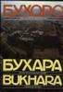
1995

4262 Uzbek/English Language Guide (copy 2)

4263 Uzbek/English Language Guide (copy 1)
Yes Ismatulla, Khayrulla & Fierman, William

Yes Ismatulla, Khayrulla & Fierman, William
Newmount Mining Company. Denver

Newmount Mining Company. Denver
1996

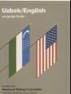
1996

4264 Uzbek/English Language Guide (copy 3)

4265 Uzbek/English Language Guide (copy 4)

4266 Uzbek/English Language Guide (copy 5)

4267 Uzbek/English Language Guide (copy 6)
Yes Ismatulla, Khayrulla & Fierman, William

Yes Ismatulla, Khayrulla & Fierman, William

Yes Ismatulla, Khayrulla & Fierman, William

Yes Ismatulla, Khayrulla & Fierman, William
Newmount Mining Company. Denver

Newmount Mining Company. Denver

Newmount Mining Company. Denver

Newmount Mining Company. Denver
1996

1996

1996

1996

4268 Uzbek/English Language Guide (copy 7)

4269 Uzbek/English Language Guide (copy 8)

4270 Uzbek/English Language Guide (copy 9)

4271 Uzbek/English Language Guide (copy 10)
Yes Ismatulla, Khayrulla & Fierman, William

Yes Ismatulla, Khayrulla & Fierman, William

Yes Ismatulla, Khayrulla & Fierman, William

Yes Ismatulla, Khayrulla & Fierman, William
Newmount Mining Company. Denver

Newmount Mining Company. Denver

Newmount Mining Company. Denver

Newmount Mining Company. Denver
1996

1996

1996

1996

4272 Uzbek/English Language Guide (copy 11)

4273 Uzbek/English Language Guide (copy 12)

4274 Uzbek/English Language Guide (copy 13)

4275 Uzbek/English Language Guide (copy 14)
Yes Ismatulla, Khayrulla & Fierman, William

Yes Ismatulla, Khayrulla & Fierman, William

Yes Ismatulla, Khayrulla & Fierman, William

Yes Ismatulla, Khayrulla & Fierman, William
Newmount Mining Company. Denver

Newmount Mining Company. Denver

Newmount Mining Company. Denver

Newmount Mining Company. Denver
1996

1996

1996

1996

4276 Uzbek/English Language Guide (copy 15)
Yes Ismatulla, Khayrulla & Fierman, William
Newmount Mining Company. Denver
1996

4329 Human Development
Report: Uzbekistan 2000
Yes Glenn, John Center for Economic Research: Tashkent
2001

4346 Band of Satan against God
No Фитрат, А. NISIM: Tashkent 2001

4350 English-Uzbek Dictionary No Буронов, Ж. Tashkent 1977

4358 State Art Museum of the Karakalpak ASSR
No Савицкии, И.В. И Панжинская, В.А.
Москва: Советский художник
1976

4363 Basic Uzbek Alphabet and Knowledge (Theory) for Writing in Latin

No Abduroziq Rafiyev Tashkent 2003

4392 125 Years of the Uzbek
Photography, v. 1

No Qo'ziev, Tursunali, ed. (?)

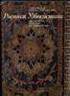
O'zbekistan Badiiy Akademiyasi: Tashkent

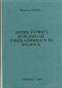
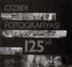
2005 200 pp.

4398 Decorative Painting of Uzbekistan
No Azimov, I Tashkent: Gafur Gulyam Lit & Art Pub House
1987 142 pp.

4399 Bukhara: A Museum in the Open
No Маньковская, Л.Ю. Tashkent:
Uzbekiston Publishers
2000

4402 Bukhara 2500 No 13 pp.

4708 National Uzbek Clothes of Bukhara and Samarkand

4709 National Uzbek Clotes of Tashkent and Fergana XIX - XX Centuries
No Naphisa Sodikova 2006
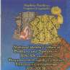

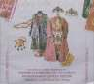
No Nafisa Sadikova 2006

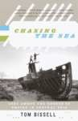
5028 Chasing the Sea: Lost Among the Ghosts of Empire in Central Asia
Cassette
Yes Bissell, Tom Vintage Books 2004 388 pp.

2031 Uzbek music No

2032 Uzbek music No

2033 Uzbek music No

2036 Komolidden Rahimov: No Ushshoq

2038 Yo'nimda Qol No 'Muhriddin Kholiqov'

2039 Fayz Domiyor Otlin No to'plami

2040 Yulduz Uzmonova No "Dune"

CD

3006 At the Bazaar of Love No The Ilyas Malayev
Ensemble

3015 From Samarkand to Bukhara: A Musical Journey Through Uzbekistan
No various Long Distance 1996

3028 Uzbekistan Yes Turgun Alimov Radio France 1995 75'37"

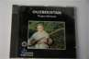

3035 Bukhara Musical Crossroads of Asia
No Smithsonian
Folkways
1991

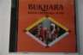

3071 U353 Music No

Cloth/Fabric
2041 Hanging No

2044 Hanging No

4710 Uzbek Cloth No

Clothing

2003 Scarf No

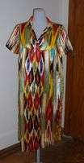
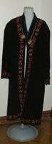
2046 Woman's dress
No
2063 Robe
No
2065 Slippers No

2066 Woman's dress No

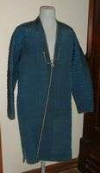
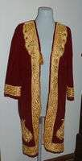
2068 Man's robe
No
2069 Robe
No
DVD
3106 Uzbek Film Collection 1 No 225 min.

3107 Uzbek Film Collection 3 No 230 min.

3108 Uzbek Film Collection 2 No 440 min.

3115 Uzbek Documentary Films of Soviet Epoch

3120 Uzbek Documentary Films of Independence
Yes Abikeeva, Gulnara Open Society
Institute

Yes Abikeeva, Gulnara Open Society
Institute
2008
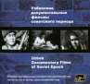

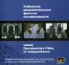
2008

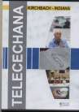
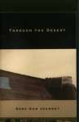
3124 Through the Desert
Yes Ratliff, Walter
Agile Arts
2008
57 min
4415 You Are Not an Orphan Yes Shukhrat Abbasov Uzbekfilm 1963 75 min.

4418 The Orator Yes Yusup Razykov Uzbekfilm 1998 83 min.

4676 Telechana No 2007 90

4726 You Are Not an Orphan Yes Shukhrat Abbasov Uzbekfilm 1963 75 min.

4727 The Orator Yes Yusup Razykov Uzbekfilm 1998 83 min.

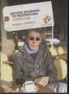
4911 Anthony Bourdain: No Reservations Uzbekistan
Yes Bourdain, Anthony Travel Channel
2005
42 min.
Hat
2097 Man's hat No

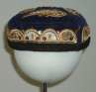

2099 Skullcap No

2100 Woman's hat No

2105 Karakalpak No

2107 Skullcap No
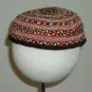

2108 Skullcap No

2109 Skullcap No

4367 Skullcap No

4368 Skullcap No

4369 Skullcap No

4373 Woman's hat No
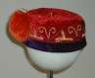
Map
2125 Map of Uzbekistan No

2126 Khiva No

4808 Map of the Republic of Uzbekistan
Yes Podpisano k pechati 1995

Misc.
2158 5 bills No

2232 envelope fragments No

Model
2147 small wooden dolls No

4517 Figurine of Watermelon No Seller

4518 Figurine of Water Seller No

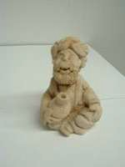
Periodical

4322 Economic Review: 10 Years of Uzbekistani Independence
No Golyshev, V.A. Tashkent: 2001

VHS
1007 Amir Timur 660 No

1021 Bayram Shou No

1032 Domla 19-20, Zebo, No Kongil

1043 Gap Yo’q parts 1 and 2 No

1044 Gapgow No

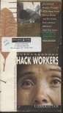
1052 Hack Workers
No Soros Foundation
Gender Montage Series
2002
20 min
1109 News, Yangiliklar No

1114 Oltin Devor -
Kinokomediyasi
No Мухамаджон, Рихсив

1116 Ona Tili Kontsert No (Mother Tongue Concert)

1117 Ona Zamin Yulduzlari No Festivali

1120 Past Days No

1133 Sen Borsan (If You Go) Concert by group Setora
No Dvar Records 2000

1146 Terrorism Comes to Uzbekistan

Yes Gender Montage
Series

1150 Wedding No

1161 Utkan Kunlar No 1998

1165 Uzbek TV Ahborat No

1172 Where the Eagles Fly: Portraits of Women of Power: Habiba, Sufi Saint from Uzbekistan
Yes Mystic Fire Video 1997 30 min

1187 Bukahra No

1196 Galatepalika Avliye, No bilib qoygan yakhshi

1202 KICHKINA TABIB No
"O'zbekkino"

1211 Tong Otguncha (Do No Rassveta/Before Sunrise)

1240 Kurso Tuv PAL No

VCD

3066 Slide-Show on Bukhara No Zilola Saidova Center for
Development of Creative Photography
2003

3069 View of Bukhara (copy 1) Yes Zilola Saidova IAUNRC

3079 View of Bukhara (copy 2) Yes Zilola Saidova

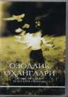
4637 Video CD of Zilola's Photos
No Saidova, Zilola Saidova, Zilola 2003

4677 Ozodlik Ohanglari: Rechitativ Svobody (Recital of Liberty)

No Dadahon Hasan Open Society
Institute - Soros Foundation

2007

