Finnish Easter Branches Craft Activity Pack

Create a traditional Finnish Easter decoration for your home or classroom.

You will need:
- This activity pack!
- At least one small branch per person (see pictures below; in Finland they use willow branches, but you can use what you have to hand)
- Any combination of beads, ribbons (cut into small lengths), feathers, tissue paper…
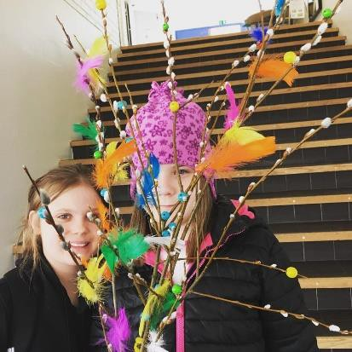

Activity pack contents:
- Printout 1: Discover Finland!
- Printout 2: Celebrating Easter and Welcoming Spring in Finland
- Printout 3: Craft Instructions
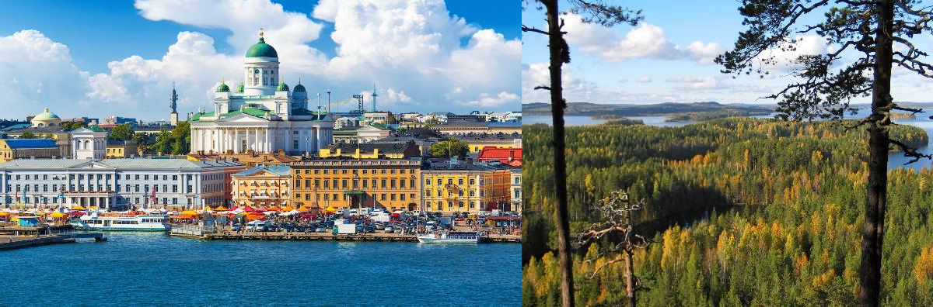

DISCOVER FINLAND!
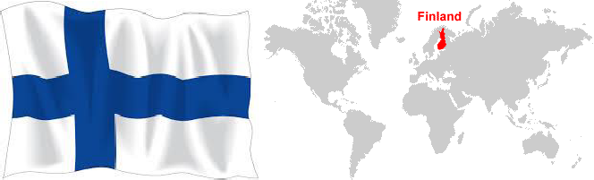
CHALLENGE 1: If you have a world atlas or globe at home or in your classroom, can you find Finland there? Can you find the capital city, Helsinki? Can you name the four countries closest to Finland? (Tip: if you don’t have an atlas or globe, try using the Internet)
CHALLENGE 2: Take a look at the https://www.visitfinland.com/destinations/ webpage and scroll down to explore some of the different places you could visit in Finland. Where would you go first?
Finland Fact File
Location: Northern Europe Capital City: Helsinki
Official Languages: Finnish, Swedish Population: 5.5 million people (less than Indiana)
Size: 130, 672 square miles (more than three times bigger than Indiana)

Some things that Finland is famous for are:

Formula One Racing Drivers
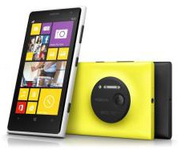
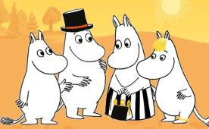

Nokia

The Moomins

Saunas

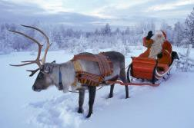
Have you met the Moomins?

Angry Birds

Lapland
- Listen to a Moomin story or watch an episode on the Moomin Official channel: https://www.youtube.com/channel/UC82jKc
_wW8iHVXU9GrYRunw
- Explore the world of the Moomins at https://www.moomin.com/en/explore/

Celebrating Easter and Welcoming Spring in Finland
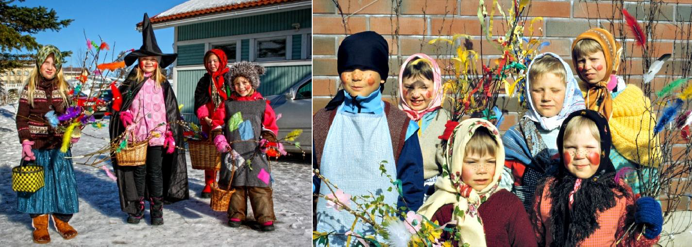
In a popular family tradition in Finland, young children dress up as cheerful Easter witches and go from door to door, giving blessings to drive away evil spirits in return for treats. They carry colorfully decorated twigs—and baskets for their treats, of course! The witches say a traditional rhyme at the door: Virvon, varvon, tuoreeks terveeks, tulevaks vuodeks; vitsa sulle, palkka mulle! (In English: I wave a twig for a fresh and healthy year ahead; a twig for you, a treat for me!). If they are lucky, they might get some chocolate eggs, sweets, or small coins.
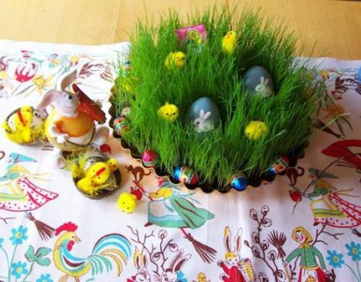
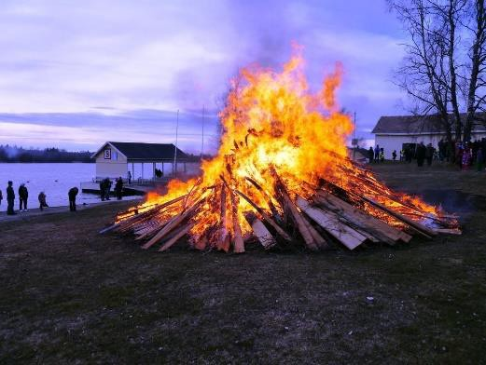
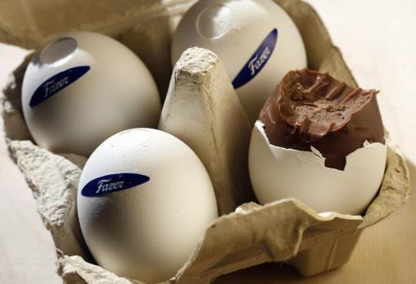
Finnish sweet company Fazer makes chocolate eggs inside real eggshells!
As Easter approaches, children plant grass seeds in dishes of soil. When the grass grows, it shows that spring is here.
In many western Finnish villages, people light bonfires to drive away evil spirits on the evening of Easter Saturday.
You can learn more about Easter in Finland here: https://finland.fi/life-society/wandering- witches-welcome-finnish-easter/
You might even find some interesting Easter recipes to try at home!
Hyvää pääsiäistä – Happy Easter!

How to make your Finnish Easter branch (it is VERY simple!)

Find a small branch. If it is damp from being outside, let it dry before you use it.
- Use colored paper, ribbons, feathers, beads, or anything colourful you can find at home to decorate your branch.
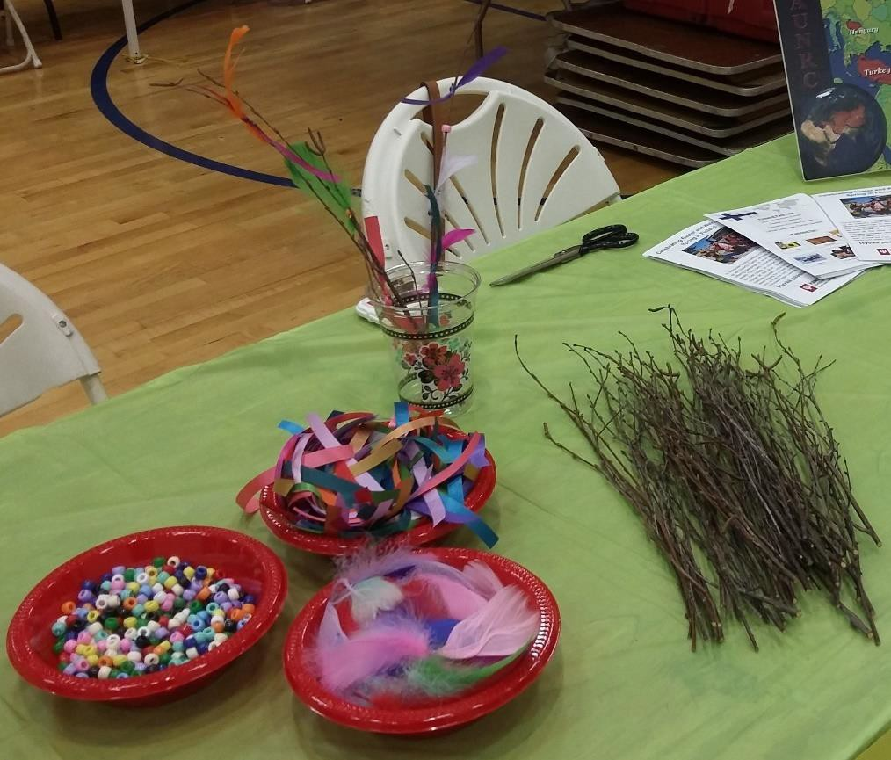
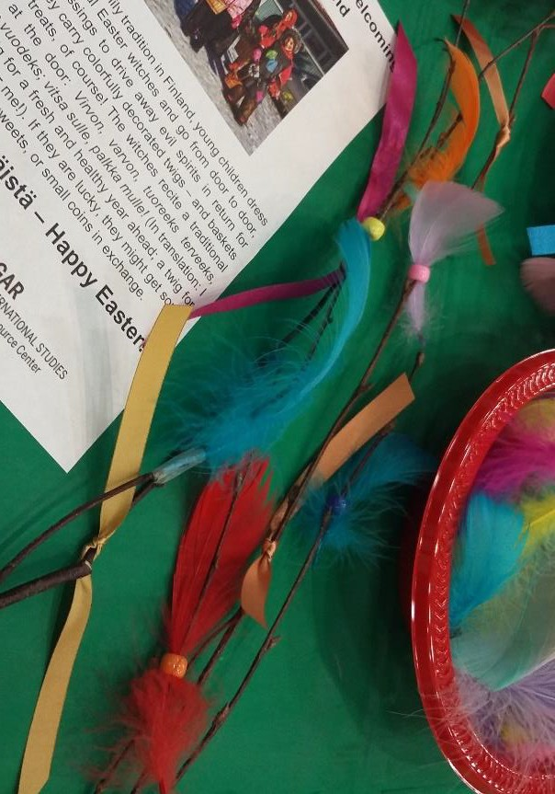
Tip: We stuck the feathers in the beads to keep the beads on, but you could also tie feathers on with ribbons, tie a ribbon above a bead to stop it falling off—or even use sticky tape.

HAVE FUN!

