Lesson One: Tibetan and Inner Asia Images Grade Level: 9-12
Overview: Visual representations can serve as a powerful tool to help students utilize their prior knowledge and apply newly acquired information. It is important for students to understand cultural and historical information in a geographic context. This lesson uses images from Tibet and Inner Asia to introduce geographic and historic information about the region. The activities in lesson one help engage students in the topic “Tibet and Inner Asia” and introduce important information about this unit.

Time: 45-50 minutes

Materials Required:
- Tibetan and Inner Asian images (provided)
- Student KWL Chart (provided)
- Student Image Sheet (provided)
- Teacher Image Information Sheet (provided)
- *Computer with projector (optional but preferred)
- *Laminated images (optional)
- *Overhead machine with transparencies of images (optional)
*One of these options is required for students to view images.

Objectives:
Students will:
- List prior knowledge about Tibet and Inner Asia and build on that knowledge throughout the lesson.
- Use visual cues to make hypotheses about the geographic, cultural, and historical relevance of the Tibetan and Inner Asian region.
- Evaluate hypotheses based on newly acquired information.
- Utilize logical reasoning skills.

Procedures:

Opening:
- Open the class by asking students to write down everything they know about Tibet.
- They can write this down in the first box on the Student KWL Worksheet. (Provided)

Main Activity:

*Notes: If the technology is available these images can be placed in a PowerPoint Presentation. If not, the images can be put on transparencies to be shown on an overhead, or printed out and laminated.

If time is limited, select images that you feel will help students identify with Tibet and Inner Asia, peak their interest, and illustrate what they know/don’t know. If you are only planning to cover 2-3 of the lessons, select the images associated with those lessons.

- Explain that you are going to share some images with the students. Their task is to try to name each image, describe what they see, and hypothesize the importance of each.
- Display one image at a time, giving students time to record their responses on their worksheets in sections A, B, and C.
- Students can work independently, however pairs or small groups might generate good discussion and brainstorming sessions.
- Push the students to probe further while examining these images by asking some of the following questions:

What do you see in the picture?, Are there familiar images?, What aspects of the images are unique or new?, Are there any objects in the image/photograph that stick out to you?, What do the signs, symbols, etc., signify?, What do you think the people in the image feel about what the are experiencing?, Where might the images take place?, or any other questions that you feel might suit your students.
- Once students have written responses for the first image, ask one students from each of the small groups (or pairs of students) to share their hypothesis about each image.
- Review image with students using information provided on the Teacher Organizing Worksheet by providing the title of each image (or name) and then describe its significance (Information is provided on the Teacher Organizing Worksheet).

Closing:
- Have students revisit the information they recorded on the first portion of the Student KWL Worksheet that they brainstormed at the beginning of the lesson.
- Instruct them to write down 2 new pieces of information that they learned during this lesson. Students are to record what they learned on the middle portion of the “What I learned about Tibet” section of the student worksheet.
- Students, for homework, or at the end of the class period, should record on the bottom portion of their KWL three (3) questions they have about Tibet or Inner Asia (or areas of

study) that they would like to pursue. These can be shared aloud at the beginning of the next class session, or collected and reviewed by the teacher.

Assessment:
Through discussion of images, teacher can assess what students know, what students learned, and if there any misunderstandings thus far. Through the Independent work, teacher can assess what students are interested in learning.

Extension to the lesson:
You can extend this lesson by including additional images or by asking the students to locate additional information about a featured image.

Students can independently or in pairs/small groups research the questions posed on their KLW charts and present findings to entire class.

Additional Use for These Images:
These images can be used as a review of information at the end of the unit.

Student K.W.L. Chart

Prior Knowledge about Tibet (Before the lesson)
What I Learned about Tibet (After the lesson)
What I Want to Know about Tibet
(After the lesson)

A. Name of the Image | B. Visual Description | C. Importance of Image | D. Actual Significance
1.
2.
3.
4.
5.
6.
7.
8.
9.
10.
Student Sheet for Tibetan and Inner Asian Images:

11.
12.
13.
14.
15.
16.
17.
18.
19.
20.

Teacher Information Sheet for Tibetan and Inner Asian Images:

Notes for Teacher regarding images

This resource includes a copy of possible images to be used during Lesson One. Most of the descriptions and images came from http://kekexili.typepad.com/life_on_the_tibetan_plate, unless otherwise mentioned. Feel free to substitute additional images that you find appropriate for your classroom.

Image Descriptions for Teacher to share with Students for Lesson One:

- This is a map of the world with Tibet highlighted. Tibet is a Plateau region in Central Asia and the indigenous home to the Tibetan people. With an average elevation of 4,900 metres (16,000 ft), it is the highest region on Earth and is commonly referred to as the "Roof of the World."

Tibet today is part of the People's Republic of China (PRC) (with a small part, depending on definitions, controlled by India). As an exclusive mandate, Tibet is also officially claimed by the Republic of China (Taiwan). In the Tibetan sovereignty debate, the government of the People's Republic of China and the Government of Tibet in Exile disagree over when Tibet became a part of China, and whether this incorporation into China is legitimate according to international law.
UNESCO considers Tibet to be part of Central Asia, while several academic organizations controversially consider it part of South Asia.

- Views of Inner Asia: Sayram Lake, Xinjiang. Inner Asia, or the interior of the Eurasian landmass, comprises in historical terms the civilizations of Central Asia, Mongolia, and Tibet, together with neighboring areas and peoples that in certain periods formed cultural, political, or ethnolinguistic unities with these regions. In the past the Inner Asian world was dominated by pastoral nomadic communities of the great Eurasian steppe, and its history was shaped by the interaction of these societies with neighboring sedentary civilizations. In the 20th century, the Inner Asian peoples were located within the borders or sphere of influence of either the Soviet Union or the People's Republic of China. The breakup of the USSR brought statehood and social transformation to much of the region. Today Inner Asia comprises the five independent Central Asian republics of Uzbekistan, Turkmenistan, Tajikistan, Kyrgyzstan, and Kazakhstan; the republic of Mongolia; the Xinjiang Uygur, Inner Mongolia, and Tibet Autonomous Regions of the People's Republic of China; and adjacent parts of Afghanistan, Pakistan, Iran, China, and Siberia in the Russian Federation. (photo taken by Brian Cwiek)

- Qinghai Lake (Tso Ngonpo in Tibetan and Kokonor in Mongolian) is the largest lake on the Tibetan Plateau and the largest in China. It is in the far northeast corner of the Amdo region of Tibet. It sits at 3200m / 10,500 feet. Numerous nomads live around the lake. Qinghai Lake is a salt lake and is covered in thick ice during the brutally cold winters. This lake is one of the largest tourist attractions in all of the greater Tibet area. Large groups of tourists can be found here during the summer months.

- Lhasa is the largest city in Tibet and the destination of tens of thousands of Tibetan Buddhist pilgrims each year. Though the Chinese migration is very evident, Lhasa still is a great place to go. The circuit around Jokhang Temple is always full of pilgrims who are spinning their prayer wheels and holding their prayer beads. There are several "must see" places in Lhasa such as the Potala Palace, Jokhang Temple, Sera Monastery, Drepung Monastery and the Norbulinka. The most popular time people go to Lhasa is in the summer between June and September. The best time to go to Lhasa though is in the winter. The winter months bring the most pilgrims to Lhasa and there are far fewer tourists. Winters in Lhasa are not nearly as cold as other regions of Tibet and are warmer than most people think.

- This next picture is of the Potala Palace which was the former winter home of the Dalai Lama's and the former seat of the Tibetan government. This massive 1000 room building is the largest structure in Tibet and dominates the skyline of Lhasa. It stands at 117 meters in height and 360 meters in width and is considered the most important example of Tibetan architecture. It is divided between the outer White Palace, which serves as the administrative quarters, and the inner Red Quarters, which houses the assembly hall of the Lamas, chapels, 10,000 shrines, and a vast library of Buddhist scriptures. (http://en.wikipedia.org/wiki/Tibet)

- This is Takster, the town where the (current) 14th Dalai Lama's Birthplace. His mother gave birth to him in 1935. Taksker, a small farming community in a remote corner of Amdo Province, is one of the lowest regions of the Tibetan Plateau sitting at an elevation of 8528 feet.

- This is a photo of Tibetan nomads. It was early winter with a temperature of -7C/20F during the day. This Tibetan woman was in her late 50's and her grandson was 6. It is difficult to get an exact age for older Tibetans since most of them do not know their birthdays. This family was poor. They had only around 10 head of yak, which is quite small in Tibet. They had no electricity, no running water and lived several hours from any town. Their Yak skin tent is their permanent residence, even in the coldest of winter months.

- This is a photo of Tibetan monks. Even though Tibet has been ruled by communist China for over 50 years, there are still a large amount of men who are monks. Tibetan monks live in one of the more than 2000 monasteries found across the greater Tibet area. Monks often begin living at a monastery as young as age 6 and spend the rest of their lives there. This picture is at Sera monastery in the Tibetan capital of Lhasa during a monk debate (monk debates take place at many monasteries across Tibet, but most foreigners are only familiar with the debates at Sera). Monks are easily identifiable in Tibet by the maroon colored robes that they wear.

- This picture is of a Kham man on a pilgrimage to the Derge (Dege) Barkhang Printing Press which makes most of the hand made Tibetan scriptures found in monasteries across Tibet. He is holding a huge prayer wheel in one hand and a set of prayer beads in the other. It is very common to see men (and women) holding both of these while walking around a holy place. This man is wearing a black sash woven in his long hair with his chuba wrapped around his waist (the picture was taken in the summer).

10. Mount Everest, also called Chomolungma or Qomolangma (Tibetan: ཇོ་མོ་གླང་མ) or Sagarmatha (Nepali: सगरमाथा) is the highest mountain on Earth, as measured by the height of its summit above sea level, which is 8,848 meters or 29,028 feet. The mountain, which is part of the Himalaya range in High Asia, is located on the border between Nepal and Tibet, China. By the
end of the 2007 climbing season there had been 3,679 ascents to the summit by 2,436 individuals. There have been 210 deaths on the mountain, where conditions are so difficult that most corpses have been left where they fell; some are visible from standard climbing routes.
Climbers range from experienced mountaineers to relative novices who count on their paid guides to get them to the top. This means climbers are a significant source of tourist revenue for Nepal, whose government also requires all prospective climbers to obtain an expensive permit, costing up to $25,000 (USD) per person. (http://en.wikipedia.org/wiki/Mount_Everest)

- This is Shigatse, the second largest city in Tibet. It is located 265kms / 166 miles southwest of the capital city of Lhasa in the traditional Tibetan province of Tsang. It has a population of around 80,000. Shigatse is the name of a city, county and prefecture. Shigatse prefecture has 18 Flag of Tibet used intermittently between 1912 and 1950. This version was introduced by the 13th Dalai Lama in 1912. The flag is outlawed in the People's Republic of China. (http://en.wikipedia.org/wiki/Tibet).

- China's national flag was adopted in September, 1949. This flag was first flown in Tiananmen Square on October 1, 1949 - the day of the founding of the People's Republic of China. The rectangular flag has a red field with five golden-yellow stars (each with five points) in the upper left corner. The star on the left is larger than the other four. The red color of the flag symbolizes revolution. The large star symbolizes the Communist Party (which rules China) and the smaller stars represent the people of China.

- “Buddha painted on a rock wall in Tibet”-Tibetan Buddhism is a religion represented by the many groups, especially numerous in Asia, that profess varying forms of this doctrine and that venerate Buddha. The teaching of Buddha that life is permeated with suffering caused by desire, that suffering ceases when desire ceases, and that enlightenment obtained through right conduct, wisdom, and meditation releases one from desire, suffering, and rebirth. (Information from http://education.yahoo.com/reference/dictionary/entry/Buddhism, Image from Nathan Freitas, http://www.onwardtibet.org/index.html)

- Tibetan prayer flags. Prayer flags are inscribed with auspicious symbols, invocations, prayers, and mantras. Tibetan Buddhists for centuries have planted these flags outside their homes and places of spiritual practice for the wind to carry the beneficent vibrations across the countryside. Prayer flags are said to bring happiness, long life and prosperity to the flag planter and those in the vicinity.

- Views of Inner Asia: Buddha Caves, Xinjiang. The Buddha Caves are corridor of murals surpassing other existing caves in China in its abundance in content, quantity and long duration. The Caves are significant in Buddhism as well as in the history of Qiuci. Currently there are 236 coded caves in the Kizil Thousand-Buddha Caves, which are divided into west and inner valley and rear mountain areas extending to over 3 kilometers (1.86 miles). Buddha Caves come in two forms, one as living quarters with earthen bed and simple facilities, and the other one as temple for worshiping. Caves of different form and function were combined into one unit. It is assumed that one unit was one temple. Caves are reputed as "The most beautiful murals in Central Asia". – (Information from http://www.travelchinaguide.com/attraction/xinjiang/korla/Kizil.htm, Photo by Brian Cwiek)

- Yaks plowing fields. The yak is a distinctive shaggy Himalayan hoofed mammal, which roams Tibet and parts of China. Yaks are differentiated into a smaller domesticated species and a large, extremely wary wild version. The wild yak is at risk due to destruction of habitat, diseases from domestic yaks, and hunting. The yak is a vital work and food animal in Tibet, where other ungulates could not survive the extreme conditions. Domestic yaks are used to pull loads and plow fields, and are combed for their fur, which is spun and woven into various fiber products. Yak milk is a popular animal product in southern China and Tibet. In some areas the yak is slaughtered, yielding a substantial amount of meat which can be cured and dried for later use.
The yak has been used as a domestic animal in Tibet for over three thousand years, and is found widely scattered across Tibet and China. (Information from http://www.wisegeek.com/what-is-a- yak.htm, Image from Nathan Freitas, http://www.onwardtibet.org/index.html)

- The Dalai Lama (Lhamo Thondup; born 1935), the 14th in a line of Buddhist spiritual and temporal leaders of Tibet, fled to India during the revolt against Chinese control in 1959 and from exile promoted Tibetan religious and cultural traditions. (Information and photos from http://www.answers.com/topic/dalai-lama-religious-figure)

- Tibetan script, “Om Mani Padme Hum” - Yeshe Nyima

- Songtsen Gampo is the forefather of Buddhism in Tibet. Two generations before King Trisong Detsen invited Shantarakshita and Padmasambhava to Tibet, King Songtsen Gampo cultivated the nation for its transformation, clearing pathways for the dharma to enter and ultimately permeate Tibetan culture. Without Songsten Gampo there would be no Tibetan alphabet, Lhasa would have no Jokang, and Buddhism would not have flourished. (Information from http://www.khyentsefoundation.org/patronkingsV.html, Image from http://en.wikipedia.org/wiki/Songts%C3%A4n_Gampo)

Images for Lesson One

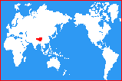
1.
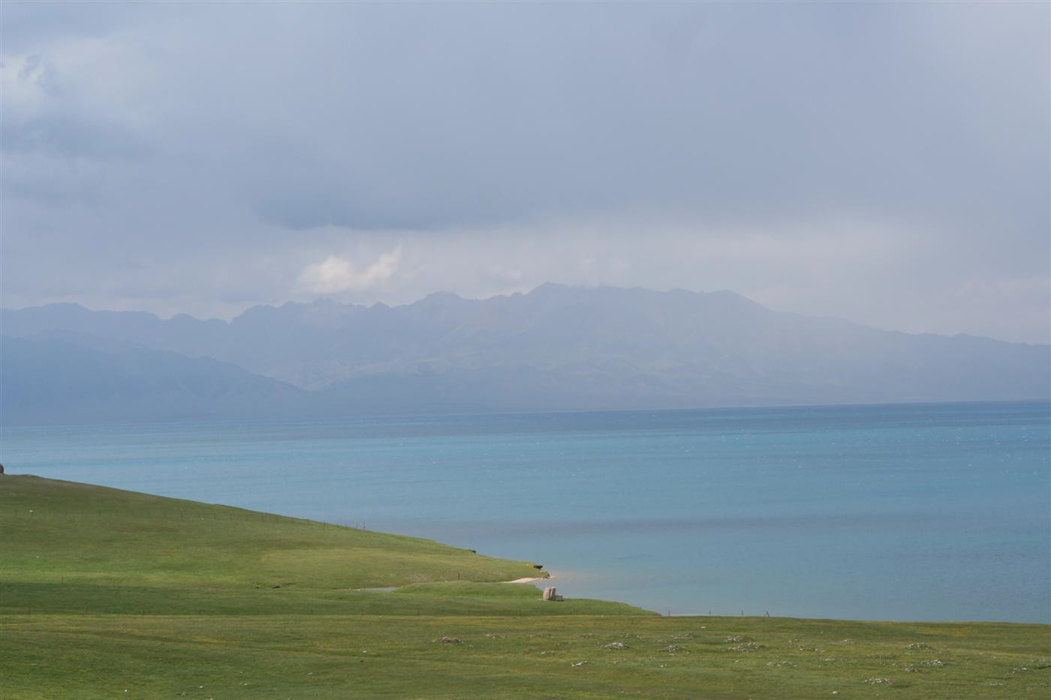
2.

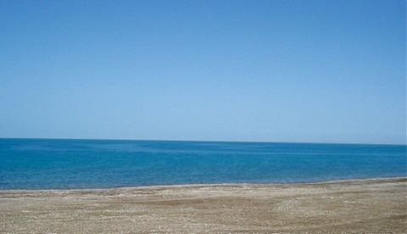
3.

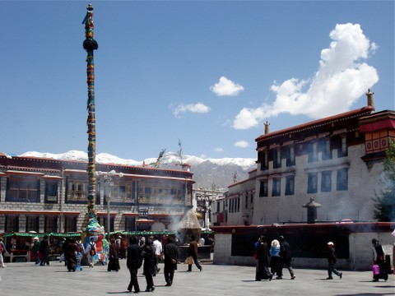
4.

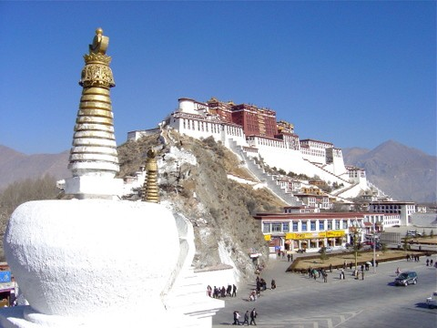

Both are images of the same building.

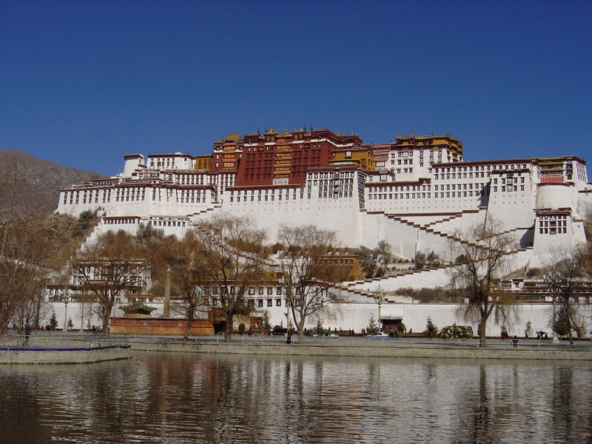

5.

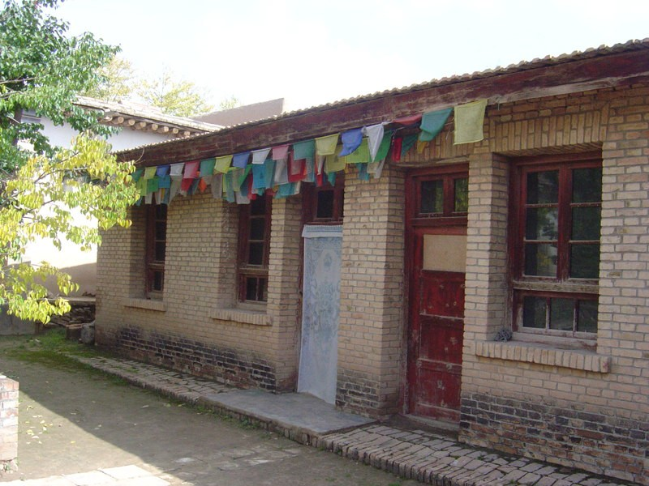

.

6.
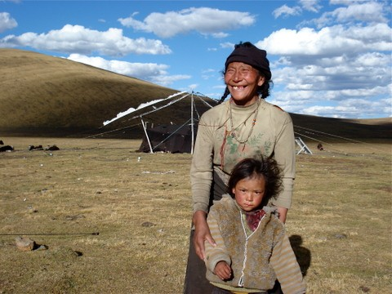

7.

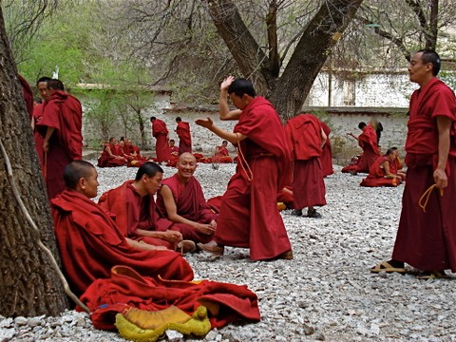
8.
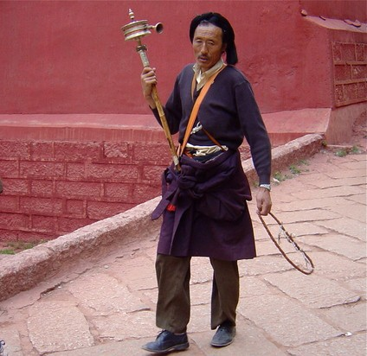

9.

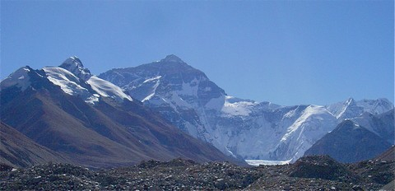
10.

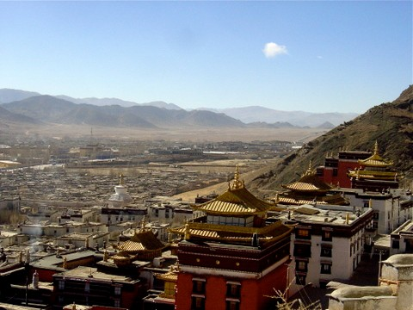
11.

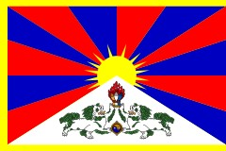
12.

13.

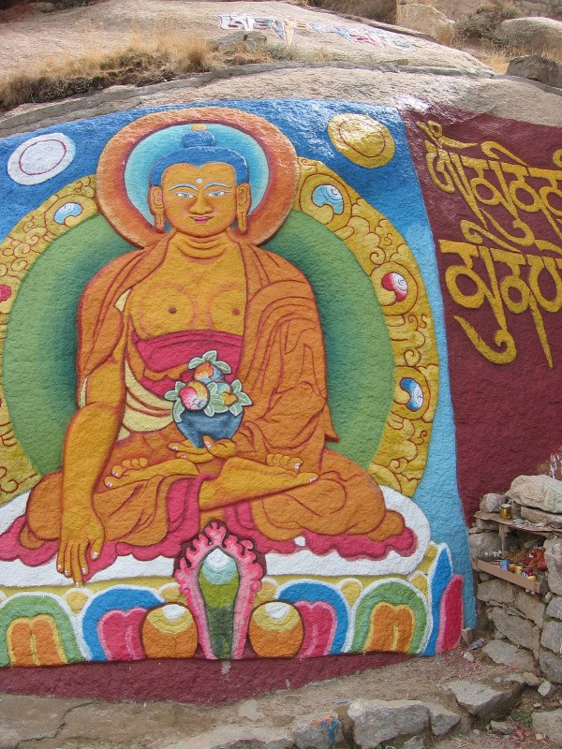
14.

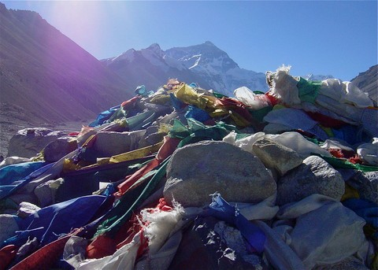
15.

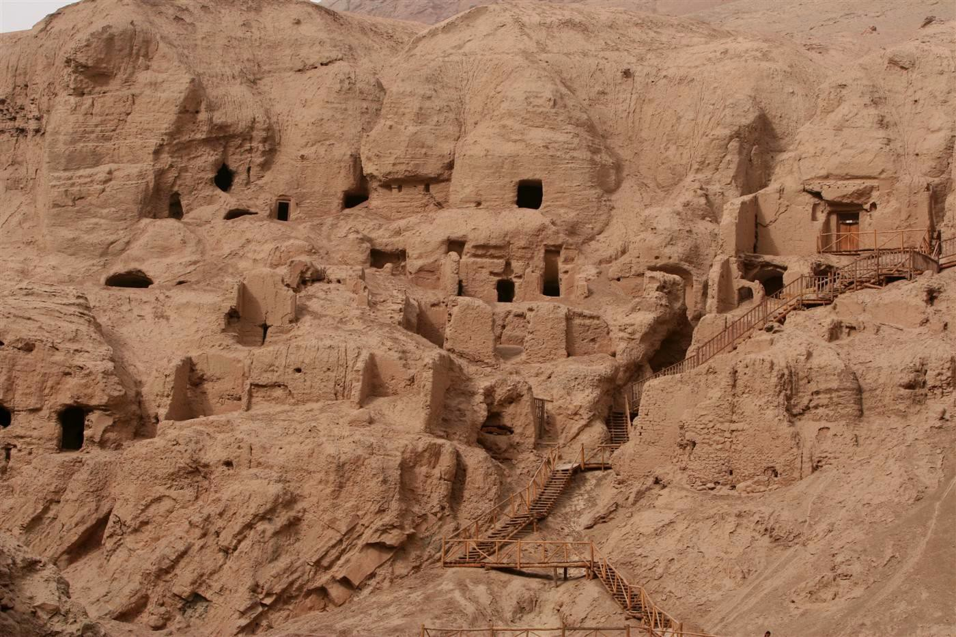
16.

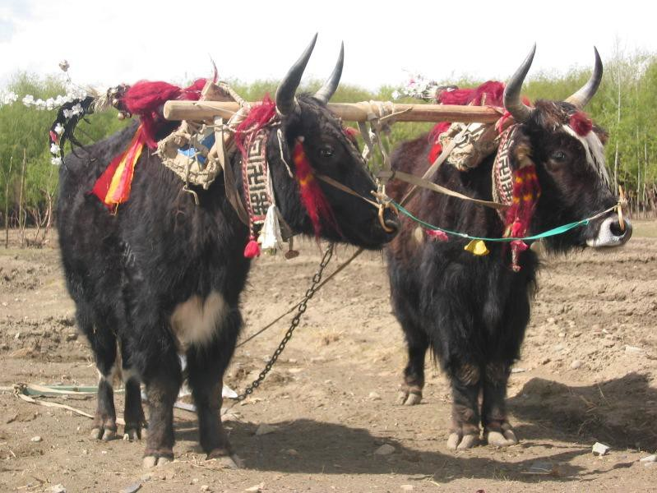
17.

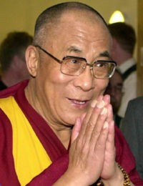
18.

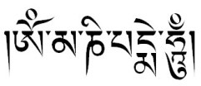

19.

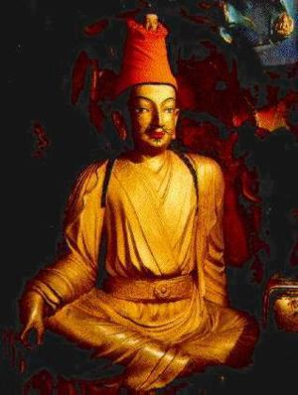
20.

Lesson 2: Geography of Inner Asia and Tibet

Grade Level: 9-12

Overview: This lesson will introduce students to the geography of Asia, specifically Inner Asia. After considering what is meant by the term "Inner Asia," students will identify the region of Tibet and consider factors for determining what is considered a "region." This lesson situates Tibet in Inner Asia as well as equips students with a basic understanding of Tibetan and Inner Asian topography, climate, linguistic diversity and demographic trends.

Time: 2-45 minutes class periods (or 1-90 minute block)

Materials:
- Computer with projector and a screen (Overhead projector with maps on transparences if computer is not available.)
- Maps (provided)
- Sample Semantic Map (provided)
- Student Blank Map Sheet with Questions (put questions on back of Blank Map Sheet)
- Student Map Resource Sheet (provided)
- Colored pencils or markers
- Teacher Content Information (provided at the end of the Unit in its entirety, with excerpts included in this lesson)

Objectives:
Students will:

- Gain a broad understanding of the regional topography, climate, and demographic trends.
- Analyze the importance of terms used to identify various regions of the world, specifically Inner Asia and Tibet;
- Determine the role of geography in designating regions; and
- Assess the possible role of factors such as ethnicity, language, foods, and religion in designating regions.

- Utilize newly acquired information to create maps and analyze issues surrounding boundaries.
*Notes: Teacher should review the information covered in the Teacher Content Material, “Situating Tibet in Inner Asia” (included at the end of the Unit).
There is a natural break in between the two portions of this lesson as noted by the “***”, however based on the class structure and students it is up to the teacher to determine how to proceed.

Procedures:
Opening:
- Open the lesson by asking the students, "What is Inner Asia?" Have students write their responses on a piece of paper. Collect the responses for use later in the lesson.

- Explain that this lesson will help students to more fully understand the answer to that question. Write the following terms on the board: hemisphere, continent, subcontinent, region and boundaries.

- Ask the students to define and give an example of each of the terms. Then, ask students to describe their understanding of Inner Asia using those terms.

- Have students share their responses aloud.
- Discuss and help students define the geographic concept of "region" and “boundaries.” Their definitions should include the idea that regions/boundaries are human constructs based on the area's common geographical characteristics (including physical, historical and cultural geography). The concept of region helps people to organize and make sense of the world.

- Use the following questions to stimulate thinking:
What do we mean by "region"?
What is Inner Asia? For that matter, what is the Mid West, Middle East or Africa?
In what circumstances might one person's definition of a region differ from another's? Who make the boundaries?

Are boundaries always followed? Are boundaries arbitrary?
Are boundaries fixed?
How can boundaries change?
Are there ‘winners’ and ‘losers’ when boundaries change? How can boundaries impact the people who live there?

Main Activity (Direct Instruction):

- After this discussion, share this information with students (you can add or delete to this information based on students’ prior knowledge).
- Students should take notes as the information will be used to help them with an activity at the end of the lesson.

“Inner Asia, or the interior of the Eurasian landmass, comprises in historical terms the civilizations of Central Asia, Mongolia, and Tibet, together with neighboring areas and peoples that in certain periods formed cultural, political, or ethnolinguistic unities with these regions.

In the past the Inner Asian world was dominated by pastoral nomadic communities of the great Eurasian steppe, and its history was shaped by the interaction of these societies with neighboring sedentary civilizations. In the 20th century, the Inner Asian peoples were located within the borders or sphere of influence of either the Soviet Union or the People's Republic of China. The breakup of the USSR brought statehood and social transformation to much of the region.

Today Inner Asia comprises the five independent Central Asian republics of Uzbekistan, Turkmenistan, Tajikistan, Kyrgyzstan, and Kazakhstan; the republic of Mongolia; the Xinjiang Uygur, Inner Mongolia, and Tibet Autonomous Regions of the People's Republic of China; and adjacent parts of Afghanistan, Pakistan, Iran, China, and Siberia in the Russian Federation. Areas pertinent to the study of Inner Asia for ethnolinguistic and historical reasons include the Tatar, Bashkir, and Kalmyk Republics in Russia and the Manchu homeland in northeast China.

The most fundamental issue in discussing Inner Asia, however, is recognition that such a designation is first and foremost defined on the basis of culture rather than topography. Understood in this manner Inner Asia becomes what it is not when one looks at a map or consults a world history book – it is not Russia, not the Middle East, not India, not China. Thus, Inner Asia can be understood as encompassing the regions beyond the world’s most famous and well-documented sedentary cultures. This negative definition leaves great room for diversity within the region, but a few common trends are present through history.

Because the lands of Inner Asia are generally unsuited to high-yield agriculture, the inhabitants of Inner Asia have typically been pastoral nomadists (raising animals such as yaks, sheep and horses) or hunters and fishers.

Accepting culture as the basis for defining Inner Asia, the next task is to explore the region’s geographical reality. It is far from the world’s oceans, The climate of Inner Asia is generally colder and drier than in neighboring areas closer to oceans. The temperature can vary widely with summers and winters tending toward extremes of hot and cold, respectively. Ringed by some of the highest mountain ranges in the world – Himalayas, Pamirs, Hindu Kush, Altai – very little moisture reaches Inner Asia.

These general characteristics of ecology certainly affect the agricultural productivity of the region and often make conditions for human existence rather difficult.

Vegetation marks some variety in the Inner Asian landscape from north to south. Tundra comprises northernmost vegetation zone with ground that remains frozen for most of the year and precludes most plant life. The taiga, or forest zone, lies south of the tundra zone and stretches all the way across the Eurasian landmass. This area is typically cold, but can support coniferous trees in the northern reaches and deciduous trees as the taiga blends into the steppe. Steppe refers to flat grasslands that are suitable for grazing animals, but generally unsuited for farming except in areas where the steppe blends with the southern reaches of the taiga. The steppe zone is narrower than the taiga zone, but has historically been home to some of the largest and most powerful political entities in Inner Asian. Moving to the south the steppe blends into deserts, typically unable to support human life except where oases are found. In addition to viewing these zones as arranged in bands from north to south, these same concepts apply to zones separated by different elevations.

Inner Asia is nearly 3,000 miles in breadth, stretching from the Pamir Mountains to Manchuria, and approximately 1,000 miles from north to south. The area of Inner Asia exceeds four million square miles. The Himalayas and the Pamir mountains run along an east-west axis and demarcate the southern limits of Inner Asia. These ranges are extremely high and nearly impassable to humans, and are home to the world’s tallest mountains e.g., Mt. Everest and K2. Several mountains ranges branch off from these two ranges. Tibet sits at confluence of these mountain ranges, north of India, on a high altitude plateau averaging 13,000 feet above sea level.

Tibet, …a region of Inner Asia, is traditionally divided into the three major provinces-U-Tsang (Ooh-Sahng), Khams (Kom) and Amdo (Om-dough). Tibet can also refer to the current province in the People’s Republic of China known as the Tibetan Autonomous Region (TAR)….The TAR was created in 1965. The Chinese government uses Tibet and TAR interchangeably. Lhasa (Lah-sah) is the capital of the TAR and has effectively served as the capital of Tibet since the Dalai Lama became an important political figure.

Because of its elevation Tibet and many mountains, Tibet is nicknamed “The Land of Snow.” Tibet can be divided into three regions roughly major provices – the northern region (Khams), the southern region (U-Tsang), and the eastern region (Amdo). The northern region is characterized by an especially high cold desert that is relatively inhospitable. There are no major population centers here, but some nomads raise yaks in limited numbers. The southern region is characterized by high mountains separated by valleys, where the Tibetan population centers are found. Lhasa is located in this region.
Lower mountains, forests, and flatlands define the eastern region, where some agriculture is possible.”
(http://www.indiana.edu/~rifias/RIFIAS_and_Inner_Asian_Studies.htm)

- Ask students to create a semantic map on Inner Asia and Tibet geographically (mountains, rivers, cities, vegetation, neighboring republics/regions) using the notes they took during the lecture. It is recommended to allow students to work in pairs. Once maps are written, have students share what their group has completed.
- Show students the Sample Semantic Map if they are not sure how to proceed (see Sample Semantic Map)
- This is a good time to fill in holes in their geographic knowledge or address any misunderstandings about this area of the world.
* * *

Pair Activity:
- Share the maps provided (except for the blank outline of China) with the students.
- Ask students to note differences and hypothesize why the maps are different, what makes them different, and how the variation in boundaries impact the people who live there. Students should be able to pull from the opening activity discussion to help think about and respond to these questions.
- Explain that the students are going to create a physical map of Inner Asia and Tibet that shows regions, mountain chains, major rivers, different landforms, major and small (but still important)cities. Ask them to divide Inner Asia into various regions, using geographical features as their guide. Students can use Student Map Resource Sheet, textbook, encyclopedias, or the Internet to help them design their map.
- Provide each student with a blank map and a copy of the Student Map Reference Sheet (both provided).
- Have students work in pairs but each on their own map to label the map based on physical characteristics. Have students:

  - Label each region of Inner Asia (in black), capitals (in red), smaller but main cities (in orange), main rivers (in blue), and main mountain ranges (in brown).

  - Create a key and legend with the elements included on their maps.

Closing Activity:

- Ask students to think about the following questions as they create their maps. They need to briefly respond (in writing) to 3 of the questions below. Responses can be shared aloud at the beginning of the next class or reviewed by the teacher to assess understanding and critical thinking:
- To what extent do the regional boundaries coincide with the
physical boundaries?
- How important is geography in determining boundaries?
- What other factors influence the designation of regions?
- What challenges could have arisen due to imposed boundaries to the people living in those regions?
- Based on physical geography, what kinds of settlements, dwellings, clothing, food and transportation would you expect to find in each region today? Why?

- What is the size of Tibet compared with Inner Asia and Asia as a whole?
- Is there significant ethnic diversity in Tibet? In Asia? Explain.

Assessment:
Discussion in opening and main activity, student-created maps; discussion on the questions associated with the maps which can occur the following day as an introduction to the next lesson.

Extension:

Students might research the history of the term "Inner Asia." How does it differ from other regions of Asia?

Given the diversity in many areas of Asia, have students suggest strategies that various nations could use to create a sense of national loyalty that transcends ethnic and other types of diversity. Given its great diversity, what does the United States do to create a sense of national unity?

Invite students to research one of their regions and compare what they learn with their predictions. Time permitting, ask students to research facts about the region through time to see how their geopolitical theories stand the test of time.

Additional Uses for Images/Maps:

The maps included can be used for the 3rd lesson of this unit which addresses the geography of Inner Asia and Tibet and to situate Tibet in Inner Asia. The maps can also be used in the 4th lesson when discussing why the Dalai Lama does not reside in Tibet but rather India (its proximity and acceptance of Buddhism). Additionally, the maps can also be used with the 5th and 6th lessons to help further students’ understanding of Tibet and China’s relationship. Maps can also be used as a part of the summative assessment.

Inner Asian and Tibetan Maps

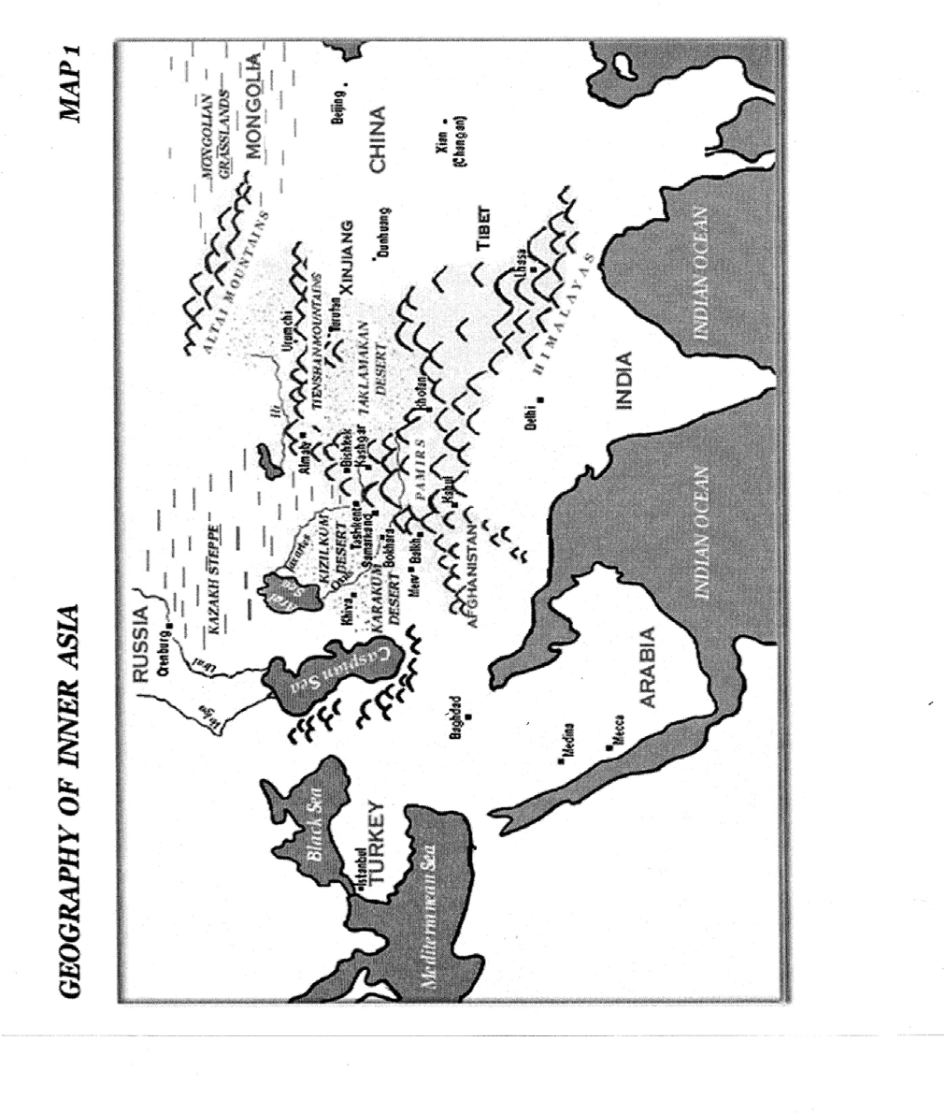

“Geography of Inner Asia” – Bizarre Bazaar http://www.eric.ed.gov/ERICDocs/data/ericdocs2sql/content_storage_01/0000019b/80/19/9b/1f.pdf

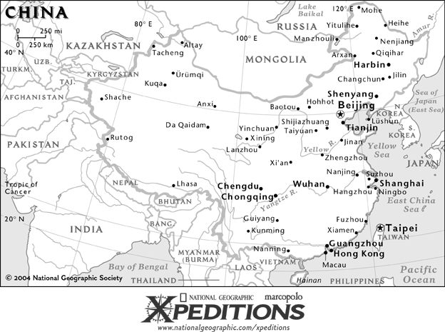
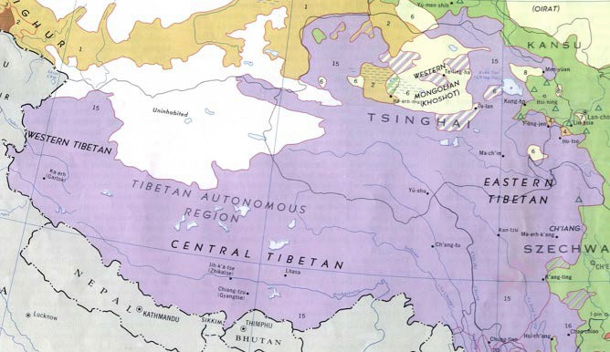
http://en.wikipedia.org/wiki/Image:Tibet_ethnolinguistic_1967.png

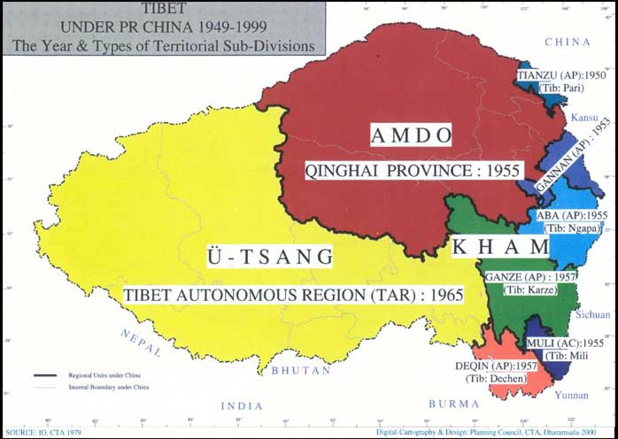

“Map of Tibet – Historical and Current Tibet” - http://www.tibet.net/en/images/tibet-map.jpg

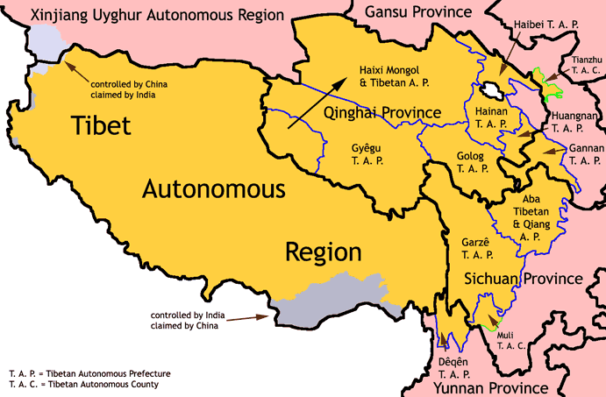

http://en.wikipedia.org/wiki/Image:TAR-TAP-TAC.png

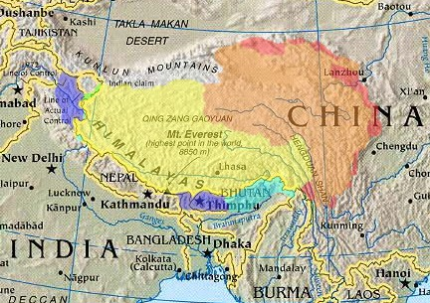

Historic Tibet as claimed by Tibetan exile groups
Tibetan areas designated by the People’s Republic of China (PRC)
Tibet Autonomous Region (TAR) (actual control)
Claimed by India as part of Aksai Chin
Claimed by PRC as part of Tibet Autonomous Region (TAR)
Other areas historically within Tibetan cultural sphere
(http://en.wikipedia.org/wiki/Tibet)

Semantic Map Sample

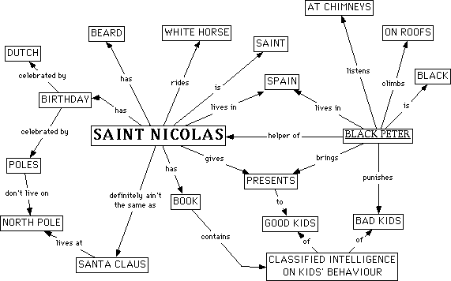

Definition: Concept maps offer a method to represent information visually. There are a variety of such maps.

Purpose: Concept maps harness the power of our vision to understand complex information "at-a-glance." The primary function of the brain is to interpret incoming information to make meaning. It is easier for the brain to make meaning when information is presented in visual formats. This is why a picture is worth a thousand words. It is essential to your studies and career that you can handle complex information; concept maps offer one method to do this.

Practical applications in your courses:

- Handy way to take notes during lecture.
- Excellent aids to group brainstorming.
- Planning your studies and career.
- Providing graphics for your presentations and term papers
- A way to outline your term papers and presentations.
- Refine your creative and critical thinking.

(Image and information found http://classes.aces.uiuc.edu/ACES100/Mind/CMap.html)

Student Blank Map Sheet with Questions

Name Directions:
- Label each region of Inner Asia (in black), capitals (in red), smaller but main cities (in orange), main rivers (in blue), and main mountain ranges (in brown).
- Create a key and legend with the elements included on their maps.
- Provide a written response to three (3) of the following questions after completing your map:
To what extent do the regional boundaries coincide with the physical boundaries?
How important is geography in determining boundaries? What other factors influence the designation of regions?
What challenges could arise due to imposed boundaries to the people living in those regions?
Based on physical geography, what kinds of settlements, dwellings, clothing, food and transportation would you expect to find in each region today? Why?
What is the size of Tibet compared with Inner Asia and Asia as a whole? Is there significant ethnic diversity in Tibet? In Asia? Explain.

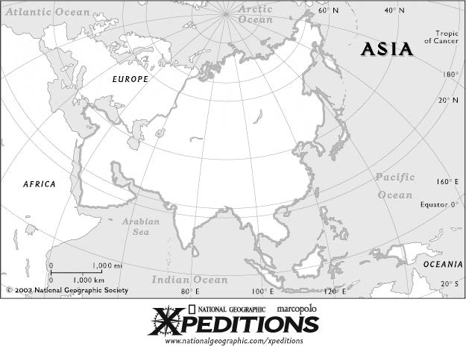

www.nationalgeographic.com/xpeditions/atlas/index.html?Parent=asia&Rootmap=&Mode=d&SubMode=

Student Map Resource Sheet (put questions on the back of the Student Map Resource Sheet when making copies)

Lesson 3: Tibetan History Grade Level: 9-12

Overview: This lesson is designed to introduce students to Inner Asian and Tibetan History. Included in the lesson will

Time: 45 minute class period

Materials:
- Teacher Content Information (provided at end of Unit)
- Student reading on Chinese and Tibetan History (provided)
- Student Timeline Form (provided)
- Teacher Timeline Answer Form (provided)
- Online Video Clip (website provided)

Objectives:
Students will:
- Complete a timeline based on a reading of the history of Tibet
- Demonstrate an understanding of Tibetan History through a video clip on Tibetan history and on the New Tibet as well as through a graphic organizer
- Organize the Tibetan events by the date listed in the chart
- Classify the Tibetan events as important culturally (C), politically (P), economically (E), geographically (G), and/or historically (H)
- Justify why they believe the event was significant (C,P,E,G, and/or H).

Procedures:

Opening Activity:
- Ask students “What do you know about Tibetan History?”
- Tell students to write 1-2 things they know (or believe they know) about Tibetan History on a piece of notebook paper. Tell students that if they don’t think they know anything about Tibetan history to write down 1-2 questions they have about Tibetan history. They will share what they know aloud but not turn in the paper. Give students about 5 minutes to address question.

- Ask students again, “So, what do you know about Tibetan History?”

- Ask for volunteers to share some of their responses or the questions they have. (There should be some responses, but if not, tell students that today’s lesson will help them answer this question as they are going to learn about the history of Tibet.)
- Teacher should write responses and questions on the board or on an overhead. Discussion can occur based on students’ comments or questions or teacher can lead students directly to the main activity.

Main Activity:
- Tell students that you are going to show them a video clip to help them get an initial understanding of the history of Tibet as well as of the New Tibet. Share with students the following clip on Tibetan History and on the New Tibet (you will need a computer with a projector and screen): http://current.com/pods/international/PD03728
- Explain that the video was to help frame the activity in which the students will be participating. Answer any questions students pose about the video and hold a mini- discussion if necessary.
- Explain to students that they are going to be reading a passage on Tibet’s History. Students will be using information from the passage to complete a Timeline Chart.
- Pass out a copy of the reading passage and Timeline Form to each student. Explain that some of their answers may be lengthy requiring additional paper while others will be rather short.
- Explain to students that they will work in pairs/small groups (whatever suits the class the best) to complete the reading and the Timeline Form. Most of the work should be completed in class, however, the last column of the Form requires thought and complete answers which may prevent students from completing the entire form in class.
- Divide students into pairs or small groups (whatever suits the class the best). Students can work at their seats or somewhere else in the room.
- Walk around making to ensure students understand what they are reading and are able to complete the Form. Teacher should make certain that the last column is answered fully before allowing students to get too far ahead.

Closing Activity:
- Explain to students that there are more than 10 important events in Tibetan History. However, this is a good way to get an overview of the History of Tibet and its connection with China.
- Tell students that in addition to completing the Form, on the back of their form, they should think about how the Chinese-Tibetan relationship can be seen as positive and negative to the Tibetan people as this will be a topic of the next lesson (If the teacher elects to address the Inner Asian Conflict and Imperial Expansion).

Assessment:
Students will demonstrate their understanding of Tibetan History through completing the graphic organizer. Students will also demonstrate their ability to correctly and thoughtfully categorize events defending their choices.

*Note: Teacher should add or delete dates listed on the Timeline Form to align with goals of class, department, school, or district. Additional information on Tibetan History can be found in Teacher Content Information at the end of this Unit as well as in the resource section.

Extension:
Students can research specific events or rulers within Tibetan History. Students can also complete comparative analyses of Tibetan History to American History (or another area of the world).

Student Information Sheet on an Overview of Tibet and its History
Tibet has a documented history that began in the 7th century AD. These 1400 years of history can be roughly divided into four periods: the dynastic period (7th -11th centuries), the first period of Buddhist rule (11-14th centuries), the period of chaos (14th – 17th centuries), and the period of the Dalai Lama (17th century – present).

Early History and Foreign Contacts

Evidence of human habitation dating between 12,000 and 11,000 years ago has been found in NW and S Tibet, with the focus being on ancient trade routes from India, China, and Central Asia. Tibet emerged from a murky history to flourish in the 7th cent.
A.D. as an independent kingdom with its capital at Lhasa. The Chinese first established relations with Tibet during the T'ang dynasty (618–906), and there were frequent wars of conquest. The Tibetan kingdom was associated with early Mahayana Buddhism, which the scholar and mystic Padmasambhava fashioned (8th cent.) into Tibetan Buddhism.
Toward the end of the 12th cent. many Indian Buddhists fled to Tibet before the Muslim invasion. In the 13th cent. Tibet fell under Mongol influence, which was to last until the 18th cent. In 1270, Kublai Khan, emperor of China, was converted to Buddhism by the abbot of the Sakya lamasery; the abbot returned to Tibet to found the Sakya dynasty (1270–1340) and to become the first lama to rule Tibet. In 1720, the Ch'ing dynasty replaced Mongol rule in Tibet. China took political control but not completely.
During the 18th centuries, British authorities in India attempted to establish relations with Lhasa (Tibet’s capital), but the Gurkha invasion of 1788 and the subsequent Gurkha war (1792) with Tibet brought an abrupt end to the any friendly relations. Throughout the 19th century, Tibet maintained its traditional seclusion.

Tibet and China

In 1906-1907, Britain recognized China's political power over Tibet. However, the Tibetans were able, with the overthrow of the Ch'ing dynasty in China, to expel the Chinese in Tibet and reassert their independence. At a conference (1913–14) of British, Tibetans, and Chinese at Shimla, India, Tibet was tentatively confirmed under Chinese power and divided into an inner Tibet, to be incorporated into China, and an outer autonomous Tibet. The Shimla agreement was, however, never approved by the Chinese, who continued to claim all of Tibet as a “special territory.” After the death (1933) of the 13th Dalai Lama, Tibet drifted back into the Chinese orbit. The 14th Dalai Lama, born in China, was installed in 1939–40 and assumed full powers (1950).
The succession of the 10th Panchen Lama, with rival candidates supported by Tibet and China, was one of the excuses for the Chinese invasion (1950) of Tibet. By a Tibetan-Chinese agreement (1951), Tibet became a “national autonomous region” of China under the traditional rule of the Dalai Lama, but under the actual control of a Chinese Communist Commission. The Communist government introduced far-reaching land reforms and sharply curtailed the power of the monastic orders. After 1956 scattered uprisings occurred throughout the country, but a full-scale revolt broke out in Mar., 1959, prompted in part by fears for the personal safety of the Dalai Lama. The

Chinese suppressed the rebellion, but the Dalai Lama was able to escape to India, where he eventually established headquarters in exile.
The Panchen Lama, who had accepted Chinese sponsorship, acceded to the spiritual leadership of Tibet. The Chinese adopted brutal repressive measures, provoking charges from the Dalai Lama of genocide. Landholdings were seized, the lamaseries were virtually emptied, and thousands of monks were forced to find other work. The Panchen Lama was deposed in 1964 after making statements supporting the Dalai Lama; he was replaced by a secular Tibetan leader. In 1962, China launched attacks along the Indian-Tibetan border to consolidate territories it claimed had been wrongly given to India by the British McMahon Commission in 1914. Following a cease- fire, Chinese troops withdrew behind the disputed line in the east but continued to occupy part of Ladakh in Kashmir. Some border areas are still in dispute.
In 1965 the Tibetan Autonomous Region (TAR) was formally established. The Cultural Revolution, with its antireligious orientation, was disastrous for highly religious Tibet. Religious practices were banned and over 4,000 monasteries were destroyed.
Though the ban was lifted in 1976 and some Buddhist temples have again been in operation since the early 1980s, Tibetans continue to complain of widespread discrimination by the Chinese. Several protests in Tibet in the late 1980s and early 1990s were violently suppressed by the Communist government and martial law was imposed in 1989. Demonstrations against Chinese rule have nevertheless continued. Moreover, in recent years other countries have increasingly raised the issue of human- rights violations in Tibet, and have pressured the Chinese government to moderate their stance in that region.
Religious tensions were again underscored in Jan., 2000, when the 14-year-old Karmapa lama fled Tibet for India to find refuge with the Dalai Lama (http://www.infoplease.com/ce6/world/A0861546.html) The Karmapa is Tibet's third- ranking reincarnated bodhisattva, or enlightened being, after the Dalai Lama and the Panchen Lama. The teenager's status had been formally recognized by both the exiled Tibetan government and Beijing. His escape represents a serious blow to Beijing's efforts to win support for its control over Tibet. And it could set back improving relations between India and China (www.time.com/time/asia/magazine/2000/0117/tibet.epicjourney.html).

Professor Grunfeld, a professor of history at SUNY-Empire State College states that “Independence for Tibet is possible only in the unlikely event of the breakup of the Chinese state. However, real Tibetan autonomy within the larger Chinese state, a situation that existed for several hundred years prior to 1951, may still be possible today. The Dalai Lama's public pronouncements have become clear indication he is reaching out to moderate officials, who while not currently directing policy towards Tibet, are still in the government. The moderates must also be pointing out to their colleagues that escalating restrictions on Tibetan culture in the TAR can only intensify anti-Chinese feelings among the Tibetans.”(www.globaled.org/chinaproject/teachingmaterials/seminar/6a1.php)

*Use the Timeline Grid to organize the above information on China and Tibet by date and event.

Student Timeline Grid Form: Name
Organize the Chinese and Tibetan events by the dates/century (cent.) listed in the chart. Identify the event/s as important culturally (C), politically (P), economically (E), geographically (G), and/or historically (H). Justify why you believe the event/s was/were significant (C,P,E,G, and/or H). If an event is significant in more than one way, please explain.

* Multiple events may have happened during a particular century-be sure to list significant events in that century*

Date | Description of Event/s | (C) | (P) | (E) | (G) | (H) | What made this event important C,P,E,G, and/or H?
1.
618–
906
2.
*12th - 13th cent.
3.
*17th- 18th cent
4.
1906-
1913

5.
1930-
1940
6.
1950-
1951
7.
1956-
1959
8.
1960-
1970
9.
late 1980s -
early 1990s
10.
2000
*Be prepared to discuss how the Chinese-Tibetan relationship can be seen as positive and negative to the Tibetan people.

Teacher Timeline Grid Form Answer Sheet:

Organize the Chinese and Tibetan events by the dates/century (cent.) listed in the chart. Identify the event/s as important culturally (C), politically (P), economically (E), geographically (G), and/or historically (H). Justify why you believe the event/s was/were significant (C,P,E,G, and/or H). If an event is significant in more than one way, please explain.

* Multiple events may have happened during a particular century-be sure to list significant events in that century*

Date | Description of Event/s | (C) | (P) | (E) | (G) | (H) | What made this event important C,P,E,G, and/or H?
1.  618–  906 | Tibet emerged from a murky history to flourish in the 7th cent. A.D. as an independent kingdom with its capital at Lhasa. The Chinese first established relations with Tibet during the T'ang dynasty and there were frequent wars of conquest. |  |  |  |  |  | *All options (C,P,E,G, and/or H) are possible, but students may not identify all significant options. They should, however, identify more than one  *For this section, students’ reasoning and debate skills are most important. As long as their responses make sense, are connected to their description/s of the event/s, and are appropriately linked to C,P,E,G, and/or H, consider responses correct. Teacher may want to embellish with additional information or perspective.
2.  *12th - 13th cent. | Many Indian Buddhists fled to Tibet before the Muslim invasion. 13th cent- Tibet fell under Mongol influence- lasted until the 18th cent. In 1270, Kublai Khan, emperor of China, converted to Buddhism by the abbot of the Sakya lamasery; the abbot returned to Tibet to found the Sakya dynasty (1270–1340) and to become the first lama to rule Tibet. |  |  |  |  |  | *All options (C,P,E,G, and/or H) are possible, but students may not identify all significant options. They should, however, identify more than one  *For this section, students’ reasoning and debate skills are most important. As long as their responses make sense, are connected to their description/s of the event/s, and are appropriately linked to C,P,E,G, and/or H, consider responses correct. Teacher may want to embellish with additional information or perspective.
3.  *17th- 18th cent | 1720- Ch'ing dynasty replaced Mongol rule in Tibet. China took political control but not completely.18th century- British authorities in India tried to establish relations with Lhasa (Tibet’s capital), but the Gurkha invasion of 1788 and the subsequent Gurkha war (1792) with Tibet brought an end to friendly relations. |  |  |  |  |  | *All options (C,P,E,G, and/or H) are possible, but students may not identify all significant options. They should, however, identify more than one  *For this section, students’ reasoning and debate skills are most important. As long as their responses make sense, are connected to their description/s of the event/s, and are appropriately linked to C,P,E,G, and/or H, consider responses correct. Teacher may want to embellish with additional information or perspective.
4.  1906-  1913 | 1906-1907, Britain recognized China's political power over Tibet. However, Tibetans expelled the Chinese in Tibet and reassert their independence. 1913–14 Tibet was tentatively confirmed under Chinese power and divided into an inner Tibet, to be added to China, and an outer autonomous Tibet. the Chinese, however, continued to claim all of Tibet. |  |  |  |  |  | *All options (C,P,E,G, and/or H) are possible, but students may not identify all significant options. They should, however, identify more than one  *For this section, students’ reasoning and debate skills are most important. As long as their responses make sense, are connected to their description/s of the event/s, and are appropriately linked to C,P,E,G, and/or H, consider responses correct. Teacher may want to embellish with additional information or perspective.

5.  1930-  1940 | After the death (1933) of the 13th Dalai Lama, Tibet drifted back into the Chinese orbit. 14th Dalai Lama, born in China, was installed in 1939– 40 (and took complete control by 1950) |  |  |  |  |  | *All options (C,P,E,G, and/or H) are possible, but students may not identify all significant options. They should, however, identify more than one  *For this section, students’ reasoning and debate skills are most important. As long as their responses make sense, are connected to their description/s of the event/s, and are appropriately linked to C,P,E,G, and/or H, consider responses correct. Teacher may want to embellish with additional information or perspective.
6.  1950-  1951 | The succession of the 10th Panchen Lama, was one of the excuses for the Chinese invasion (1950) of Tibet. By a Tibetan-Chinese agreement (May, 1951), Tibet became a “national autonomous region” of China under the traditional rule of the Dalai Lama, but remained in control by the Chinese Communist Commission. The Communist government introduced far- reaching land reforms and sharply curtailed the power of the monastic orders. |  |  |  |  |  | *All options (C,P,E,G, and/or H) are possible, but students may not identify all significant options. They should, however, identify more than one  *For this section, students’ reasoning and debate skills are most important. As long as their responses make sense, are connected to their description/s of the event/s, and are appropriately linked to C,P,E,G, and/or H, consider responses correct. Teacher may want to embellish with additional information or perspective.
7.  1956-  1959 | 1956-scattered uprisings occurred throughout the country, with a full-scale revolt 1959. This was prompted by fears for the personal safety of the Dalai Lama. The Chinese suppressed the rebellion, but the Dalai Lama escaped to India, where he established headquarters in exile. |  |  |  |  |  | *All options (C,P,E,G, and/or H) are possible, but students may not identify all significant options. They should, however, identify more than one  *For this section, students’ reasoning and debate skills are most important. As long as their responses make sense, are connected to their description/s of the event/s, and are appropriately linked to C,P,E,G, and/or H, consider responses correct. Teacher may want to embellish with additional information or perspective.
8.  1960-  1970 | The Panchen Lama acceded to the spiritual leadership of Tibet. The Chinese adopted brutal repressive measures (such as seizing land, emptying lamaseries which forced monks to work). This provoked charges from the Dalai Lama of genocide.  1964-Panchen Lama removed after saying he supported the Dalai Lama; he was replaced by a secular Tibetan leader. 1962- China attack the Indian-Tibetan border to consolidate territories. Some border areas are still in dispute.  1965-Tibetan Autonomous Region (TAR) was formally established. The Cultural Revolution, with its antireligious orientation, was disastrous for highly religious Tibet. Religious practices were banned and over 4,000  monasteries were destroyed. |  |  |  |  |  | *All options (C,P,E,G, and/or H) are possible, but students may not identify all significant options. They should, however, identify more than one  *For this section, students’ reasoning and debate skills are most important. As long as their responses make sense, are connected to their description/s of the event/s, and are appropriately linked to C,P,E,G, and/or H, consider responses correct. Teacher may want to embellish with additional information or perspective.

9.  late 1980s -  early 1990s | Several protests in Tibet were violently suppressed by the Communist government-martial law was imposed in 1989.  Demonstrations against Chinese rule continued. Recently, other countries have raised issue of human-rights violations in Tibet, and have pressured the Chinese government to moderate their stance in that region. |  |  |  |  |  | *All options (C,P,E,G, and/or H) are possible, but students may not identify all significant options. They should, however, identify more than one  *For this section, students’ reasoning and debate skills are most important. As long as their responses make sense, are connected to their description/s of the event/s, and are appropriately linked to C,P,E,G, and/or H, consider responses correct. Teacher may want to embellish with additional information or perspective.
10.  2000 | 14-year-old Karmapa lama fled Tibet for India to find refuge with the Dalai Lama. His escape represents a serious blow to Beijing's efforts to win support for its control over Tibet. This could set back improving relations between India and China. |  |  |  |  |  | *All options (C,P,E,G, and/or H) are possible, but students may not identify all significant options. They should, however, identify more than one  *For this section, students’ reasoning and debate skills are most important. As long as their responses make sense, are connected to their description/s of the event/s, and are appropriately linked to C,P,E,G, and/or H, consider responses correct. Teacher may want to embellish with additional information or perspective.

Lesson 4: Buddhism
Grade Level: 9-12

Overview: This lesson is designed to introduce students to Tibetan History and Buddhism. Included in the lesson will be an overview of the history of Tibet, Buddhism and its beliefs, religious items associated with Buddhism, the spread of Buddhism, major Buddhist Monastery sites, and information on the Dalai Lama.

Time: 45 minute class period

Materials:
- Computer with projector and a screen needed for Video Clip & Powerpoint Presentation
- Video Clip on Buddhism (Website provided-Real Player or Windows Media Player needed)
- PowerPoint Presentation (provided on CD)*
(Copies of PowerPoint slides are provided if computer is not available. Copies of slides can be turned into transparencies to use with an overhead projector).
- Notes on Buddhism Page (provided)
(use information provided to students on Buddhism as well as Teacher Content Information to assess students’ responses which is provided at end of Unit)
- Student Information Page on Buddhism (provided)
- EXTRA CREDIT on BUDDHISM Page (provided)

Objectives:
Students will:
- Explore the fundamentals of Buddhism and its beliefs
- Identify key components of Buddhism and its beliefs
- Understand the spread of Buddhism
- Generate thoughtful questions and answers based on newly learned information about Buddhism

Procedures:
Opening Activity:
- Share the Buddhism vocabulary with students (either write terms on the board, put terms on an overhead, or put terms on a PowerPoint slide).
- Ask students to think about what these words have in common, where they have seen these words before, or what they know about these words. Hold a mini-discussion if

needed. Explain that the words all relate to Buddhism, a religion and philosophy commonly followed/practiced in Asia and in other parts of the world.
- Explain that you are going to share with them a video and presentation on Buddhism and that they will need to take notes by filling in an outline on Buddhism that you have prepared. Their notes will be used to create questions with answers at the end of the class period and these questions may be used on their final assessment of Inner Asia and Tibet.
- To access Buddhism Video Clip, go to site listed below, select “What is Buddhism” video, and choose either Real Player 300K or Windows Media Player 300K http://www.libraryvideo.com/series_streaming.asp?mscssid=2E9D5XHR5SU69LXLRBG PST6FE01GD5E3&sku=K6760&s_sku=K6760

Main Activity (Direct instruction):
- While you pass out the Notes on Buddhism page to students, explain that you are going to show a short video clip on Buddhism followed by a PowerPoint Presentation. They will need to read the Notes on Buddhism page to see what information they need to listen for before the video clip begins (give them 2-3 minutes to read over sheet). Explain that they will not get all of the information for their Notes Page from the video.
- Show video clip and after it has finished, ask if there are questions so far about the material presented. Discuss questions or issues raised before moving on.
- Show PowerPoint Presentation (PPP). Since students are looking for information, be aware that you may need to move more slowly through the slides. After the PPP has finished, ask if there are questions so far about the material presented. Discuss questions or issues raised before moving on.

Main Activity (Pair work):
- Explain that the students are to work in pairs to create 8 thoughtful questions with accurate and reasonable answers based on the video, Powerpoint Presentation, the notes they took during the lesson, and from the class discussion. Questions should address main points about Buddhism and should not be “Yes or No” responses or responses that are one word answers.
- Teacher should walk around to ensure questions are thoughtful, incorporate material presented in class, and that the students’ answers appropriately match their questions.
- For extra credit, students can respond to one or both of the following:
(either in class with their partner or at home this evening): For any students interested in responding to the extra credit, provide the EXTRA CREDIT SHEET.

  - “Explain how Buddhism can be viewed by some as both a religion and philosophy but by others as neither a religion nor philosophy.” (10 pts)

  - Explain how a Buddhist would respond to the following situations? (5 pts)

    - A student knows that they are failing a class. Students from each of these doctrines know they will be in trouble when their parents find out. How do they handle this situation?
    - A student's friends smoke and are trying to get them to start. How do they handle this situation?
    - A student sees an opportunity to take something they have really wanted, without being caught. How should that student act?

Closing Activity
- Ask students if they believe there are parts of Buddhism in their religion or in the way treat others and view life. Ask for examples.
- Remind students that if they have not completed the 8 questions with answers, that they must complete them for homework and submit them at the beginning of the following class. Also remind them of the extra credit option.

Assessment:
Students will demonstrate understanding of the basics of Buddhism, its beliefs, the rulers, monasteries, etc. through discussion and through creating questions with answers based on material presented during lesson.

Extension:
Students can research specific events or aspects of Buddhism. Students can also complete comparative analyses of Buddhism to either their own religion or Christianity.

Terms:

Siddhartha Gautama

Buddha

The Middle Way

Karma

Four Noble Truths

Love, wisdom, goodness, calm, and self-control

Dalai Lama

Monks

Nirvana

Prayer wheel and prayer flags

Monasteries

Notes on Buddhism:
Directions: As you watch the video and read the passage, complete this page of information Buddhism. You will use this information to create and answer 8 (eight) questions which may be used on a final assessment of Inner Asia and Tibet.

Meaning of name "Buddhism":
Date founded:
Place founded:
Founder of Buddhism:
Approximate number of followers/practitioners:
Main locations where Buddhism is practiced:
Major divisions (or schools):
1.
2.
3.
Spiritual leader of Buddhism:
Ultimate belief:
Purpose of life (may be different based on the different types of Buddhism practiced):
Three Jewels and what they mean:
1.
2.
3.

Four Noble Truths:
1.
2.
3.
4.

Noble Eightfold Path:
1.
2.
3.
4.
5.
6.
7.
8.

Describe the spread of Buddhism:

Explain why Monasteries are important:

Name two famous and important Buddhist structures or buildings:

1.
2.

Name of the current Dalai Lama:

How many Dalai Lamas have come before the current one?

Place where the Dalai Lama is currently living:

Reason why the Dalai Lama is not living in Tibet:

Slides for Powerpoint Presentation on Buddhism:
- Defining Buddhism
- Who was the Buddha?
- What did Buddha teach?
- What is the 8-Fold Path?
- The 3 Jewels of Buddhism
- What do Buddhists Believe?
- The Spread of Buddhism
- Three Major Types of Buddhism
- Schools of Buddhism-Theravada
- Schools of Buddhism- Mahayana
- Schools of Buddhism- Tibetan
- The Dalai Lama
- Additional Schools of Buddhism- Buddhism in the West & Zen Buddhism
- Importance of Monasteries
- Major Buddhist Sites-Potala Palace
- Major Buddhist Sites-Jokhang Temple
- Major Buddhist Sites-Tashilhunpo Monastery
- Buddhism Resources

Student Information on Buddhism

Buddhism is a religion to about 300 million people around the world. The word comes from 'budhi', 'to awaken'. It has its origins about 2,500 years ago when Siddhartha Gotama, known as the Buddha, was himself awakened (enlightened) at the age of 35. To many, Buddhism goes beyond religion and is more of a philosophy or 'way of life'. It is a philosophy because philosophy 'means love of wisdom' and the Buddhist path can be summed up as:
- to lead a moral life,
- to be mindful and aware of thoughts and actions, and
- to develop wisdom and understanding.

Buddhism is becoming popular in western countries for a number of reasons, The first good reason is Buddhism has answers to many of the problems in modern materialistic societies. It also includes (for those who are interested) a deep understanding of the human mind (and natural therapies) which prominent psychologists around the world are now discovering to be both very advanced and effective.

In general, Buddhism is a way of finding peace within oneself. It is a religion that helps us to find the happiness and contentment we seek. Buddhists develop inner peace, kindness and wisdom through their daily practice; and then share their experience with others bringing real benefit to this world. They try not to harm others and to live peacefully and gently, working towards the ultimate goal of pure and lasting happiness for all living beings. (http://www.aboutbuddhism.org/)

"Awakened One" (Buddha): Prince Siddhartha Gautama, who would one day be known as the Buddha, began his life as a prince in a kingdom in ancient India. Prince Gautama (Buddha) was born about 553 BCE. He had parents who loved him, many servants to wait on him, the finest clothes, and a different palace for each season of the year. Yet, he found his world full of suffering. It upset him that painful old age, sickness, and death were all part of life in this world.

One day, he met a monk. He was amazed that this monk could find calm and peace in a world filled with such sufferings. That day he made a very difficult decision. He decided to leave his wealth, his comfort, his wife, and his newborn son, to become a monk. For the next six years he traveled throughout India. But the answers he found were not enough. One day, while sitting under a fig tree, an understanding came to him. This understanding was a way to end suffering. That was the day Prince Siddhartha Gautama began to earn a new title, the Buddha, which means "Awakened One".

Four Noble Truths: His journey to find the meaning of life had concluded. The Buddha realized that life is ruled by Four Noble Truths: one, Life is filled with suffering; two, Suffering is caused by people's wants; three, Suffering can be ended if people stop wanting things, like more pleasure or more power; and four, To stop wanting things, people must follow 8 basic laws, called the Eightfold Path.

Eightfold Path: In brief, these are the laws of the Eightfold Path: To know the truth, To intend to resist evil, To not say anything to hurt others, To respect life, property, and morality, To work at a job that does not injure others, To try to free one's mind from evil, To be in control of one's feelings and thoughts, and To practice appropriate forms of concentration

The Middle Way: The Eightfold Path was designed to guide people without making life too strict or too easy. The Middle Way is the name Buddhists call lives guided by the laws of the Eightfold

Path. Buddha spent the rest of his life traveling around India and sharing his message with everyone. He had many followers, who lived according to his Four Noble Truths. Some of his followers became Buddhist monks. They gave up all they owned and depended on other followers and kind hearted people to give them food. Their message was one of love.

After the Buddha's death in 483 BCE, Buddhism spread rapidly throughout Southern and Eastern Asia.

The Laughing Buddha: Have you ever seen a ceramic or carved representation (a statue) of the Buddha, perhaps in a Chinese restaurant, or for sale in a store, or in your home or garden? Have you ever wondered why the Buddha is laughing?

The laughing Buddha reminds us that to be happy we need to have a loving heart. A big heart gives you tolerance. It helps you to greet each day with joy and all people with gladness. It helps you to tolerate a great many things with a big happy smile that reaches your eyes and your heart. Buddha says that the best way to solve a problem we might have with someone else is to have a warm and loving heart. By not being resentful, by not bearing grudges, only then are we able to smile like the Buddha - only then can we be truly happy.

The Goal - To Become The Greatest Person in the World: Buddhism teaches that being the greatest is an absolute achievement free of comparison. What does that mean? It means that to be the greatest is not an achievement that can be attained through competition. You can't win greatness - but you can achieve it. That means everyone can be the greatest.

Here's an example: For a healthy ant to successfully carry one grain of rice is a great achievement. For a healthy horse to successfully carry one grain of rice is not all that terrific. The ant has put his best effort into his job. It has fulfilled its purpose as an ant. When this truth is achieved, the ant is no longer just an ant. The ant has moved into the realm of Truth - it has become the greatest ant in the world.

Buddhism teaches that a person is successful not because he or she is better than someone else, and not because they received a higher grade on a test or won a Gold Medal at the Olympics, or beat out other ants to see who could carry the biggest and heaviest grain of rice. True achievement does not come from competition or comparison. A person (or an ant, or a horse) is successful because he or she has given their best within their means. For this reason, every single person can become the greatest person in the world, all at the same time.

The Growth of Buddhism: Buddhism values love, wisdom, goodness, calm, and self-control. Buddhists believe that The Buddha and his teachings should be honored, that people should try to end suffering, that they should follow the Eightfold Path. In T'ang times, people thought of Buddhism as a chart of behavior that they could follow to lead them to a life beyond the grave.

Today, Buddhism is a major world religion. There are over 300 million Buddhists in the world.

(Information from http://ancienthistory.mrdonn.org/Buddhism.html)

EXTRA CREDIT on BUDDHISM:

- Explain how Buddhism can be viewed by some as both a religion and philosophy but by others as neither a religion nor philosophy. (10 pts)

- Explain how a Buddhist would respond to the following situations?(5 pts)
  - A student knows that they are failing a class. Students from each of these doctrines know they will be in trouble when their parents find out. How do they handle this situation?
  - A student's friends smoke and are trying to get them to start. How do they handle this situation?
  - A student sees an opportunity to take something they have really wanted, without being caught. How should that student act?

Possible Responses for Extra Credit:

- “Explain how Buddhism can be viewed by some as both a religion and philosophy but by others as neither a religion nor philosophy.”

Buddhism is an ethical system — a way of life — that leads to a very specific goal and that possesses some aspects of both religion and philosophy:

It is a philosophy.

Like most philosophies, Buddhism attempts to frame the complexities of human existence in a way that reassures us that there is, in fact, some underlying order to the Universe. In the Four Noble Truths the Buddha crisply summarizes our predicament: there is suffering, it has a cause, it has an end, and there is a way to reach the end. The teachings on kamma provide a thorough and logically self-consistent description of the nature of cause-and-effect. And even the Buddhist view of cosmology, which some may at first find farfetched, is a logical extension of the law of kamma. According to the Dhamma, a deep and unshakable logic pervades the world.

It is not a philosophy.

Unlike most philosophical systems, which rely on speculation and the power of reason to arrive at logical truths, Buddhism relies on the direct observation of one's personal experience and on honing certain skills in order to gain true understanding and wisdom. Idle speculation has no place in Buddhist practice.
Although studying in the classroom, reading books, and engaging in spirited debate can play a vital part in developing a cognitive understanding of basic Buddhist concepts, the heart of Buddhism can never be realized this way. The Dhamma is not an abstract system of thought designed to delight the intellect; it is a roadmap to be used, one whose essential purpose is to lead the practitioner to the ultimate goal, nibbana.

It is a religion.

At the heart of each of the world's great religions lies a transcendent ideal around which its doctrinal principles orbit. In Buddhism this truth is nibbana, the hallmark of the cessation of suffering and stress, a truth of utter transcendence that stands in singular distinction from anything we might encounter in our ordinary sensory experience. Nibbana is the sine qua non of Buddhism, the guiding star and ultimate goal towards which all the Buddha's teachings point. Because it aims at such a lofty transcendent ideal, we might fairly call Buddhism a religion.

It is not a religion.

In stark contrast to the world's other major religions, however, Buddhism invokes no divinity, no supreme Creator or supreme Self, no Holy Spirit or omniscient loving God to whom we might appeal for salvation.¹ Instead, Buddhism calls for us to hoist ourselves up by our own bootstraps: to develop the discernment we need to distinguish between those qualities within us that are unwholesome and those that are truly noble and good, and to learn how to nourish the good ones and expunge the bad. This is the path to Buddhism's highest perfection, nibbana. Not even the Buddha can take you to that goal; you alone must do the work necessary to complete the journey: (http://www.accesstoinsight.org/lib/authors/bullitt/bfaq.html#neither-and-both)

- Explain how a Buddhist would respond to the following situations?
  - Try to improve. If they don't improve, accept punishment gracefully
  - Help them to try and stop smoking.
  - Would not take it. Respect other people's property

Lesson 5: Imperial Expansion: Inner Asian Conflict, Conquest, and Expansion

Time: 2-45 minute classes (or one 90-minute block) Day 1-Opening Activity and Main Activities A & B Day 2- Main Activities C & D and Closing Activity

Overview: In this lesson, students learn the meaning of imperialism and about the issues surrounding Tibet’s struggle for independence since China’s invasion in 1950. They then write dialogues discussing the issue from opposing points of view. These dialogues are to be used to help students prepare for a role play so students can demonstrate their understanding of China’s invasion of Tibet.

*Note: This lesson is adapted from http://www.nytimes.com/learning/teachers/lessons/20071017wednesday.html?searchpv
=learning_lessons#standards

Materials:
- American Imperialism Examples Sheet (provided-give 1 copy to each pair)
- Tibet map (provided-give 1 copy to each pair) http://www.tibetmap.com/TARbr.html
- Copies of NY Times article-(provided- give 1 per student)
http://www.nytimes.com/learning/teachers/featured_articles/20071017wednesday.html
- Timeline – (provided-make into a transparency to share with whole class and/or give each student a copy) http://www.pbs.org/wgbh/pages/frontline/shows/tibet/etc/cron.html
- Questions for NY Times article and for Point of View Statements (Provided)
- Overhead Machine (optional-use if timeline sheet is put on a transparency)
- Background of Tibetan History and Chinese Activities within Tibet (optional reading- provided)
- Inner Asian Conflict Content Reading for Teacher (provided at end of unit)

Objectives:

Students will:
- Define the concept imperialism
- Read a map showing the changing borders of Tibet
- Understand how geography impacted the Chinese conquest of Tibet
- Learn about China’s objections to President Bush’s proposed meeting with the Dalai Lama by reading and discussing the article "China Warns U.S. on Dalai Lama Trip."

- Use a timeline to discuss the issues surrounding Tibet’s struggle for independence since China’s invasion in 1950; Write dialogues expressing both points of view.
- Use dialogues written about Tibet’s struggle for independence to role play their view point.
- Determine whether or not Chinese conquest is considered an act of imperialism.

Procedures:

*Notes: In social studies classrooms, it is often important for students to understand abstract concepts within specific geographical and historical contexts. The goal of the entire lesson is to help students view conquest and imperialism through the geographical and political influence of historical China and Tibet. This first activity helps students define and redefine “imperialism” by working out the definition as a group. If this concept has already been introduced in this class, this activity can be skipped over. Instead of engaging in the entire concept lesson the teacher might simply ask students to describe the term as a reminder to the class. You also need to ensure students understand the term “sovereignty”. If this term has not been addressed in prior units of study, it is recommended that teacher explain or hold a mini-discussion about its meaning.

The goal of this activity is to help students form their own definition of this abstract term. Therefore, there is some flexibility in terms of their final definitions. The teacher should help them eliminate aspects that are not possible by helping them define what imperialism is not. One possible definition of imperialism is: The control by one country of the political, economic, or cultural life of another country.

Opening Activity:

- Introduce this activity by explaining to students that the day’s lesson is going to focus on the Inner Asian Conflict, specifically China’s invasion of Tibet.
- Explain that before they delve into this issue it is necessary that they understand what imperialism means.
- Provide students with the sheet containing examples of American Imperialism acts to help them form a working definition of imperialism (provided). You may want to make a transparency of this sheet and guide students through these examples.
- Ask students to write down what they think a definition of imperialism could be based on these examples and the discussion on the back of their example sheet.
- Then, instruct them to pair up with another student and share their definitions.

- Students should engage in a Think-Pair-Share with their partner/s and discuss the meaning of imperialism based on their own definitions they previously wrote down.
- Tell the students to add and subtract newly acquired information as they reform their definition with their partner/s.
- After pairs have finished, regroup and discuss as an entire class what the pairs of students had decided on as a definition of imperialism.
- At this time ask students to offer additional examples and non-examples of imperialism. They should explain why an example would be or would not be considered an example of imperialism. Throughout this process, help students develop/redevelop their definition of imperialism.
- As a class, come up with a working definition of imperialism.
Main Activities:

Activity A):
- Give copies of the Tibetan map showing the changing borders of Tibet over the past century to the pairs of students. (provided)
- Have students work in pairs to review the map and discuss how the changing borders has positively and negatively impacted both Tibet and China.
- Provide a few minutes for pairs of students to complete this task.
- Regroup to share what the pairs had discussed regarding the impact of the changing borders. The teacher can either record students’ responses on the board or on an overhead, if desired.

Activity B):

- As a class, read and discuss the NY Times article "China Warns U.S. on Dalai Lama Trip" (http://www.nytimes.com/learning/teachers/featured_articles/20071017wednesday.html) focusing on the following questions:

*Note: It is recommended that the teacher print these questions for students so that they can read the questions prior to reading the article and respond in small groups to 2 of the questions (like a & b, or c & d, or e & f). After small groups have responded to their questions, groups can share their answers with the entire class so all students can hear possible responses to all questions.

  - Why are Chinese officials opposed to the Dalai Lama’s planned visit with President Bush?

  - What steps are the White House taking to respect China’s opinion on the matter of the Dalai Lama receiving the Congressional Gold Medal and why?

  - What does it mean to respect Chinese sovereignty over Tibet?

  - What is the Dalai Lama’s political and spiritual platform on Tibet and why is he in exile?

  - Why do you think the Communist Party boss of Tibet, Zhang Qingli, made statements against the Dalai Lama’s efforts toward Tibetan independence?

  - In your opinion, should China’s threats be taken more seriously by the United States?

Activity C:

*Note: As the timeline included is very detailed, you may wish to focus on the following years: 1949, 1950, 1959, 1965, 1976, 1988, 1990, and 1997.

- Review the timeline of significant events involving Tibet and China since 1949, when Mao Zedong and his People’s Liberation Army assumed political leadership of China and established the People’s Republic of China. Include the invasion of Tibet in 1950 by Chinese military forces which ended Tibetan independence.

- Discuss China’s suppression of religion freedoms and human rights prior to and during the Cultural Revolution and how that resulted in the political exile of the Dalai Lama.

- Provide an overview of the efforts of the Tibetan people and the Dalai Lama to regain Tibetan sovereignty between 1987 and 1997 and the status of Tibet today. As this source is very detailed, you may wish to focus on the following years: 1949, 1950, 1959, 1965, 1976, 1988, 1990, and 1997. Stop periodically during the discussion of the timeline to allow the class to ask questions or make comments. Note instances where the Chinese government and the Dalai Lama have had differing opinions.

Activity D):

- Have groups number off as 1’s or 2’s.

- Explain that the ones will be acting from the point of view of the Chinese government and the twos will be taking the point of view of the Dalai Lama and his supporters. If the class is large, students can number 1-4 with the 1’s and 3’s taking the point of the Chinese government and the 2’s and 4’s taking the view point of the Dalai Lama and his supporters.

- Have groups discuss their points of view and write simple statements describing the wants and beliefs of their respective sides on the debate over Tibetan sovereignty. Students may use the article, the map, the timeline of Tibetan history, and any other articles or information they find online to help write statements. You may wish to use the following guiding questions to encourage groups to go into greater depth:

  - What are the benefits of declaring Tibet a sovereign nation? What are the drawbacks of denying Tibetan sovereignty?

  - What are the political motives of each side?

  - What role would you like the United States to play in the current debate over Tibetan sovereignty?

  - What impact would Tibetan sovereignty have on the United States’ current relationship with China and the hopes for China’s cooperation on a global scale?

  - Is a compromise on this issue possible? What might be the terms of reconciliation?

- Once small groups have written position statements, have each student pair up with a partner from one of the groups with the opposite point of view.

- Have each pair then work together to write a dialogue between the Chinese government and the Dalai Lama on the issue of Tibetan sovereignty. All students should discuss whether or not Tibet should join China on its own accord.

- Encourage students to use the position statement their groups produced to strengthen the dialogue, but remind them that a dialogue should be a sensible, flowing conversation between two parties.

Activity D):

- Students are to share their dialogues from the pair work aloud with the rest of the class. Students should pretend that they are the person (ie: role playing) trying to make the class believe his or her stance on the issue.

- Teacher may want to ask for volunteers to do this if there is not enough time for all students to share their dialogues.

Closing:
- Individually, students should respond to the question supporting their response with facts from the lessons (this and prior), “Why or why not is the Chinese invasion of Tibet an example of imperialism?”

- This assignment can be shared at the beginning of the next class or reviewed by teacher.

*Note: Any of the questions listed below could be used instead of the one provided as a homework activity.

Additional Questions for Discussion:

-What other countries, like Tibet, have faced a similar debate over sovereignty?
-What human rights and freedoms do you value? How would you feel if you were unable to practice your beliefs in your country or home?
-How might history have been different if Tibet had had greater military power?
-What might have happened if the United Nations had acted on behalf of Tibet in 1950?

Assessment:
Students will be evaluated based on participation in the initial exercises, participation in group and class discussions, creation of accurate dialogues, ability to accurately demonstrate perspectives of those involved in the role play activity, and thoughtful response to question for homework.

Extension:
- Compare China’s invasion of Tibet to Iraq’s invasion of Kuwait in 1990 or the Soviet Union’s invasion of Afghanistan in 1980. How are these situations alike? How are they different? Why have these countries regained their sovereignty while Tibet has not? Write a summary of what you learned.

- How have the borders of other countries changed throughout history? Select a region and make a map that shows your findings.

- Read the article, “Dalai Lama's U.S. award not to affect Tibet's Stability,” found online on the China Internet Information Center's Web site (http://search1.china.com.cn/hlftiweb/search.jsp) and compare it to today’s article in the New York Times. Write a comparative essay discussing how these two different sources portray the Dalai Lama and his political agenda.

Examples of American Imperialism:
EXAMPLES OF MODERN AMERICAN IMPERIALISM: CHINA, 1945-51
"At the close of World War II, the US intervened in a civil war, taking the side of Chiang Kai- shek's Nationalists against Mao Tse-tung's Communists, even though the latter had been a much closer ally of the United States in the war.
"To compound the irony, the US used defeated Japanese soldiers to fight for its side.
"After their defeat in 1949, many Nationalist soldiers took refuge in northern Burma, where the CIA regrouped them, brought in other recruits from elsewhere in Asia, and provided a large supply of heavy arms and planes.
"During the early 1950s, this army proceeded to carry out a number of incursions into China, involving at times thousands of troops, accompanied by CIA advisers (some of whom were killed), and supplied by air drops from American planes."
EXAMPLES OF MODERN AMERICAN IMPERIALISM: MARSHALL ISLANDS, 1946-58

"Driven by perceived Cold War exigencies, the United States conducted dozens of Inter- continental ballistic missile (ICBM), nuclear bomb and other nuclear tests on this trust territory in the Pacific, after forcing the residents of certain islands, notably Bikini Atoll, to relocate to other, uninhabited islands.

"In 1968, the former residents of Bikini were told by the Johnson administration that their island had been cleaned and was safe for habitation. Many went back, only to be told later that they had been subjected to massive doses of radiation and would have to leave again.

"In 1983, the US Interior Department declared that the islanders could return to their homes immediately— provided they ate no home-grown food until the late 21st century. They have never returned."

EXAMPLES OF MODERN AMERICAN IMPERIALISM: ITALY, 1947-70’s

"In 1947, the US forced the Italian government to dismiss its Communist and Socialist cabinet members in order to receive American economic aid.

"The following year and for decades there-after, each time a combined front of the Communists and Socialists, or the Communists alone, threatened to defeat the US-supported Christian Democrats in national elections, the CIA used every (dirty) trick in the book and trained its big economic, political and psychological-warfare guns on the Italian people, while covertly funding the CD candidates.

"And it worked. Again and again. This perversion of democracy was done in the name of ‘saving democracy’ in Italy. American corporations also contributed many millions of dollars to help keep the left from a share of power."

Based on these examples, what is “IMPERIALISM?”

Map of Tibet’s Changing Borders
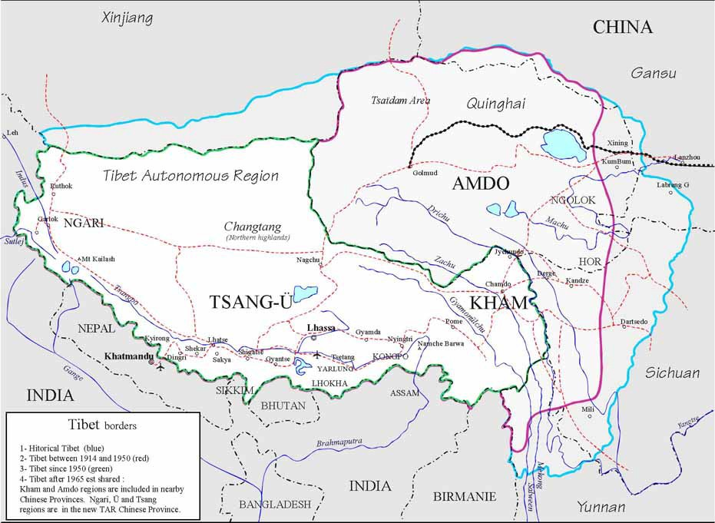

How do you think the changing borders have positively and negatively affected Tibet and China?

NY Times Article:
(http://www.nytimes.com/learning/teachers/featured_articles/20071017wednesday.html)

With One Eye on China, Bush Receives Dalai Lama, By SHERYL GAY STOLBERG
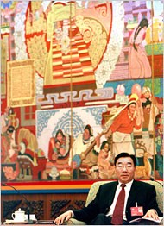
Teh Eng Koon/AFP-Getty Images
Tibet’s Communist Party boss, Zhang Qingli, at the Communist Party’s 17th National Congress in
Beijing today.

WASHINGTON, Oct. 16 — President Bush met privately with the Dalai Lama at the White House on Tuesday, as tensions escalated between the US and China over Congress’s awarding its highest civilian honor to the exiled Tibetan spiritual leader.

The 30-minute meeting, which the Dalai Lama said included a discussion of the situations in Tibet and Myanmar, formerly Burma, was fraught with symbolism and cloaked in secrecy — an effort by the White House to avoid further angering the Chinese.

The session was held upstairs in the Yellow Oval Room of the White House residence, not the Oval Office, to send a message that Mr. Bush was receiving a spiritual leader, not a political one.

Aides to Mr. Bush declined to disclose details of the discussion, and the White House would not release a photograph of the two together, as it has during previous visits.

“We in no way want to stir the pot and make China feel that we are poking a stick in their eye,” Dana Perino, the White House
press secretary, told reporters, adding, “We understand the Chinese have very strong feelings about this.”

The Dalai Lama, a Nobel laureate, has lived in exile in India since the Chinese army crushed an uprising in his homeland in 1959, and is revered as the spiritual leader of Tibetan Buddhists. He has been pressing, without success, to return to China to advocate for greater cultural and religious freedoms for his followers.

The Dalai Lama’s envoy, Lodi Gyari, who attended the meeting, said Mr. Bush described his efforts with China’s president, Hu Jintao, on the Dalai Lama’s behalf: “The president said he has been telling the Chinese president that you need to meet with this man, you should trust the Dalai Lama, I know this man and I trust him and you must not hesitate to meet with his holiness.”

At the end of the meeting, Mr. Gyari said, the Dalai Lama closed his eyes, as if in prayer, and then offered gifts to the president and first lady: white silk ceremonial shawls, which he draped around each of their necks.

The Dalai Lama is in Washington for a week of festivities. On Wednesday, he will receive the Congressional Gold Medal in a ceremony at the Capitol, and will later deliver a speech on the Capitol lawn. Mr. Bush will participate in the award ceremony, marking the first time he and the

Dalai Lama will have appeared together in public during this visit. That has infuriated the Chinese, who on Tuesday warned the United States not to honor the Dalai Lama, saying it would have “an extremely serious impact” on relations between the United States and China.

Speaking at a Foreign Ministry briefing and on the sidelines of the 17th National Congress of the Communist Party, the Communist Party boss of Tibet, Zhang Qingli, condemned the Dalai Lama as a “splittist” who wants to break Tibet away from China.

“Such a person who basely splits his motherland and doesn’t even love his motherland has been welcomed by some countries and has even been receiving this or that award,” Mr. Zhang said, adding, “We are furious.”

But the officials did not say what actions the Chinese would take. A senior White House official, speaking on condition of anonymity to avoid further straining relations, said the award was unlikely to seriously disrupt China’s relations with the United States, which have warmed as the countries have cooperated on an agreement to end North Korea’s nuclear program. “They know where we stand on the Dalai Lama and religious freedom, and we know where they stand,” the official said. “So we can all make these statements, but we wind up in the same place at the end of the day.”

Still, by participating in the ceremony, Mr. Bush will be walking a fine line. He began laying the groundwork to soothe Chinese feelings more than a month ago, in Sydney, where he told President Hu that he would attend the Congressional medal ceremony — at the same time that he accepted an invitation to attend the 2008 summer Olympics in Beijing.

Mr. Bush cannot afford to alienate Mr. Hu; he wants China to help end Iran’s nuclear program, as it has done with North Korea.

But on Monday, the Chinese postponed a meeting in Berlin at which world powers were to discuss Iran, raising speculation that it had done so because of the Dalai Lama’s visit to Washington. China also recently canceled its annual human rights dialogue with Germany, to protest the September meeting between Chancellor Angela Merkel and the Dalai Lama.

In a brief encounter with reporters on the sidewalk outside his Washington hotel after leaving the White House on Tuesday, the Dalai Lama shrugged off China’s protest. Dressed in his familiar flowing burgundy robe with gold trim, he threw up his hands when asked about the Chinese.

“Oh, that always happens,” he said, laughing.

He said Mr. Bush was “showing his concern about Tibet” and, “accordingly, I explained.” He also said he had “expressed my appreciation to Mrs. Bush” for her advocacy on Myanmar, where the military government last month cracked down on pro-democracy demonstrations led by Buddhist monks.

He described the meeting as “very good,” adding, “Since we know each other and we develop some kind of, I think, very close friendship, therefore something like a reunion of one family.”

Questions accompanying NY Times Article:

- Why are Chinese officials opposed to the Dalai Lama’s planned visit with President Bush?

- What steps are the White House taking to respect China’s opinion on the matter of the Dalai Lama receiving the Congressional Gold Medal and why?

- What does it mean to respect Chinese sovereignty over Tibet?

- What is the Dalai Lama’s political and spiritual platform on Tibet and why is he in exile?

- Why do you think the Communist Party boss of Tibet, Zhang Qingli, made statements against the Dalai Lama’s efforts toward Tibetan independence?

- In your opinion, should China’s threats be taken more seriously by the United States?

Questions to think about and address when writing points of view statements:

- What are the benefits of declaring Tibet a sovereign nation? What are the drawbacks of denying Tibetan sovereignty?

- What are the political motives of each side?

- What role would you like the United States to play in the current debate over Tibetan sovereignty?

- What impact would Tibetan sovereignty have on the United States’ current relationship with China and the hopes for China’s cooperation on a global scale?

- Is a compromise on this issue possible? What might be the terms of reconciliation?

Key Dates and Events in Tibetan history: (Entire timeline provided at end of unit)

1949 | In China the People's Liberation Army overcome the Nationalists (KMT) and, on October 1st, Mao Zedong proclaims the People's Republic of China. The 10th Panchen Lama, then 11 years old, telegrams Mao Tsetung  asking him to "unify the motherland". The PLA announces its intention to "liberate Tibet from foreign imperialists".
1950 | The 14th Dalai Lama, then 15 years old, takes over the running of the Government.  October 7th: the Chinese cross the Yangtse into Central Tibet and destroy the small garrison force at Chando,  claiming Tibet had always been Chinese territory. India objects. Tibet files protest with United Nations. Security Council approves British proposal to let the parties negotiate among themselves.
1959 | 10th March: thousands of Tibetans take to the streets in Lhasa.  March 17th: The Dalai Lama flees to India; 80,000 other Tibetans follow him. March 19th: Tibetan troops join the uprising against the Chinese.  March 23rd: Uprising suppressed. The Chinese dissolve the Tibetan local Government and impose military Government, fronted by the Panchen Lama, and in April begin "democratic reforms'. Thousands of Tibetans are executed, imprisoned, or sent to labor camps. Destruction of monasteries begins.
1965 | September 9th: The Tibet Autonomous Region is formally established. The Cultural Revolution begins, destroying 90% of the remaining monasteries and outlawing most Tibetan cultural customs and religion. The UN  passes a resolution supporting the Tibetan people's right to self-determination.
1967 | During Chinese Cultural Revolution, Tibetan temples, monasteries, libraries, and scared monuments destroyed or made into state museums.
1976 | The Cultural Revolution ends with the death of Mao. The Chinese acknowledge "past mistakes in Tibet", blaming them on the Cultural Revolution and on the ultra-leftist policies of the Gang of Four.
1988 | March 5th: Major demonstration on last day of Monlam Festival in Lhasa; hundreds of arrests follow. Chinese policeman and several Tibetans killed.  June: Dalai Lama puts forward the Strasbourg Proposal, offering the Chinese control of Tibetan foreign policy and defense in return for full internal autonomy. The Chinese promise to negotiate with him.
1990 | April: expulsion of politically suspect monks and nuns from monasteries.  May 1st: martial law is lifted. Varying-restrictions on foreign visitors and journalists remain in force. Small demonstrations continue in the capital but most are dealt with rapidly by increased presence of armed police.  July: Chinese Party Secretary and President Jiang Zemin visits Tibet, calls for dual policy of "security and development", ushers in "active" or low-profile policing. He is accompanied by Chi Haotian, chief of Defence Staff, suggesting that the visit has military objectives.  October: first foreign official allowed to visit a Tibetan prison.  In exile Dalai Lama is officially received by Swedish, Dutch, and French Governments, and privately by Czech and German Presidents.
1997 | Gendun Choeki Nyima is held under house arrest in Beijing.  November: President Jiang Zemin of China arrives in the U.S. for his first official state visit. Many demonstrations are planned by groups protesting human rights abuses by China, in particular, the repression of  religion and other freedoms in Tibet.

Background for Students on Chinese Activities within Tibet

Before the 7th century ad, when Buddhism was introduced into Tibet, the history of the region is legendary and obscure. Buddhist missionaries developed an alphabet for the Tibetan language, initiated translations of the Buddhist sacred books, and conducted a relentless struggle against shamanism, the indigenous religion. In the period of Buddhist penetration, which led to the development of Lamaism and a powerful Lamaist hierarchy, Tibet was a strong kingdom. Toward the close of the 10th century the kingdom began to disintegrate, eventually splitting into a number of petty principalities. The Mongol conqueror Genghis Khan incorporated the area into his empire in 1206. In 1270 political power was bestowed on the head of the Lamaist hierarchy.

Chinese Sovereignty.

The Chinese Empire acquired sovereignty over Tibet in the 17th century but in the course of the following two centuries Chinese authority steadily diminished. Meanwhile, British colonial officials in India, initially Warren Hastings, attempted to secure a foothold in the region. These efforts were fruitless, mainly because of Tibetan resentment over a Nepalese invasion in 1790, which the British supported. In 1904 Tibet, then virtually independent of Chinese authority, was invaded by the British, who were alarmed over purported Russian influence in the country. The expedition laid the foundation for the Anglo-Chinese convention of 1906. By the terms of this agreement, the Chinese Empire acquired recognition as the sovereign power in Tibet. The agreement also provided for the payment of a large indemnity to the British, who subsequently withdrew their troops. In 1907 the British and Russian governments concluded an agreement pledging noninterference in Tibetan affairs.

Nominal Independence.

Tibet attained nominal independence from China following the revolutionary overthrow of the Manchu dynasty in 1912. All Chinese officials and troops were expelled from the country by 1913. In 1914, at a conference, held at Simla, of representatives of the British, Chinese, and Tibetan governments, tentative agreement was reached on a convention regulating mutual relations and, specifically, boundaries. Among other things the convention provided for an autonomous Tibet and for Chinese sovereignty in the region, called Inner Tibet, contiguous to China proper. The Chinese government subsequently repudiated the convention, which was signed by Great Britain in July 1914. In 1918 the strained relations between Tibet and China culminated in armed conflict. A truce was arranged, with British help, in September of that year. Subsequent efforts to conciliate the dispute were unsuccessful.

Reincorporation into China.

In October 1950, little more than a year after the Communists gained full control of mainland China, their troops invaded Tibet. To rally the nation against the advancing invasion force, the regency in November invested Tenzin Gyatso (1935- ), the 14th DALAI LAMA, (q.v.), although still a minor, with full authority. The Tibetan government capitulated in May 1951, however, signing a treaty that provided for the maintenance of the power of the Dalai Lama in domestic affairs; for Chinese control of Tibetan foreign and military affairs; and for the return from China of the Lamaist spiritual leader, the

Panchen Lama (1938-89), reputedly a partisan of the Communist regime. Communist military units reached Lhasa in October. The Panchen Lama arrived there in April 1952.

Chinese Activities.

During 1952 the Chinese, accelerating a communications-improvement program launched the previous year, completed airfields in various parts of Tibet and continued with the construction of military highways. A purge of anti-Communists was reportedly carried out early in 1953. The following year India recognized Tibet as part of China and withdrew the garrisons it maintained at two Tibetan- frontier trading posts. The Dalai Lama was subsequently elected a vice-president of the National People's Congress, the Chinese legislative body. Under terms of an agreement signed in 1955, India relinquished to China its control of the Tibetan telephone, telegraph, and postal systems. A committee was established in 1956 to prepare a constitution for Tibet; the Dalai Lama was named chairman, the Panchen Lama, first vice-chairman.

Tibetan Revolt.

In 1956 Indian and Nepalese sources reported Tibetan uprisings and guerrilla activity against the Chinese regime. The Chinese Communist leader Mao Zedong declared a few months later that Tibet was not yet ready for the establishment of a Communist regime. In the latter half of 1958 widespread anti-Communist guerrilla activity was reported in eastern Tibet. It was believed that the rebellion was provoked by attempts to institute so-called people's communes, similar to those established in other parts of China, in which people labored under quasi-military discipline in order to increase production. Although the Chinese announced that the establishment of the communes in Tibet had been postponed, the rebellion was not contained, and in March 1959 it flared into a full-scale revolt in Lhasa. The Dalai Lama fled to India and subsequently established a community of Tibetans there.
The Chinese then crushed the revolt and made the Panchen Lama head of state. On October 21 of that same year, the UN General Assembly approved a resolution deploring the suppression of human rights in Tibet. A similar resolution was also passed in 1961.

Present Status.

Of the tens of thousands of Tibetans who fled abroad after the Chinese invasion, most settled in India, while most of the others took refuge in the Himalayan kingdoms of Nepal and Bhutan. In 1965 Tibet was formally established as an autonomous region of the People's Republic of China, and Beijing announced that the region would undergo steady socialist transformation. The Panchen Lama, who had been removed from his post in 1964, was readmitted to the regime in 1978. He repeatedly appealed to the Dalai Lama to return. The Chinese in 1980 admitted that Tibet had been misgoverned and announced reforms for the region. Violent demonstrations protesting Chinese rule broke out in October 1987 and have continued sporadically

(http://streaming.discoveryeducation.com/search/assetDetail.cfm?guidAssetID=045F83B0- 7904-4A61-ADC0-E58503ADD1FC)

