Traditional Felt Patterns of Kyrgyzstan Craft Activity Pack
Create greetings cards, magnets, or wall decorations based on traditional symbols found in the nomadic culture of Kyrgyzstan, in Central Asia.

You will need:
- This activity pack!
- A printer
- Colored/plain paper
- Plain/colored cardstock
- Pencil, ruler, scissors, glue
- Crayons/markers (optional)
- Magnetic strips (if making magnets)

Activity pack contents:
Printout 1: Discover Kyrgyzstan! Printout 2: The Art of Felt in Kyrgyzstan
Printout 3: Some Kyrgyz Symbols and Their Meanings Printout 4: Symmetrical Felt Patterns
Printout 5: Craft Instructions Printouts 6-8: Craft Templates

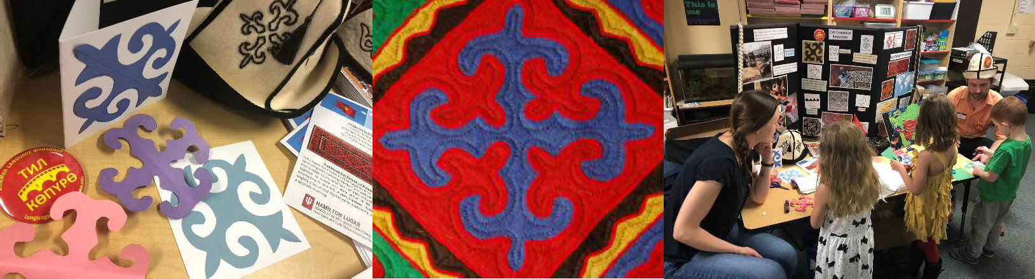

DISCOVER KYRGYZSTAN!
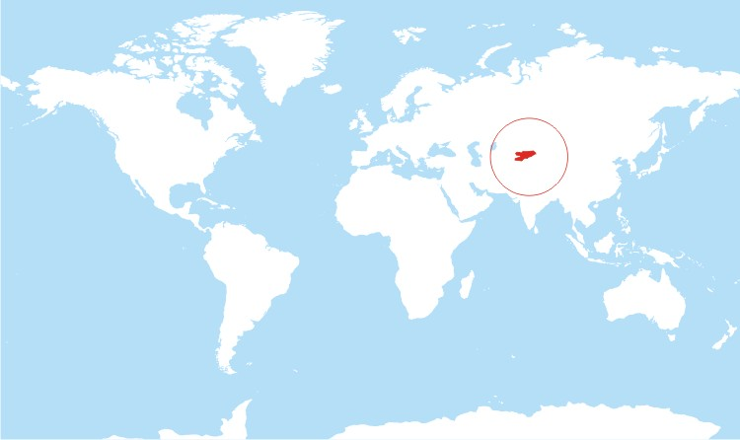
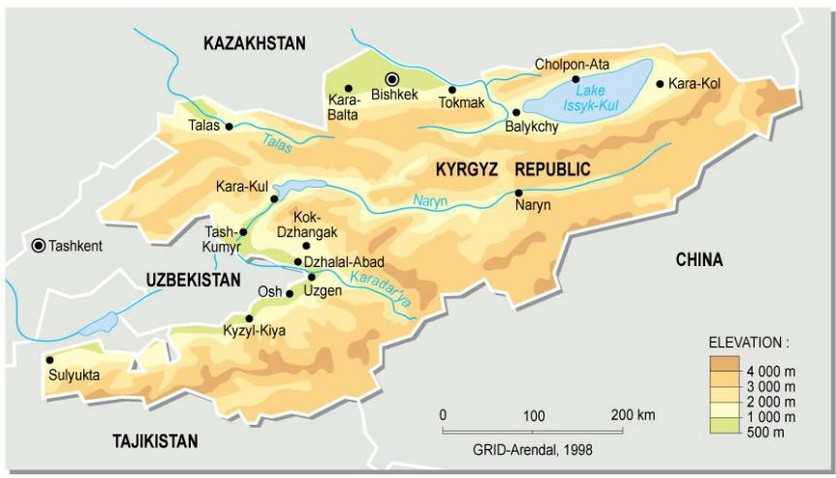

CHALLENGE 1: If you have a world atlas or globe at home or in your classroom, can you find Kyrgyzstan there?
Kyrgyzstan Fact File Capital: Bishkek Languages: Kyrgyz, Russian
Population: 6.2 million (a little bit smaller than Indiana) Size: 77,202 square miles (a little bit bigger than Nebraska)

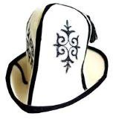
CHALLENGE 2: Do a Google search for “Kyrgyzstan” and look at the images that come up. What do you see? You might see people wearing hats like this one:
You might also see pictures of a special kind of moveable home called a yurt. In this part of the world, people who own livestock (like sheep, cows, goats, and horses) sometimes live in homes like these in the summer. This means they can travel with their animals to find the best summer grass.
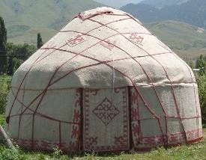

The hat and the yurt cover are both made using a material called felt (made from wool) and are often decorated with traditional patterns.

The Art of Felt in Kyrgyzstan
Felt is made by pouring hot water on layers of wool and pressing them together (see videos below). In Kyrgyzstan, people usually make felt from sheep’s wool. Apart from being used to make hats and yurt covers, this material can also be dyed bright colors and used to make beautiful carpets, seat covers, and other things.

Felt carpets have been made in Kyrgyzstan for centuries for decorating the floor and walls of the home and for keeping it warm and cozy. There are two main types of felt carpet:
- An ala-kiyiz is made by pressing layers of different colored sheep’s wool together to create one thick piece of felt.
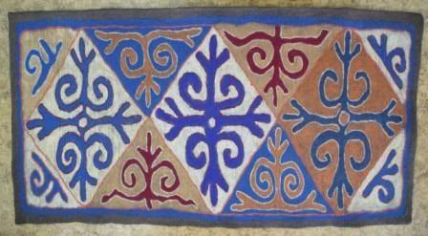
  - A shyrdak uses embroidery to sew felt shapes together.
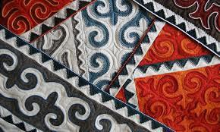
Both styles are often brightly colored and display various patterns, each of which has a special meaning.

To see how an ala-kiyiz and a shyrdak are traditionally made in Kyrgyzstan, watch this video on YouTube: https://www.youtube.com/watch?v=fQAlll0ybP8
These days, artists in Kyrgyzstan use felt-making techniques to create all sorts of carpet designs. Have a look at this example: https://www.youtube.com/watch?v=5QJZYqJg2Nc What would you put on your custom-made carpet?

reaching for freedom
brave defender of the nation

Some Kyrgyz Symbols and Their Meanings

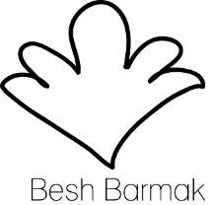
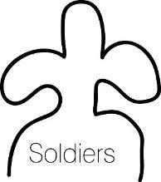
Patterns drawn by Made & Told (https://www.pinterest.com/madeandtold/)
fullness, plenty (besh barmak is a popular dish in Central Asia, made of meat, onions, and fresh pasta cooked in meat broth)

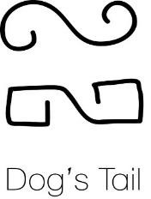
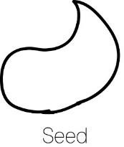
friendship
new life

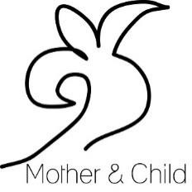
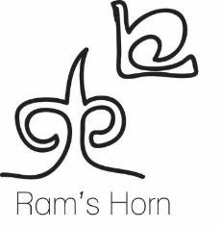
protector of the home
wealth and fortune

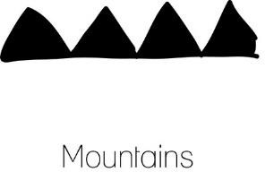
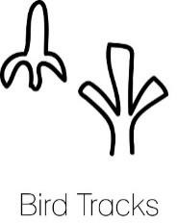
legacy, memory

Here are some examples of patterns used in felt crafts in Kyrgyzstan.

CHALLENGE 1: Look at the patterns below. Can you spot any of the symbols shown on the previous page?
CHALLENGE 2: These patterns are all symmetrical. Maybe you have learned about symmetry in your math class at school. Can you find the lines of symmetry in these patterns?
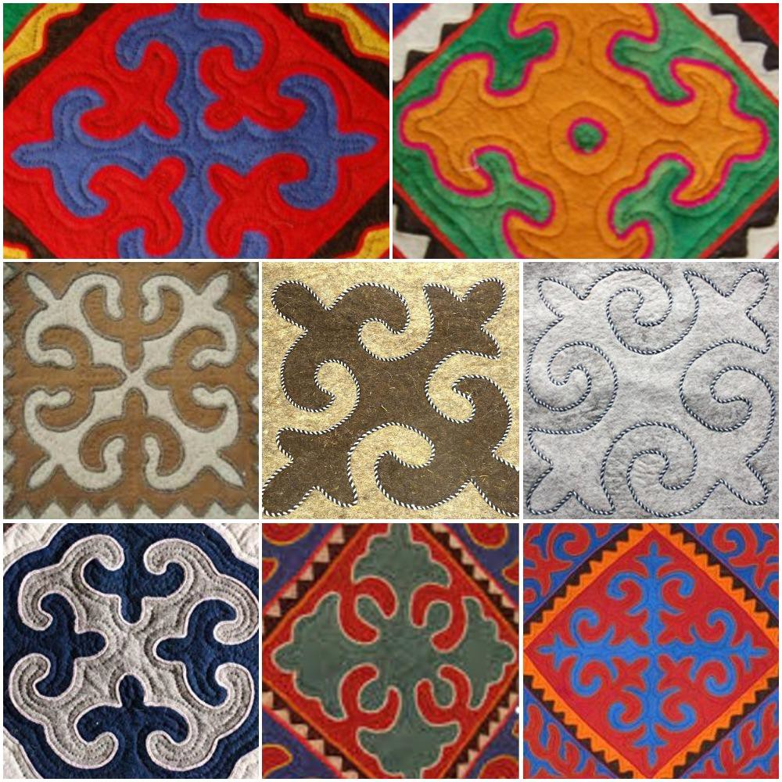

CRAFT INSTRUCTIONS
- Print the templates on colored paper.
- Cut out the whole square.
- Use the square, a ruler, and a pencil to mark the size of your greeting card/magnet/wall decoration on the cardstock you are using. You should end up with a square outline for a magnet or wall decoration, and a rectangle if making a card.
- Cut out this shape. If you are making a card, fold it down the middle so that it is ready to use.
- Go back to your colored pattern template. Fold the square along the line.
- Keep the square folded and, starting at the folded edge, carefully cut around the shape outline.
- Unfold the shape, apply glue to the messy side (where lines are still showing), and stick the pattern onto your background.
- Enjoy your beautiful Kyrgyz pattern – or maybe even give it as a gift to someone special!

Other Ideas
  - If you don’t have colored paper, you could use white paper and color the pattern yourself.
  - If you don’t have cardstock to use for backing, you can still use these patterns to decorate your wall, or try sticking them on the window and letting the light shine through.
  - Instead of colored paper on white card, you could try white paper on colored card.

SCHOOL OF GLOBAL AND INTERNATIONALSTUDIES
Inner Asian and Uralic National Resource Center
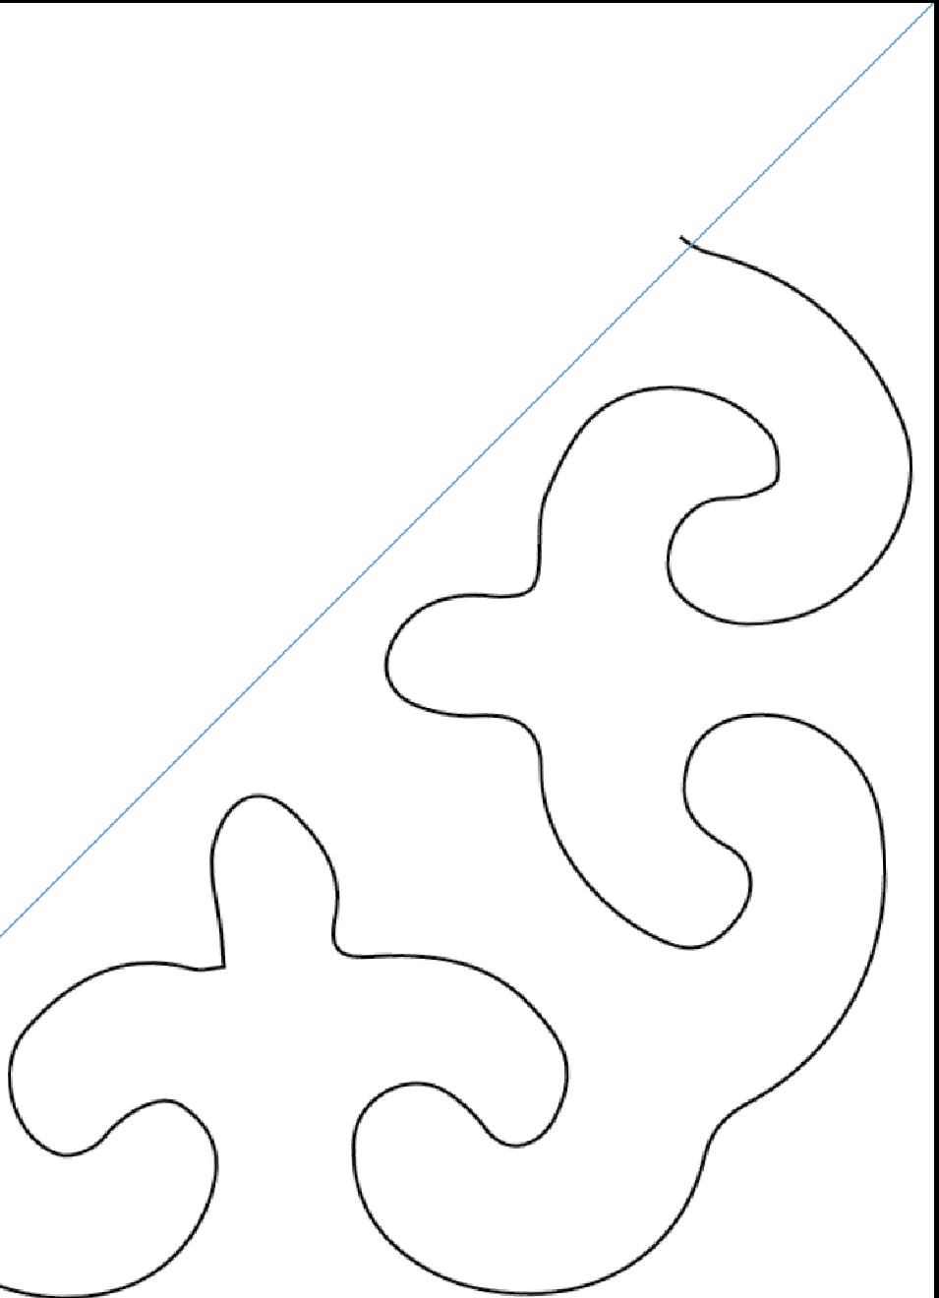
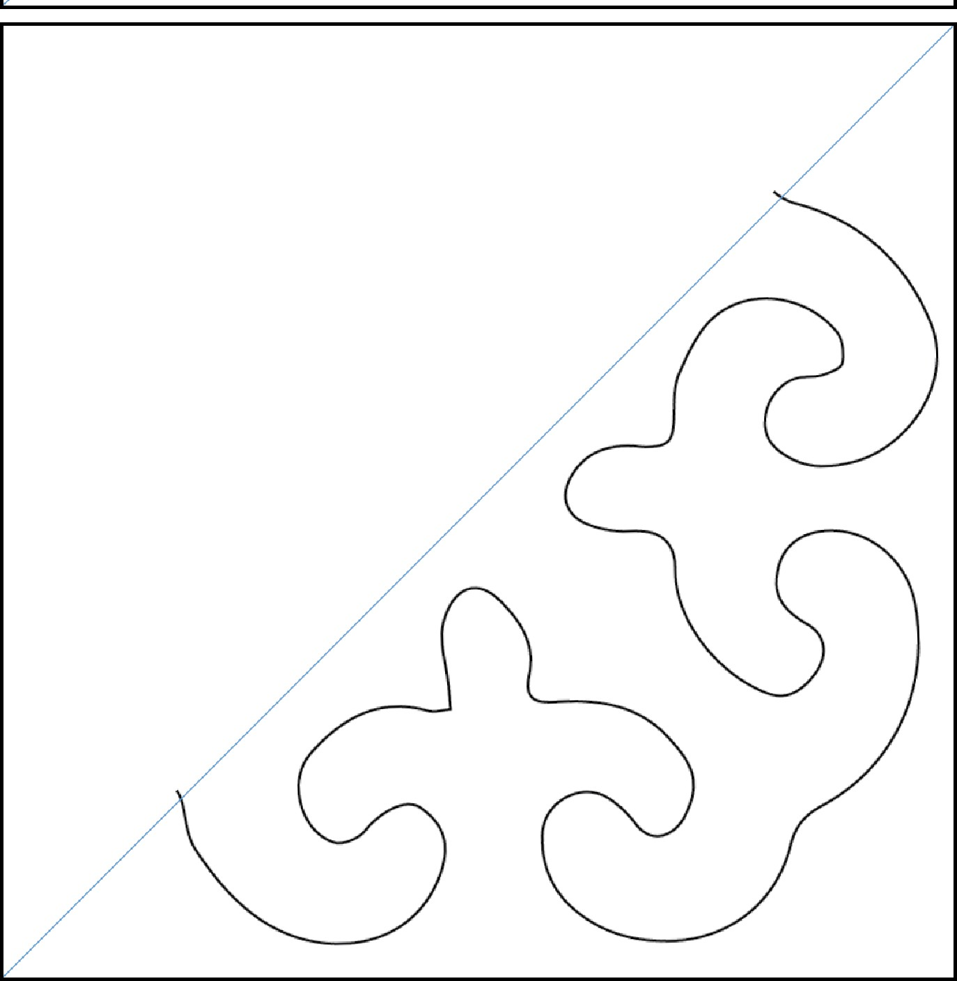

SCHOOL OF GLOBAL AND INTERNATIONALSTUDIES
Inner Asian and Uralic National Resource Center
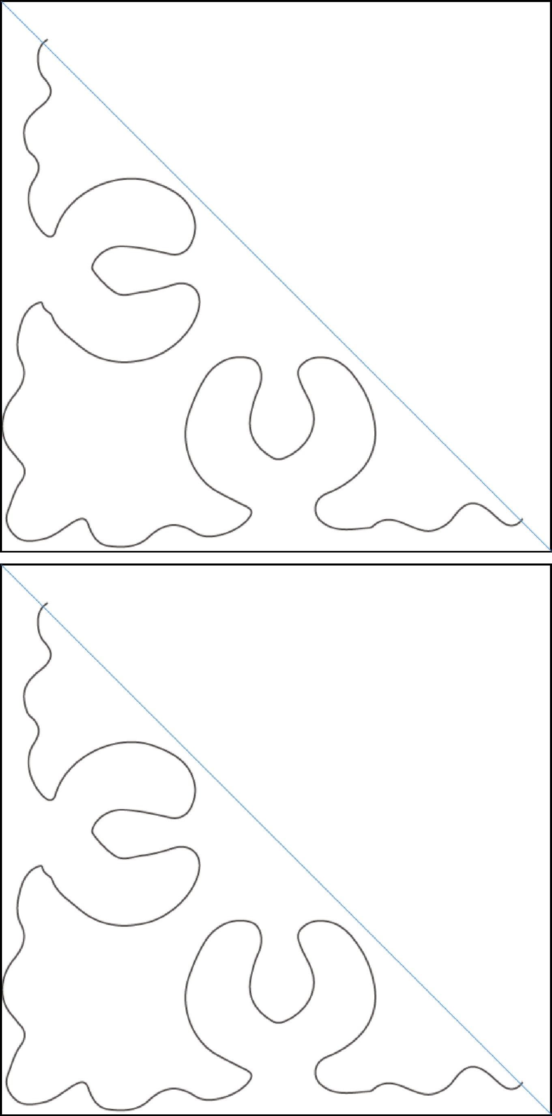

SCHOOL OF GLOBAL AND INTERNATIONALSTUDIES
Inner Asian and Uralic National Resource Center
