Mongolian Shagai Games
Activity Pack
Games traditionally played with animal bones can be found in history and today in cultures around the world. Among the semi-nomadic, animal herding cultures of Central Eurasia, there are a number of such games, usually played with sheep or goat anklebones. The Mongolian word for anklebone is shagai. In this activity pack, you will discover Mongolia and learn about shagai games and fortune telling, before making your own set of shagai cards and playing some of these games yourself.
You will need:
- This activity pack!
- A printer
- Plain paper
- Scissors
Activity pack contents:
- Discover Mongolia! 6. Horse Race Game Board
- About Shagai 7. Game 2: Four Shagai
- Make Your Own Shagai Cards 8. Shagai Fortune Telling
- Shagai Card Printout 9. Shagai Fortune Telling Guide
- Game 1: Horse Race

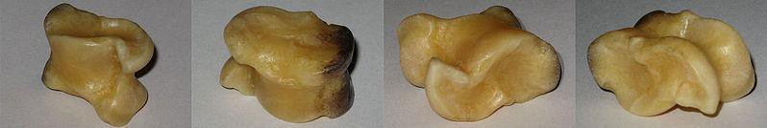

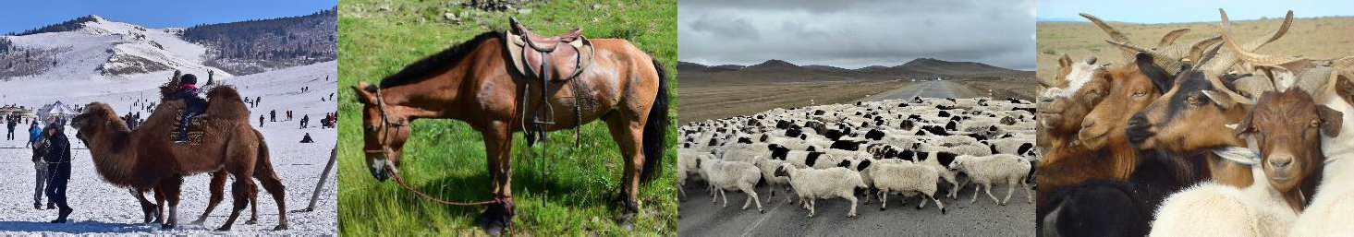

DISCOVER MONGOLIA
https://geology.com/world/mongolia-satellite-image.shtml
Encyclopaedia Britannica (https://www.britannica.com/place/the-Steppe)

Mongolia Fact File Capital: Ulaanbaatar Language: Mongolian  Population: 3.2 million (less than half the population of Indiana) Size compared to USA:  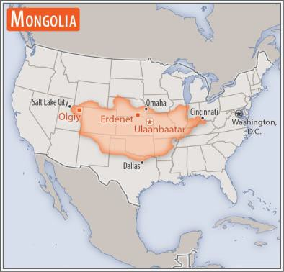  https://www.cia.gov/library/publications/the-world- factbook/geos/mg.html | 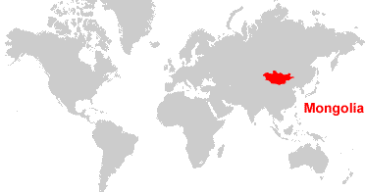
 | CHALLENGE 1: If you have a world atlas or globe at home or in your classroom, can you find Mongolia there? Can you find Ulaanbaatar? What other countries can you see around Mongolia?

THE STEPPE  Mongolia is at the eastern end of the Eurasian steppe, a huge area of mostly dry, grassy plain stretching across Asia into Europe. This area is similar to the North American Prairie. Find out more and see some pictures here:  https://www.nationalgeographic.org/en cyclopedia/steppe/ | 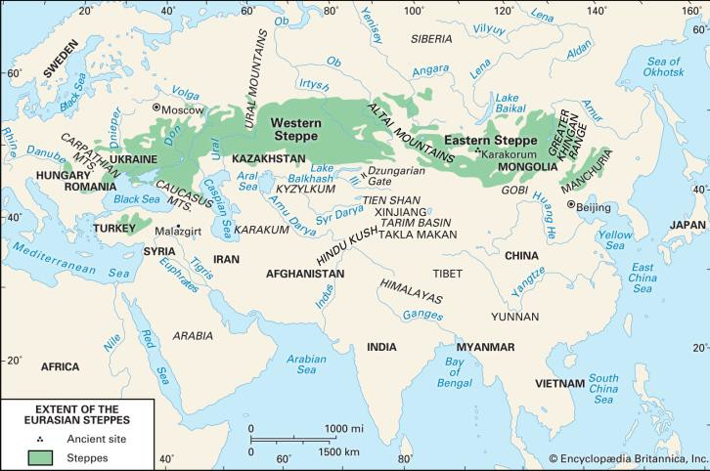
NOMADS OF THE STEPPE
For thousands of years, people living on the steppe survived by keeping animals for food, clothing, transport, and trade. They moved between different areas of grassland so that their animals would always have enough to eat. They used a special, movable home called a ger (or yurt, in English). Many people on the steppe still follow this way of life today.

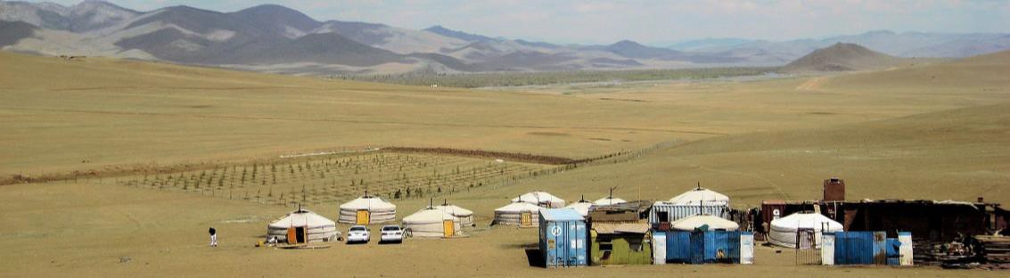
Francisco Anzola, CC BY 2.0, via
Wikimedia Commons

ABOUT SHAGAI
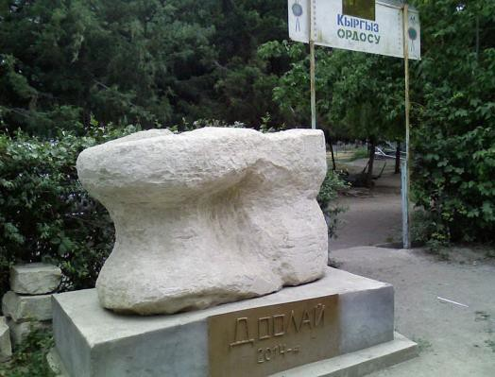
Shagai is the Mongolian word for anklebone. It is also the name for a number of dice-like and fortune-telling games played with the anklebones of a sheep or a goat. Versions of these games are played all over Central Asia. In Kyrgyz, they are called chükö; in Kazakh, asyk; in Turkish, ashyk; and in Tajik, oshuq.
A monument marking where knucklebone games are played in Osh, Kyrgyzstan.
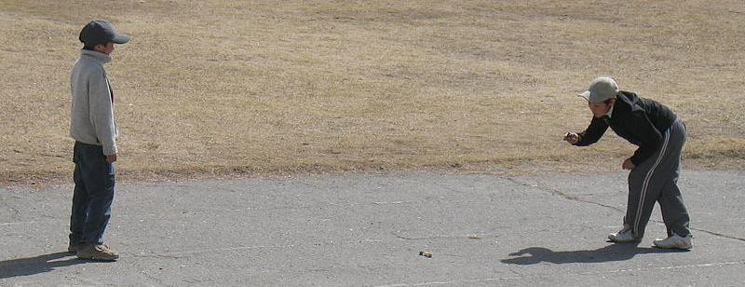
Arthoum, CC BY-SA 3.0, via Wikimedia Commons
Playing an anklebone game in Krygyzstan. Firespeaker, CC BY-SA 3.0, via Wikimedia Commons | CHALLENGE 2: Can you find Kyrgyzstan, Kazakhstan, Turkey, and Tajikistan on the world map? What do you learn about these countries just by looking at the map?
In shagai, the rolled bones usually land on one of four sides. Each side is a different shape, and represents a different animal: camel, horse, sheep, or goat. Because of this, many of the games played involve chance and matching pairs and sets of these animals. Shagai are also used in fortune telling: different combinations of animals indicate a good or bad outcome.
 | GOAT/yamaa

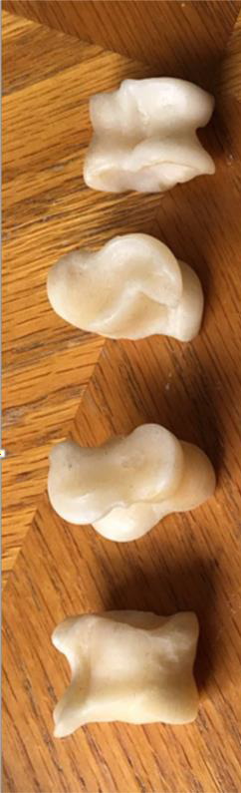
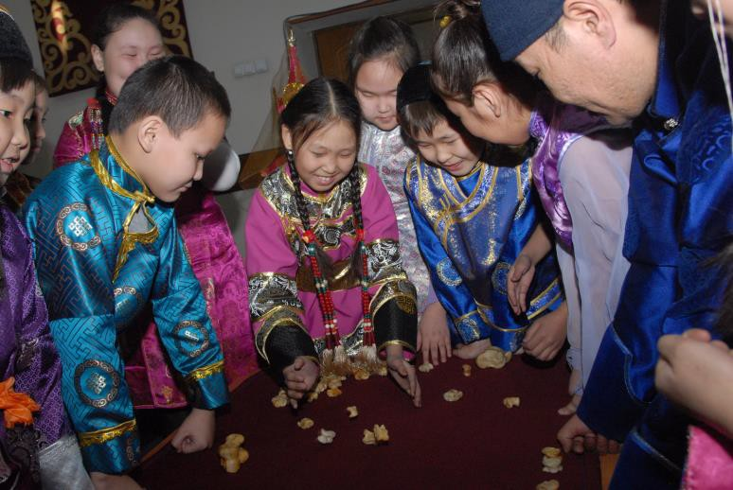
CAMEL/temee

HORSE/mori

SHEEP/khoni

Балчый-оол, CC BY-SA 4.0, via Wikimedia Commons
Used in games for thousands of years, shagai are one of the earliest forms of dice. Sometimes, the bones are painted bright colors. In Mongolia, they are sometimes carried in a small cloth pouch, and friends may exchange one shagai for another as a sign of their friendship.

MAKE YOUR OWN SHAGAI CARDS

If you live in the United States, you probably don’t have sheep anklebones at home. But that doesn’t mean you can’t play Mongolian shagai games. You can use the template provided to create your own set of shagai cards and use them to play the same games that might have been played by the Mongol warriors of Chinggis Khan—when they
weren’t busy conquering, that is. You will also find instructions and other materials for some of the games you can play with your shagai cards, as well as a guide to telling the future, Mongolian style.

Instructions
- Print the sheet of animal cards and the “Horse Race” game board. The instructions and fortune telling guide can be printed or read from the screen if you prefer.
- Cut out the animal cards so that you have four of each animal. It doesn’t matter if they are a bit see-through, but printing them on
colored paper (if you have it) might help. You only need one set of cards between all players.
- Follow the instructions to play a game of your choice, or have a go at predicting the future using the shagai fortune telling guide.

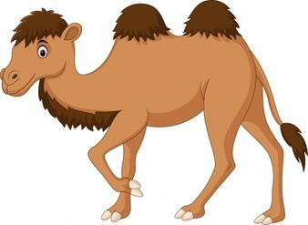
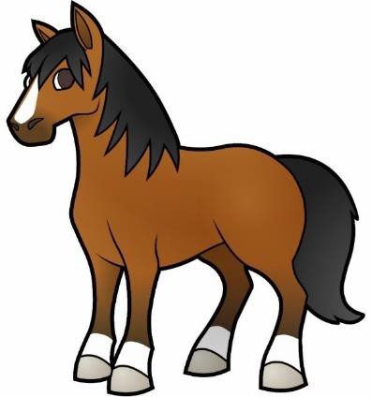
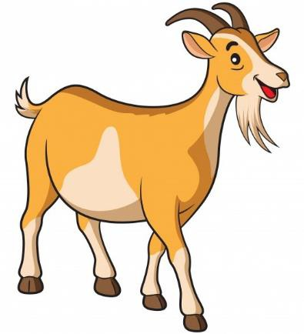
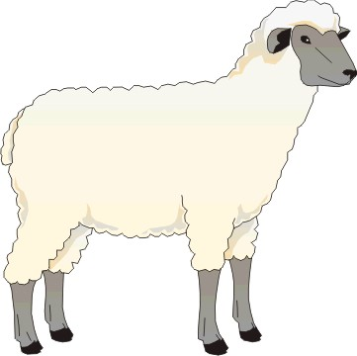

GAME 1: Horse Race
You need:
  - A set of shagai cards
  - 1 counter per player (you could use pencil sharpeners or paper clips if you don’t have counters)
  - A printout of the “Horse Race” racetrack sheet

Instructions

- Line up your counters at the start of the racetrack.
- Shuffle the shagai cards and place them picture down.
- The player who starts draws the top four cards from the pile and places them face up for everyone to see.
- For every horse card in their hand, they move one space (two horses, two spaces; three horses, three spaces, etc.). If the player draws no horses, they do not move.
- The player returns their cards to the deck and reshuffles.
- The next player picks the top four cards and follows the same steps as above.
- The players take turns.
- When a player reaches the end of the racetrack on one side they must come back along the other side.
- The first player to get their counter back to the start wins.

A t Charyshtyrary
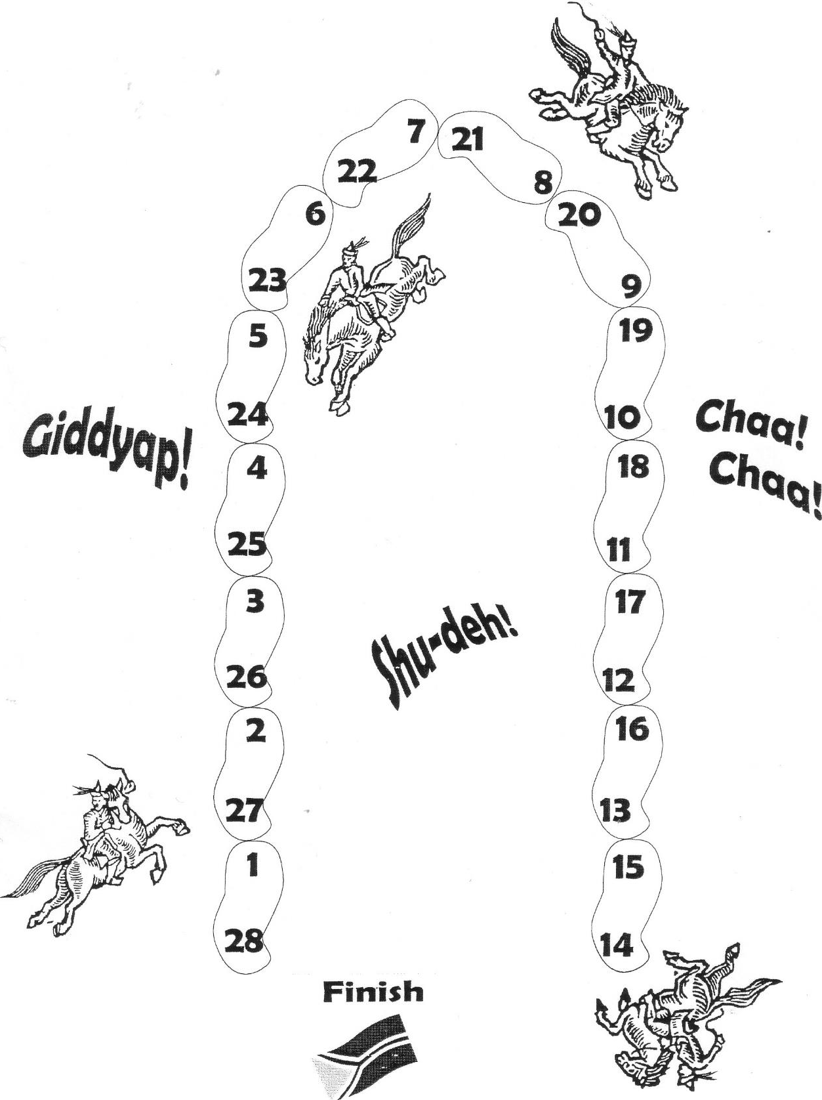
The Horse Race

Start
If\/\
I )u)

GAME 2: Four Shagai
You need:
- A set of shagai cards
- A piece of scrap paper
- A pencil or pen.

Instructions

- Shuffle the shagai cards and place them face down.
- The first player picks up the top four cards and places them face up for everyone to see.
- Points are scored depending on the combination of cards drawn:

One of each animal – 8 points All four the same – 4 points Three the same – 3 points Two different pairs – 2 points One pair – 1 point

- Use the piece of paper to keep track of players’ scores.
- The first player to score 20 points or more wins.

Shagai Fortune Telling
You need:
  - A set of shagai cards
  - The Shagai Fortune Telling Guide sheet

Instructions

- Think of a question you want to ask about the future.
- Shuffle the shagai cards and turn over the top four cards.
- Depending on the combination of cards drawn, use the Shagai Fortune Telling Guide to find the answer to your question.

Shagai Fortune Telling Guide
(Adapted from Riding Windhorses: A Journey into the Heart of Mongolian Shamanism , by Sarangerel)

Horse | Camel | Sheep | Goat | Meaning
4 | 0 | 0 | 0 | The best possible result— luck, happiness, health and success
0 | 4 | 0 | 0 | All that is desired will be accomplished easily
0 | 0 | 4 | 0 | Luck will come, but it will take a long time
0 | 0 | 0 | 4 | Everything will happen very slowly
3 | 1 | 0 | 0 | It will come to pass quickly
3 | 0 | 1 | 0 | There will be no difficulties
3 | 0 | 0 | 1 | Middle of the road; everything will be even and balanced
2 | 1 | 1 | 0 | Happy ending
2 | 0 | 1 | 1 | Luck will play a role, but things will work out
2 | 1 | 0 | 1 | It will develop quickly
2 | 2 | 0 | 0 | All things will be successful
2 | 0 | 2 | 0 | Events will proceed with no difficulty
2 | 0 | 0 | 2 | Conflict; success may come, but not in what is most desired
1 | 3 | 0 | 0 | Happiness will come, but slowly
1 | 0 | 3 | 0 | You must do it yourself
1 | 0 | 0 | 3 | There will be a minor conflict
1 | 2 | 1 | 0 | Disagreement, dispute, and argument; conflict will arise
1 | 1 | 2 | 0 | There will be opposition; someone else may benefit
1 | 1 | 0 | 2 | Health and happiness will improve slowly
1 | 0 | 2 | 1 | There will be no difficulties
1 | 2 | 0 | 1 | Keep eyes peeled for good news
1 | 1 | 1 | 1 | A good omen; whatever will come to pass will be desirable
0 | 3 | 1 | 0 | Careful, there is room for error and things may end badly
0 | 3 | 0 | 1 | Unlucky; take care to avoid disaster
0 | 2 | 1 | 1 | A successful outcome is doubtful
0 | 2 | 2 | 0 | Things will not go entirely your way; illness is a possibility
0 | 2 | 0 | 2 | There will be no difficulties
0 | 1 | 2 | 1 | There will be some troubles, but none that can’t be overcome
0 | 1 | 1 | 2 | In the favor of others; it will not happen where intended
0 | 1 | 3 | 0 | No outside influences, but there will be misfortune
0 | 1 | 0 | 3 | Bad omen; failure is probable
0 | 0 | 3 | 1 | Success is probable
0 | 0 | 2 | 2 | It’s complicated, but the matter will probably be settled
0 | 0 | 1 | 3 | It cannot be done

