Make Your Own Mongolian Yurt Craft Activity Pack
The Mongolian word for yurt is ger. These are the traditional homes of livestock-herding nomads across Central Eurasia, including Mongolia. In this craft pack, you will discover Mongolia and learn how a ger is made, who lives in it, and why. You will hear about some of the other places where people live in yurts—and then make your own paper ger!

You will need:
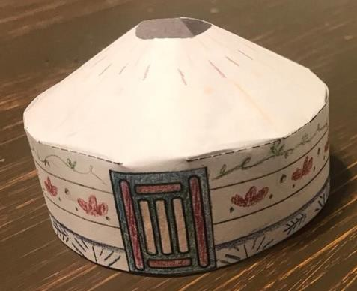
- This activity pack!
- A printer
- Plain paper
- Crayons/markers
- Scissors, a glue stick
- Optional extras: glitter, sequins, stickers, etc. (If you are using these, we recommend you add them after you have finished the model)

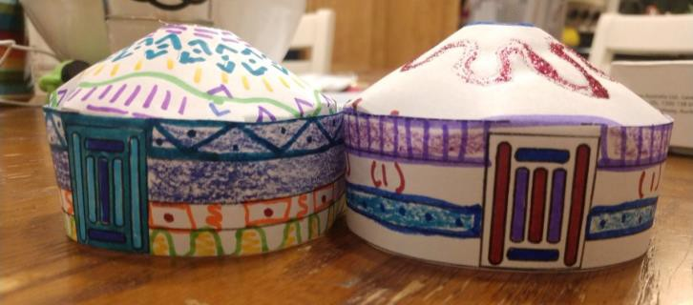
Activity pack contents:
Printout 1: Discover Mongolia! Printout 2: What is a Ger?
Printout 3: Yurts Galore! Printout 4: Make Your Own Ger Printout 5: Ger Template

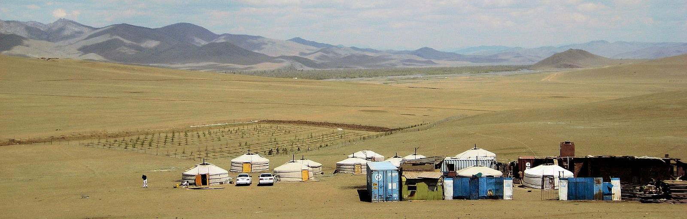
Francisco Anzola, CC BY 2.0, via Wikimedia Commons

DISCOVER MONGOLIA
https://geology.com/world/mongolia-satellite-image.shtml
Encyclopaedia Britannica (https://www.britannica.com/place/the-Steppe)

Mongolia Fact File Capital: Ulaanbaatar Language: Mongolian  Population: 3.2 million (less than half the population of Indiana) Size compared to USA:  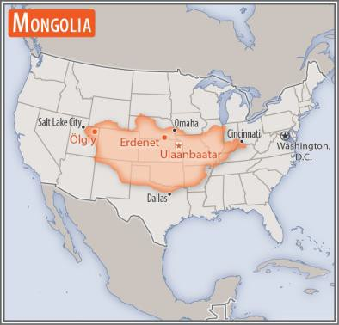  https://www.cia.gov/library/publications/the-world- factbook/geos/mg.html | 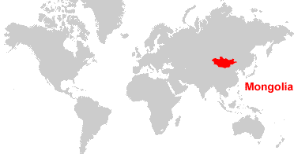
 | CHALLENGE 1: If you have a world atlas or globe at home or in your classroom, can you find Mongolia there? Can you find Ulaanbaatar? What other countries can you see around Mongolia?

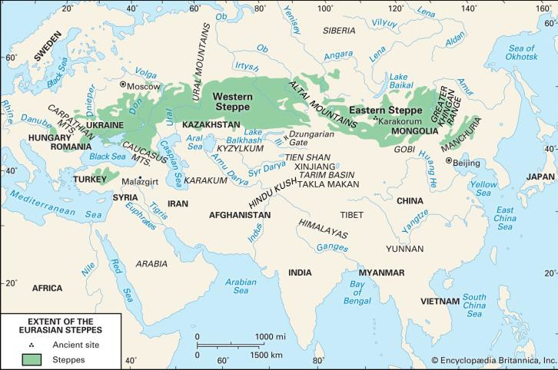
THE STEPPE
Mongolia is at the eastern end of the Eurasian steppe, a huge area of mostly dry, grassy plain stretching across Asia into Europe. This area is similar to the North American Prairie. Find out more and see some pictures here:
https://www.nationalgeographic.org/en cyclopedia/steppe/

NOMADS OF THE STEPPE
For thousands of years, people living on the steppe survived by keeping animals for food, clothing, transport, and trade. They moved between different areas of grassland so that their animals would always have enough to eat. They used a special, movable home that we call a yurt. In Mongolia, it is called a ger. Many people on the steppe continue to follow this way of life today.

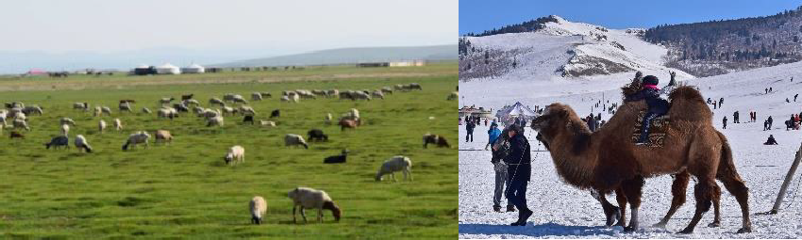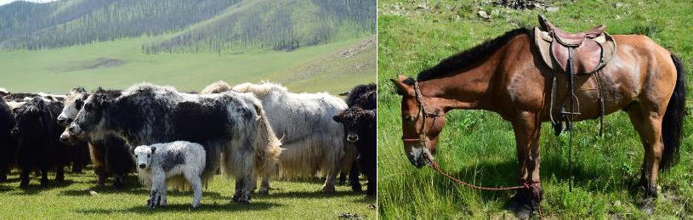
Photos by Kenny Linden

WHAT IS A GER?

A ger is a round, moveable home called a yurt in English. It is made using a wooden frame covered with a material called felt.  Felt is usually made from sheep’s wool. It is strong, and keeps the home warm and dry. | 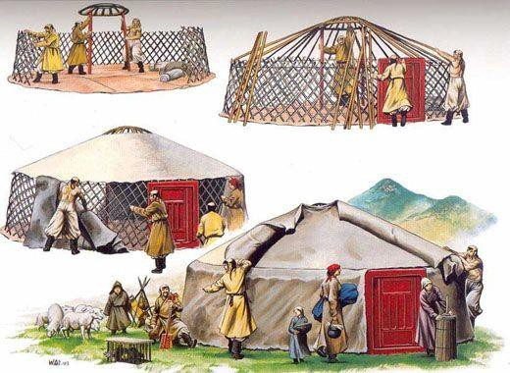
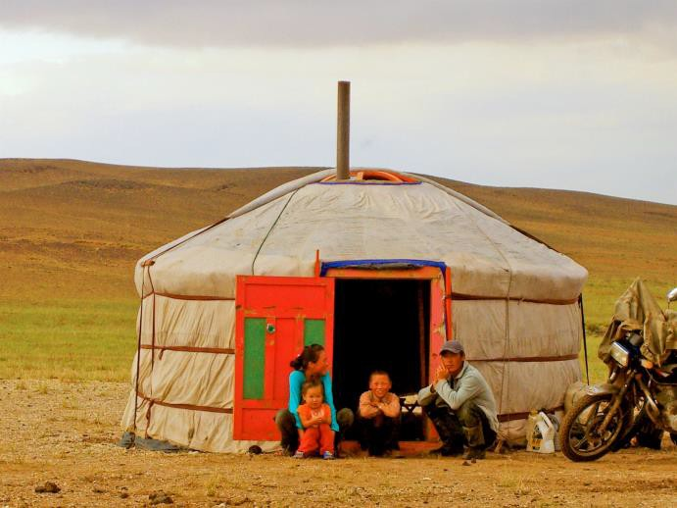
The Wandering Angel, CC BY 2.0, via Wikimedia Commons
Today, gers can be built using more modern materials, and are often covered with a waterproof fabric like canvas.
Watch this video to find out what life is like inside a ger—and how you build one!
https://www.youtube.com/watch?v=tuAc11slLxQ
CITY OF GERS
Almost half the population of Mongolia live in the capital city of Ulaanbaatar (pronounced “oo-lahn-bah-ter”). More than half the city’s residents live outside the
downtown area in “ger districts” where people live in a mixture of gers and houses. Even families who live in a house sometimes have a ger in their back yard.
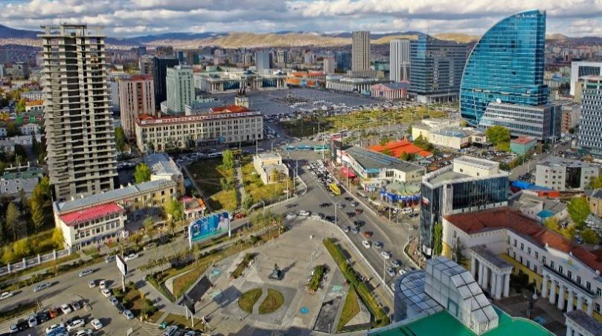
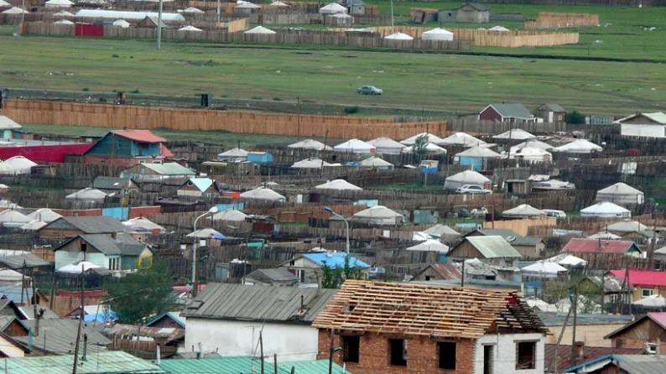
Zazaa Mongolia, CC BY-SA 4.0, via Wikimedia Commons Brücke-Osteuropa, Public domain, via Wikimedia Commons
So why do we call it a yurt? In many languages of Central Asia, yurt means “homeland.” Russians use the word yurta to talk about the tents used by the nomadic people there. This is where the English word “yurt” comes from. But the locals use different names. In Mongolia, ger simply means “home.” In Kazakhstan, it’s called a kiyiz ui (felt home); in Kyrgyzstan, boz ui (grey home); and in Turkmenistan, aq oi or gara oi (white/black home). CHALLENGE 2: Can you find these three countries on a map?

YURTS GALORE!

Photo: Susynoid, Public domain, via Wikimedia Commons |  | Mongolia
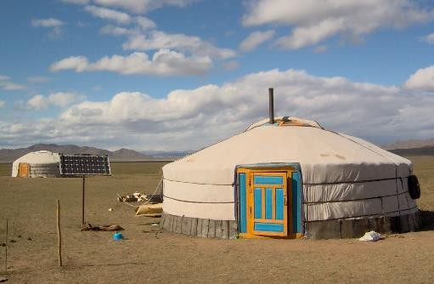 | Mongolian gers are typically white with colorful wooden doors. Can you spot the solar panel? This will generate electricity that might be used for lighting, to refrigerate food, to charge a mobile, or to power a TV.
Photo: Wackyrussell at English Wikipedia, Public domain, via Wikimedia Commons |  | Kazakhstan
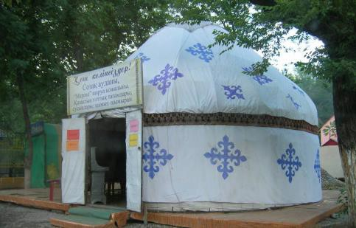 | Yurts today aren’t always homes. This modern yurt in a city in Kazakhstan is being used as a cafe. It is decorated with traditional Kazakh symbols. The sign says, “Welcome!" On the menu are typical Kazakh food and drink items—including horse milk!
Photo: Hux at the English language Wikipedia, CC BY-SA 3.0, via Wikimedia Commons |  | Kyrgyzstan
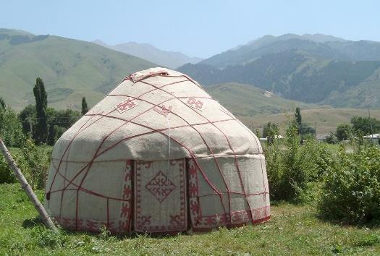 | This yurt in Kyrgyzstan has a felt door flap instead of a solid door. You can see all the ropes that are needed to tie the felt cover onto the wooden frame. There is a flap over the roof hole that can be removed to let out smoke from the cooking fire.
Photo: Sergei Prokudin-Gorskii , Public domain, via Wikimedia Commons |  | Turkmenistan
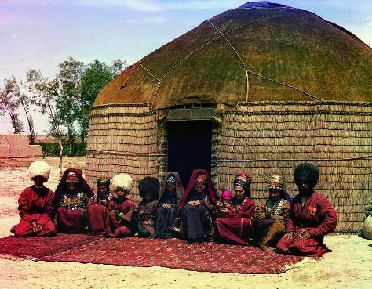 | This photo was taken more than 100 years ago. It shows a Turkmen yurt whose walls are covered with reeds instead of felt. A family wearing traditional Turkmen clothing is sitting outside.
CHALLENGE 3: Can you think of any other kinds of movable home? What are some similarities and differences between your example and a yurt or ger?
See more pictures and keep learning here: https://www.nationalgeographic.org/encyclopedia/yurt/

MAKE YOUR OWN GER
Print the ger template and make sure you have crayons, scissors, and glue, plus any other decorations you want to use. Then…

1. Color the door of your ger. Add any other designs you want to the roof and wall of the ger, or leave it white. | 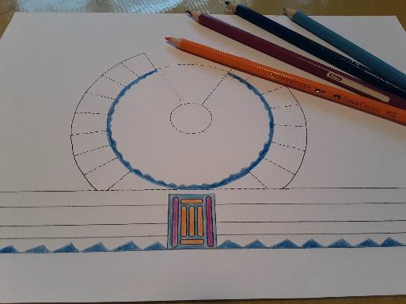  These bits are going to have glue on them, so don’t color here!
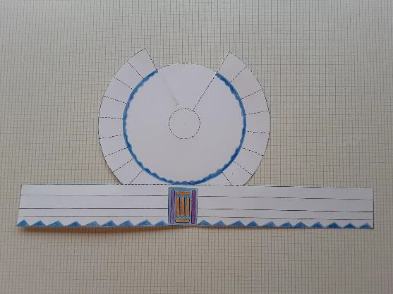 | 2. Cut around the outside of the whole template.
3. Cut along all the dotted lines. DO NOT CUT WHERE THERE IS NO DOTTED LINE!  The roof and wall sections of the template should stay joined. | 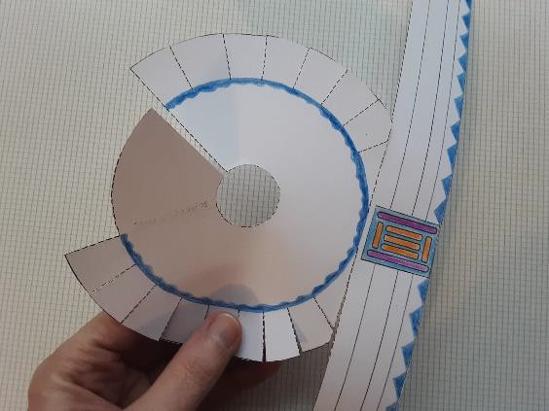  Do not  cut here…  …or here!
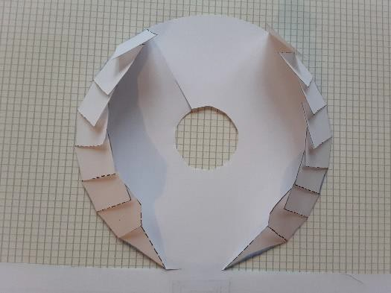 | 4. Turn the template face down and fold the flaps inwards around the roof circle. They will overlap.

5. Turn the template face up again. Flatten the flaps out around the roof circle so that they don’t get in the way of the glue. | 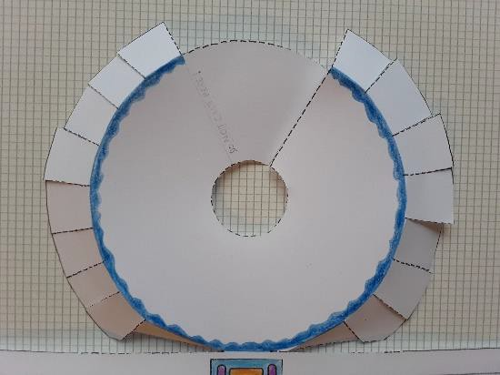
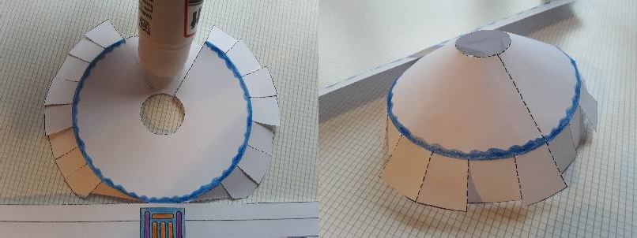 | 6. Cover the section of the roof circle between the cut edge and the “DO NOT CUT HERE!” line with glue. Pull the cut edge around so that it exactly meets the opposite line, and stick.
7. Cover the back of the wall strip with glue, avoiding the section in the middle where the door is. | 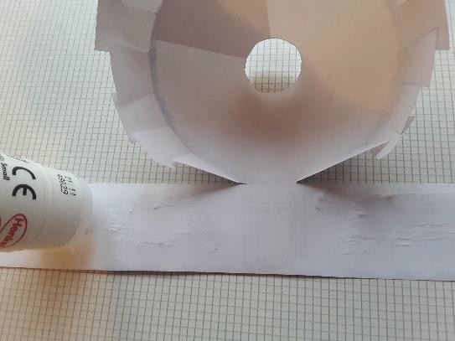
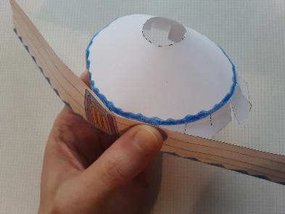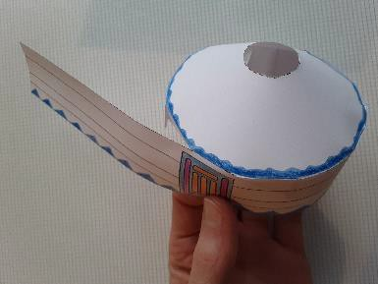 | 8. Starting on one side of the door, use your fingers to press the flaps to the glue, wrapping the wall around the flaps. Repeat on the other side.
9. Admire your ger—and maybe make another one! | 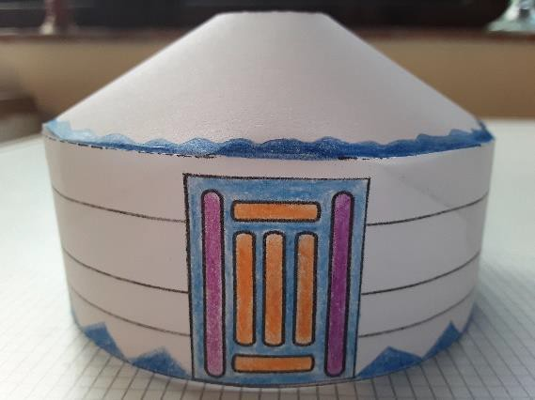

I I
J I
I
I
I II
I
I
I I I
:
I
I I
I I
\
I
\
\
'\

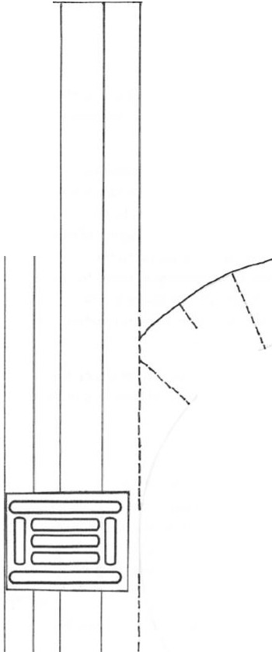
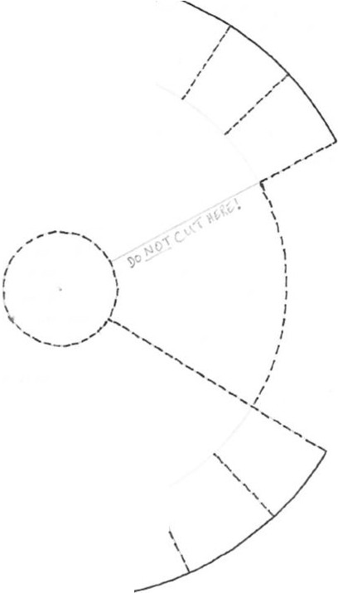

I
II
1,/
(
I

,,,,"

I I
.
\
I I
I I
I I
I I
I I

