Tibetan Mandala Craft Activity Pack
Create your very own Tibetan mandala to represent the Buddha and his teachings, based on traditional sand mandalas made in Tibet.

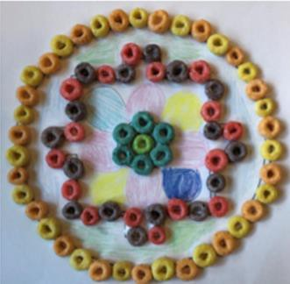
You will need:
- This activity pack!
- A printer
- Plain paper
- Glue
- Froot Loops (colorful cereal)
- Colored pencils

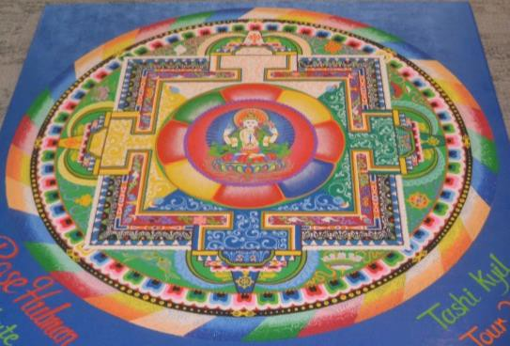
Activity pack contents:
- Printout 1: Discover Tibet
- Printout 2: Buddhism in Tibet
- Printout 3: What is a Mandala?
- Printout 4: Some Mandala Symbols
- Printout 5: How to Make Your Own Mandala
- Printout 6: Mandala Template
- Printout 7: Follow-Up Questions
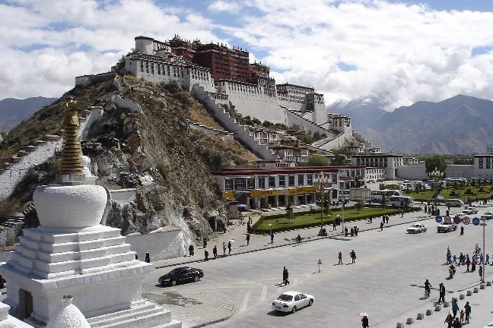
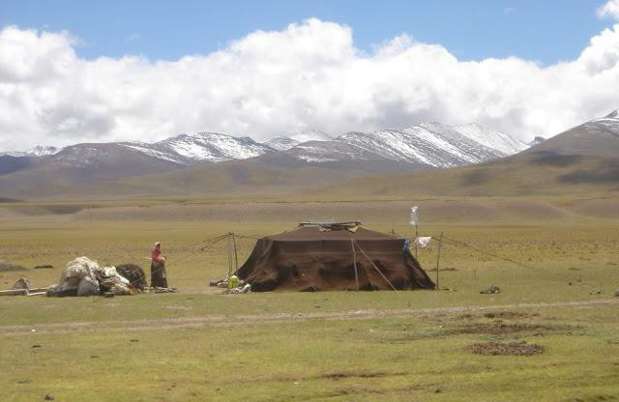
I, Ondřej Žváček, CC BY-SA 3.0, via Wikimedia Commons Philipp Roelli (2005) GNU Free Documentation License via Wikimedia Commons

With many thanks to Dr. Tim Grose and his students at Rose-Hulman Institute of Technology for contributing the idea for this craft pack and much of its contents.

Discover Tibet

The cultural homeland of the Tibetan people is the Tibetan Plateau. This is the world’s highest and largest plateau. It is often called “The Roof of the World.” The Himalayas mountain range is at the  southern edge of the plateau. | In 1951, the Chinese army took control of Tibet. Today, the Tibetan Plateau is divided between the Tibet Autonomous Region and other regions of China, but many Tibetans want Tibet to be an independent  country.
https://www.map-of-china.org/relief-map.htm | 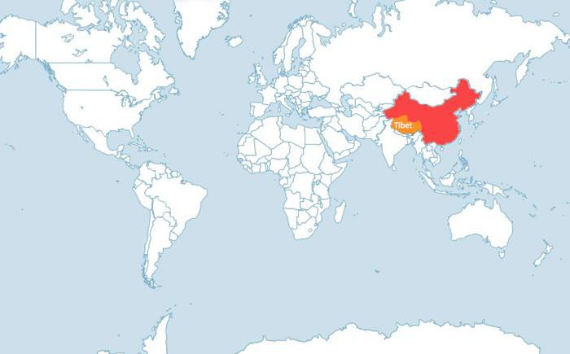  https://www.tibettour.org/tibet-map/tibet-regional-maps.html

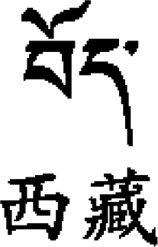
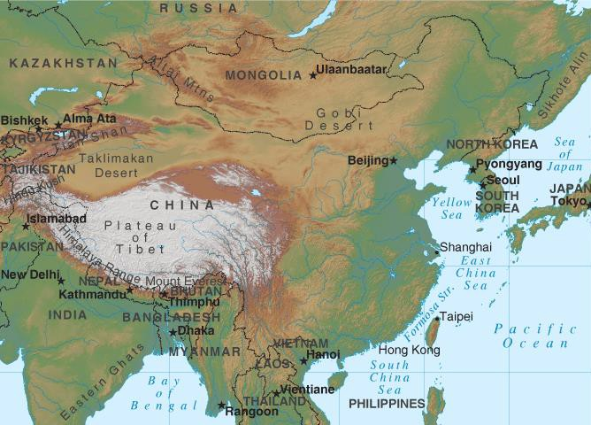
Mount Everest, the tallest mountain in the world, is here!

Tibet AR Fact File
Capital: Lhasa Languages: Tibetan
Mandarin Chinese
Population: 3.2 million (about half the population of Indiana)

Glossary
An autonomous region is part of a country and can make some of its own decisions, but is not independent.
A plateau is a high area of land that is quite flat, like the Colorado Plateau in North America.

“TIBET” in Tibetan
script…

Size: 474,300 square miles (13 times the size of Indiana)

Find out more!
…and in Mandarin
Chinese.

- Using a world atlas or a globe, can you find China / Tibet / Lhasa / Mount Everest?
- Go to Google Images and search for “Tibet animals.” What kinds of animals can you find on the Tibetan Plateau?
- Visit the Free Tibet website to learn about the struggle for Tibetan independence: https://freetibet.org/

Buddhism in Tibet

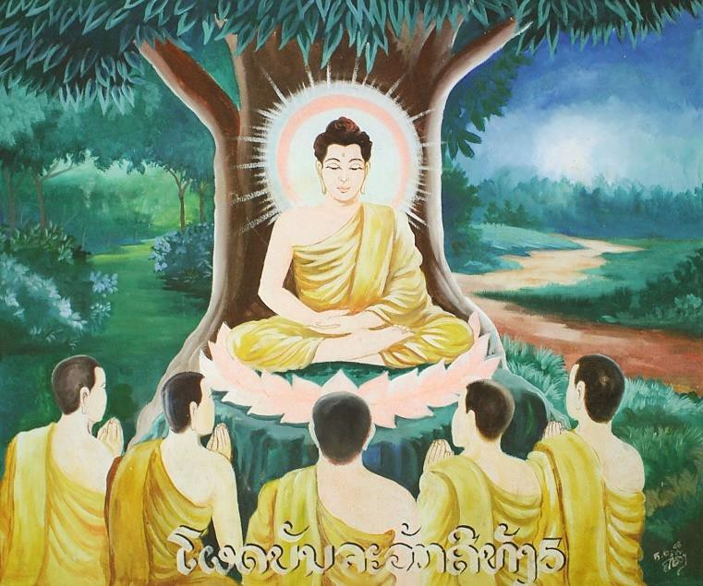 | Who was the Buddha?  In the 5th century BCE (2500 years ago), Siddhartha Gautama was born. His family was rich, but Siddhartha looked around him and saw that life was full of hardship. He understood that money and pleasure were not the way to true happiness, so he left the easy life behind to live a life of meditation and teaching. He taught that you can only be truly happy if you are content with what you have and show compassion to all living creatures.  After his death, he became known as Buddha, which means “Awakened One” or “Enlightened One,” and people who follow his teachings are called Buddhists.
myself, CC BY-SA 3.0, via Wikimedia Commons

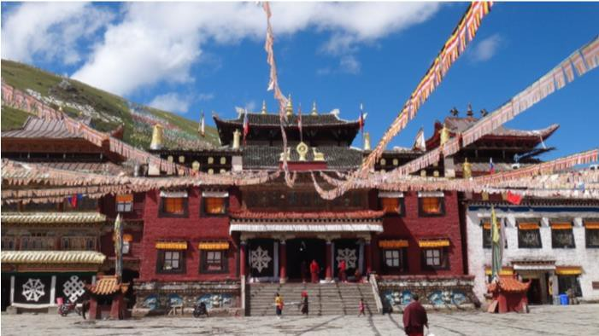
Watch this short cartoon of Buddha’s life: https://www.youtube.com/watch?v=ns N7NLs-0jI
What about Tibetan Buddhism?  More than a thousand years after Siddhartha Gautama Buddha lived, the rulers of the Tibetan Empire brought Buddhism to Tibet. Today, Buddhism is kept alive in monasteries like this one. Buddhist monks live away from the outside world. They spend their time studying the Buddha’s teachings, meditating, and praying. |  | Glossary  There are different kinds of meditation, but a person who meditates is often sitting quietly, thinking about a question or an idea, and looking for answers.  Compassion is seeing other people’s pain and unhappiness and showing them kindness.  A monastery is a place where monks live. A monk is a man who has decided to live a simple life of prayer. There are monks in many religions, including Christianity.

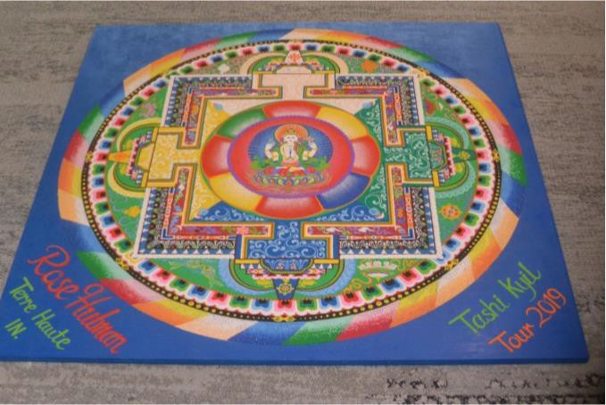
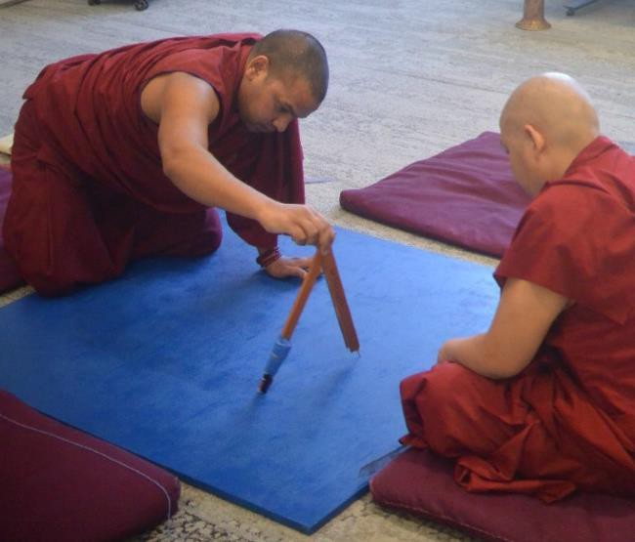
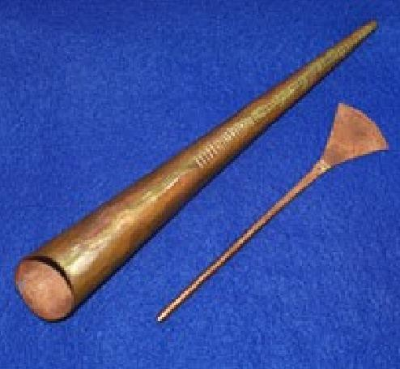
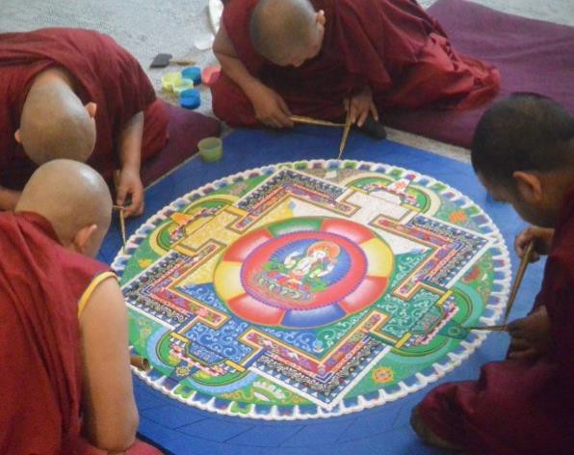
What is a Mandala?

Watch a mandala being made: https://www.youtube.com/watch?v=GA3su0ECdPc
The many colors and symbols come together to create a masterpiece!
First, the monks use a compass and a ruler to draw the outline of the mandala.
At special events, monks often create mandalas. These are geometric pictures usually made from colored sand. They help people understand the Buddha’s teachings and how to be more like him.
http://faithseekerkids.com/interfaithmistakes-the-buddhist-chakpur/

Then they use a special tool called a chakpur. They fill the funnel with colored sand and use it like a pen to fill in the details of the mandala.

Some Mandala Symbols

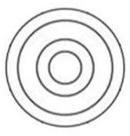
The inner circle shows where the Buddha lives in the temple and represents the pure* mind of the Buddha. The outer circle represents the Buddha’s teachings.

The next layer represents the four gates of the Buddha’s temple. It shows the way to achieve the pure mind of the Buddha.

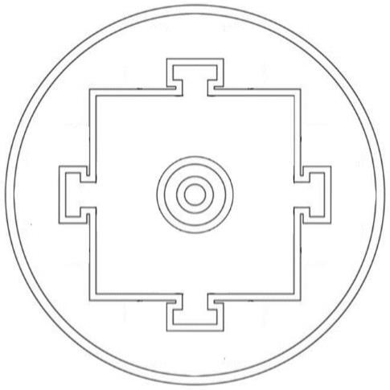
The last circle represents wisdom and compassion. These are what you need if you want to enter the temple and reach enlightenment.

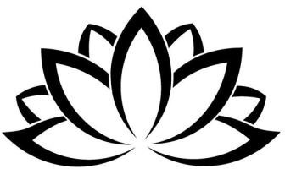
You might also see the lotus flower, a symbol of pure body, speech, and mind.

*pure means perfectly clear, clean, or good.

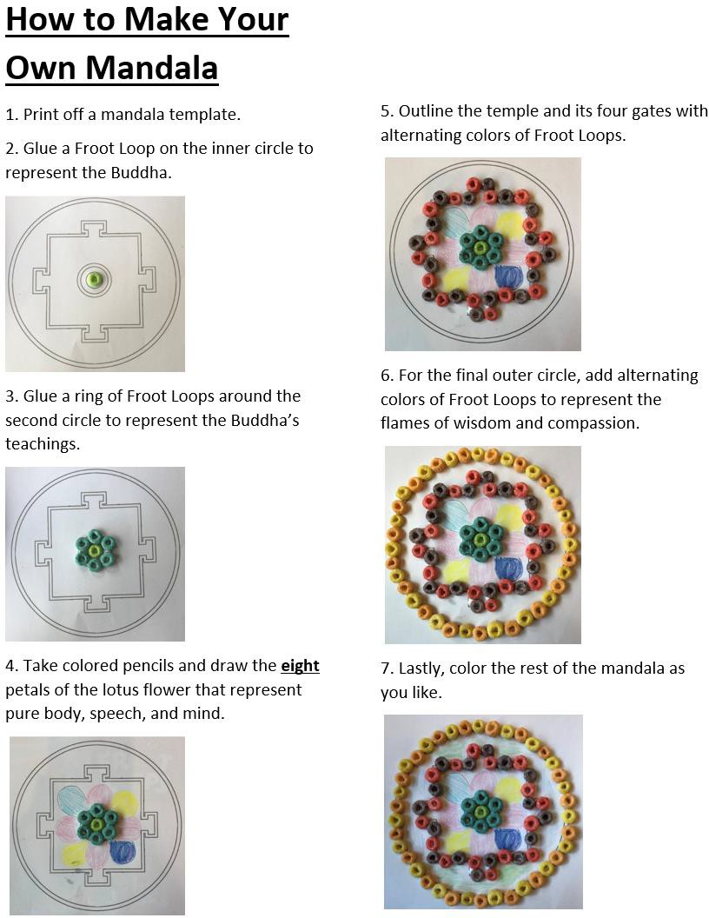

You could do the coloring first and stick the Froot Loops on after if it is easier. Also, you could give your mandala some sparkle by adding glitter!

My Tibetan Mandala Name:

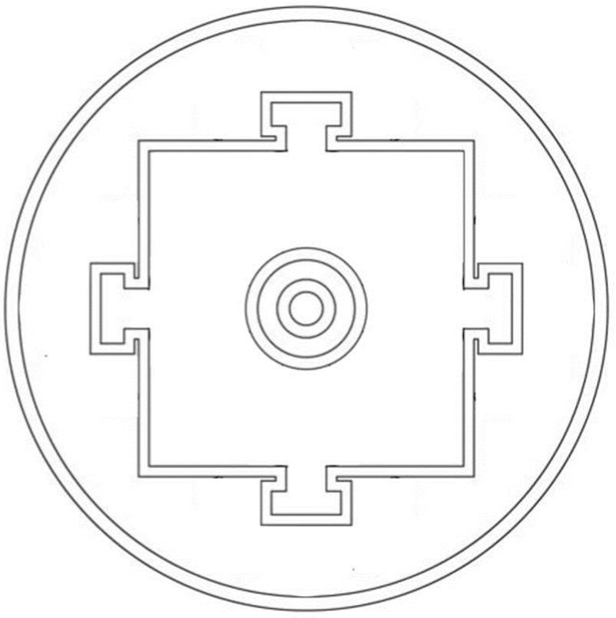

Follow-Up Questions

- Discover Tibet
  - What is the Tibetan capital and what languages do they speak there?
  - What is another name for the Tibetan Plateau?
- Buddhism in Tibet
  - What did the Buddha say is the secret to being happy?
  - How is Buddhism kept alive in Tibet?
  - What activities do monks participate in?
- What is a Mandala?
  - What are mandalas made from?
  - What three tools are used to make a mandala?
- Some Mandala Symbols
  - What does the innermost circle represent?
  - What does the outermost circle represent?

